Report on an analysis of responses to the 2020 Survey for the Revision of the Society for American Archaeology’s Principles of Archaeological Ethics

Ben Marwick

Eloise Potter

Raelee Hampton

Kaylee Pruski

Liying Wang

December 2020, Revised February 2021

Table of Contents

**Introduction** **4**

**Methods** **5**

**Results** **12**

Questions about demographics 12

Q: Are you a current SAA member? 13

Q: What is your primary work setting? 13

Q: Are you a member of the RPA? 14

Q: How many years have you worked in/with archaeology? 14

Q: Where do you do fieldwork/research? 14

Q: Geographical area of origin 14

Q: Current place of residence 15

Q: What is your age? 15

Q: What is your gender identity? 15

Q: Do you consider yourself a member of the LGBTQIA+ community? 15

Q: Please indicate your ethnicity 15

Multiple Correspondence Analysis of Demographic Categories 16

Questions about usage 17

Q: How frequently would you estimate you have consulted the SAA Principles of Ethics in the past? 17

Q. How have you used the SAA Principles of Ethics? 19

Q: Have you consulted any other codes of ethics? 22

Questions about the current nine Principles of Archaeological Ethics 24

Q: Principle 1: Stewardship (311 text responses) 30

Q: Principle 2: Accountability (341 text responses) 35

Q: Principle 3: Commercialization (281 text responses) 39

Q: Principle 4: Public Education (251 text responses) 45

Q: Principle 5: Intellectual Property (331 text responses) 51

Q: Principle 6: Public Reporting (301 text responses) 57

Q: Principle 7: Records and Preservation (243 text responses) 62

Q: Principle 8: Training and Resources (229 text responses) 68

Q: Principle 9: Safe Educational and Workplace Environments (329 text responses) 72

Latent Factors in the Likert Responses about the Nine Principles 76

Questions about how the current Principles of Ethics address situations and concerns 80

Q: As a whole, the SAA Principles of Ethics satisfactorily addresses the ethical situations archaeologists find themselves in today (323 text responses) 83

Q: The SAA Principles of Ethics adequately addresses ethical concerns in the country in which I work, am a student, or teach (197 text responses) 86

Q: The SAA Principles of Ethics adequately addresses ethical concerns in sector in which I work (189 text responses) 91

Questions about the future of SAA’s documentation about ethics 93

Q: What do you see as being the primary ethical concerns in the field today? (455 text responses) 93

Q: What should be the purpose of the SAA's ethical document? (526 responses) 106

Q: What type of ethical document(s) do you feel would best serve the SAA membership? (1,016 responses) 108

Q: Are there additional ethical issues that should be addressed by the Principles? (1012 yes/no responses, 409 text responses) 112

**Discussion** **117**

Demographics of respondents 117

Use of the Principles 117

The Nine Principles 118

How the Current Principles of Ethics Address Situations and Concerns 119

The future of SAA’s documentation about ethics 120

Primary ethical concerns 120

The purpose of the SAA's ethical document 121

Types of ethical document that would best serve the SAA membership 121

Additional ethical issues that should be addressed by the Principles 122

Possible responses to concerns raised in the survey 122

Revising the text of the Principles 122

Actions beyond the text of the Principles 124

**Conclusion** **126**

**References cited** **128**

**Appendix: Responses that include any of the words race/racism/racial/racist** **135**

**Appendix: Confidential - Proposal for a Principle 10 on anti-racism** **146**

Context 146

Recommendation by Task Force 2 on the proposed Principle 10 on anti-racism 147

Responses to a draft Principle 10 compiled by Bonnie Pitblado and Kelley Hays-Gilpin circulated on September 11, 2020. 149

# Introduction

In this report we describe our analysis of 1542 responses to 31 questions in a survey administered by the Society for American Archaeology about their Principles of Archaeological Ethics. Of these 1542 respondents, 1112 identified as members of the SAA, representing 18.3% of the total number of 6500 SAA members (as of March 2020). That said, the sample here is nearly double that of the most recent SAA membership needs survey (839 responses), and so can be considered a successful data collection activity. To the best of our knowledge it is the largest survey on archaeological ethics ever conducted, and is thus a robust baseline for future studies. Although we received a total of 1542 responses, many questions were optional, so not all respondents provided answers for every question. This means that the number of responses for each question varies throughout the survey. We have indicated the specific number of responses to each question throughout the report to guide the reader.

In the Spring of 2018, the SAA initiated a process of revising and updating the [Principles of Archaeological Ethics](https://www.saa.org/career-practice/ethics-in-professional-archaeology). More background information about this process is available on this SAA webpage: [Task Force on Revisions of the SAA Principles of Archaeological Ethics: Stage One (2018)](https://www.saa.org/quick-nav/saa-media-room/news-article/2018/09/05/task-force-on-revisions-of-the-saa-principles-of-archaeological-ethics-stage-one) As part of this process, in Fall 2018 the SAA organised the ‘Task Force on the Revision of the SAA Principles of Archaeological Ethics: Stage 2 (TF 2)’ to develop and deploy a survey to collect feedback on the current Principles of Archaeological Ethics, and suggestions for revision. The main objectives of the survey are to collect feedback on revising the SAA’s Principles of Archaeological Ethics and to compile data with preliminary interpretations to guide a future Task Force 3 in its mission to revise the Ethics. Members of Task Force 2 drafted the survey questions under the direction of the chair, Sarah Miller. The survey questions and data handling protocols were assessed by the University of Washington Human Subjects Division and determined that our proposed activity is ‘human subjects research that qualifies for exempt

status’ (UW IRB ID: STUDY00009700). This means that our research is exempt from the federal human subjects regulations, including the requirement for IRB approval and continuing review.

During April-June 2020 the SAA administered this survey. Access to the survey was not limited in any way. The survey was open for responses from SAA members and non-members to enable participation by multiple stakeholders.

The survey was administered online using Qualtrics software hosted by Gordon Rakita at the University of North Florida. At the conclusion of the survey, 1542 responses had been obtained. Rakita anonymized all the questions containing demographic data and forwarded the survey data for analysis on 10 June 2020. The analysis was led by Ben Marwick, who directed a team that included Raelee Hampton, Eloise Potter, Kaylee Pruski, and Liying Wang.

We grouped the survey questions into five groups and have organised this report around these groups. We first present results of our analysis in this order:

* questions about respondent demographics
* questions about usage of the current Principles
* questions about the individual Principles
* questions about how the current Principles address situations and concerns
* questions about the future of SAA’s documentation about ethics.

The most important findings are contextualized in the Discussion section, which also considers measures the SAA could take to address concerns revealed by the survey.

# Methods

The survey used several response types, often with multiple types used for a single question. We used a variety of analysis and visualization methods depending on the response type. The R code and data for the analysis reported here are available in a research compendium [(Marwick, Boettiger, and Mullen 2018)](https://www.zotero.org/google-docs/?6BzVLJ) at <http://doi.org/10.17605/OSF.IO/643C8>. To comply with the EU’s General Data Protection Regulation (GDPR) we do not include any responses to the demographic questions in our compendium because these are ‘personal data’. Personal data is information relating to an identified or identifiable person, for example someone who can be identified, directly or indirectly, in particular by reference to a data value.

Single option response

Only one option was allowed, e.g. yes/no. We visualise these responses with a simple ordered bar plot that shows the frequencies of each response.

Multiple responses

One or more options could be selected, e.g. “I am satisfied with the format of the current Principles” / “An aspirational code” / “A living document” / etc. We used an UpSet plot for basic visualisation of these responses. This is an alternative to a Venn Diagram that plots the intersections of a set as a matrix [(Lex et al. 2014)](https://www.zotero.org/google-docs/?WVCsSt).

Five-level Likert item response

Where respondents select one item to indicate their level of agreement or disagreement on a symmetrical agree-disagree scale, e.g. Strongly disagree / Disagree / Neutral / Agree / Strongly agree. We used a diverging stacked proportional bar plot to visualise responses to questions with this Likert-type scale. Although this type of response is widely used in several disciplines, there is disagreement about the most suitable statistical methods for hypothesis testing.

To summarise variation in responses across the demographic categories, we computed “mean disagreement” values for each group by re-scaling the Likert type responses from 1 (strongly agree) to 5 (strongly disagree) and computing the mean within each group. To test for non-random differences between groups, we used the Kruskal-Wallis rank sum test. The test results are summarised on the plots accompanying each survey question, with solid data points indicating a non-random difference, and hollow data points indicating no difference in mean disagreement between the groups. Because Likert type responses may violate assumptions for comparing means or ranks, we also show all the individual data points on the plots to aid in interpretation. To further guide interpretation of the plots, the data point sizes are scaled to the number of respondents in each group.

Free text

Where the respondent can enter any text. e.g. a single word, sentence or paragraphs), or leave the field blank. The amount of text submitted varied greatly between questions and respondents (Figure 1). We take a computational social science approach that combines social science qualitative methods with computer and data science methods (Lazer et al. 2009; Salganik 2019).

We used two sets of methods for analysing the free text: traditional qualitative data analysis (QDA) and more novel exploratory data analysis (EDA) using computational methods.

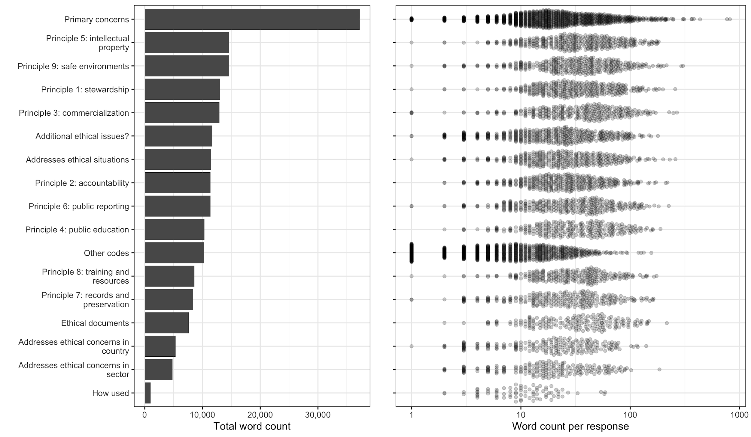

Figure 1. Word count for questions with free text responses.

Qualitative Data Analysis

Surveys that include open‐ended, free‐text responses are often analyzed using qualitative methods (Baumer et al. 2013; Rader, Wash, and Brooks 2012). Analytic methods from grounded theory [(Charmaz 2006)](https://www.zotero.org/google-docs/?A2DNeY) can generate rich, thick descriptions (Geertz 1973). Our QDA used a grounded-theory approach, and followed typical three steps for text analysis [(Bernard and Ryan 1998)](https://www.zotero.org/google-docs/?lLc9M4). First we read over all the free text responses to immerse ourselves in the content to infer key recurring themes. We also examined the results of the EDA to inform our thematic analysis. Second, we organised these themes into a small set of tags or codes to classify the key concepts among the responses (Table 1). Third, we studied all the free text responses and applied tags to identify our key themes among the responses. We then analysed the tagged text to identify the relative importance of themes, relationships between themes, and identify examples to summarise the themes. We report on the results of our tagging by organising the data into *Commonalities* (what are the most common tags across many responses?), *Contrasts* (Contrasts: what tags never or rarely appear together; what are examples where one tag has different types of responses?), *Comparisons* (what tags frequently appear together?), *Relationships* (Relationships: do some tags seem to have a cause and effect relationship?), and *Sentiment* (are there positive and negative reactions among the tagged text?).

Table 1. Tags and their descriptions used for the QDA

|  |  |
| --- | --- |
| **Tag** | **Description** |
| Indigenous | also First Nations, descendant communities, rights, involvement, communities, traditional knowledge, consultation, patrimony, decolonising |
| Repatriation | also returning artefacts to Indigenous communities |
| Human remains | also bioarchaeology, human bones |
| Museums | also anything about museums |
| Looting | also illegal antiquities dealing, private collections, hoarding, damage to sites |
| Avocational | also treasure hunting, metal detecting |
| Archiving | also long term preservation of finds, curation, controlling access to data and objects |
| Public engagement | engaging with, communicating with, training members of the public |
| Laws | also state and federal legislation, compliance with laws and policy |
| Relevance | also things like ‘not relevant to me/my sector’, outdated, needs to be updated, |
| Enforcement | also not enforced, need for a high standard, more ‘teeth’, need to be backed up, lack of consequences, needs to be stronger |
| IP and copyright | also intellectual property, data sovereignty, authorship |
| Plagiarism | also lying, dishonesty, stealing work of others |
| Field methods | also sampling |
| Conflicts of interest | profit over quality, protection of the archaeological record, competition |
| Training students | also teaching, experience, quality of education, acquiring professional skills, job preparation |
| Mentoring | also professional relationships between advisors and students |
| Power dynamics | also power imbalances, exploitation of students and junior workers, abuse of power |
| Diversity | also people of diverse backgrounds, also improving access to training |
| Research | also PhD thesis, dissertations, journal articles, books |
| Open science | also open data and open access, information sharing, digital data, transparency, and reproducibility |
| Harassment | also bigotry, abuse, misogyny |
| Sexual harassment | also 2019 SAA, David Yesner, #MeToo |
| Racism | also Black, Latinx communities, exclusion, under-representation |
| Discrimination | age, gender, ethnicity, career stage/type (CRM vs academia) |
| Physical safety | also workplace safety, field work or lab work |
| Reporting | also whistleblowing, making complaints |
| Money | also pay, salary, income, financial concerns, budgeting, job security |
| Collegiality | also collegial and supportive environments, behavior toward other professionals, colleagues |
| Environment | also climate change, fossil fuels, plastics, |

For the question about how the Principles were used, we developed a separate set of tags:

Table 2. Tags used for the question about how the Principles were used.

|  |  |
| --- | --- |
| **Tag** | **Description** |
| Research | to compare and critique with other org or with SAA’s actions |
| Teaching | to show students or prepare for a class |
| Derive | to develop/adopt a code for another organisation |
| Assessment | to guide own behaviour or other people’s behaviour |
| Implement | to guide employee or members of an organisation (without adapting it, just using as-is) |

Exploratory Data Analysis

To complement our QDA, we employed a suite of computational text analysis methods to summarise the free text responses and automatically extract topics. The computational methods are useful for the descriptive analysis of unstructured text data sets, and can provide robust confirmation of qualitative data analysis results. Compared to the grounded-theory approach of QDA, our computational methods are ‘theory-free’, and the results can be independently reproduced by any researcher, regardless of the biases and motivations they bring to their study.

To prepare the text for EDA methods we used the quanteda package for R [(Benoit et al. 2018)](https://www.zotero.org/google-docs/?S3nxlh) to remove stop-words (e.g. ‘the’, ‘and’, etc.) and convert the text into a document-feature matrix (a table where each row is a document and each column is a word, and the cell values are word counts per document). After these preparatory steps we used two techniques for analysis and visualisation.

First, are network plots that show how frequently-used words co-occur with each other. This shows the most frequent words, and also adds additional information in the form of a visual connection between words that often co-occur.

Second are topic models that show computational models of topics present in the responses. As they usually do not make use of human‐curated notions of the topics in a document but instead derive them purely from the data, topic models are often classified under unsupervised machine learning methods. A topic model indicates which topics are most abundant in the responses. A topic model is a statistical analysis of text that assumes there are an arbitrary number (k) topics present in all the responses (we have to choose this number in advance, we use methods to estimate it). It assumes that every unique word in the text has a certain probability that it will appear in each topic. Computing these probability distributions is an iterative process, so each time we run the code we get slightly different combinations of words in the topics. A ‘topic’ then, is a distribution of all the unique words in the text, and one topic is different from another topic by the probability distributions of the unique words. One word can have a high probability of appearing in multiple topics, that’s why we see some duplication of words in different topics. The highest probability words for each topic are shown in the bar plot. Some of our topics are a bit ‘noisy’, and not highly exclusive, distinct, or easily interpretable, this might be improved with some further tuning. This probabilistic approach is an advantage over the methods used for frequency-based methods (such as the word cloud), which are simply based on counts on the unique words, and so only allows a word to have a single meaning.

Topic modelling of survey results has been used in political science (Roberts, Stewart, and Tingley 2016), but as far as we know this is the first application of topic modelling to the results of a survey of archaeologists. Our use of topic models is motivated by Baumer, Mimno, Guha, Quan, and Gay [(Baumer et al. 2017)](https://www.zotero.org/google-docs/?T0BrYA) who found that topic modelling is surprisingly similar to grounded theory-based QDA, demonstrating how similar results could be obtained by applying these two methods to the same research problem..

We computed structural topic models (STM) for some questions with free text responses using the stm package for R [(Roberts, Stewart, Tingley, and others 2014)](https://www.zotero.org/google-docs/?F3G2V7). Structural topic models use the conventional machine learning algorithm, Latent Dirichlet Allocation, for discovering topics automatically, and also incorporate metadata, such as demographic variables [(Roberts, Stewart, Tingley, Lucas, et al. 2014)](https://www.zotero.org/google-docs/?11vi0z). This enables us to make credible inferences about the effect of covariates such as age and ethnicity on the content of open-ended responses. We summarise these covariate relationships with plots that show estimates of a regression where the free text responses are the units, the outcome is the proportion of each response about a topic in an STM model, and the covariates are demographic metadata associated with each response. This allows us to compute a conditional expectation of topic prevalence given the demographic characteristics of the respondents, and incorporate estimation uncertainty in the visualisation. If the error bar for a data point on these visualizations does not include zero, we consider that it indicates a non-random relationship.

# 

# Results

## Questions about demographics

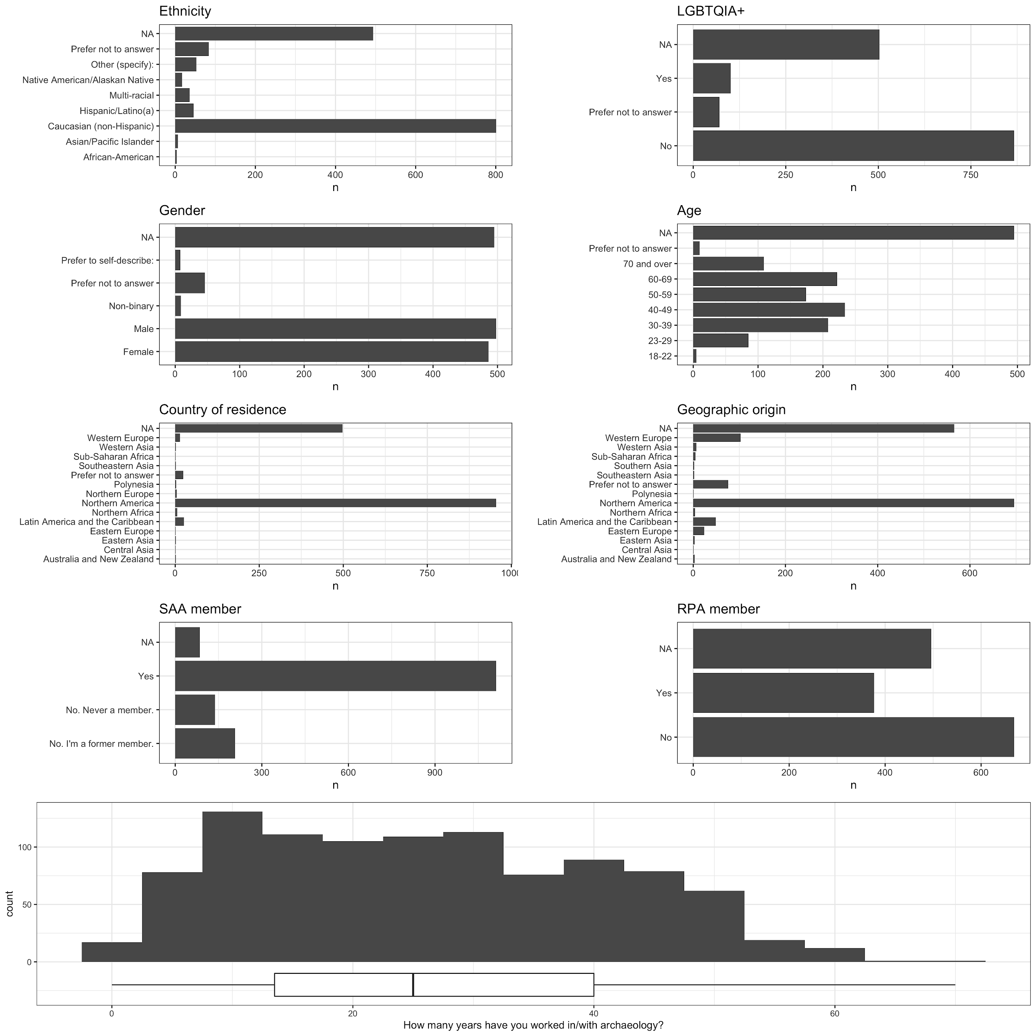

Figure 2. Summary of responses to demographic questions asked in the survey

### 

### Q: Are you a current SAA member?

This question was a single option response. The majority of respondents answered “Yes” (72%, n = 1112). The remainder were former members (13%, n = 207) or never had been members (9%, n = 138).

### 

### 

Figure 3. Distributions of fieldwork/research locations and work settings of survey respondents

### Q: What is your primary work setting?

This question was a single option response. Of the 16 options, we found the top three sets of options were “Academic” (28%, n = 439, including with and without graduate programs, and community colleges), “CRM” (11%, n = 174) and “Government” (9%, n = 136, including federal, state and tribal). About half of all respondents were spread across other settings (51%, n = 793, e.g. student, retired, museum, etc.). Membership of the SAA was significantly lower for respondents working in Government, compared to other work settings (χ2  = 29.7, df = 6, p = 4.32 x 10-5).

|  |  |  |  |  |
| --- | --- | --- | --- | --- |
| Are you a current SAA member? | Academic | CRM | Government | other |
| No. I'm a former member. | 47 | 18 | 20 | 37 |
| No. Never a member. | 8 | 8 | 16 | 23 |
| Yes | 384 | 148 | 99 | 234 |

### Q: Are you a member of the RPA?

This question was a single option response. The majority of respondents answered “No” (43%, n = 669), followed by no response (32%, n = 496). Only about quarter of respondents answered “Yes” (24%, n = 377). Membership of the RPA was significantly higher for respondents working in CRM, compared to other work settings (χ2  = 68.6, df = 3, p = 8.11 x 10-15).

|  |  |  |  |  |
| --- | --- | --- | --- | --- |
| Are you a member of the RPA? | Academic | CRM | Government | other |
| No | 285 | 68 | 86 | 230 |
| Yes | 154 | 106 | 48 | 69 |

### Q: How many years have you worked in/with archaeology?

The average number of years was 26, with a range of 0 to 70 years. Most respondents have worked in/with archaeology for 15-40 years. There was no significant difference in the number of years worked across the four main work setting groups (F = 0.99, df = 3, p = 0.39).

### Q: Where do you do fieldwork/research?

This question was a multiple option response. The majority of respondents indicated “Northern America” (38%, n = 800), followed by “Latin America and the Caribbean” (13%, n = 276). None of the other 15 global regions made up more than 5% of respondents.

### Q: Geographical area of origin

The majority of respondents indicated an origin in “Northern America” (45%, n = 696), with the next largest group coming from “Western Europe” (7%, n = 103). A high proportion of respondents did not respond (36%, n = 566). Other locations that contributed more than one percent were “Latin America and the Caribbean” (3%, n = 49) and “Eastern Europe” (1%, n = 24). All other major regions of the world were represented by less than 10 people each.

### Q: Current place of residence

As for the previous question, most respondents indicated “Northern America” (61%, n = 955). Many people did not respond at all (32%, n = 498). The next most represented location is “Latin America and the Caribbean” (2%, n = 26). All other major regions of the world were represented by less than 10 people each.

### Q: What is your age?

The age of respondents is skewed to older people, with roughly half of respondents reporting an age of 40 or older (47%, n = 739), About one third of respondents did not respond (32%, n = 495).

### Q: What is your gender identity?

The majority of respondents reported either “Female” (31%, n = 486) or “Male” (32%, n = 498). “Non-binary” was reported by nine people (less than one percent), and eight people self-described their gender. We omit further discussion of these individuals to protect their privacy.

### Q: Do you consider yourself a member of the LGBTQIA+ community?

More than half of all respondents indicated “No” (56%, n = 867), and 6% (n = 101) responded “Yes”.

### Q: Please indicate your ethnicity

The majority of respondents indicated “Caucasian (non-Hispanic)“ as their ethnicity (51%, n = 801), followed by “Hispanic/Latino(a)” (3%, n = 46). Only 17 people identified as Native American (1%). About one third of the respondents did not respond (32%, n = 494)

### 

### Multiple Correspondence Analysis of Demographic Categories

MCA allows us to investigate the pattern of relationships of several categorical variables. It is a factor analysis for categorical data that is useful for providing a general understanding of how categorical variables are related. In this case, it can help us to visualize the associations between the demographic categories represented by the respondents. This is useful for summarizing the diversity of the respondents.

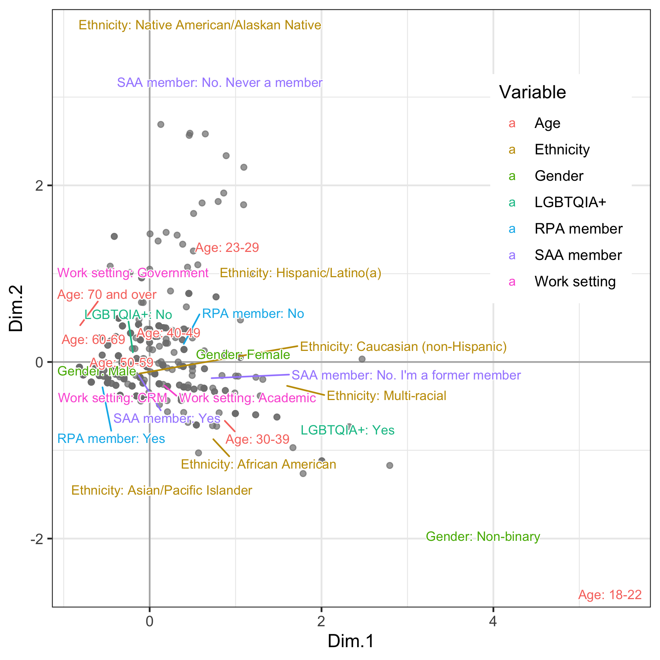

Figure 4. Multiple correspondence analysis of demographic variables in the survey

The MCA plot shows how the diversity of the respondents is structured (Figure 4). The horizontal axis mostly captures variation in the age of the respondents, with younger respondents appearing on the right side. The vertical axis mostly represents the ethnicity category. The overall picture is that there is little demographic diversity among the respondents, with most respondents clustered in the older age and Caucasian (non-Hispanic) ethnicity. Younger members of the Society are probably underrepresented here. This is a problem because younger members are most often associated with the LGBTIA+ community, and non-binary gender, as we see from the position of these categories on the horizontal axis of the plot. Another important demographic category that is underrepresented here is Native Americans, who made up only 1% of respondents.

## Questions about usage

### Q: How frequently would you estimate you have consulted the SAA Principles of Ethics in the past?

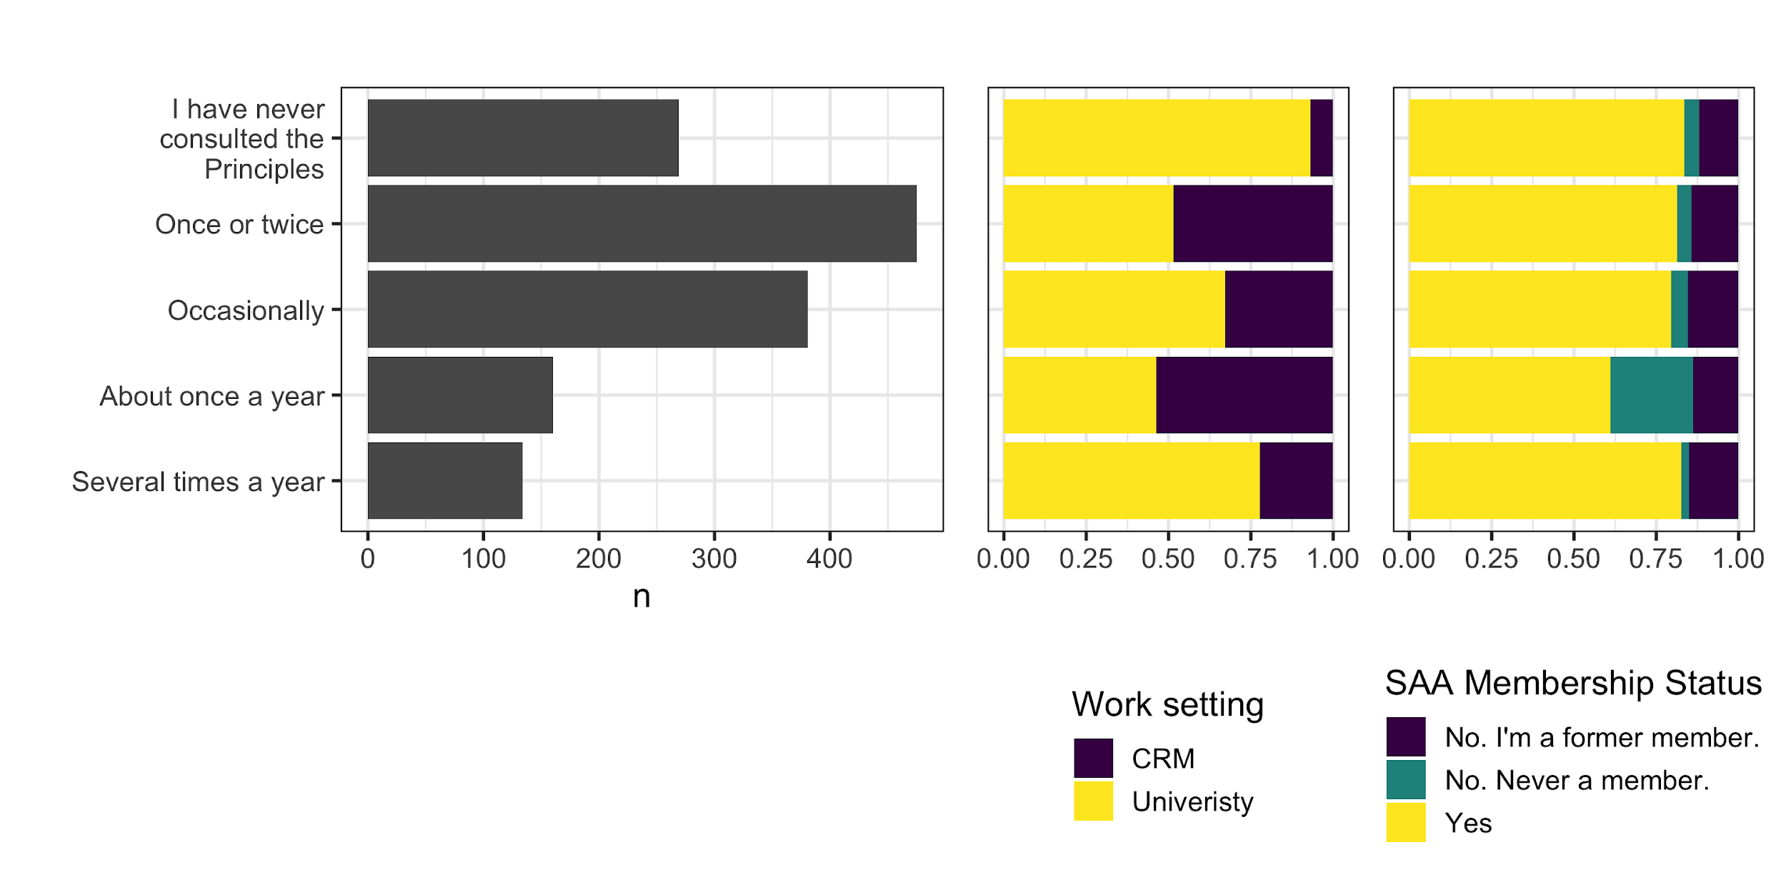

Figure 5. Frequency of consultation of the SAA’s Principles.

|  |  |  |  |
| --- | --- | --- | --- |
| **Frequency** | **Former member** | **Never a member** | **Current member** |
| Several times a year | 16 | 6 | 111 |
| About once a year | 24 | 4 | 132 |
| Occasionally | 59 | 19 | 303 |
| Once or twice | 68 | 21 | 385 |
| I have never consulted the Principles | 37 | 68 | 164 |

Table. Count of respondents to the question “How frequently would you estimate you have consulted the SAA Principles of Ethics in the past?” by membership status.

This question was a single option response. The most common response was “Once or twice” (30%, n = 475), closely followed by “Occasionally” (25%, n = 381), perhaps reflecting the difficulty that respondents had in distinguishing between these two options (Figure 5). Some respondents had never consulted the Principles (17%, n = 269). Respondents working at Universities were more likely to consult the Principles ‘several times a year’ compared to respondents in CRM. SAA members appear to consult the Principles more frequently than non-members.

### Q. How have you used the SAA Principles of Ethics?

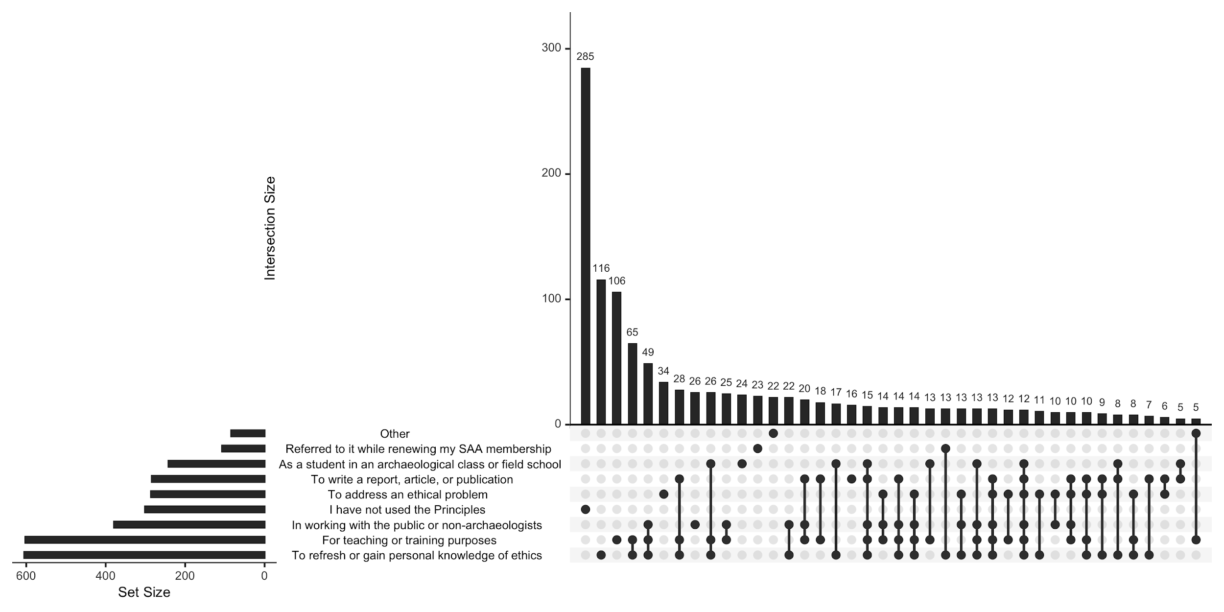

Figure 6. UpSet plot of the respondents to the multiple choice question about how respondent have used the Principles

This question had a multiple response section, one option was a write-in ‘Other’ field. The most common single response was "I have not used the Principles” (33%, n = 301). The most common response combined with other responses was “To refresh or gain personal knowledge of ethics” (67%, n = 605) (Figure 6). The most common pair of responses was “To refresh or gain personal knowledge of ethics” and “For teaching or training purposes”. The most common triplet of responses added to these two “To write a report, article, or publication”, highlighting the use of the Principles in education and communication.

In a preliminary reading of the 77 free text responses in the “Other” field, we identified five tags that captured the variation, and used these tags to analyse the responses in detail: Research, Teaching, Derive, Assessment, Implement.

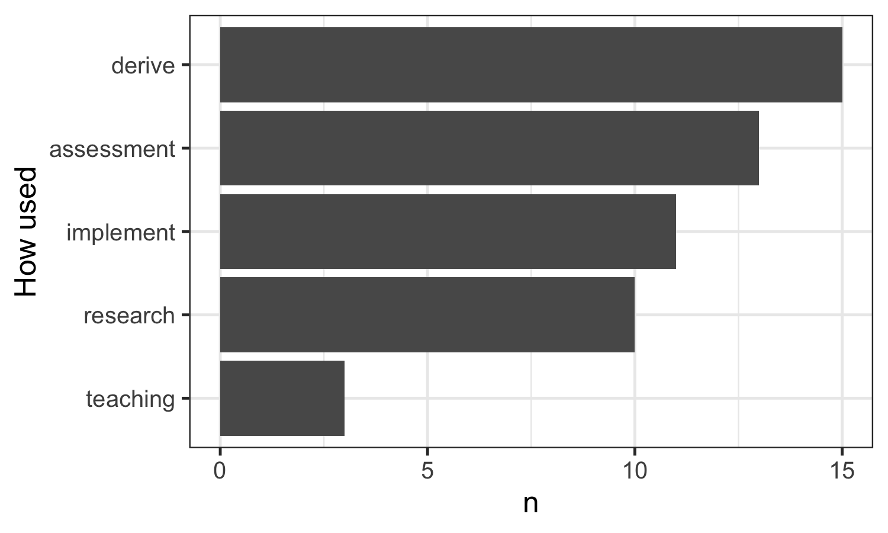

Figure 7. Themes in the 77 free text responses to the question about how the Principles are used.

Commonalities

According to our analysis of the 77 text responses in the ‘other’ field, the most common way people use the SAA guidelines is with the tag “Derive” (Figure 7). This means that most people use SAA’s Principles to develop similar documents for other organizations:

“While working to develop and write guidelines and standards for conducting archaeological investigations that support compliance with federal laws”

Contrasts

Multiple tags were rarely used in the responses to this question. But, it is important to note that the tag “Teaching” had the fewest responses. This is striking because it seemed like the SAA’s Principles would be useful in an academic environment. Here is an example of an instructor using the Principles for teaching:

“As a teacher in the classroom”

Comparisons

There were no responses in this section that used more than one tag. The lack of correspondences between the tags could possibly indicate that respondents are not using SAA’s Principles in more than one way.

Sentiment

Most of the 77 responses to this section of the survey were explaining how they have used the SAA’s Principles in their line of work or otherwise. This question requires more of an explanation than an opinion; however, there were a few comments that had a negative reaction about the SAA’s use of ethics in the past.

“To understand the magnitude of SAA’s failure at the Albuquerque conference and the board’s lack of caring and concern for its members”

Among the 77 respondents to this question there seems to be a general distrust towards the SAA and how they handle their ethics:

“After 2019 I learned the SAA had no ethics and the Principles of Ethics were nothing more than lipservice”

### Q: Have you consulted any other codes of ethics?

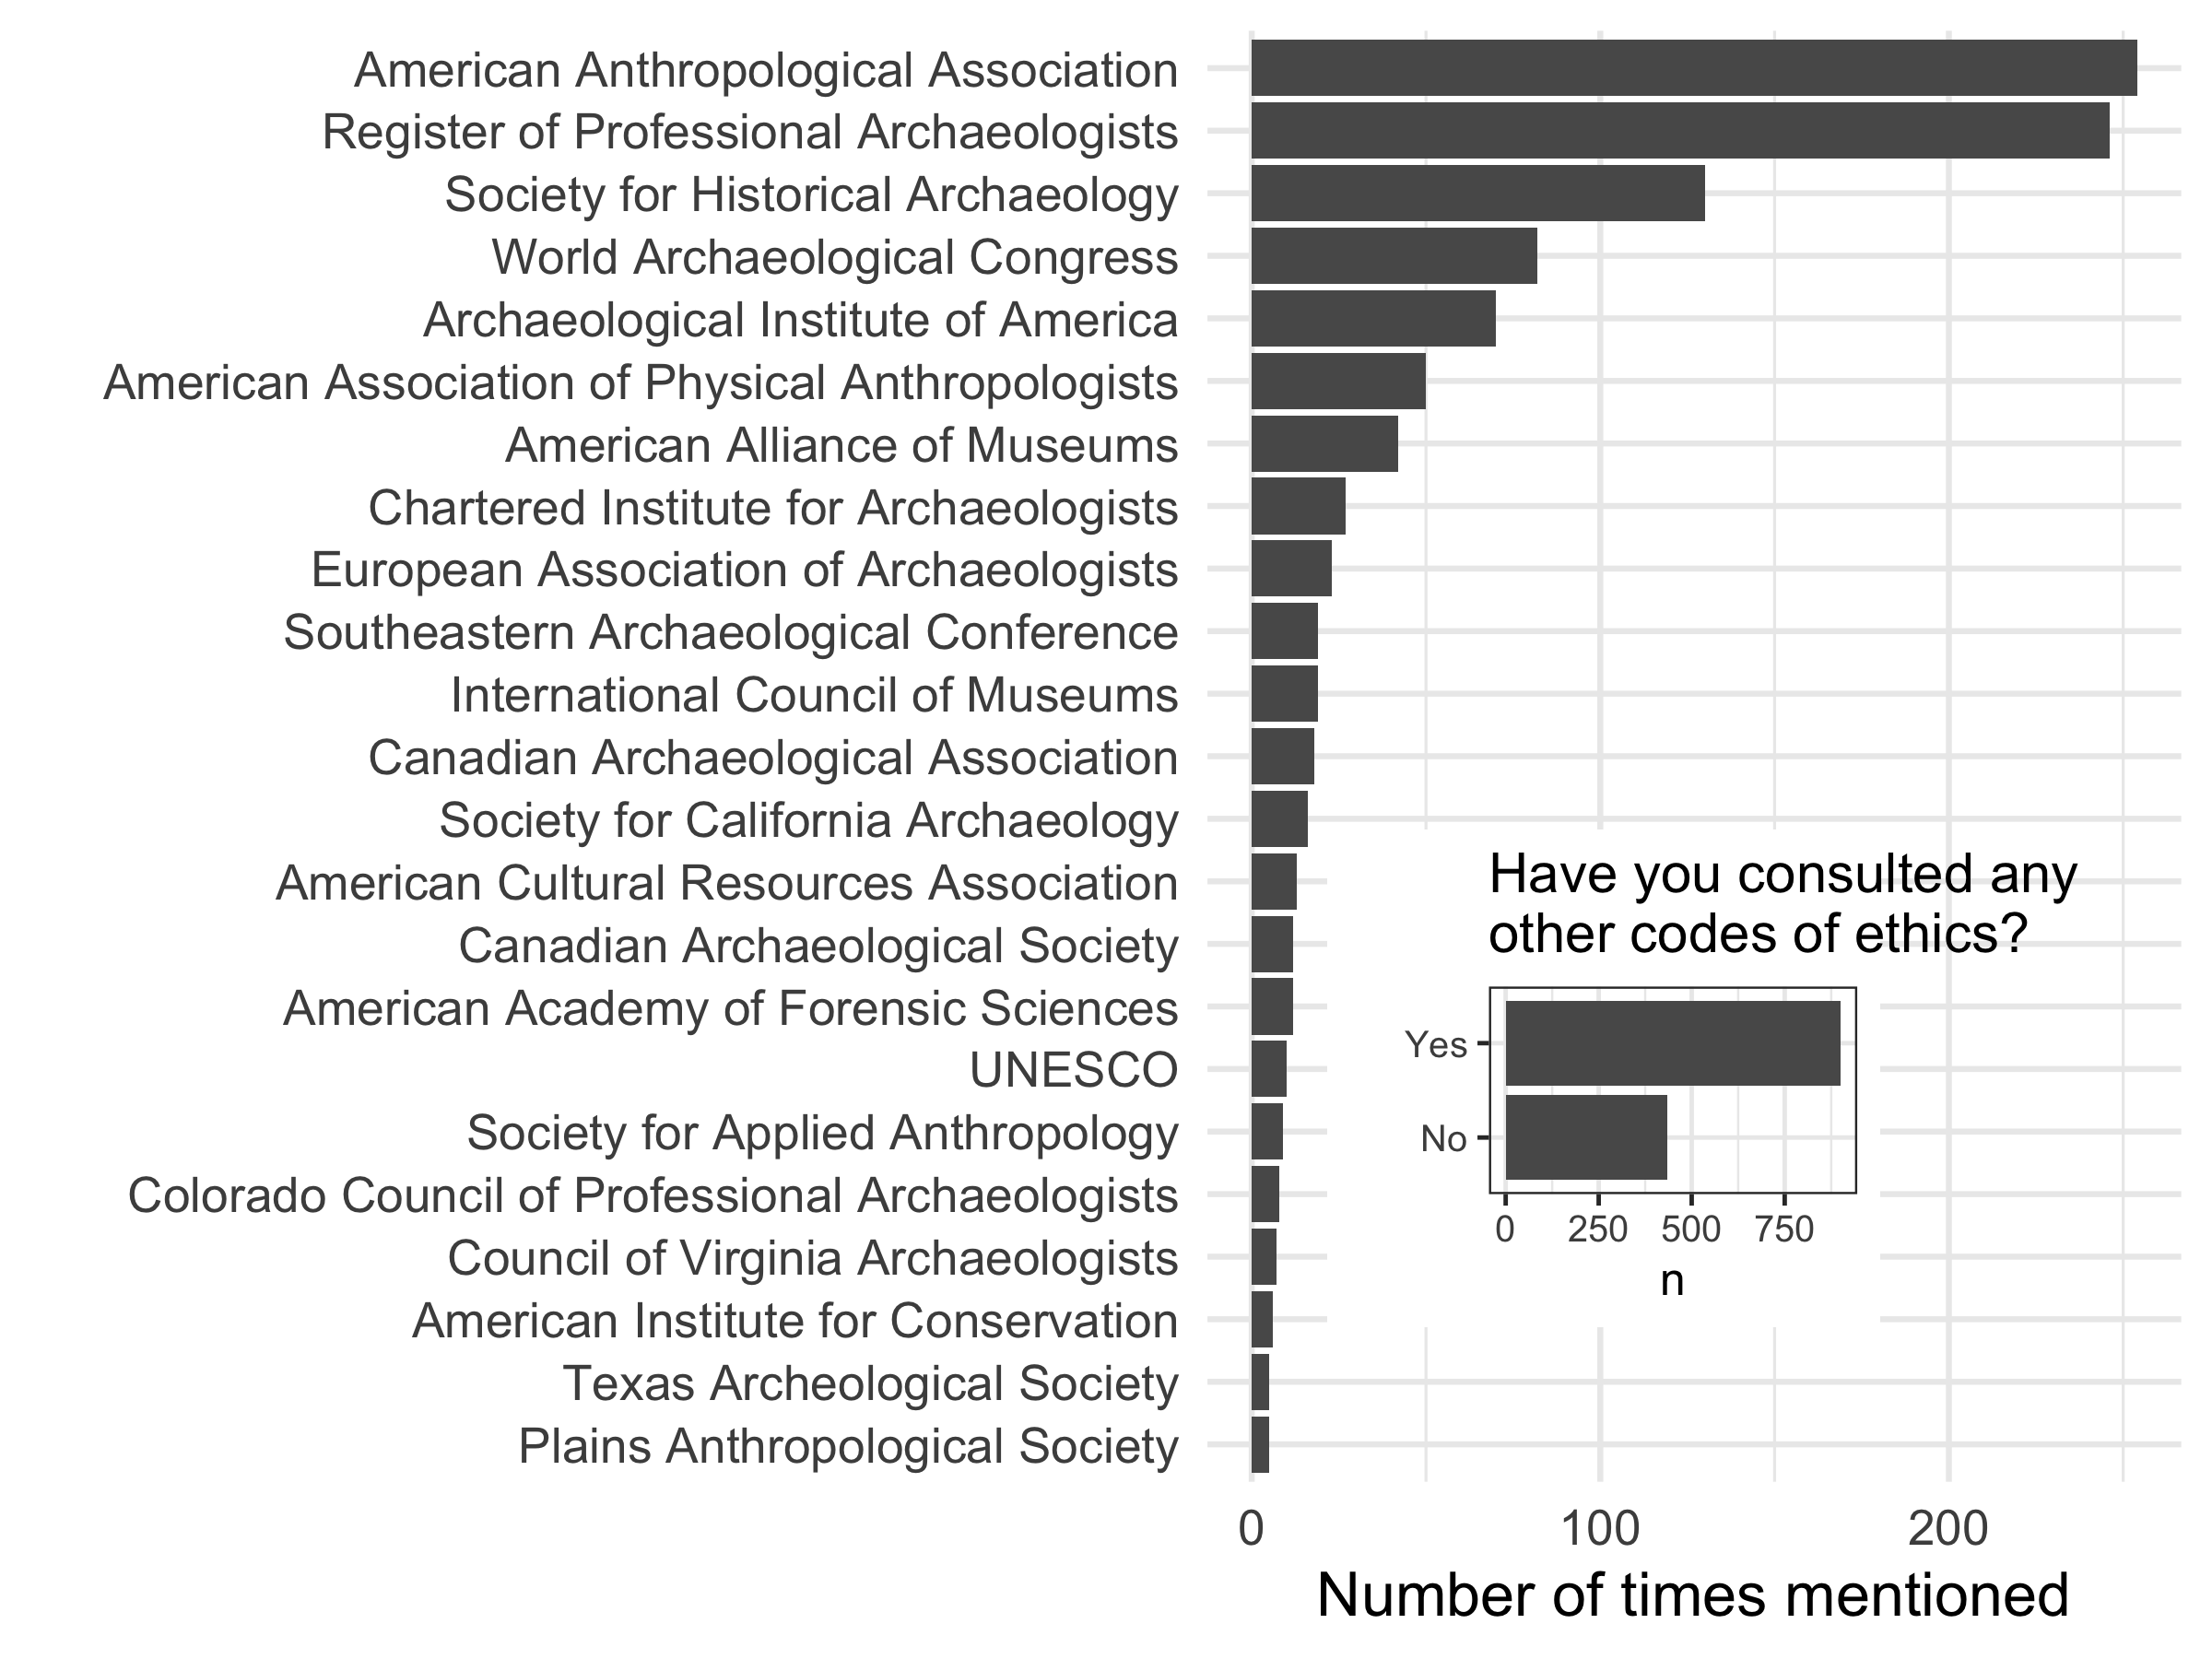

Figure 8. Other organizations mentioned by respondents. Only those mentioned by more than five respondents shown here. A total of 121 organizations were mentioned by 1542 respondents.

This question had a yes/no single choice response and a free text response field. Overall, the majority of respondents to this question had consulted other codes, and most of these were from national or international organizations relating to archaeology, anthropology and museums (Figure 8). By far the most frequently mentioned organisations were the American Anthropological Association and the Register of Professional Archaeologists. Outside of these fields, other scientific organisations were also mentioned, such as the Ecological Society of America, the Geological Society of America, and the American Geophysical Union. The majority of respondents working in CRM mentioned using the Register of Professional Archaeologists, but respondents working in Academia and Government rarely mentioned using the RPA code.

|  |  |  |
| --- | --- | --- |
| Work setting | Doesn't use RPA code | Uses RPA code |
| Academic | 233 | 82 |
| CRM | 49 | 57 |
| Government | 59 | 23 |
| other | 250 | 67 |

Commonalities

While looking through the free text responses for the other organizations that people use, there were some distinct differences in the types of organizations. Some of these types were federal, local, and museums. Where multiple organisations were mentioned in individual responses, most frequent of these groupings were organizations of the local and federal level. This could indicate that respondents to the survey have a trust or rapport with their local organizations.

Contrasts

The groupings that had the widest variety of respondents was the local organizations. The local organizations that were most frequent were “Canadian Archaeological Society” with over five responses. Other local organizations that were frequently mentioned were the Texas and Virginia organizations. These include “Texas Archeological Society”, Texas Archaeological Stewardship Network”, “Archaeological Society of Virginia”, and “Council of Virginia Archaeology”. These two states were the states with the most replies of different organizations.

Comparisons

It seems overwhelming that most respondents to the survey are looking towards local and STEM oriented organizations. The prominence of local organizations suggests the high value respondents relationships with their local community of practice.

## 

## Questions about the current nine Principles of Archaeological Ethics

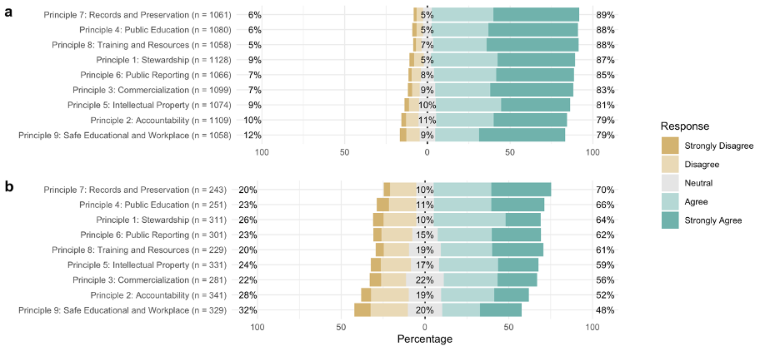

Figure 9a. Summary of the Likert-type responses to the prompt, “I feel that this principle and its description adequately applies to archaeological practice and its ethical challenges today” for each of the nine Principles. a) all survey respondents, b) only the subset of respondents that also submitted a text response on the Principle.

|  |  |  |  |  |  |  |
| --- | --- | --- | --- | --- | --- | --- |
| **Principle** | **Strongly Agree** | **Agree** | **Neutral** | **Disagree** | **Strongly Disagree** | **Total** |
| Principle 1: Stewardship | 46.8% (528) | 40.2% (453) | 4.5% (51) | 5.7% (64) | 2.8% (32) | 1128 |
| Principle 2: Accountability | 44.2% (490) | 34.8% (386) | 10.6% (118) | 7.6% (84) | 2.8% (31) | 1109 |
| Principle 3: Commercialization | 50.2% (552) | 33.2% (365) | 9.5% (104) | 4.5% (50) | 2.5% (28) | 1099 |
| Principle 4: Public Education | 54.0% (583) | 34.4% (371) | 5.2% (56) | 4.0% (43) | 2.5% (27) | 1080 |
| Principle 5: Intellectual Property | 41.6% (447) | 39.5% (424) | 10.1% (109) | 6.1% (65) | 2.7% (29) | 1074 |
| Principle 6: Public Reporting | 47.0% (501) | 37.6% (401) | 8.0% (85) | 5.6% (60) | 1.8% (19) | 1066 |
| Principle 7: Records and Preservation | 51.7% (549) | 37.2% (395) | 5.5% (58) | 3.9% (41) | 1.7% (18) | 1061 |
| Principle 8: Training and Resources | 55.6% (588) | 32.3% (342) | 6.9% (73) | 3.5% (37) | 1.7% (18) | 1058 |
| Principle 9: Safe Educational and Workplace | 52.1% (551) | 26.6% (281) | 9.4% (99) | 8.0% (85) | 4.0% (42) | 1058 |

Table 1a. Counts and percentages of responses to each Likert-type scale response anchors for each of the nine Principles.

|  |  |  |  |  |  |  |
| --- | --- | --- | --- | --- | --- | --- |
| **Principle** | **Strongly Agree** | **Agree** | **Neutral** | **Disagree** | **Strongly Disagree** | **Total** |
| Principle 1: Stewardship | 49.4% (452) | 38.0% (348) | 4.7% (43) | 5.2% (48) | 2.6% (24) | 915 |
| Principle 2: Accountability | 44.6% (403) | 35.8% (324) | 10.2% (92) | 6.4% (58) | 3.0% (27) | 904 |
| Principle 3: Commercialization | 51.3% (460) | 33.5% (300) | 8.8% (79) | 4.1% (37) | 2.2% (20) | 896 |
| Principle 4: Public Education | 54.9% (485) | 35.1% (310) | 4.2% (37) | 3.4% (30) | 2.4% (21) | 883 |
| Principle 5: Intellectual Property | 42.4% (374) | 39.8% (351) | 9.7% (86) | 5.5% (49) | 2.6% (23) | 883 |
| Principle 6: Public Reporting | 49.8% (435) | 36.7% (321) | 6.9% (60) | 5.0% (44) | 1.6% (14) | 874 |
| Principle 7: Records and Preservation | 53.4% (465) | 36.2% (315) | 4.7% (41) | 4.0% (35) | 1.7% (15) | 871 |
| Principle 8: Training and Resources | 56.8% (496) | 31.6% (276) | 6.8% (59) | 3.2% (28) | 1.6% (14) | 873 |
| Principle 9: Safe Educational and Workplace | 54.1% (472) | 26.1% (228) | 8.7% (76) | 8.0% (70) | 3.1% (27) | 873 |

Table 1b. SAA members only: Counts and percentages of responses to each Likert-type scale response anchors for each of the nine Principles.

|  |  |  |  |  |  |  |
| --- | --- | --- | --- | --- | --- | --- |
| **Principle** | **Strongly Agree** | **Agree** | **Neutral** | **Disagree** | **Strongly Disagree** | **Total** |
| Principle 1: Stewardship | 35.7% (76) | 49.3% (105) | 3.8% (8) | 7.5% (16) | 3.8% (8) | 213 |
| Principle 2: Accountability | 42.4% (87) | 30.2% (62) | 12.7% (26) | 12.7% (26) | 2.0% (4) | 205 |
| Principle 3: Commercialization | 45.3% (92) | 32.0% (65) | 12.3% (25) | 6.4% (13) | 3.9% (8) | 203 |
| Principle 4: Public Education | 49.7% (98) | 31.0% (61) | 9.6% (19) | 6.6% (13) | 3.0% (6) | 197 |
| Principle 5: Intellectual Property | 38.2% (73) | 38.2% (73) | 12.0% (23) | 8.4% (16) | 3.1% (6) | 191 |
| Principle 6: Public Reporting | 34.4% (66) | 41.7% (80) | 13.0% (25) | 8.3% (16) | 2.6% (5) | 192 |
| Principle 7: Records and Preservation | 44.4% (84) | 41.8% (79) | 9.0% (17) | 3.2% (6) | 1.6% (3) | 189 |
| Principle 8: Training and Resources | 49.7% (92) | 35.7% (66) | 7.6% (14) | 4.9% (9) | 2.2% (4) | 185 |
| Principle 9: Safe Educational and Workplace | 42.7% (79) | 28.6% (53) | 12.4% (23) | 8.1% (15) | 8.1% (15) | 185 |

Table 1c. SAA non-members only: Counts and percentages of responses to each Likert-type scale response anchors for each of the nine Principles.

Overall, most of the 1074-1128 respondents to the Likert-type questions agree or strongly agree that the Principles “adequately applies to archaeological practice and its ethical challenges today.“ (Figure 9a). However, at least 5% of respondents disagree or strongly disagree that all of the Principles are adequate. The highest proportions of disagreement are evident for Principle 5 (Intellectual Property), Principle 2 (Accountability), and Principle 9 (Safe Educational and Workplace Environments).

There is little difference in the Likert scale responses between the SAA members and non-members responding to these questions (Figure 9b and 9c). Non-members slightly more often disagree with the statements about the Principles. A notable similarity is that for both groups of respondents the two principles with the most negative responses are the same: Principle 2 (Accountability), and Principle 9 (Safe Educational and Workplace Environments).

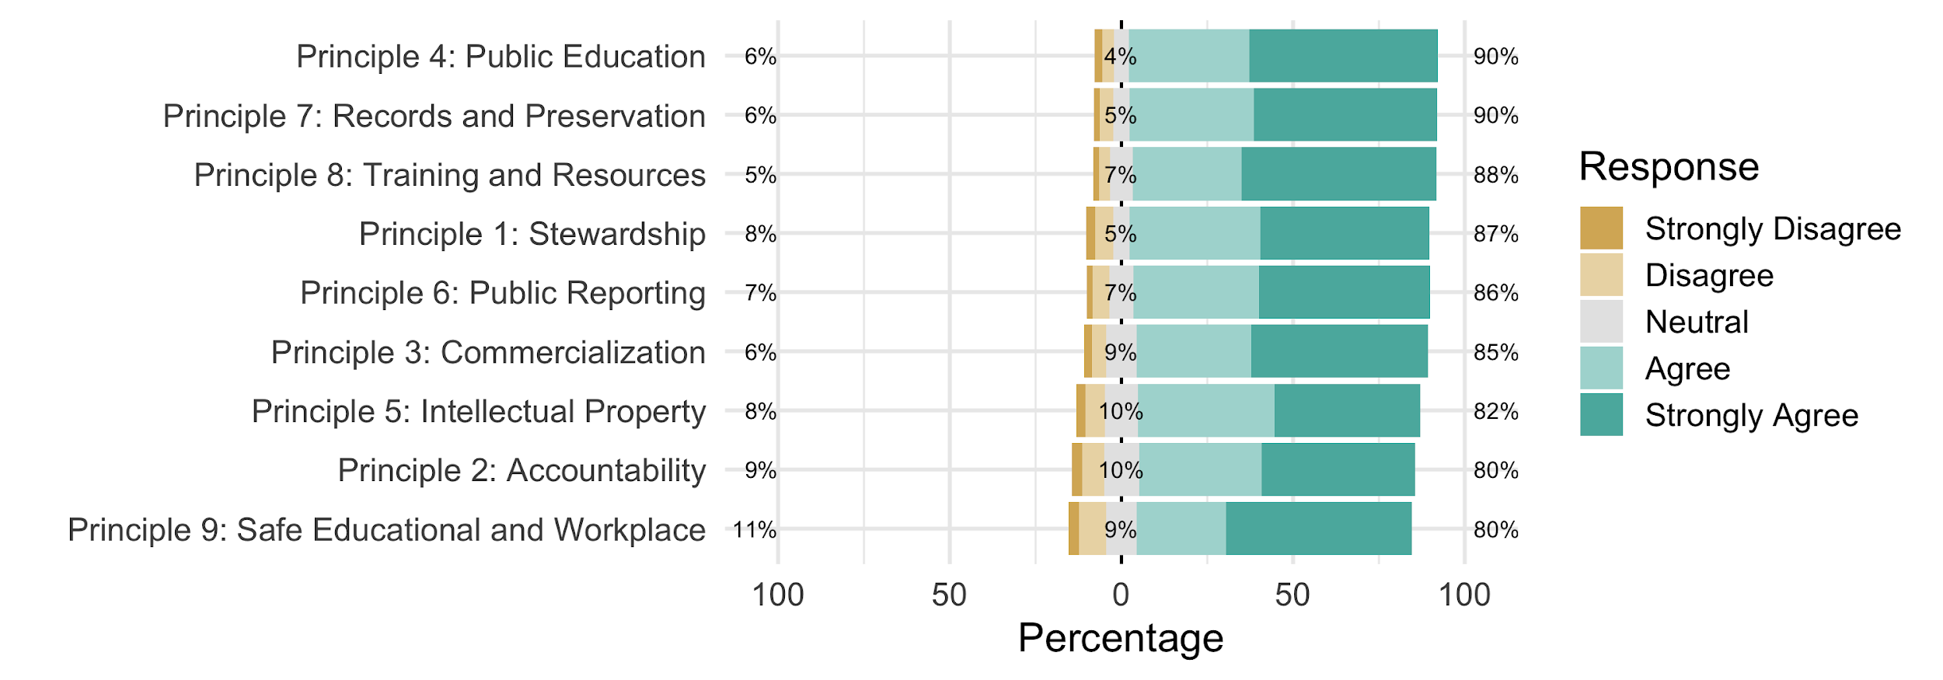

Figure 9b. Summary of the Likert-type responses for each of the nine Principles for respondents who are current SAA members.

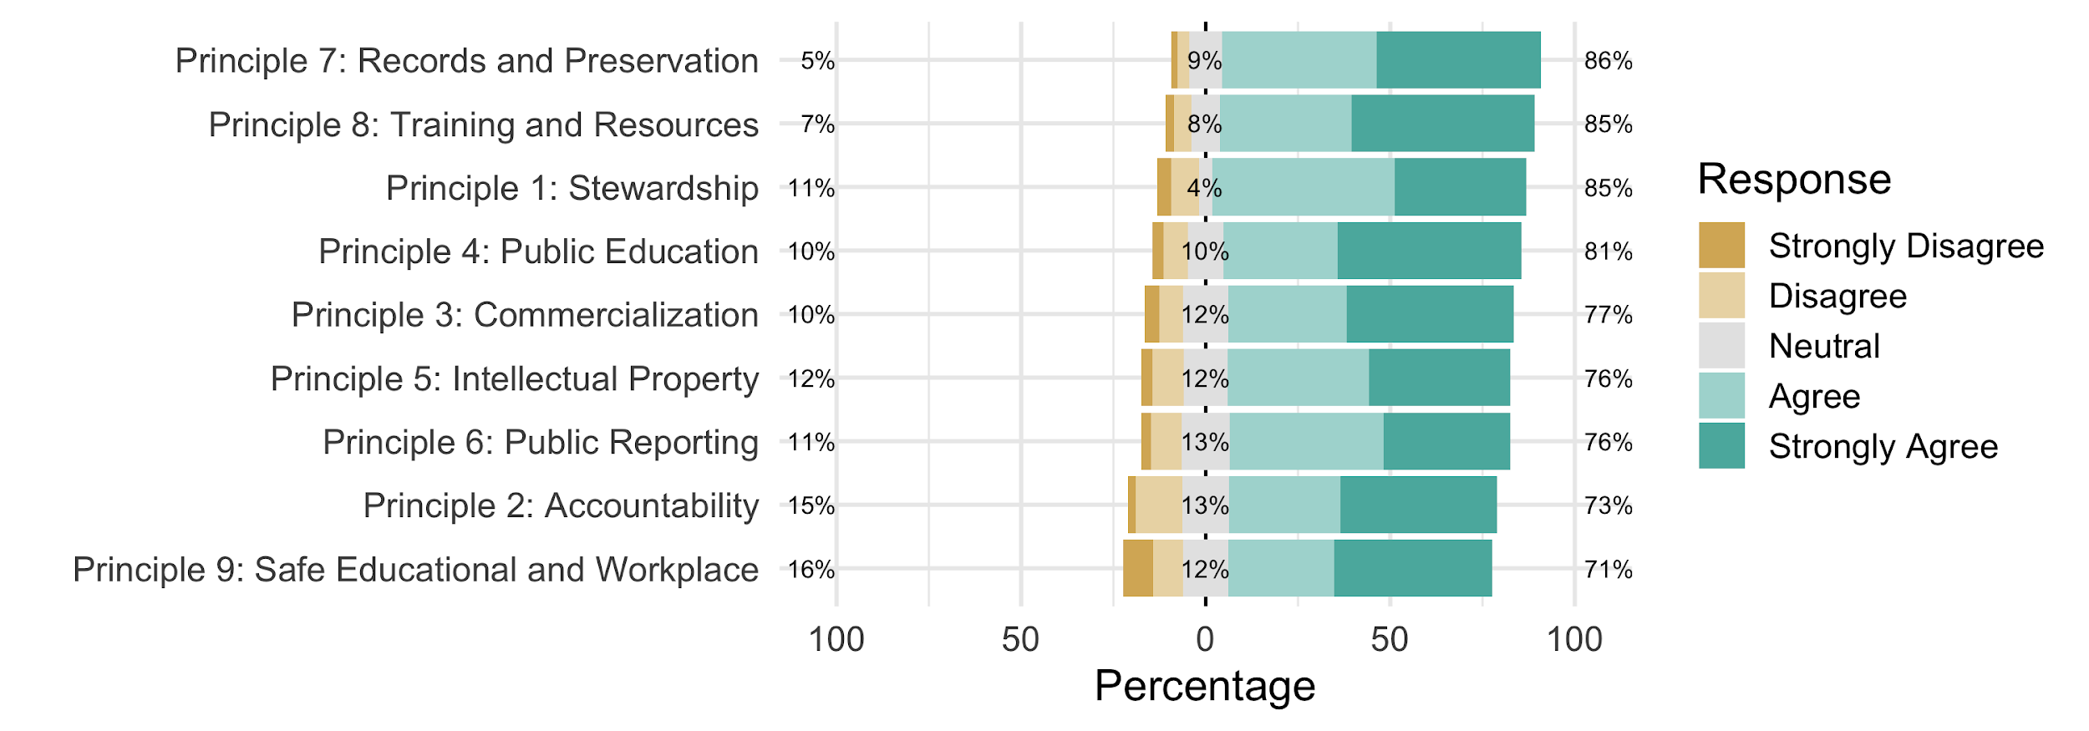

Figure 9c. Summary of the Likert-type responses for each of the nine Principles for respondents who are not SAA members.

|  |  |  |  |  |
| --- | --- | --- | --- | --- |
| **Principle** | **Number of responses to the Likert-type question** | **Number of responses to the text field** | **Percentage of people responding to the Likert-type question that also submitted a text response** | **Percentage of people submitting a text response that also responded to the Likert-type question** |
| Stewardship | 1128 | 311 | 27.6 | 99.7 |
| Accountability | 1109 | 341 | 30.7 | 99.4 |
| Commercialization | 1099 | 281 | 25.6 | 99.6 |
| Public Education | 1080 | 251 | 23.2 | 98.4 |
| Intellectual Property | 1074 | 331 | 30.8 | 99.4 |
| Public Reporting | 1066 | 301 | 28.2 | 98.7 |
| Records and Preservation | 1061 | 243 | 22.9 | 99.2 |
| Training and Resources | 1058 | 229 | 21.6 | 98.7 |
| Safe Educational and Workplace | 1058 | 329 | 31.1 | 99.7 |

Table 1d. Counts of responses to the Likert-type questions about each Principle, and counts of free text responses about each Principle. Between 20-30% of respondents to the Likert-type questions about each of Principles also submitted a text response about the Principles.

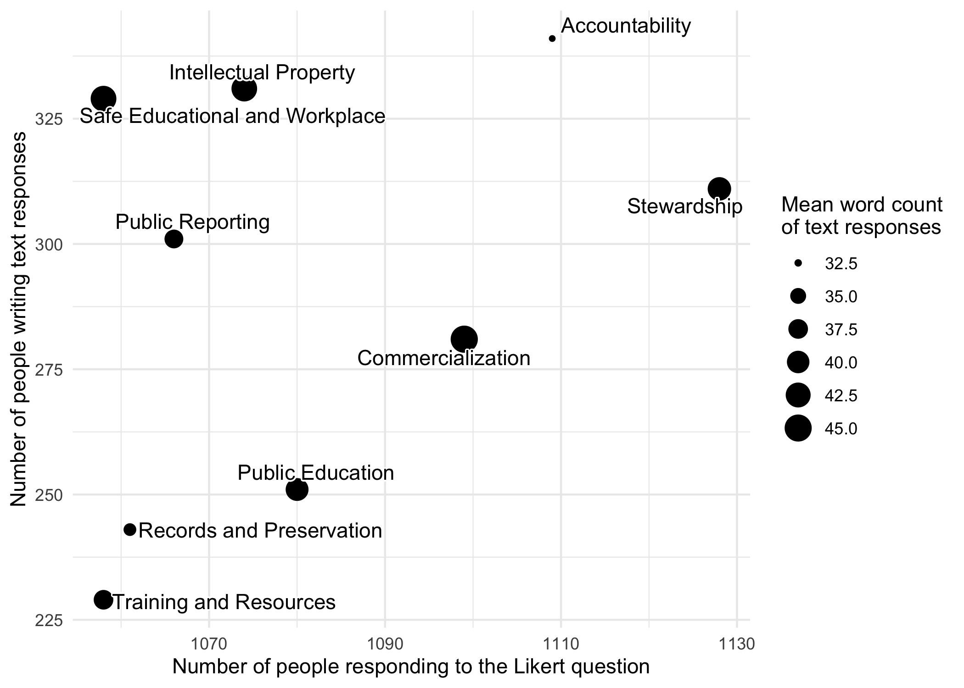

Figure 9d. Plot of the numbers of people responding to the Likert-type questions and submitting text responses, including the average length of each text response. “Stewardship” is a topic that stands out as highly important because of high numbers of both Likert and text responses, and high mean word counts for the text responses. “Safe Educational and Workplaces” and “Intellectual Property” also stand out as important to survey respondents because they received a relatively high number of text responses, combined with relatively high mean word counts.

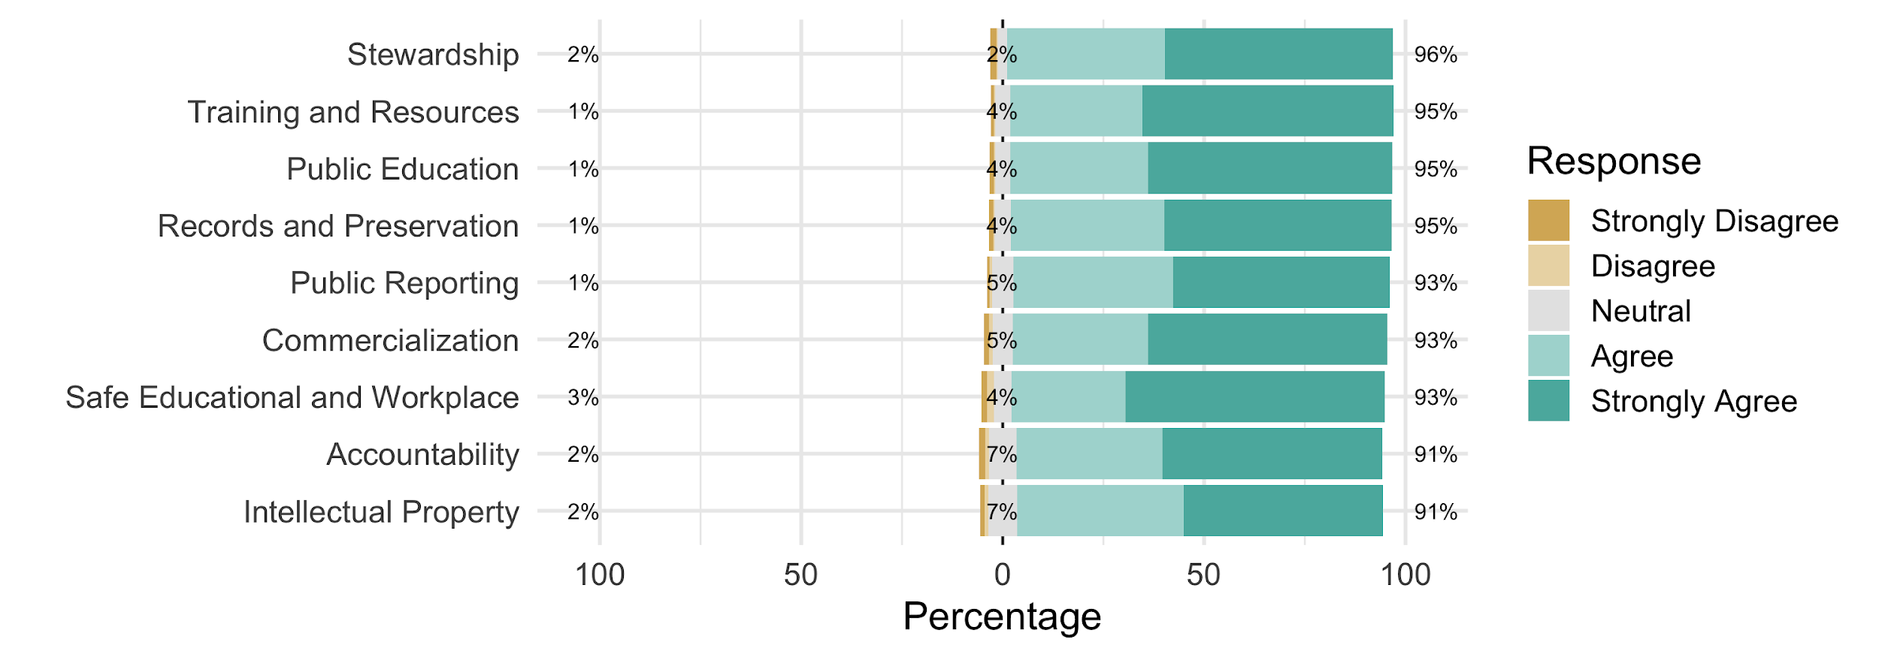

Figure 9e. Summary of the Likert-type responses for each of the nine Principles for respondents who did not submit text responses about the Principles.

|  |  |  |  |  |  |
| --- | --- | --- | --- | --- | --- |
|  | **Strongly Disagree** | **Disagree** | **Neutral** | **Agree** | **Strongly Agree** |
| **Stewardship** | |  |  |  |  |
| No. I'm a former member. | 9.3% (4) | 16.3% (7) | 4.7% (2) | 48.8% (21) | 20.9% (9) |
| No. Never a member. | 5.3% (1) | 42.1% (8) | 15.8% (3) | 26.3% (5) | 10.5% (2) |
| Yes | 5.6% (14) | 18.5% (46) | 10.9% (27) | 43.1% (107) | 21.8% (54) |
| **Accountability** | |  |  |  |  |
| No. I'm a former member. | 4.5% (2) | 36.4% (16) | 18.2% (8) | 18.2% (8) | 22.7% (10) |
| No. Never a member. | 4.2% (1) | 25.0% (6) | 29.2% (7) | 25.0% (6) | 16.7% (4) |
| Yes | 6.3% (17) | 19.9% (54) | 18.8% (51) | 34.3% (93) | 20.7% (56) |
| **Commercialization** | | |  |  |  |
| No. I'm a former member. | 14.7% (5) | 14.7% (5) | 17.6% (6) | 29.4% (10) | 23.5% (8) |
| No. Never a member. | 15.0% (3) | 20.0% (4) | 35.0% (7) | 20.0% (4) | 10.0% (2) |
| Yes | 4.9% (11) | 14.6% (33) | 22.1% (50) | 33.6% (76) | 24.8% (56) |
| **Public Education** | |  |  |  |  |
| No. I'm a former member. | 2.9% (1) | 20.6% (7) | 14.7% (5) | 26.5% (9) | 35.3% (12) |
| No. Never a member. | 25.0% (4) | 25.0% (4) | 12.5% (2) | 25.0% (4) | 12.5% (2) |
| Yes | 6.6% (13) | 14.7% (29) | 9.6% (19) | 36.5% (72) | 32.5% (64) |
| **Intellectual Property** | | |  |  |  |
| No. I'm a former member. | 7.7% (3) | 30.8% (12) | 12.8% (5) | 30.8% (12) | 17.9% (7) |
| No. Never a member. | 15.4% (2) | 30.8% (4) | 15.4% (2) | 30.8% (4) | 7.7% (1) |
| Yes | 5.4% (15) | 15.5% (43) | 17.3% (48) | 36.1% (100) | 25.6% (71) |
| **Public Reporting** | |  |  |  |  |
| No. I'm a former member. | 5.0% (2) | 22.5% (9) | 15.0% (6) | 37.5% (15) | 20.0% (8) |
| No. Never a member. | 11.8% (2) | 29.4% (5) | 11.8% (2) | 29.4% (5) | 17.6% (3) |
| Yes | 4.2% (10) | 17.1% (41) | 15.4% (37) | 31.7% (76) | 31.7% (76) |
| **Records and Preservation** | | |  |  |  |
| No. I'm a former member. | 6.7% (2) | 16.7% (5) | 3.3% (1) | 50.0% (15) | 23.3% (7) |
| Yes | 3.5% (7) | 15.8% (32) | 10.4% (21) | 33.2% (67) | 37.1% (75) |
| No. Never a member. | (NA) | 11.1% (1) | 33.3% (3) | 11.1% (1) | 44.4% (4) |
| **Training and Resources** | | |  |  |  |
| No. I'm a former member. | 6.2% (2) | 15.6% (5) | 18.8% (6) | 37.5% (12) | 21.9% (7) |
| No. Never a member. | 6.2% (1) | 12.5% (2) | 6.2% (1) | 18.8% (3) | 56.2% (9) |
| Yes | 4.5% (8) | 15.2% (27) | 20.2% (36) | 30.3% (54) | 29.8% (53) |
| **Safe Educational and Workplace** | | | |  |  |
| No. I'm a former member. | 20.8% (11) | 15.1% (8) | 24.5% (13) | 26.4% (14) | 13.2% (7) |
| No. Never a member. | 16.7% (3) | 11.1% (2) | 5.6% (1) | 27.8% (5) | 38.9% (7) |
| Yes | 7.0% (18) | 24.5% (63) | 20.6% (53) | 21.4% (55) | 26.5% (68) |

Table 1e. Counts and percentages of responses to the Likert-type questions about each Principle for people who also submitted a text response, grouped by SAA membership status.

### Q: Principle 1: Stewardship (311 text responses)

Principle No. 1: Stewardship The archaeological record, that is, in situ archaeological material and sites, archaeological collections, records and reports, is irreplaceable. It is the responsibility of all archaeologists to work for the long term conservation and protection of the archaeological record by practicing and promoting stewardship of the archaeological record. Stewards are both caretakers of and advocates for the archaeological record for the benefit of all people; as they investigate and interpret the record, they should use the specialized knowledge they gain to promote public understanding and support for its long-term preservation.

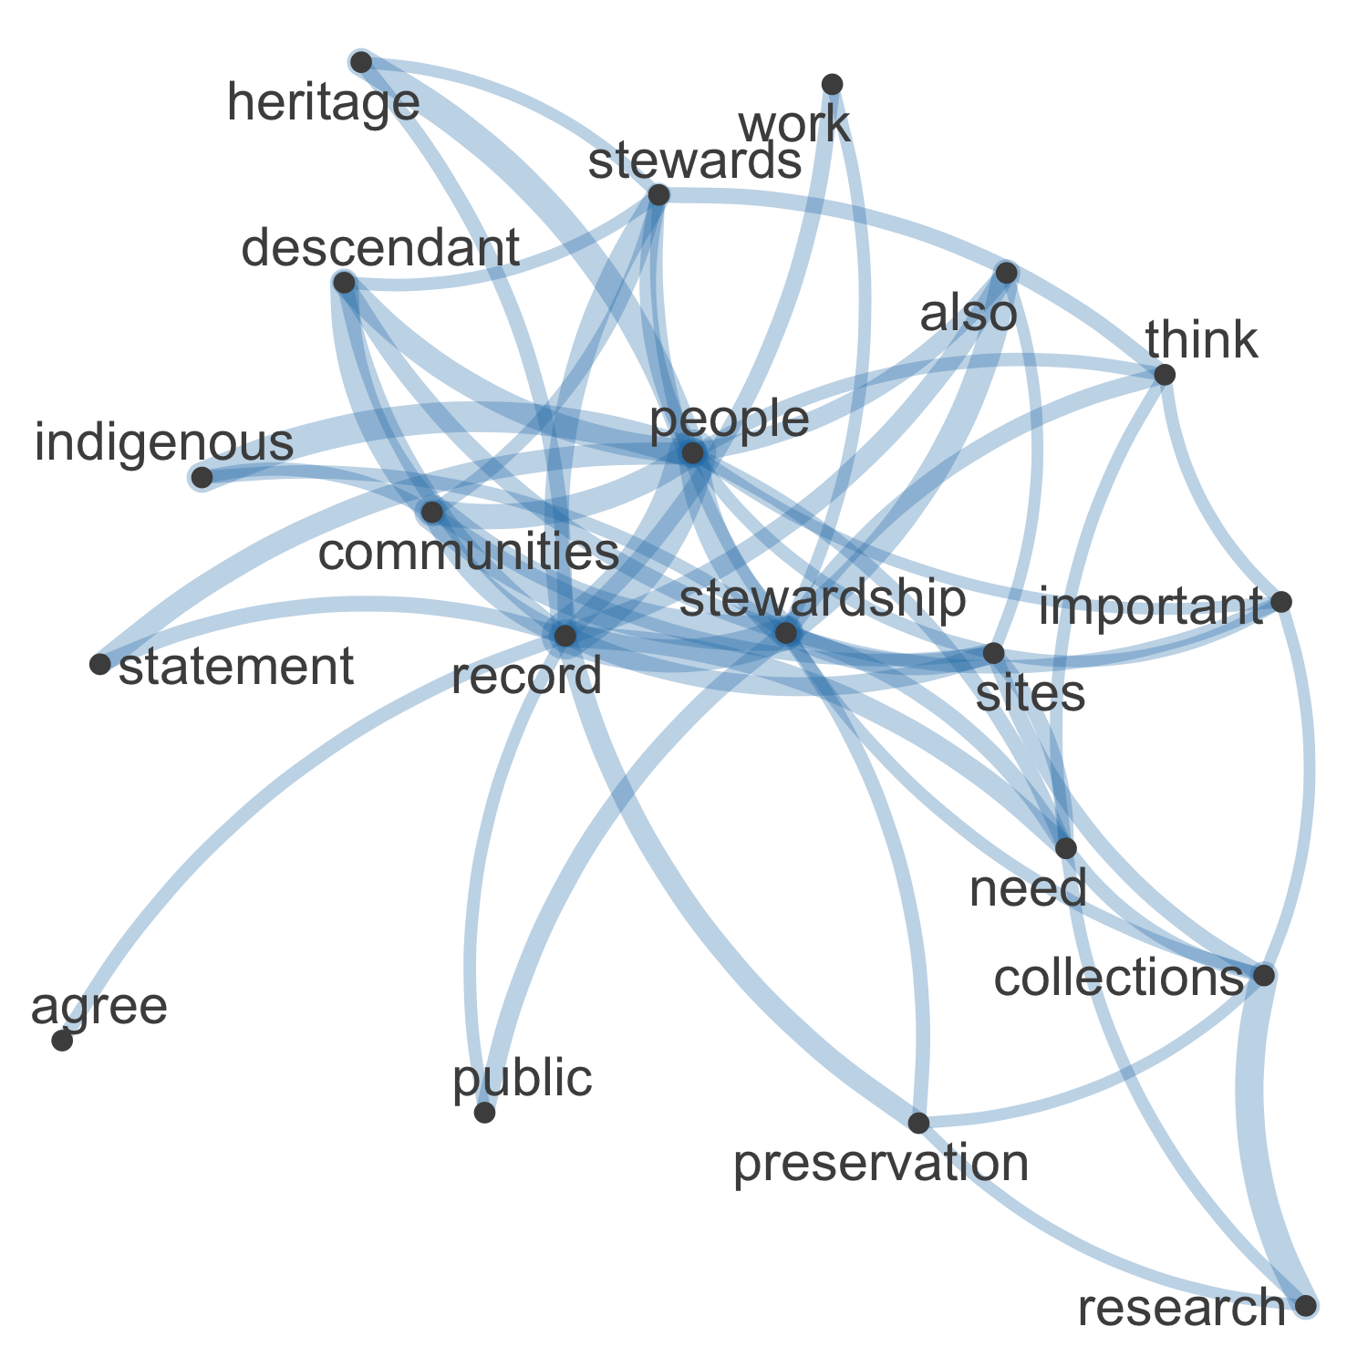

Figure 10. Network plot of high frequency words and their relationships in the 311 free text responses about Principle 1

In the network visualisation of the 311 text responses in the “Please elaborate here:” field for the question about Principle 1 (Stewardship) we see strong connections through “stewardship” between the human dimension, namely, “communities”, “descendant”, “Indigenous”, and “people”, and the material dimension, such as “sites”, “collections”, and “preservation” (Figure 10).

Commonalities

The most frequently used tags for this principle are “Indigenous”, “public engagement”, “archiving”, and “conflicts of interest”.

Contrasts

The tags that appear in the 311 responses with the least co-occurrences are “repatriation”, “reporting”, “human remains”, “diversity”, “environment”, and “relevance”.

Comparisons

The most common co-occurrence is “Indigeneous” and “public engagement.” Two tags are associated with other tags more so than any other tag, and these are “conflicts of interest” and “research”.

Relationships

In general there were also questions as to the priority that Indigenous people are given in relation to the rest of the public, whether their voice should be considered first, considering a majority of United States sites are connected to their cultural ancestry:

“A good principle generally except that it doesn’t acknowledge that the record doesn’t belong equally to "all people"

There were also questions concerning the relationship between archaeologists and indigenous people:

“Archaeological resources benefit all people, but the stewards of those resources should be descendant or other relevant communities whenever possible, as they are more directly connected to those resources than the rest of us.”

In regards to archaeologist’s role in engaging the public, there was a general frustration at the lack of accessible published research:

“Too many archaeologists (especially in academic settings) think that ‘promot[ing] [sic] public understanding and support for its long-term preservation’ is someones else’s job - not theirs. Too many archaeologists have not published and disseminated their findings.”

Other concerns relating to preservation were whether findings were even being housed in properly archival institutions, often costly and an afterthought when writing up project budgets,

“Long term preservation is always a problem, to do it correctly it is expensive. Funding is always a problem at all levels, state, federal, and private.”

And in a growing digital age, long-term preservation efforts need to evolve:

“*This principle should be updated to include stewardship, preservation and availability of digital data including databases, images, GIS data, remote sensing data, and textual records,”*

Sentiment

The 311 responses to “Principle 1: Stewardship” consistently expressed disappointment in the lack of recognition to Indigneous communities. As one member succinctly responded, there is

“No mention of stewardship/rights of cultures involved.”

found in the principle. Another, perhaps more poetically stated,

“*If we cannot do this in partnership with Native*

*Americans I do not know what we are.*”

Including Indigenous voices in archaeological decisions was the most commonly voiced concern among the 311 responding members. Respondents identifying as Native Americans had mostly negative comments about this Principle, and the gap between the aspirational text and the reality of archaeological practice:

"Consultants are boots on the ground. The entire process to consult begins at the early planning stage, which means other stakeholders. I disagree because (in my experience) I rarely, ever, see an archaeological consultant sitting at the consultation table during the planning stages."

and

"Not adequately. There should be an emphasis on accountability to indigenous people."

and

"SAA has done a less than perfect job in articulating with indigenous communities in North America. I am a tribal member as well as an archaeologist. Our SAA president is likewise. Joe knows. Many of our membership congratulate themselves on what they perceive as an informed and progressive relationship to decolonized peoples. In many ways, it is no more than self-congratulation and hardly included in their practice of archaeology. SAA, in any ethics statement, must come down hard on this issue because the very community it exploited for decades, it now must address and reconcile."

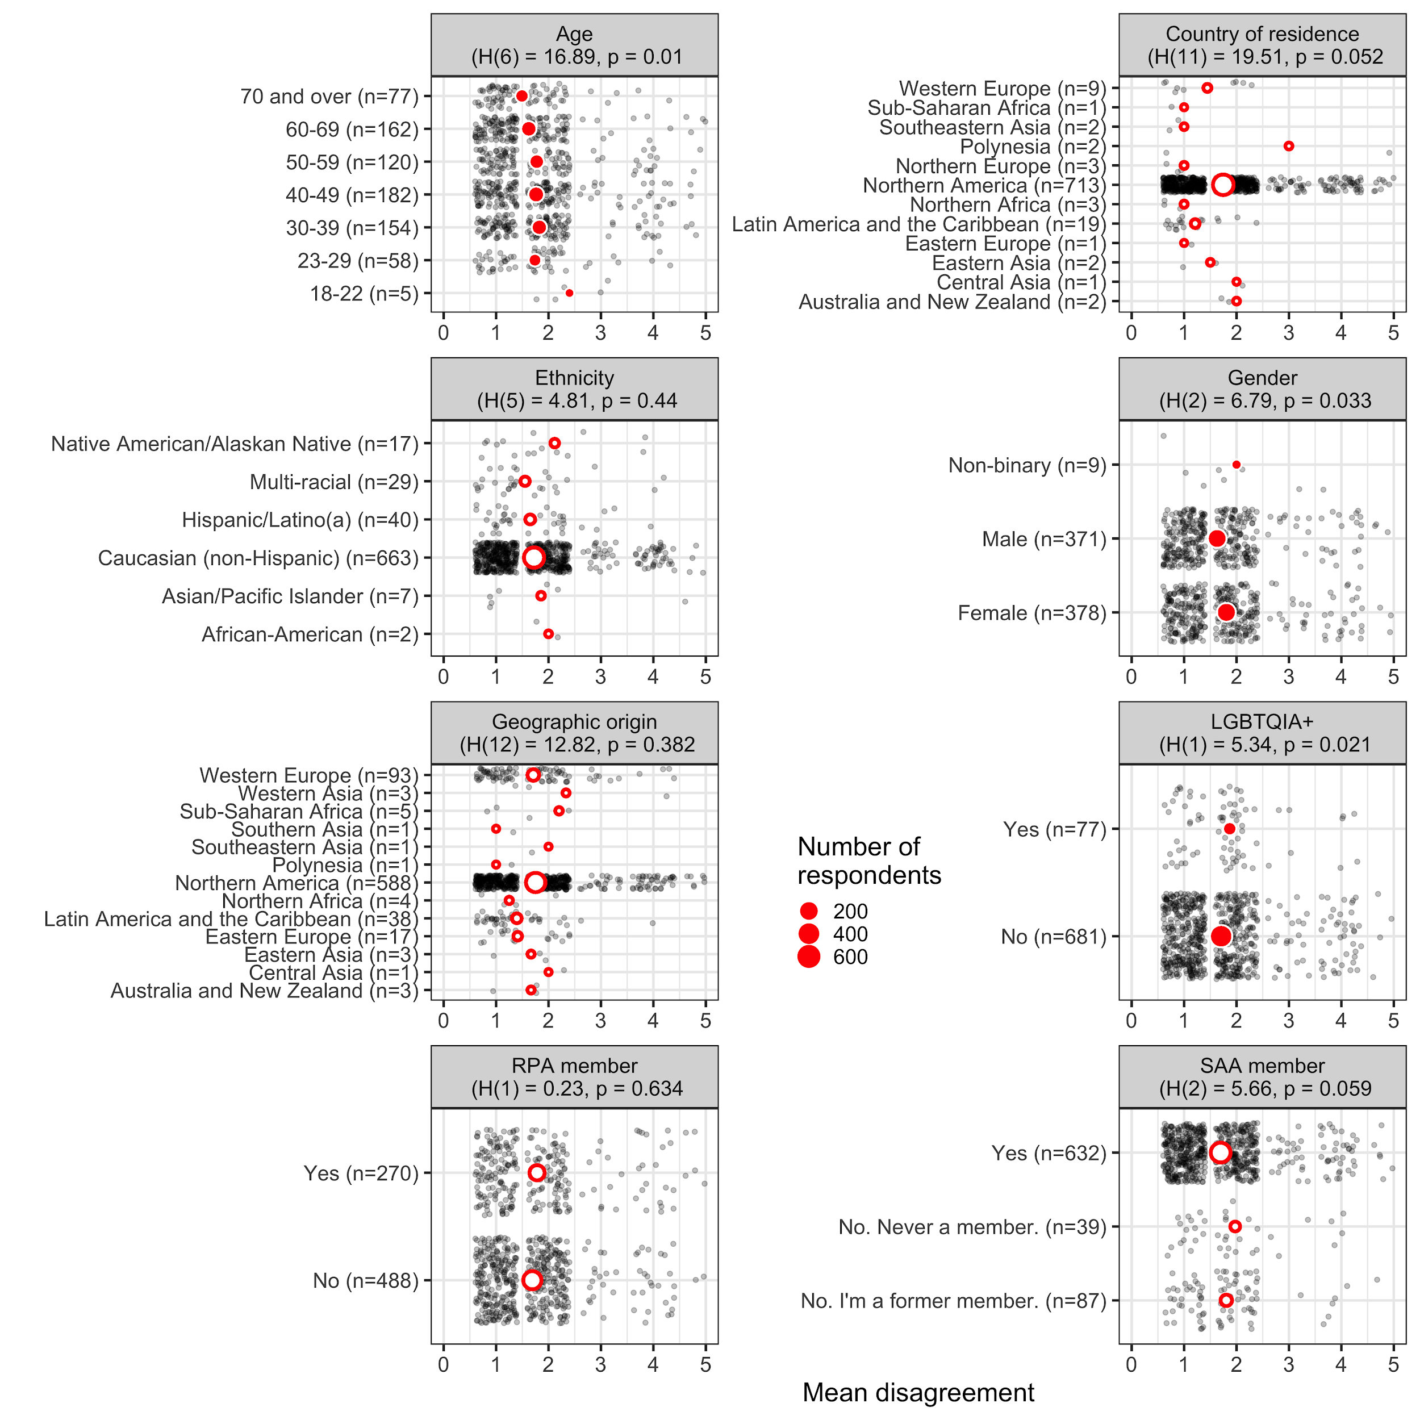

Figure 11. Plots of mean disagreement by demographic category for the 1128 Likert-scale responses about Principle 1

In the demographic plots of mean disagreement for Principle 1 (Stewardship) we see significant differences among age, gender, and LGBTQIA+ groups (Figure 11). Generally, younger people, women and non-binary people, and members of the LGBTQIA+ community disagree more that the “principle and its description adequately applies to archaeological practice and its ethical challenges today”

### Q: Principle 2: Accountability (341 text responses)

Principle No. 2: Accountability Responsible archaeological research, including all levels of professional activity, requires an acknowledgment of public accountability and a commitment to make every reasonable effort, in good faith, to consult actively with affected group(s), with the goal of establishing a working relationship that can be beneficial to all parties involved.

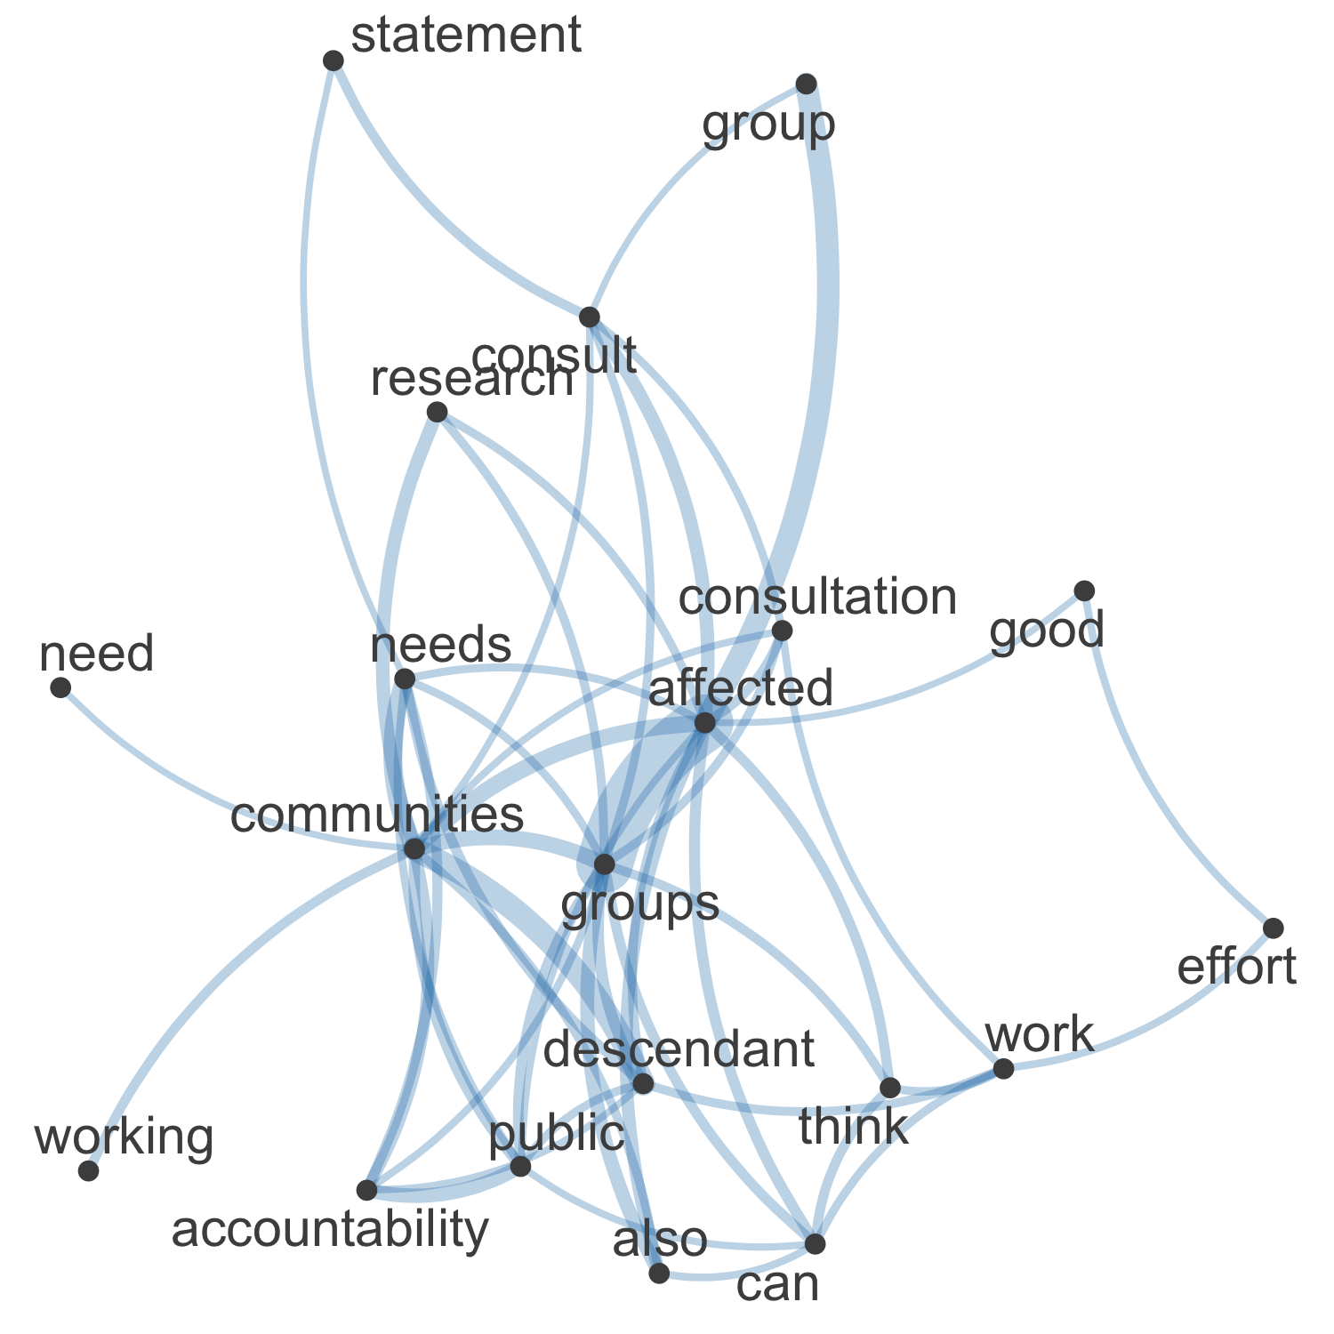

Figure 12. Network plot of high frequency words and their relationships in the 341 free text responses about Principle 2

In the network visualisation of the 341 text responses in the “Please elaborate here:” field for the question about Principle 2 (Accountability) we see that central concepts in the responses are “affected”, “groups”, “descendant”, “communities”, “public” and “consult” (Figure 12).

Commonalities

The most common tag in the 341 responses to this question was ‘enforcement’, followed by ‘Indigenous’ and ‘conflicts of interest’. This dramatic account captures all of these themes:

"I agree that many different parties have stakes in archaeological research. I have worked at some well-known (hence, profitable) archaeological sites and found myself embroiled in local politics several times. This is an interesting point, but a complex conundrum on the ground. I remember excavating monuments that later went to a local museum, only to have the central government send trucks to move the monuments to the capital, 900km away. I did not want to monuments to make the journey and saw the protests at the museum when locals demanded that their cultural patrimony remain local. The archaeologists in charge of the recoveries were never consulted, which led to more animosity. There were different cultural groups speaking different languages, local and federal officials making constant demands [grifts and grafts] etc. This reality was never covered in any book or class at any university I attended."

Contrasts

The tags ‘harassment’ and ‘sexual harassment’ were not found at all in the 341 reponses to this question. There was disagreement among the respondents about how to accommodate the results of consultation, for example:

"Use of the word "consult" with -- could be changed with collaborate. Consultation emphasizes the top down relationship. To the extent possible, I would like the revised codes to emphasize the value of real partnerships, recognizing the power differential, but working to ameliorate that."

And a strident alternative perspective:

""Affected groups" are politicizing scientific research in a determinedly unscientific way. They have succeeded in deliberately stopping and distorting conclusions and results to conform to leftist ideaology, rather reminiscent of Soviet Lamarckism of 1930's-1950's, a sickening trend abhorrent to scientists everywhere, which SSA has latterly called "ethics".

Relationships

The tag ‘enforcement’ was often found with tags such as ‘Indigenous’, 'conflict of interest’, and ‘public engagement’. The tag 'conflict of interest’ also co-occurs with the tag ‘power dynamics’, here’s an example of these two themes:

"This considers accountability broadly - but does not take into account: 1) conflicting publics, 2) recognizing different power dynamics at multiple levels between archaeologist(s) and publics, or 3) what equity means in terms of "beneficial" to different parties."

Sentiment

A negative sentiment was evident in the 341 reponses, with many feeling that the Principle lacked sufficient detail, for example:

"Vague. Open to multiple interpretations."

and

"This is simply too vague to have real guidance for archaeologists. While accountability is a worthwhile goal, there simply provides too much "grey" area"

And should be more insistent:

"consultation should be mandatory not just attempted in good faith. if community isn't there for it, fieldwork shouldn't happen."

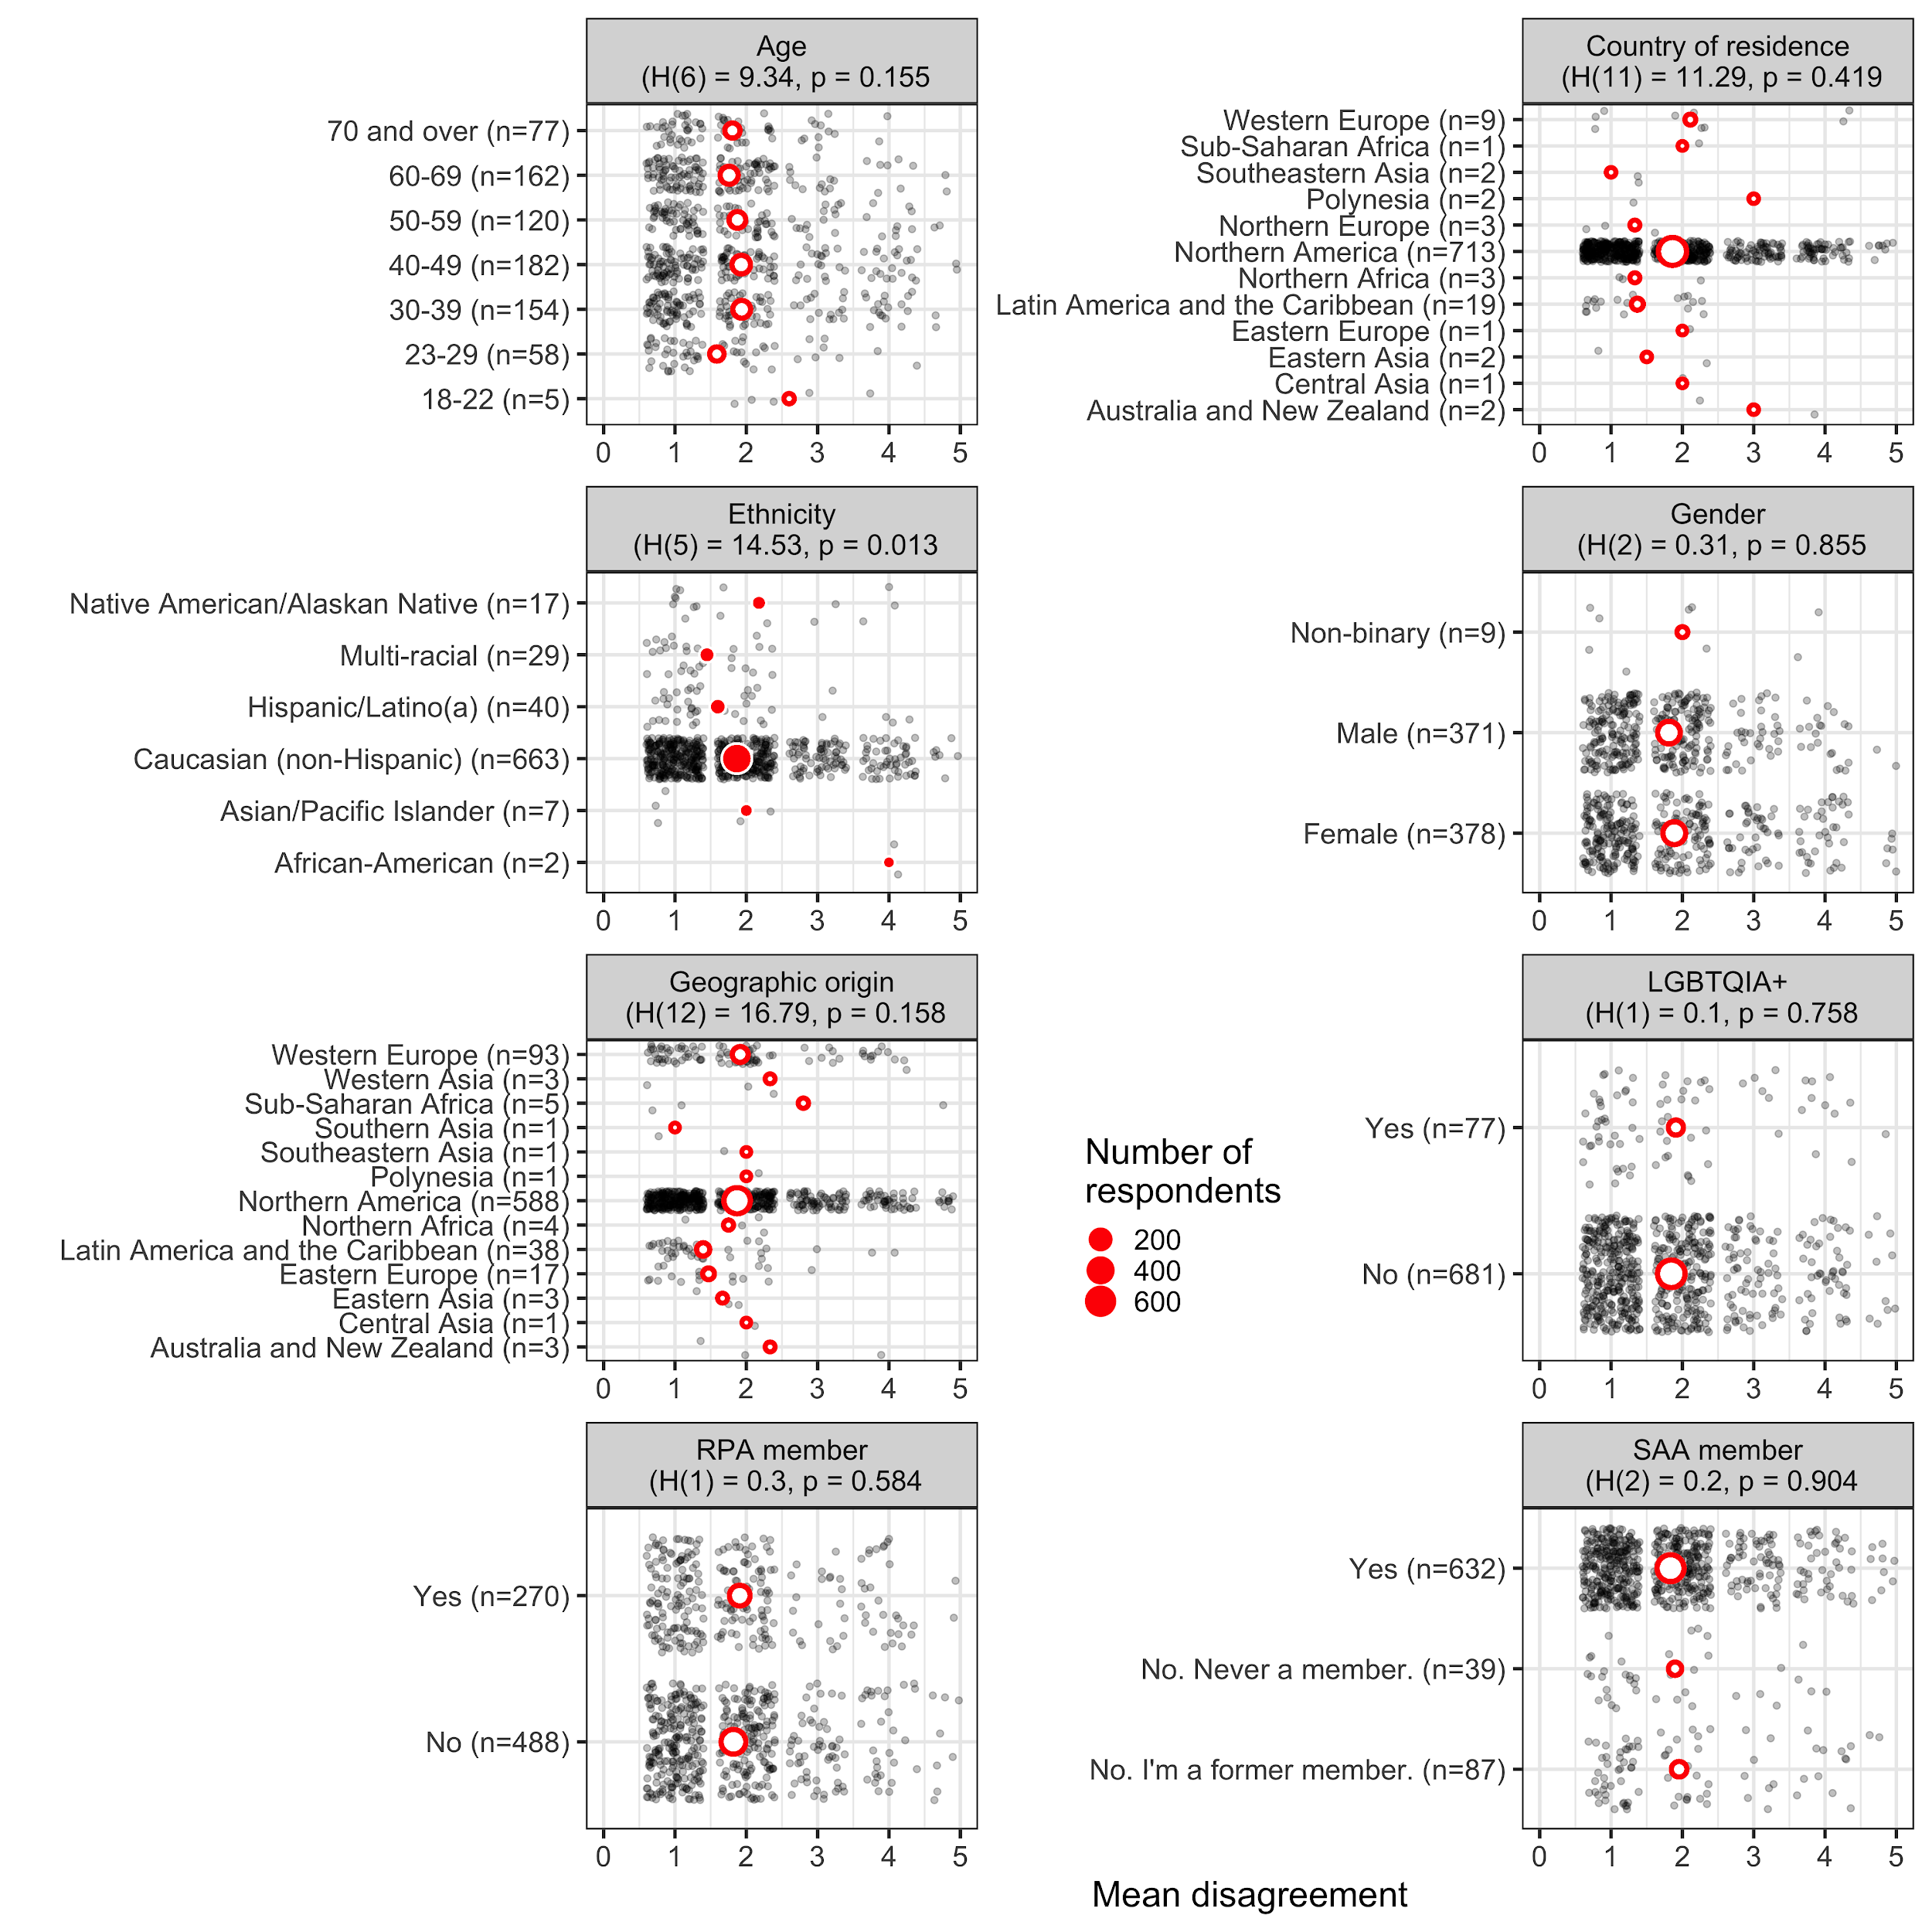

Figure 13. Plots of mean disagreement by demographic category for the 1109 Likert-scale responses about Principle 2

In the demographic plots of mean disagreement for Principle 2 (Accountability) we see significant differences among ethnic groups (Figure 13). Generally, African-Americans and Native Americans disagree more than other ethnic groups that the “principle and its description adequately applies to archaeological practice and its ethical challenges today”

### 

### Q: Principle 3: Commercialization (281 text responses)

Principle No. 3: Commercialization The Society for American Archaeology has long recognized that the buying and selling of objects out of archaeological context is contributing to the destruction of the archaeological record on the American continents and around the world. The commercialization of archaeological objects - their use as commodities to be exploited for personal enjoyment or profit - results in the destruction of archaeological sites and of contextual information that is essential to understanding the archaeological record. Archaeologists should therefore carefully weigh the benefits to scholarship of a project against the costs of potentially enhancing the commercial value of archaeological objects. Whenever possible they should discourage, and should themselves avoid, activities that enhance the commercial value of archaeological objects, especially objects that are not curated in public institutions, or readily available for scientific study, public interpretation, and display.

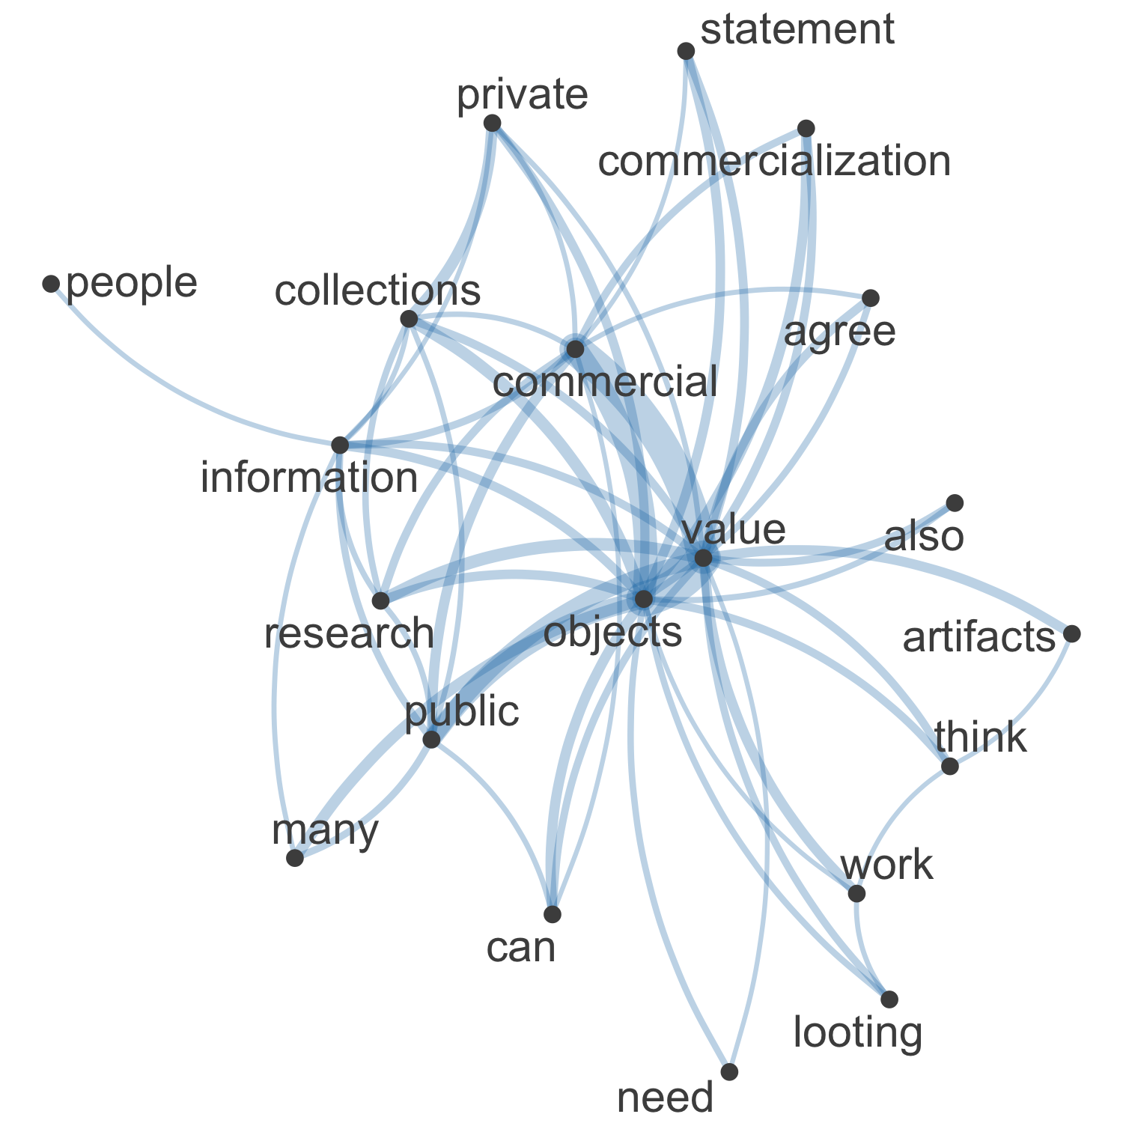

Figure 14. Network plot of high frequency words and their relationships in the 281 free text responses about Principle 3

In the network visualisation of 281 text responses in the “Please elaborate here:” field for the question about Principle 3 (Commercialization) we see that central concepts in the responses are “objects”, “commercial”, “value”, “public” and “collections” (Figure 14). We can see some contrasting relationships with “public” and “research” compared to “private”, “collections”, and “commercial”.

Commonalities

The most commonly used tag was “looting,” followed by “enforcement.” Many of the 281 survey takers that responded to this question expressed concern over looting, antiquites dealing and private collections. One specific concern was how to address the looting and trading of antiquities that occurred a long time ago. One survey respondent asked:

“Some objects were looted 100s of years ago. How do we handle that?”

Another common area of concern was the role that the CRM industry plays in the commercialization of archaeology. The following is an example of one respondent’s concerns:

“This statement does not do enough to address the commercialization inherent to the CRM industry. I have seen far too many cases of CRM companies falling short of compliance and allowing for the destruction of the archaeological record because it fits with their commercial interests.”

Contrasts

The tag “training students” rarely appears at all, let alone with the tag “looting.” This is striking, as looting and the trading of antiquities, and study of looted items is a problem that archaeologists face. The 281 respondents to this question do not seem to consider that learning about the varying forms of looting, the causes, repercussions, and solutions to the problem should be a major part of an archaeologist’s education.

There were several responses to the “looting” tags that noted the research value of working with artifacts produced by looting. One survey responded explained:

“Two centuries of looting and avocational excavations have produce [sic] a large number of archaeologically important materials. to simply ignore the potential information in these is professionally unsound. The scientific treatment of these artifacts may enhance their value, thus ensuring their preservation in the very large and active collector market. I happen to work with rare stone figures - of the several dozen known only two have been recovered in the last half century in archaeological context. To ignore the other specimens is a failure to fulfill our ethical responsibility to the people who made them and to the profession.”

Several of the 281 survey respondents to this question were also apparently not opposed to the commercialization of archaeology and archaeological objects:

“The value of archaeological objects is enhanced by context. The archaeologist necessarily increases commercial value by research, analysis and reporting.”

Another respondent had a more politically driven motive for support commercialization:

*“The only way to actually support the position as articulated is to stand in opposition to private, free-market capitalism. I’m not a Ma[r]xist, I’m not a communist, and I’m not opposed to "commercialization." Removal of objects from the archaeological record for multiple purposes is obviously as old as the record itself. A Middle Archaic forager that dug a roasting pit through an intact Paleoindian midden "destroyed" part of the record just as assuredly as a backhoe trenching out a sewer line. The fact that one was part of a capitalist endeavor is irrelevant.”*

Comparisons

The tags that most appear most frequently together are: “Indigenous” and “looting”; “enforcement” and “looting”; “public engagement” and “looting”; and “research” and “looting. The survey respondents make it clear that looting is a large area of concern. This concern is further broken down into the effect of looting on indigeous communities, how to address looting and avocational archaeology amongst the public, and stronger enforcement of the Principle by the SAA. The following is an example of the concern respondents have about the impact of looting on indigenous communities:

“This principle statement glosses over the fact that many looted "art" objects are burial goods that are sacred or hold special importance to descendant communities and that their procurement has resulted — and in many cases continues to result — in the destruction and desecration of human burials. The SAA should take a stronger ethical stance against the study and publication of looted objects and should advocate for the repatriation of burial goods and other objects of indigenous cultural patrimony — both privately held ones and those that are part of museum collections.”

On the topic of public engagement, one respondent responded:

“Further archaeologists should work to educate the public at large on why the artifact alone is lacking in significance to reduce the number of "buyers" an item may have, and partner WITH avocational archaeologists to teach them the value of research and data collection to at least diminish the destruction of that info and for them to act as educator advocates to others who may sell artifacts.”

Relationships

There is a cause and effect relationship between the “racism” and “looting” tags. The antiquities trade is a product of many factors, including colonialism. This has resulted in looting often being the only viable mode of income for native communities. Several of the 281 respondents to this question brought this up:

“I think that this is a good principle for archaeologists to follow, but not always possible for socioeconomically disadvantaged communities to follow. Who are archaeologists to come in and tell people they cannot sell objects if that is the only mode of income for feeding their families? The only ethical way archaeologists could discourage this practice is if they are offering another source of income to replace this practice.”

Another wrote:

“In the communities I work, subsistence looting is one of the only ways to make money. Archaeology can’t do much to address this, until we help address the underlying structural violence and racism facing Native communities”

Sentiment

There is mixed sentiment amongst the 281 respondents to this question. Most respondents are against looting and avocational archaeology. However, there are varying views on whether or not to work with private collectors and avocational archaeologists. One respondent stated:

“We should not work with collectors, period. If you have a question about this talk to the tribes and what they see done by these people.”

Contrasting to this view, another respondent wrote:

*“Still works for me. This doesn’t mean that archaeologists shouldn’t find supportive, positive ways to work with collectors.”*

There was also a lot of confusion surrounding the concept of commercialization. Several of the 281 respondents to this question asked how archaeology raises commercial value of artifacts. One respondent explained:

“I don’t understand what ‘enhance the commercial value’ means. Does that mean don’t do interviews with local papers, don’t work with nat geo or similar, don’t do public archaeology days, don’t do any outreach to any groups? What does this even mean? Why are all the statements oblique? It is like written in code for people with specific issues. I really dislike this.”

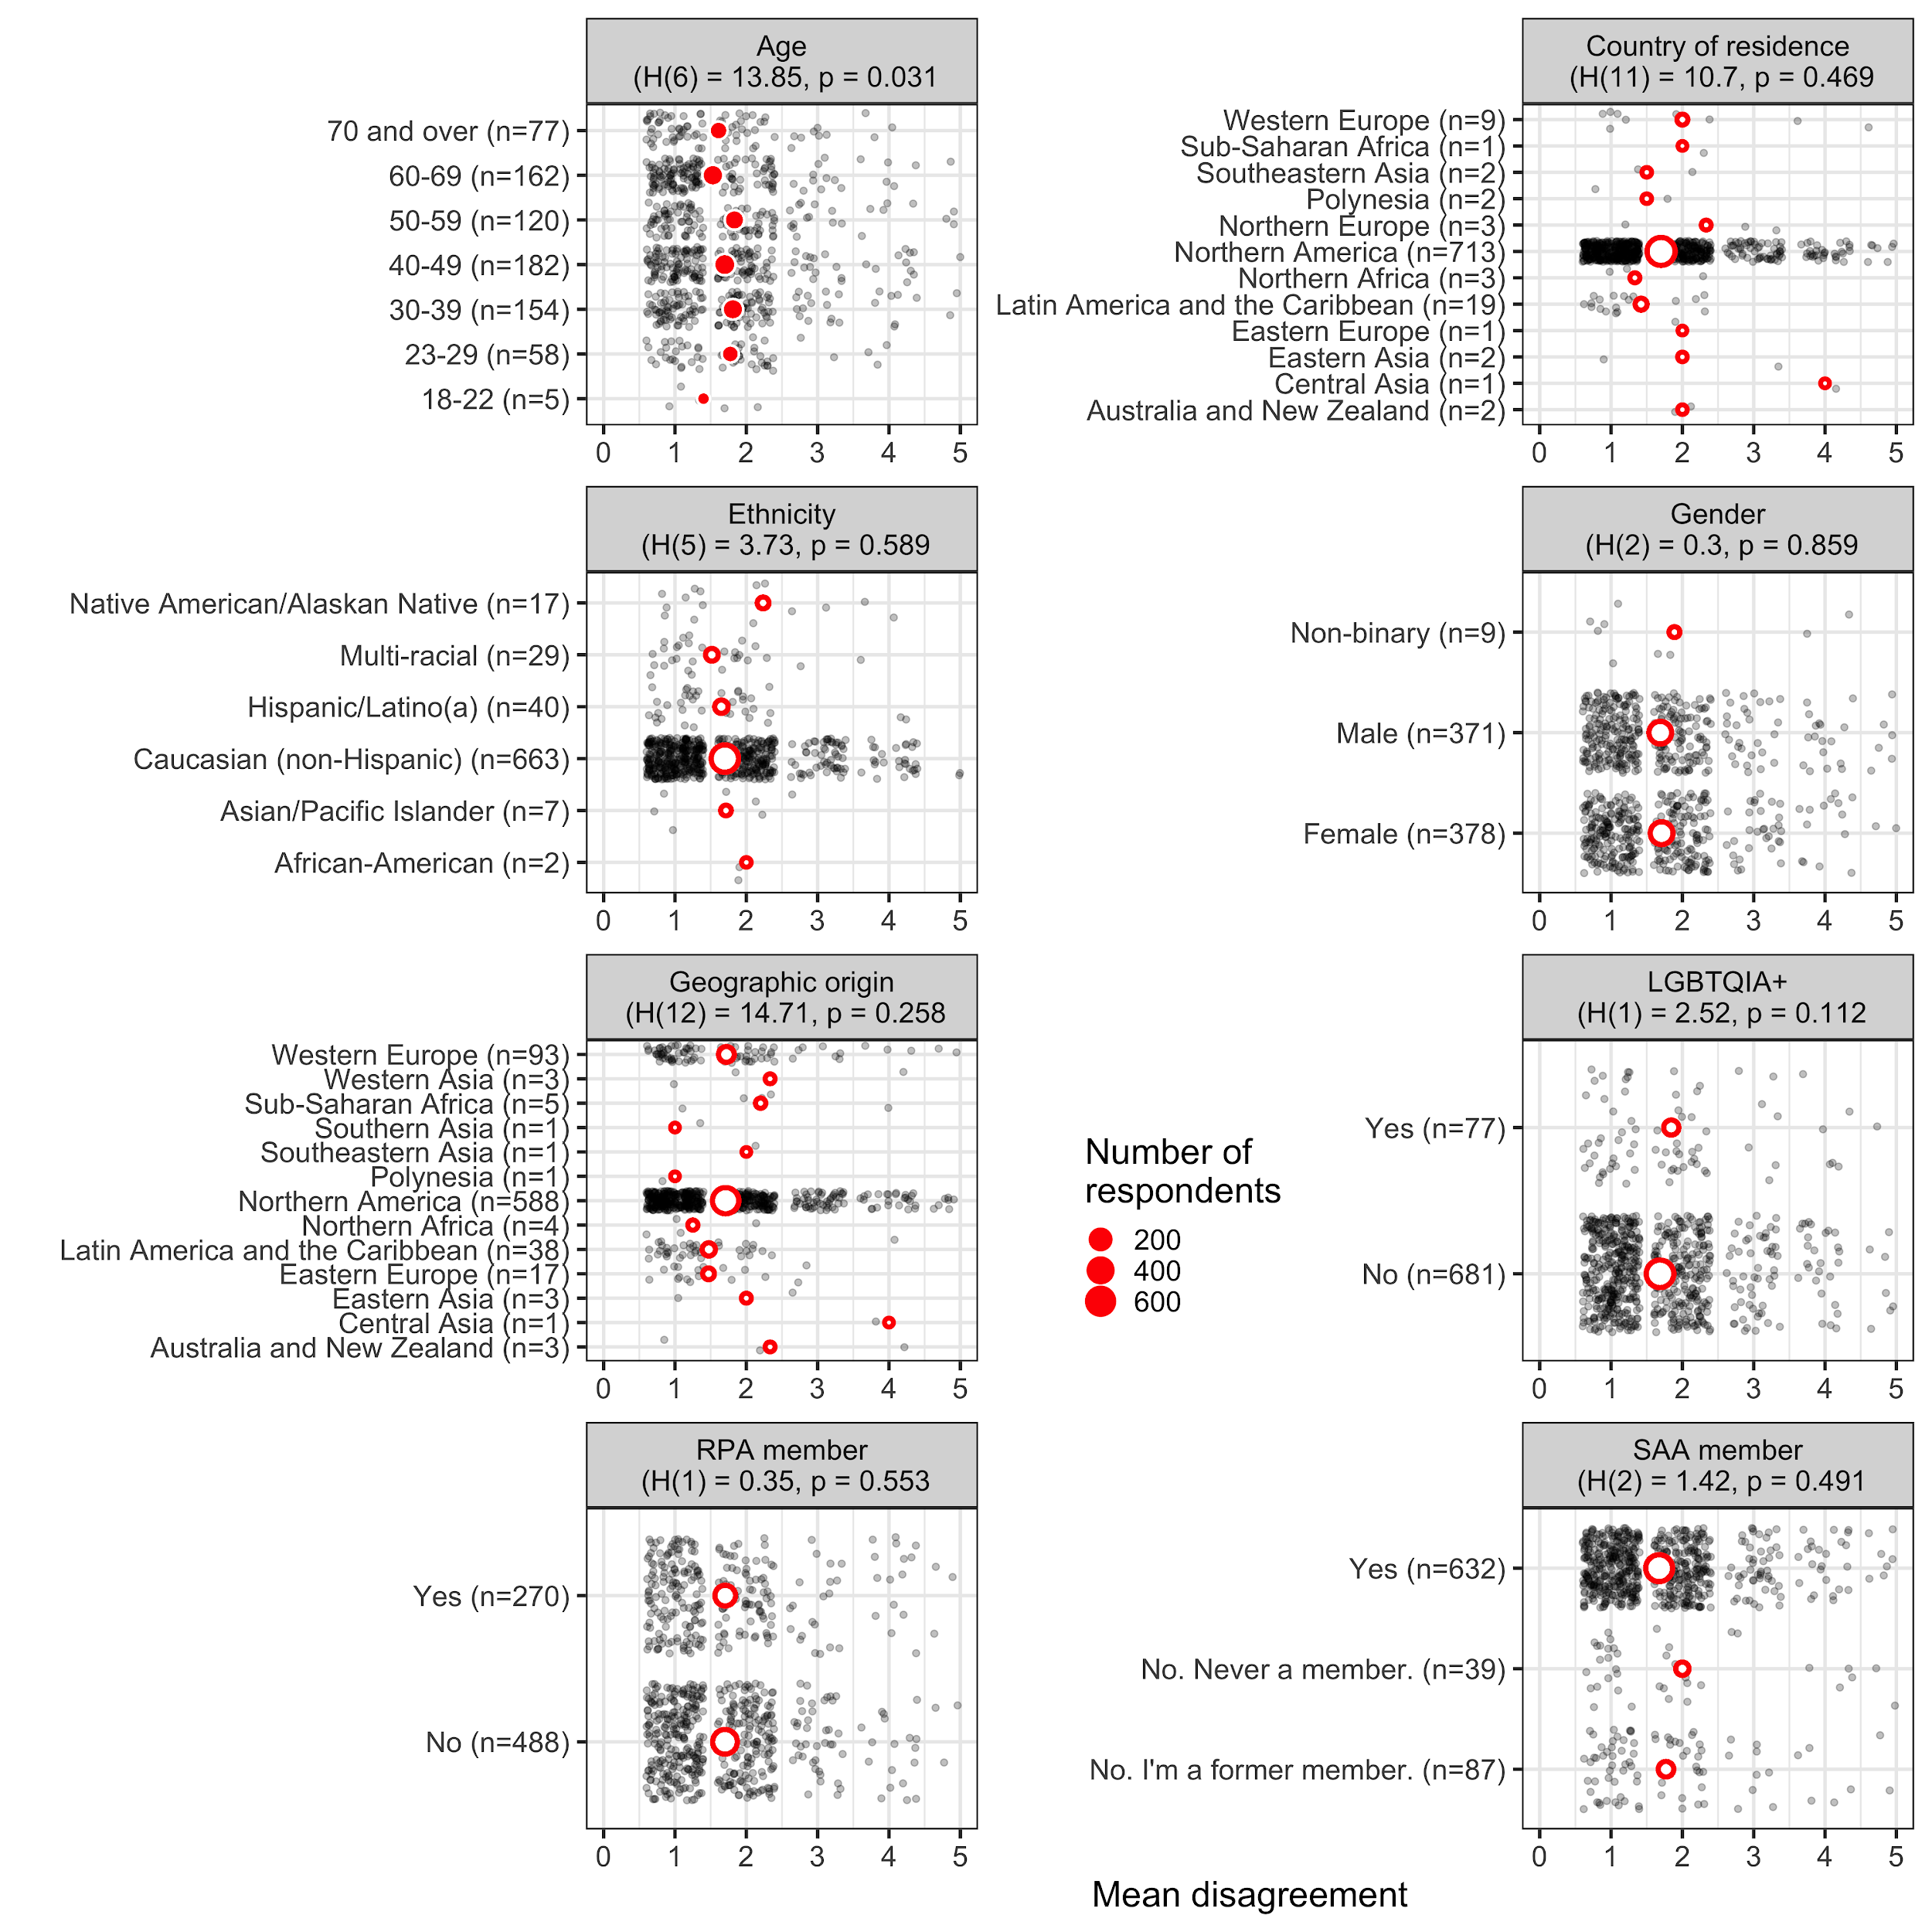

Figure 15. Plots of mean disagreement by demographic category for the 1099 Likert-scale responses about Principle 3

In the demographic plots of mean disagreement for Principle 3 (Commercialization) we see significant differences among age groups (Figure 15). Generally, younger people disagree less than other age groups that the “principle and its description adequately applies to archaeological practice and its ethical challenges today”

### Q: Principle 4: Public Education (251 text responses)

Principle No. 4: Public Education and Outreach Archaeologists should reach out to, and participate in cooperative efforts with others interested in the archaeological record with the aim of improving the preservation, protection, and interpretation of the record. In particular, archaeologists should undertake to: 1) enlist public support for the stewardship of the archaeological record; 2) explain and promote the use of archaeological methods and techniques in understanding human behavior and culture; and 3) communicate archaeological interpretations of the past. Many publics exist for archaeology including students and teachers; Native Americans and other ethnic, religious, and cultural groups who find in the archaeological record important aspects of their cultural heritage; lawmakers and government officials; reporters, journalists, and others involved in the media; and the general public. Archaeologists who are unable to undertake public education and outreach directly should encourage and support the efforts of others in these activities.

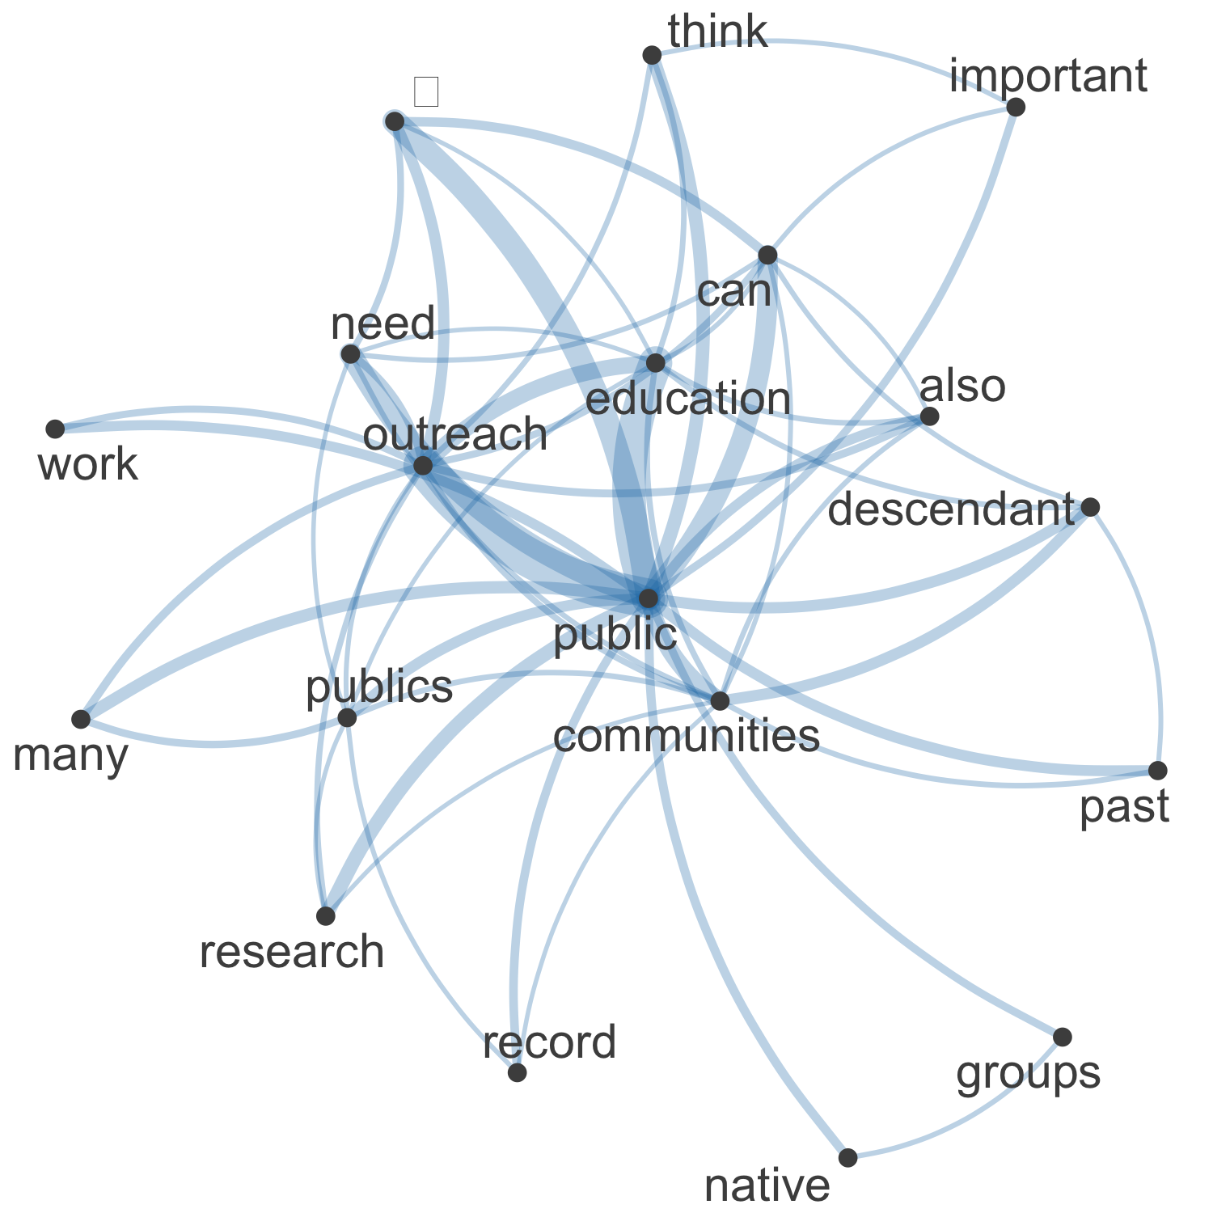

Figure 16. Network plot of high frequency words and their relationships in the 251 free text responses about Principle 4

In the network visualisation of 251 text responses in the “Please elaborate here:” field for the question about Principle 4 (Public Education) we see that central concepts in the responses are “public”, “outreach”, “education”, “communities” (Figure 16). Other notable terms are “descendant” and “native”, highlighting the importance of these communities in public education.

Commonalities

The most commonly occurring tag by a large margin is “public engagement,” followed by “indigenous.” Many survey 251 respondents expressed the desire for a more collaboration based approach to public engagement and education. As one respondent explained:

“It sounds very self-serving to say that archaeologists should reach out to interested communities in order to preserve and protect the archaeological record. Maybe the public engagement would be better off serving community well-being (today). In addition, archaeologists may be able to learn from members of the public in such a way that archaeologists can learn about and not just communicate archaeological interpretations of the past through engagement.”

Many of the 251 survey respondents also expressed a desire to see a stronger statement from the SAA on working with descendent and indigenous communities:

“This statement should be revised for the 21st Century. Descendant communities and other stakeholders are not simply passive "publics for archaeology" but rather should be given agency to participate or comment on archaeological research from the early project design stages to deciding whether and how they want results of research to be presented. Some descendant communities may not want archaeological data and interpretations to be made public, or may offer alternative interpretations. Archaeologists should be strongly encouraged to involve descendant communities and stakeholders in decision [sic] about public education and outreach, and to move away from the role of sole interpreters of the past to that of facilitators of multivocal exchanges about the past.”

Contrasts

While the “avocational” tag is often paired with the “public engagement” tag, it is never paired with the “Indigenous” tag. This is striking, as the “Indigenous” tag was the second most commonly used tag in responses to this question. Several survey respondents discussed collaborating with avocational archaeologists:

“Specific language should be included to clarify that this should not lead to exclusion of collaborations with avocational archaeologists, as they have a vested interest in working with the archaeological record and are important collaborators. A conversation about ethical recording and collection can and should be had—they are members of the public, too.”

While the majority of the 251 responses to this question that contained the “public engagement” tag were in favor of active engagement with the public by archaeologists, one comment stood out for its opposing viewpoint:

“We have been focused on "the public" far [sic] too long. History and culture does not belong to everyone, and its [sic] not ours to give to everyone. Further, as one who was involved with a volunteer stewardship program as a volunteer coordinator, my feelings about volunteers has [sic] changed over the years. To be an archaeologist requires a degree, when we choose to give archaeological work to volunteers over paying young, new archaeologists, we devalue our profession. Further, in my experience, most volunteers are older and white and can afford to dabble (play) at being archaeologist [sic]. There is an elitism to it that I think we need to be more considerate of. We need to reexamine our relationship with the "public" so that we are being considerate of young professionals, of descendant communities, of ownership of the past and past materials, and of opportunity [sic].”

Comparisons

The tags that most appear most frequently together in the 251 responses to this question are: “Indigenous” and “public engagement”; “enforcement” and “public engagement”; “enforcement” and “Indigenous”; and “conflicts of interest” and “public engagement.” The majority of the survey responses, while in favor of public education and engagement, wanted to see more inclusion and consideration of indigenous communities. One respondent wrote:

“While it is important to get archaeological information out to the public, archaeologists need to be respectful of the "affected groups" that are [sic] mentioned a few principles ago. Some tribes consider many archaeological objects and traditional knowledge to be confidential information that should not be shared with the public.”

Another common concern amongst survey takers was how to do public outreach in a way that benefits and serves the general public. One survey respondent explained:

“This is too archaeologist-centric. We have to engage the public in ways that are meaningful to them, not just set up on our terms.”

Relationships

There is a cause and effect relationship between the “public engagement” and “enforcement” tags. When respondents are in favor of public engagement and education, they are often also in favor of stronger enforcement of the principle. One of the 251 respondents to this question further explained:

“I think that if we actually care about any of the other principles education and public outreach are imperative. I think it is a bit of a cop out to imply that archaeologists are "unable to undertake public education and outreach directly." There are so many ways to do public outreach/education, and I think it should be a priority for every archaeologist to engage with this in some way (not saying that everyone needs to be giving this their all one hundred percent of the time, but they shouldn’t be let off the hook when it comes to thinking about and engaging with this in some way).”

Another survey respondent stated:

“No just should— archaeologists MUST participate or support public education and outreach.”

Sentiment

The majority of the 251 respondents to this question agree that public education and engagement is a valuable and essential part of archaeology. However, there is disagreement on whether it should be a requirement that all archaeologists take part in public education. As one survey taker stated:

“The last line is the best part. Not everyone is capable or, if willing, is able (for a variety of reasons) to engage in these practices. The growing number of public archaeologists should be enlisted, hired, supported, and otherwise turned to as professionals.”

Another respondent had different opinion:

“All archaeologists should undertake these activities. Supporting efforts of others is fine but a way many get out of doing it. Public benefit of archaeology should be done for all, by all. Advocacy is important, but scientific literacy, informing local decision making processes, impacting social issues through archaeology-more than just making a poster or brochure. And enlist public support for stewardship is great-but enlist the public as stewards, make more [sic] active, would strengthen this principle.”

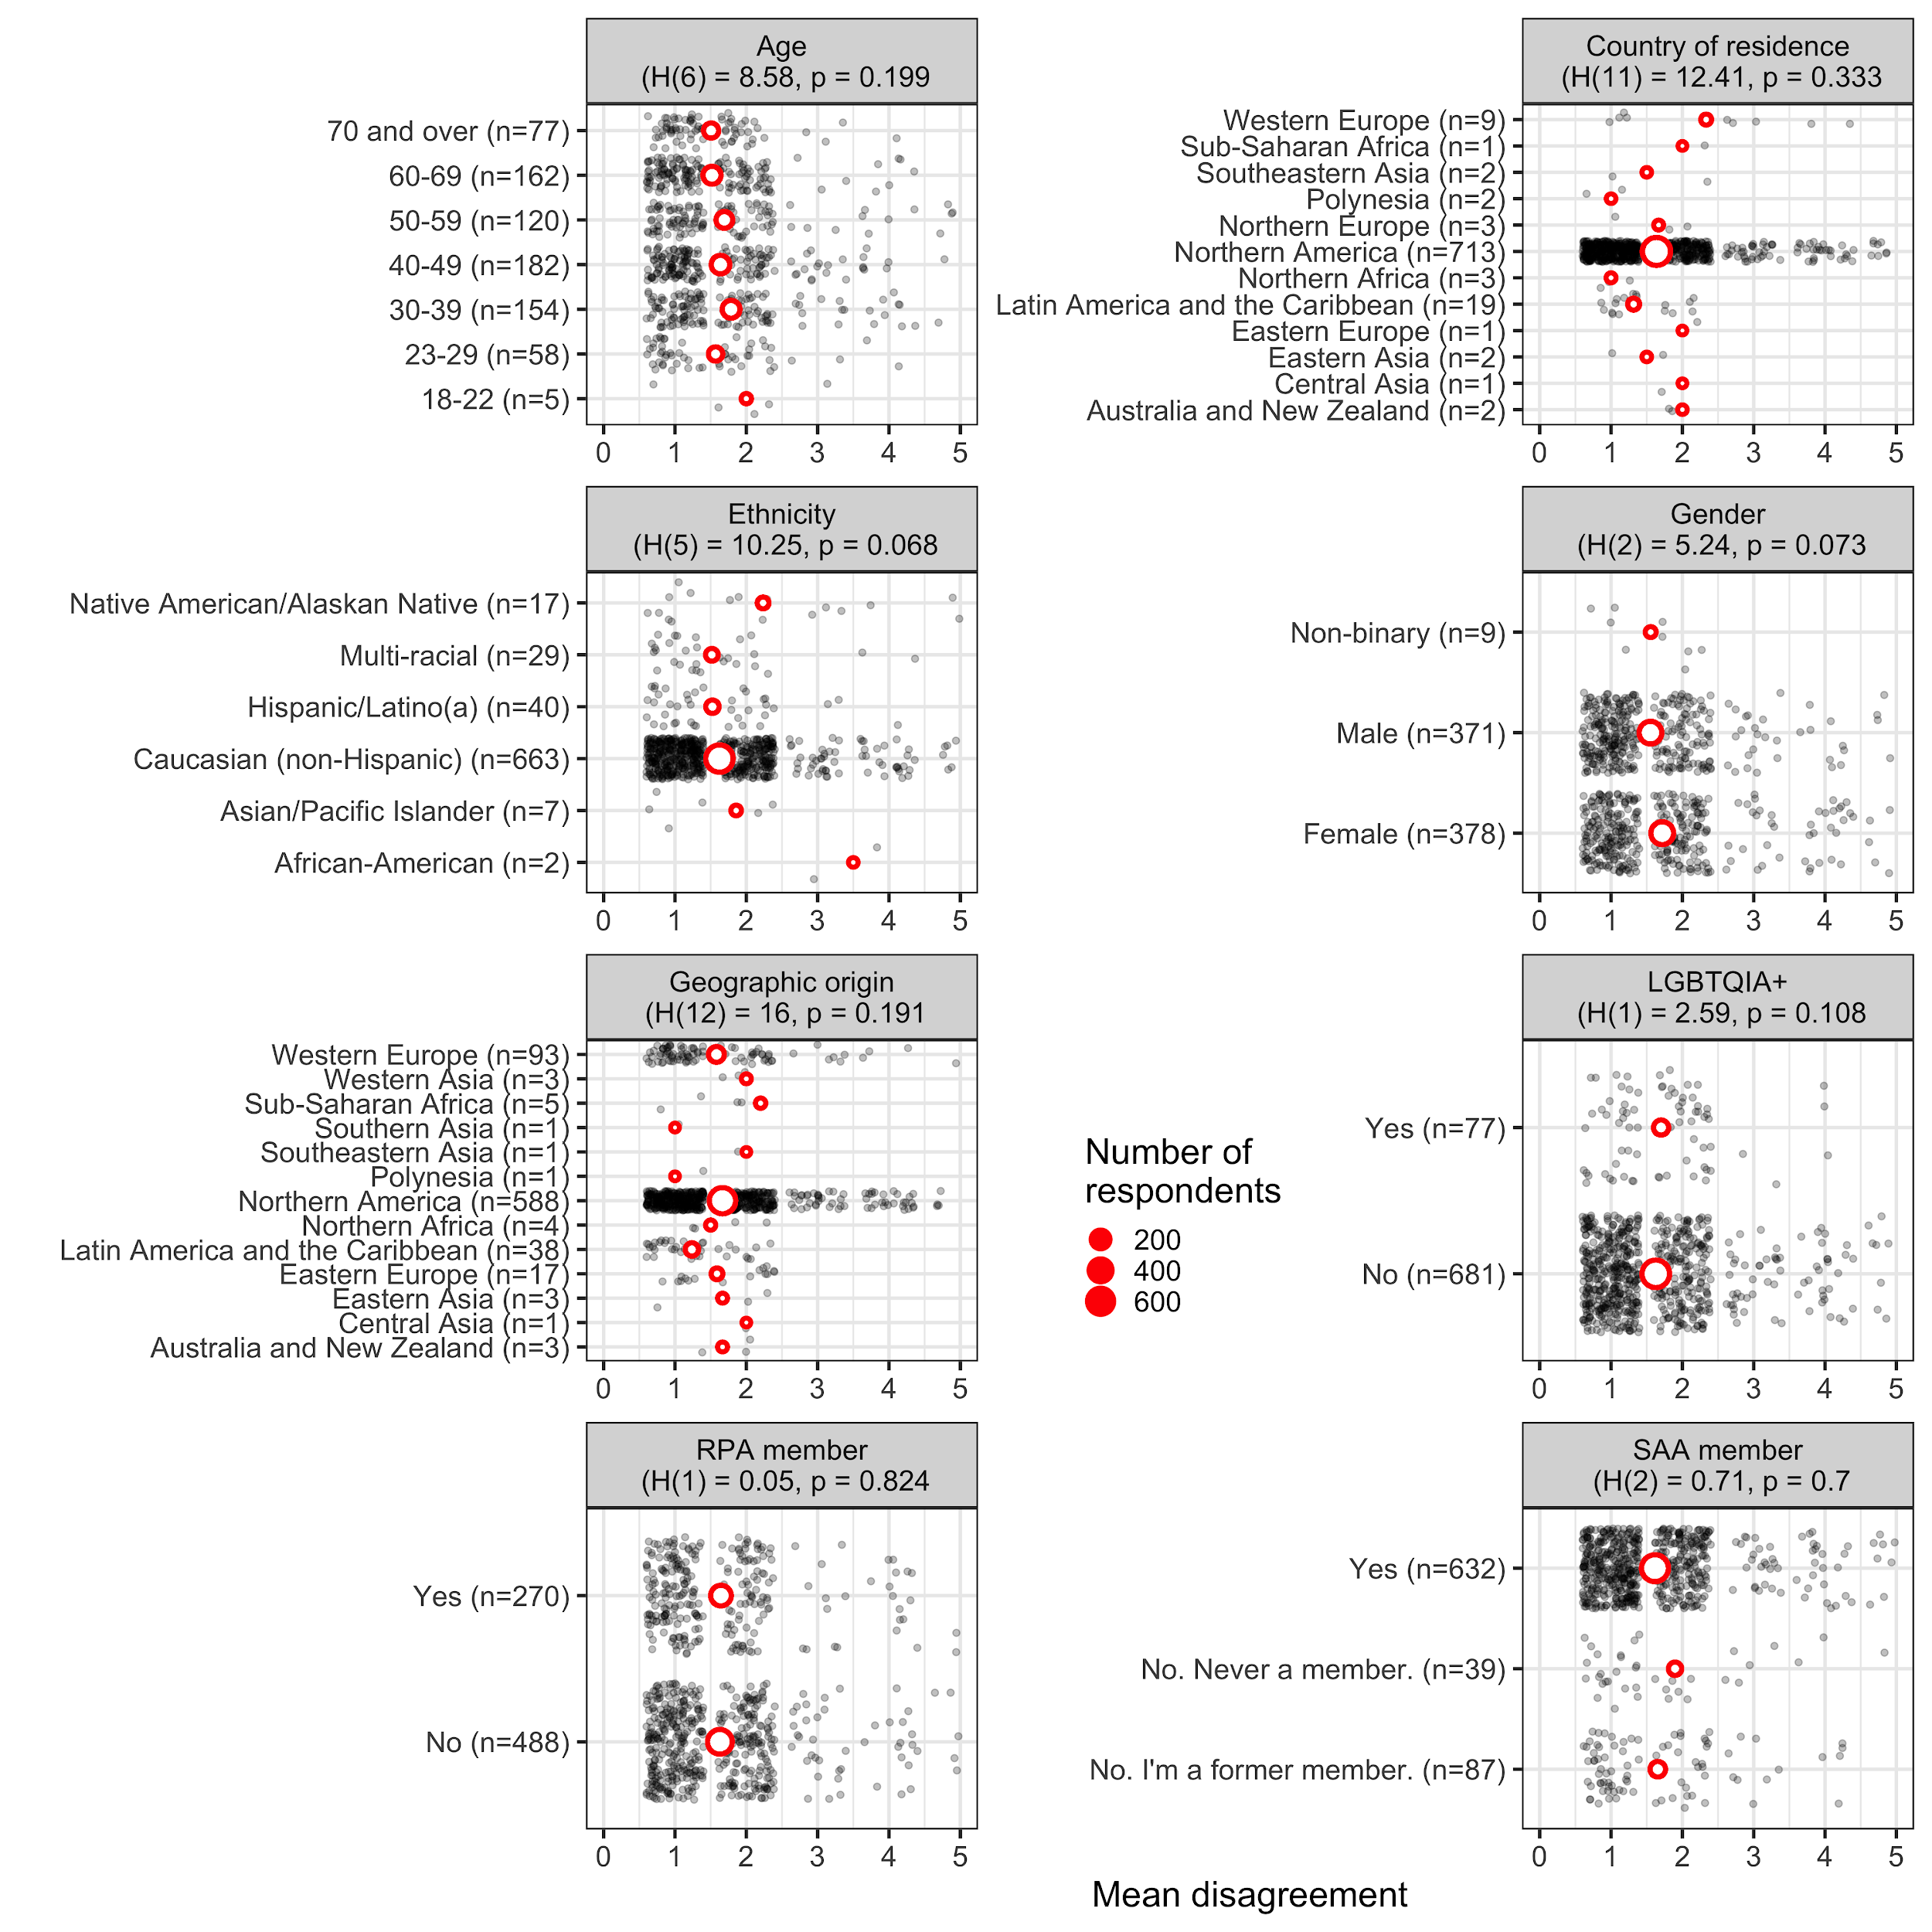

Figure 17. Plots of mean disagreement by demographic category for the 1080 Likert-scale responses about Principle 4

In the demographic plots of mean disagreement for Principle 4 (Public Education) we see no significant differences among any groups (Figure 17). African-Americans tend to disagree more often than other ethic groups that the “principle and its description adequately applies to archaeological practice and its ethical challenges today”. The small sample size means this difference does not show as statistically significant.

### 

### Q: Principle 5: Intellectual Property (331 text responses)

Principle No. 5: Intellectual Property Intellectual property, as contained in the knowledge and documents created through the study of archaeological resources, is part of the archaeological record. As such it should be treated in accord with the principles of stewardship rather than as a matter of personal possession. If there is a compelling reason, and no legal restrictions or strong countervailing interests, a researcher may have primary access to original materials and documents for a limited and reasonable time, after which these materials and documents must be made available to others.

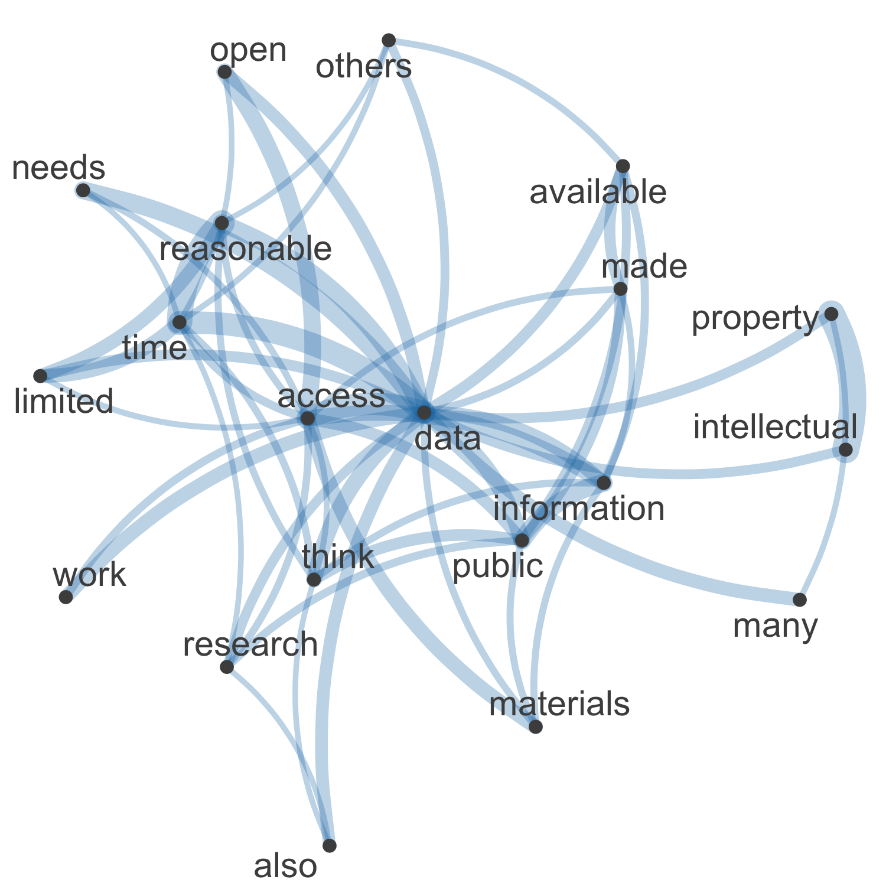

Figure 18. Network plot of high frequency words and their relationships in the 331 free text responses about Principle 5

In the network visualisation of the 331 text responses in the “Please elaborate here:” field for the question about Principle 5 (Intellectual Property) we see that central concepts in the responses are “data”, “access”, “reasonable”, “time” (Figure 18). Other notable terms are “descendant” and “native”, highlighting the importance of these communities in public education.

Commonalities

The most commonly used tag by a substantial margin in the 331 responses to this question, was “open science.” Open access to data and research is a current important topic of discussion by society members as exemplified by one particular survey response:

“I would add that as a discipline that promotes the concepts of science, the results and the core discoveries must be made available to other researchers for replication, re-testing and reinterpretation. Public access (with some limits for protection of the resource) is necessary to advance understandings and appreciations.”

Other commonly used tags for Principle 5 included “enforcement,” “IP and copyright,” and “indigenous.” The following response is a clear example of how the common tags intertwine with each other:

“Intellectual property issues seem to have gotten increasingly complicated with time. Tribes are concerned with data sovereignty that potentially involves archaeological data in many ways. Government agencies restrict sharing of information on agency lands. This is a complex issue that extends well beyond the issues related to individual researchers and data sharing that is the focus on this principle.”

Contrasts

When discussing IP and copyright, tags related to social issues (“harrassment”, “racism”, “discrimination”, etc.) are rarely or never used by the 331 respondents. This also extends to tags relating to collegiality and the workplace environment.

There are contrasting responses to the tag “open science.” Responses typically fall into three categories (independent of the Likert response to this question): strongly against, strongly agree, and agree with added conditions. The following is an example of a response falling into the strongly against category:

“Artifacts should not be treated like public documents at a library.”

A response from the strongly agreed category reads:

“This makes sense at both a general intellectual and more pragmatic level. On the former, all scholars benefit when the reports, articles, etc. are widely and freely disseminated. On the latter, since much of our work is supported by public funds, the information should be made widely available.”

Here is an example of a response falling into the agree with added conditions:

“This needs to be updated to reflect the importance of the open access movement and strong justification for making archaeological data available. These directives most often come from funding agencies and the SAA is lacking an opportunity to firmly establish the importance of data sharing.”

Comparisons

The tags that appear together the most frequently among the 331 responses to this question are: “open science” and “research”; “open science” and “indigenous”; “open science” and “IP and copyright”; “open science” and “enforcement”; and “IP and copyright” and “indigenous.” These results suggest that the primary concerns of the respondents in regards to Principle 5 is access and publication to data and the role that the SAA will play in the enforcement of said Principle. Another primary concern is the rights of indigenous communities in terms of IP and copyright and publication of culturally sensitive material. One respondent explained:

“This principle does not reflect the fact that archaeologists often do not honor the intellectual property of indigenous communities when they offer insights, explanations, or assistance with interpretations. There is also no discussion of confidentiality agreements, co-stewarding of data, etc. Additionally, archaeologists have long treated their personal research as a personal possession and there remain many collections that are unavailable for viewing, use, study, or exhibit by others. A limited and reasonable time to retain original materials is not decades or someone’s lifetime, but that is the reality in the discipline today.”

The following is an example of a response concerning the “open science” and “enforcement.”:

“Again this feels very out of date. The concept of a "limited and reasonable time" has been cited by some archaeologists to restrict data to themselves for 20+ years! We need a stronger stance on data sharing and a commitment to archive data in publically available ways for future scholars.”

Relationships

There is a cause and effect relationship between the “enforcement” and “open science” tags. The “open science” tag and the “enforcement” tag are often seen together. When respondents are strongly in favor of open science, they often state that they want the SAA to have a firmer stance and stronger enforcement policy concerning open science. The following are two responses from survey takers:

“This principle is very weak. It is the obligation of the archaeological community to create broadly accessible long-term, repositories that have the capacity to authentic users and user credentials for use and access. It is the responsibility of archaeologists to contribute to these repositories in a timely fashion. It is also the responsibility of hiring and funding institutions to recognize that the contribution of structured archaeological data is at least as important as published interpretations and reward such contributions with financial incentives. Failure to do so will foster a continuation of data hoarding practices that will impede broad scale understandings of long-term historical trends using archaeological data.”

“The SAA and other archaeological bodies should seek to enforce this. The geographical region I work in is particularly medieval and nepotistic when it comes to who has access to data. Without stronger guidelines personalities tend to control their own data as they see fit.”

Sentiment

The sentiment surrounding the tags was mixed. While many of the 331 respondents agreed with the Principle set forth by the SAA, they had concerns and suggestions for change. The following are strong examples of such a response is:

“I strongly agree with the first two sentences. But, I do not think there is general, widespread agreement on what "a limited and reasonable time" is. I have seen academic researchers tie up collections for years by requesting them through loans for years, as they struggle to conclude their research. They drag their feet, or are completely oblivious to requests for returning the material so that others can access it. This is a principle that appears to be systematically abused.”

“I agree in principle, but this is extremely vague and does not actually capture the position and decisions that archaeologists must make when archaeologists publish their work. More detail is needed regarding what constitutes a published work, what additional documentation is needed to support the sustainable access and use of that work (especially regarding open data), and any commitments that should be encouraged on the part of those who access or use that work (i.e. reaching out to authors, citation, acknowledgement, etc)”

One of the most common suggestions, as noted in the example above, was specifically defining what “a limited and reasonable time” is. One survey taker noted:

“A "limited" and "reasonable" time is often at odds in the reality of working on federal lands, where battles over budgets, personnel hiring practices, constantly changing managers, and local bureaucracy often make it impossible to get projects done in any sort of timely manner.”

### 

Figure 19. Plots of mean disagreement by demographic category for the 1074 Likert-scale responses about Principle 5

In the demographic plots of mean disagreement for Principle 5 (Intellectual Property) we see no significant differences among any groups in their levels of disagreement about the statement “this principle and its description adequately applies to archaeological practice and its ethical challenges today” (Figure 19).

### Q: Principle 6: Public Reporting (301 text responses)

Principle No. 6: Public Reporting and Publication Within a reasonable time, the knowledge archaeologists gain from investigation of the archaeological record must be presented in accessible form (through publication or other means) to as wide a range of interested publics as possible. The documents and materials on which publication and other forms of public reporting are based should be deposited in a suitable place for permanent safekeeping. An interest in preserving and protecting in situ archaeological sites must be taken in to account when publishing and distributing information about their nature and location.

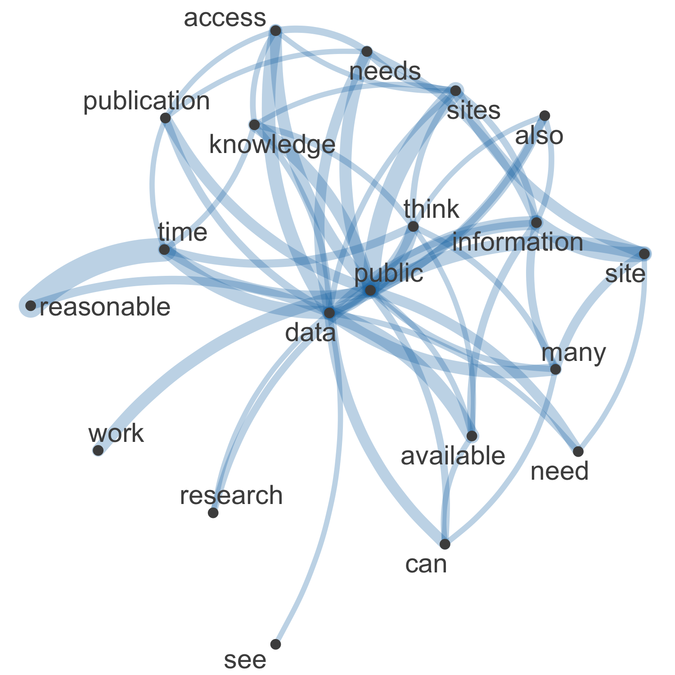

Figure 20. Network plot of high frequency words and their relationships in the 301 free text responses about Principle 6

In the network visualisation of the 301 text responses in the “Please elaborate here:” field for the question about Principle 6 (Public Reporting) we see that central concepts in the responses are “data”, “public”, “knowledge”, and “available” (Figure 20). As for Principle 5, we also see “reasonable” and “time” connected here, emphasising timeliness of reporting as a concern.

Commonalities

The most commonly used tag by a large margin was “enforcement.” Other common tags included “open science,” “public engagement,” and “conflicts of interest.” While the majority of the 301 respondents to this question agreed with the basis of the principle, many were in favor of stronger enforcement concerning open access and open science. The following is an example of such a response:

“I agree with the principle stated here and think this is a major problem in academic archaeology today. Many researchers are unwilling to share or publish data sets and a lot of research is based on who you know and whether or not they find favor in working with you. Some data sets never become accessible even after decades since data collection or the death of a researcher..”

Multiple respondents also asked for more specificity. One of the 301 respondents to this question wrote:

“There is a lot of gray area here. I agree in principle, but all kinds of things can complicate it, so what is "reasonable" is often difficult to assess.”

Contrasts

Tags relating to social issues (harassment, diversity, discrimination) are rarely or never seen when discussing Public Reporting.

While the majority of the 301 respondents to this question supported public reporting of all projects, one respondent had a different view:

“9/10s of what we do in CRM is not all that interesting. Rather than flood the market with a thousand pamphlets on old homesteads, focus funds/time/energy on a few really really interesting projects that will in fact capture the public attention.”

Comparisons

The tags most often paired together include: “enforcement” and “relevance”; “conflicts of interest” and “enforcement”; “research” and “conflicts of interest”; and “open science” and “public engagement.” One of the primary concerns for many of the 301 respondents to this question is the enforcement of public reporting. Open access was also a common topic. The majority of respondents were in favor of open access to data and open science and requested a stronger statement from the SAA concerning it. One respondent explained:

“I think this language could be updated to include the publication and distribution of archaeological information in a digital medium which is much more widely available today than when this principle was originally written. Digitally published information (project webpages, museum exhibits, webinar presentations, etc.) is also much more accessible to the public and other stakeholders now than peer-reviewed journal articles that are buried behind subscriber-only firewalls.”

While the majority of the 301 respondents support public reporting, many have questions about when it is appropriate to publish sensitive information. The following is an example of such a response:

“I have the same question as my earlier statement that not all information is appropriate for all audiences. However, is a potentially underfunded archive or even the attics of community leaders a "suitable place for permanent safekeeping"? I think that if there is a descendant community interested in claiming the materials, they should have the primary claim - although I understand that would be an extremely complex determination in many cases). But the alternative is reproducing colonial relations in which Indigenous materials are unilaterally claimed as national heritage. Of course, many tribes have excellent museums and preservation capacities, and many might prefer objects to be kept in a university or museum with those capacities, but I think these are issues that the SAA needs to tackle head on.”

Relationships

There is a cause and effect relationship between the tags “open science” and “research.” Multiple respondents cited the lack of open access to data as a hindrance to research. One of the 301 respondents to this question shared their experience with this:

“Given our modern digital age, this should really be revised and updated to encourage immediate sharing of primary data. Archaeology is lagging behind many other scientific fields in this regard, and it can be unreasonably difficult to get archaeologists to share data that they have used in publications. For example, I have requested lab numbers (and other basic information) for radiocarbon dates presented in publications within the last 10 years, and have had multiple authors refuse to provide them. If radiocarbon dates are used in publications, they should be open for scrutiny by any archaeologist who wishes to see them. A request should not even be necessary, they should be digitally available. If archaeologists do not want to share data, then they should not publish with it. Archaeologists are also increasingly relying on self-written computer code for statistical analyses. This should ALWAYS be made available (they are simply text files, there is little to no reason that they cannot be hosted somewhere online), but this is, unfortunately, not always the case. Effort should also be made to make this code legible.”

Sentiment

The majority of the 301 respondents to this question were in favor of public reporting, along with open science and open access. There was disagreement, however, in what information should be included in publication. Confidentiality of site locations was a common topic of discussion. While several respondents were in strong favor of making site locations confidential from the public, other respondents had doubts about the effectiveness of this practice. A respondent strongly in favor of maintaining site location confidentiality wrote:

“Confidentially of site locations for the public must be maintained.”

A respondent with an opposing view explained their stance:

“My only disagreement here is the site location protection issue. I truly believe that we shoot ourselves in the foot trying to be so secretive about sites in the interest of protection. The locations of historic sites are often part of the public record, and collectors know better where most precontact sites are than archaeologists do so we gain nothing by restricting public access to our reports. Community engagement is a better strategy in an age when people (rightfully) demand access to the data their tax dollars paid for. Empowering the community by letting them know of the rich resources in their area so they want to help protect them is a benefit, and I think that benefit outweighs the rare instances where people will abuse the knowledge.”

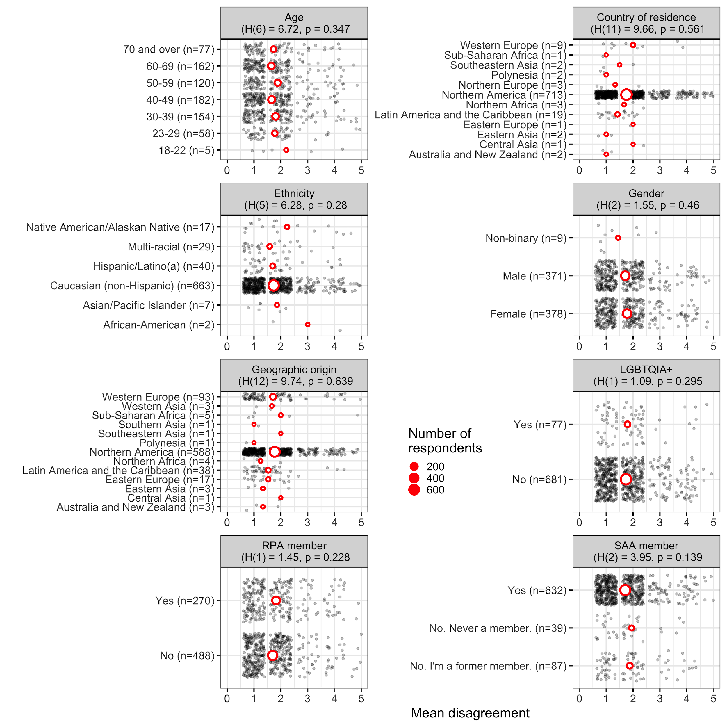

Figure 21. Plots of mean disagreement by demographic category for the 1066 Likert-scale responses about Principle 6

In the demographic plots of mean disagreement for Principle 6 (Public Reporting) we see no significant differences among any groups in their levels of disagreement about the statement “this principle and its description adequately applies to archaeological practice and its ethical challenges today”.

### 

### Q: Principle 7: Records and Preservation (243 text responses)

Principle No. 7: Records and Preservation Archaeologists should work actively for the preservation of, and long term access to, archaeological collections, records, and reports. To this end, they should encourage colleagues, students, and others to make responsible use of collections, records, and reports in their research as one means of preserving the in situ archaeological record, and of increasing the care and attention given to that portion of the archaeological record which has been removed and incorporated into archaeological collections, records, and reports.

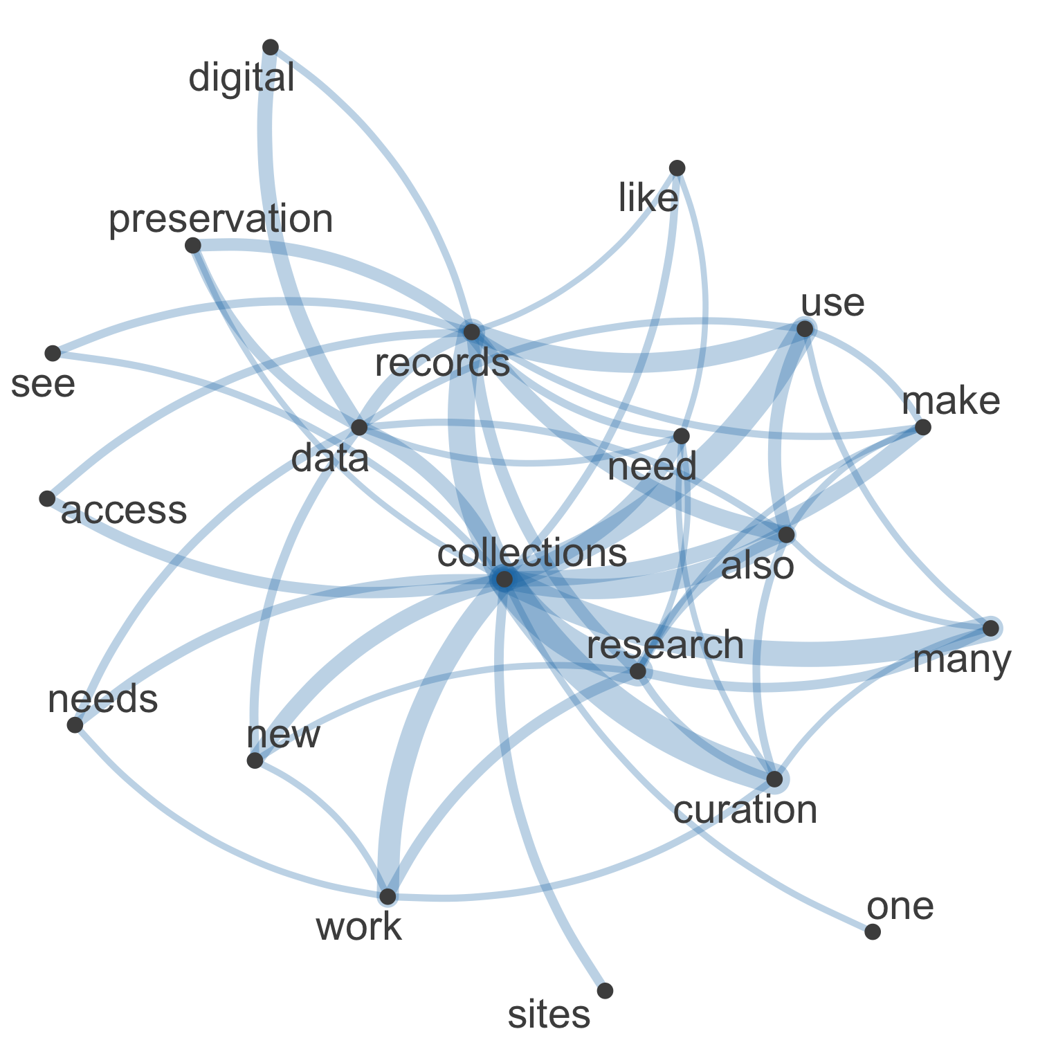

Figure 22. Network plot of high frequency words and their relationships in the 243 free text responses about Principle 7

In the network visualisation of the 243 text responses in the “Please elaborate here:” field for the question about Principle 7 (Records and Preservation) we see that central concepts in the responses are “collections”, “curation”, “research”, “records”, and “use” (Figure 22). These keywords show a tension between preservation/curation and access/use of not only archaeological materials, but also digital files.

Commonalities

The most commonly used tags in the 243 responses to this question were: “archiving,” “enforcement,” “open science,” and “research.” Many responses were strongly supportive of the current Principle, but were in favor of seeing it enforced more. Multiple responses claimed that archiving and curation were not given the same prioritization or funding as field work. One respondent wrote:

“If anything this statement needs to become stronger. Archival research should be given the same priority and held to the same standard by practitioners as classic ‘fieldwork’.”

Open science and open access was also a common topic of discussion. Many of the 243 respondents were in favor of digital curation and the use of digital archives. The following response is an example of this:

“Must be amended to include something about digital data and digital objects and long-term digital curation.”

Contrasts

Many of the 243 respondents to this question were in favor of putting more emphasis on curation of records and archives. However, there were several respondents who felt that such efforts did not have a place in archaeology. An example of such a viewpoint is seen in one respondent’s response:

“It is aspirational not practice-based. Frequent handling of objects may expedite their deterioration. Records and reports are not archaeological objects.”

Several people also brought up the issue of storage space and curation. One respondent explained:

“However, archaeologists and curators should seriously work to eliminate or only curate representative samples of artifacts of mundane nature that have little to no value for current and/or future research as a way to more effectively utilize existing space in repositories.”

Comparisons

The tags most often paired together in the 243 responses to this question are: “archiving” and “museums”; “research” and “archiving”; “open science” and “archiving”; and “conflicts of interest” and “archiving.” One of the most common topics brought up amongst survey respondents was the curation crisis. Many respondents were in favor of using existing collections for research, in place of creating new collections. The following is a response exemplifying this view:

“This needs stronger wording. Academic archaeologists need to encourage students to use existing collections. With storage space in museums, universities, and government facilities reaching their limit it is hard to justify storing new collections when very few archaeologists themselves or their students use these collections. This is especially true of collections from CRM projects.”

Many respondents were also in favor of open access to records:

“This gets at the heart of the idea of open science: the reproducability [sic] of our results. Here again this principle should explicitly state that records should be made open access so they are preserved for use by everyone into the future.”

Relationships

There is a cause and effect relationship between the tags “money” and “research.” Multiple respondents of the 243 people responding to this question mentioned that while they support Principle 7, lack of funding prevents archival research from being done. One respondent further explained:

“This is a good statement, but in reality, much of this sort of research is not done because it is not prioritized by funding institutions. That could be addressed here by a statement encouraging funding institutions to provide more funds for lab and archival research.”

Another respondent added:

“I think most of us genuinely want to do this, but it is often true that funding for reporting and analysis can be difficult to secure.”

Sentiment

The majority of the 243 respondents to this question agreed that curation and preservation is important and should be actively worked towards. However, there is disagreement about the curation crisis and whether to keep excavating and forming new collections, or working with what is currently available. The following response is from a survey taker who is in favor of using existing collections:

“Too many archaeologists are still digging away instead of spending a lot more time studying existing collections and encouraging their students to do the same. Furthermore, there are thousands of important, provenienced [sic], private collections, that are not being studied for the invaluable information that they might offer. Too many archaeologists are collecting more and more materials and data and creating a deeper and ever-growing collections-curation crisis.”

A respondent with an opposing view explained their thoughts on the curation crisis:

“There are is [sic] a disconnect with who does the reporting and the "determination" of how usable the collections are in curation. I find that people do not understand that collections that have been in storage for many years in less than ideal conditions cannot be readily made available for study and that repositories don’t have the funds to make the collections available without some help from the researchers who want access.”

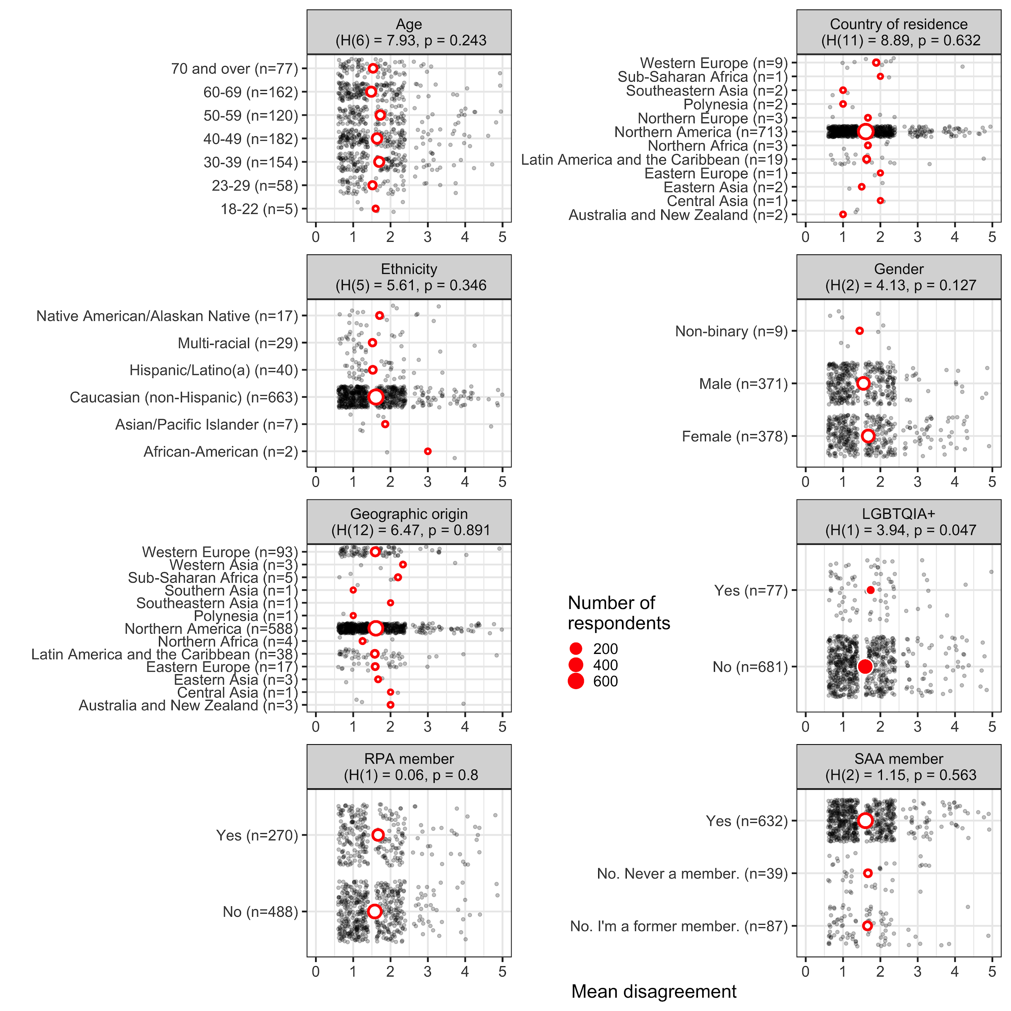

Figure 23. Plots of mean disagreement by demographic category for the 1061 Likert-scale responses about Principle 7

In the demographic plots of mean disagreement for Principle 7 (Records and Preservation) we see significant differences among the LGBTQIA+ group, with people identifying with the LGBTQIA+ more strongly disagreeing that “this principle and its description adequately applies to archaeological practice and its ethical challenges today”.

### 

### 

### 

### Q: Principle 8: Training and Resources (229 text responses)

Principle No. 8: Training and Resources Given the destructive nature of most archaeological investigations, archaeologists must ensure that they have adequate training, experience, facilities, and other support necessary to conduct any program of research they initiate in a manner consistent with the foregoing principles and contemporary standards of professional practice.

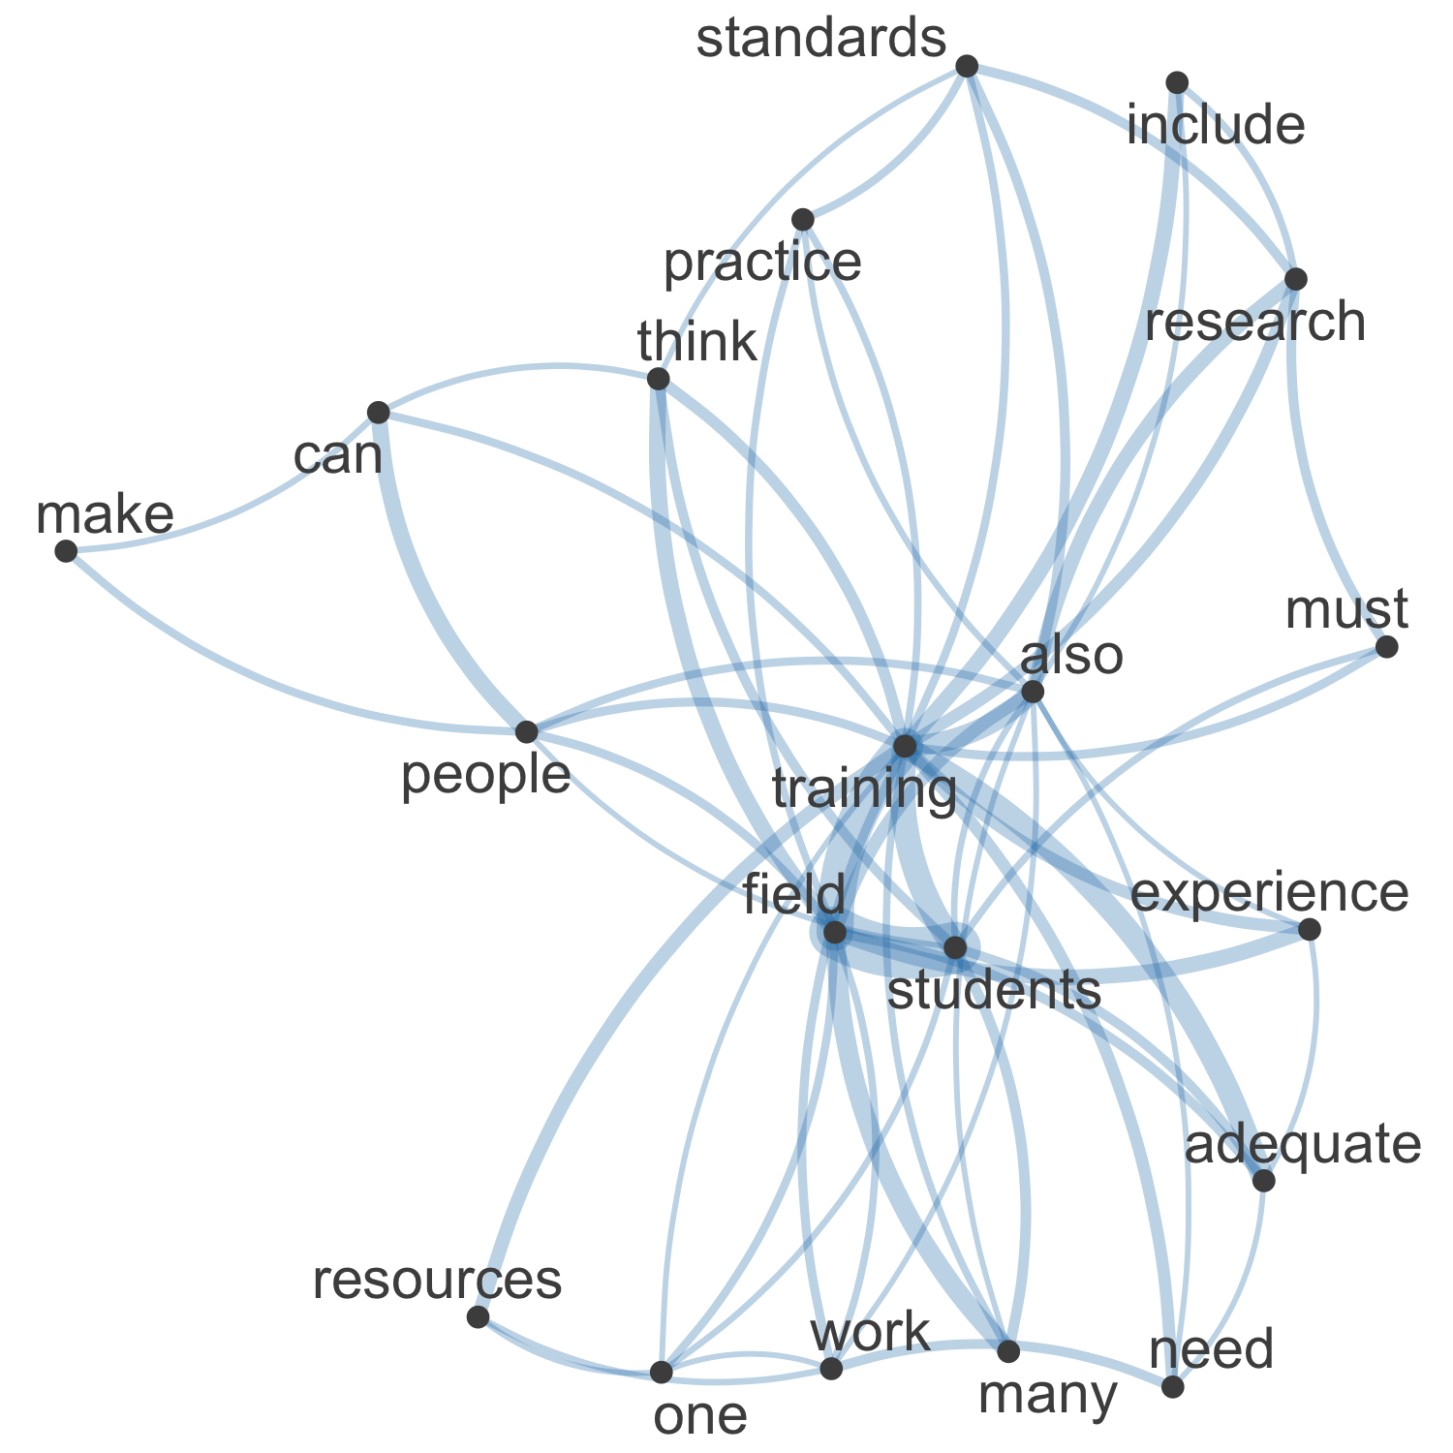

Figure 24. Network plot of high frequency words and their relationships in the 229 free text responses about Principle 8

In the network visualisation of 229 text responses in the “Please elaborate here:” field for the question about Principle 8 (Training and Resources) we see that central concepts in the responses are “training”, “field”, “students”, and “adequate” (Figure 24). “Work” and “experience” highlight the practical nature of training that many respondents are concerned with.

Commonalities

The tags that appeared most frequently in the 229 responses to this Principle was “Training Students”. The concerns of the respondents were that most students do not receive the proper training to have an adequate job outside of college. One response claimed:

“I do not feel we are adequately preparing the students of today”.

This seems to be an issue across all sectors of archaeology: field work, labwork, CRM, and Research.

Contrasts

There were certain tags that never appeared together in the 229 responses to this question, most notably the tags “Training Students” and “Sexual Harassment” were rarely addressed in the same reply. This is a striking result because in the comments under ‘Principle 9: Safe Environments’, many responses mentioned the abuse of power relations between students and professors/mentors. One rare response stated that:

“Training and resources should not only be about technical training and physical resources, but should include workplace training, sexual harassment, etc.”

Comparisons

Some tags were often paired together and can be seen in multiple responses such as “Training Students” and “Research” or “Field Methods”. The concern that respondents had between the tags “Training students” and “Research” was that there seems to be a focus on purely teaching students how to excavate, and not how to conduct research with the materials already in museums:

“Archaeology students should get much more training and guidance toward using existing collections for Masters and PhD research.”

Many of the 229 respondents to this question want to advocate and teach students how to properly analyze materials and conduct research on what is already in museums, instead of using destructive methods.

Relationships

A striking relationship amongst the tag “Environment” is that it is always in reference to the destruction or lack of preservation of archaeological sites. Most of the 229 respondents to this question that mention Environment the blame the lack of training given to students, both undergraduate and graduate, for the destruction of archaeological materials:

“[Bad] fieldwork, [Bad] excavations results in destruction of important archaeological data and resources.”

Sentiment

There appears to be a mixed reaction between the tags “Training Students” and “Field Methods”. A multitude of the 229 respondents to this question that claimed that there is not enough focus on proper excavation techniques.

“The federal standards for "professional archaeologists" are a joke and most graduate programs do little to train archaeologists to undertake field excavations.”

The respondents who urge for more adequate field training are concerned with the destruction of sites from people who are not trained properly. This leads respondents to advocate for more excavations to teach students correct excavation techniques so they do not damage archaeological material.

There were also responses that raised the concern for students who cannot afford field schools and an interest to make funding more available:

“training must be made available to any and all that want it”

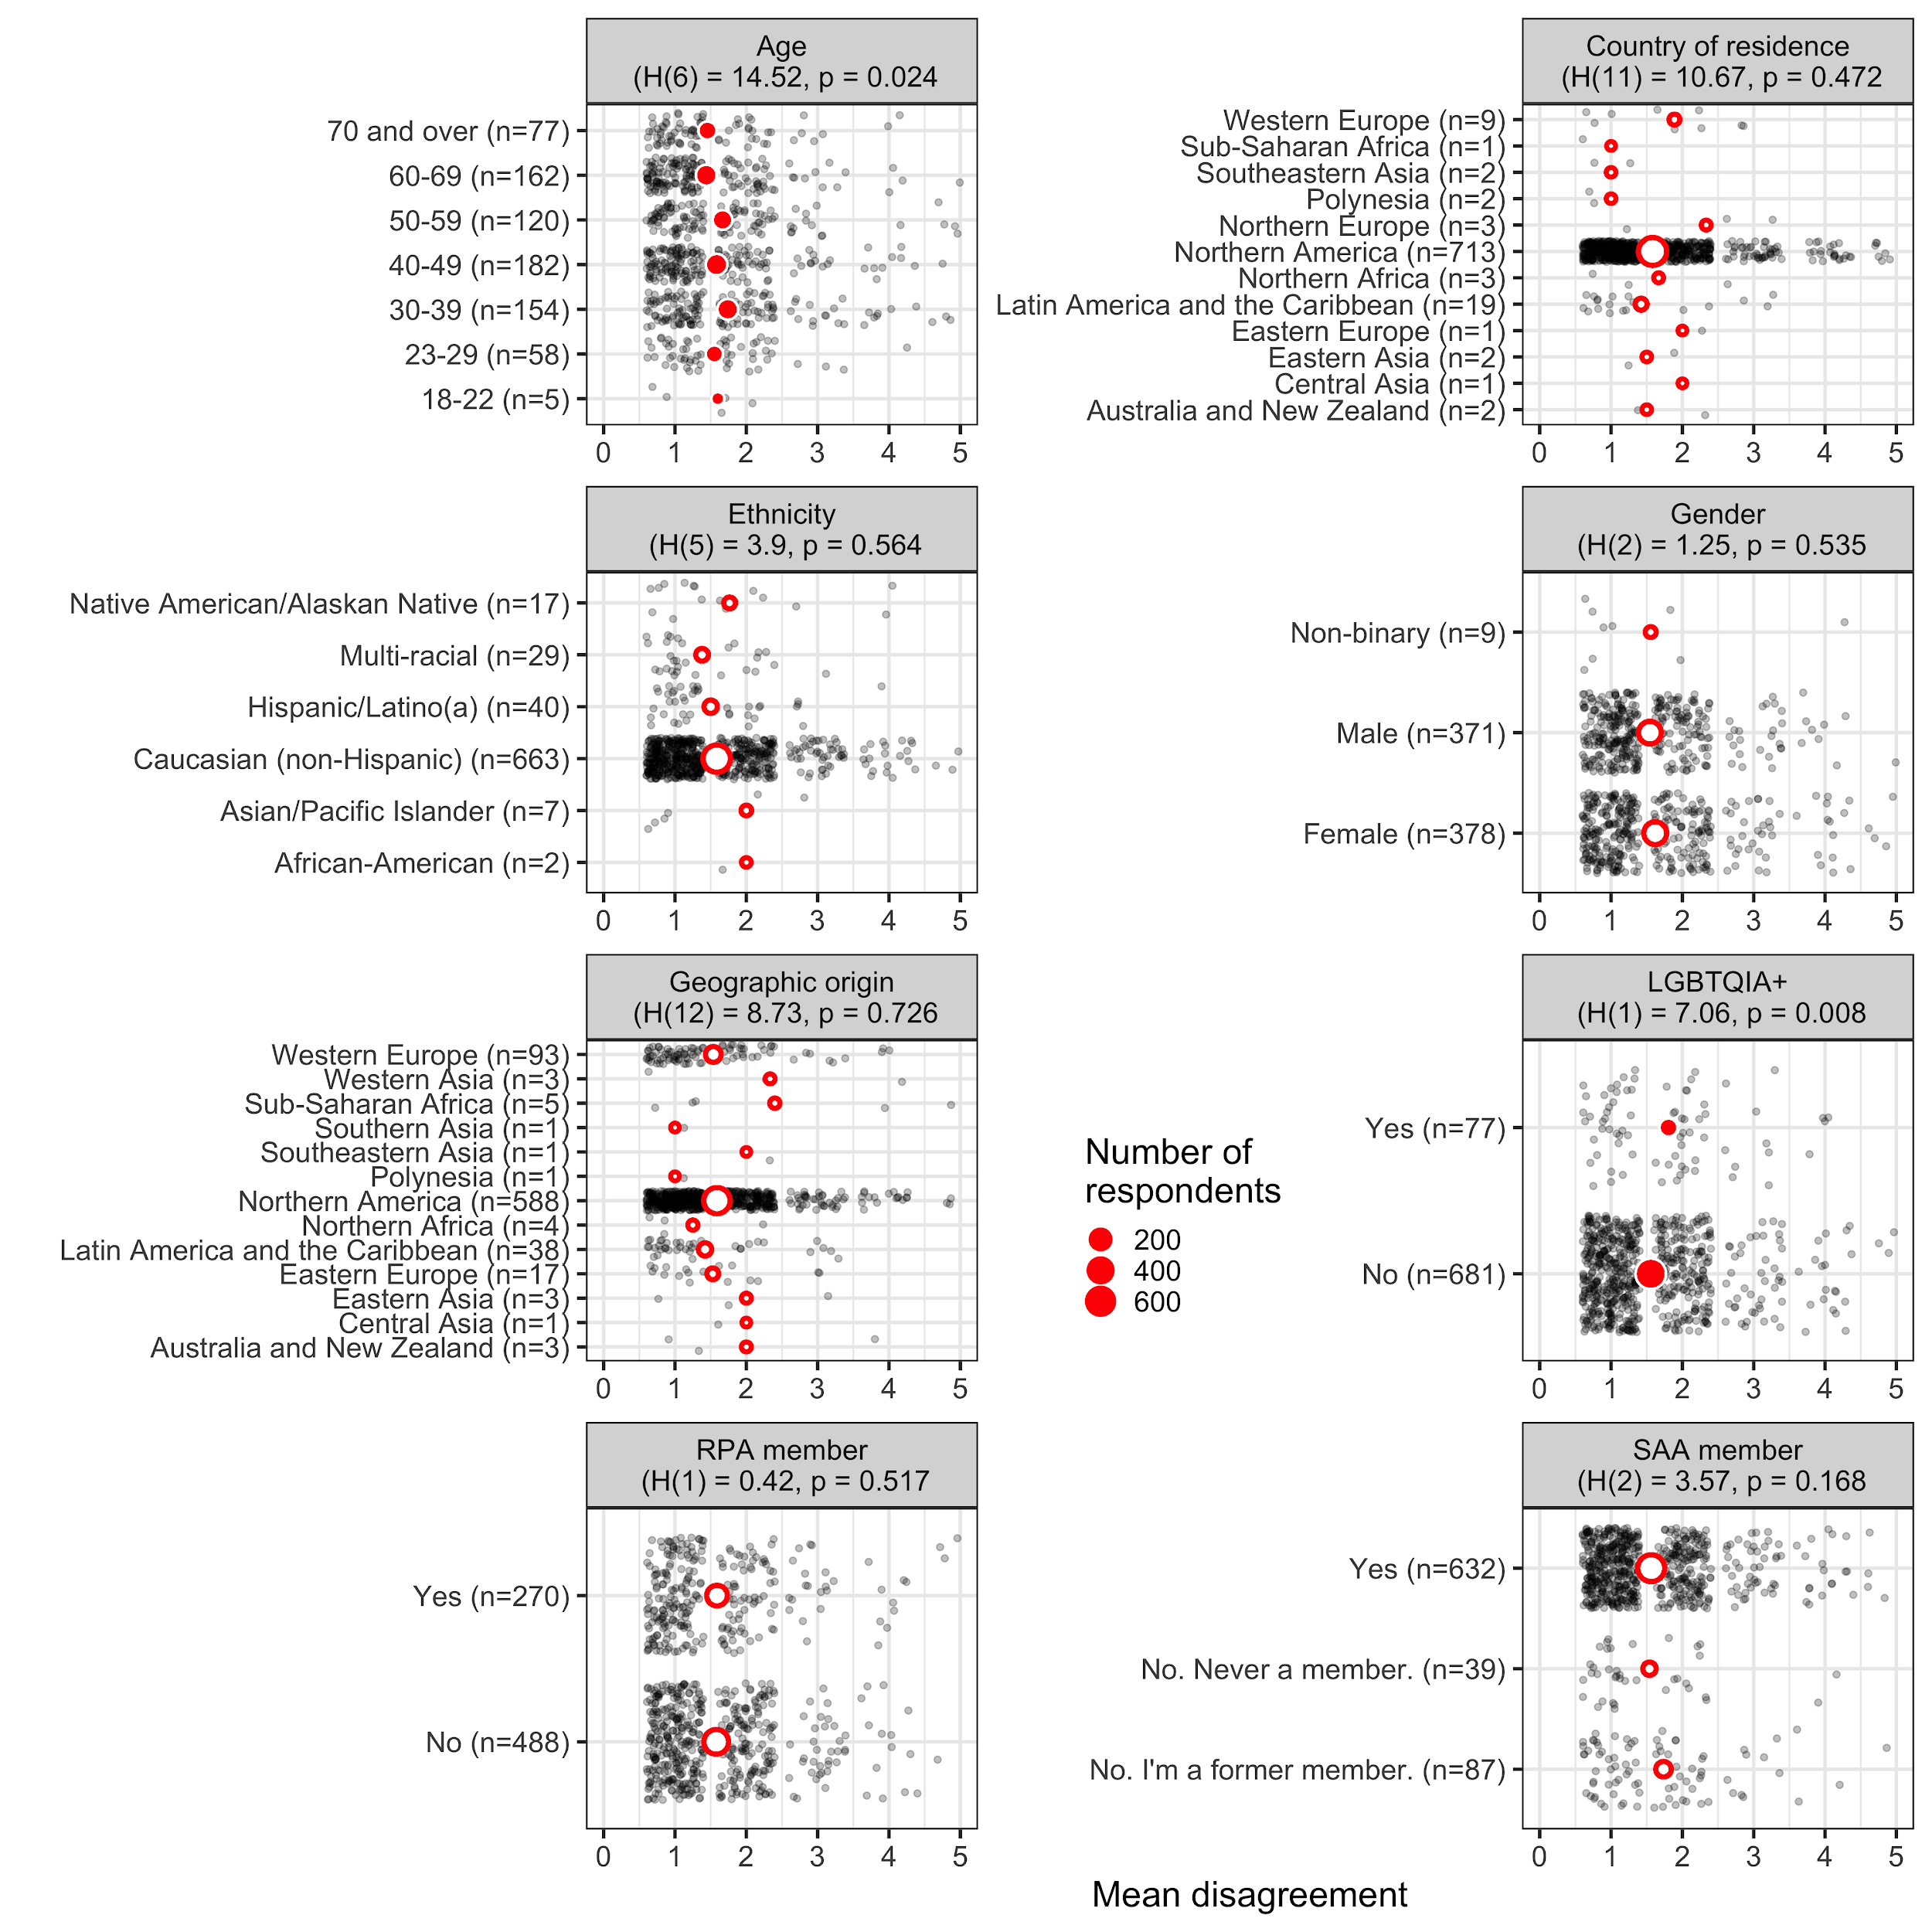

Figure 25. Plots of mean disagreement by demographic category for the 1058 Likert-scale responses about Principle 8

In the demographic plots of mean disagreement for Principle 8 (Training and Resources) we see significant differences among the LGBTQIA+ group and the age group. Generally, older people agree more, and people identifying with the LGBTQIA+ community more strongly disagree that “this principle and its description adequately applies to archaeological practice and its ethical challenges today”.

### Q: Principle 9: Safe Educational and Workplace Environments (329 text responses)

Principle No. 9: Safe Educational and Workplace Environments Archaeologists in all work, educational, and other professional settings, including fieldwork and conferences, are responsible for training the next generation of archaeologists. Part of these responsibilities involves fostering a supportive and safe environment for students and trainees. This includes knowing the laws and policies of their home nation and institutional workplace that pertain to harassment and assault based upon sex, gender identity, sexual orientation, ethnicity, disability, national origin, religion, or marital status. SAA members will abide by these laws and ensure that the work and educational settings in which they have responsible roles as supervisors are conducted so as to avoid violations of these laws and act to maintain safe and respectful work and learning environments.

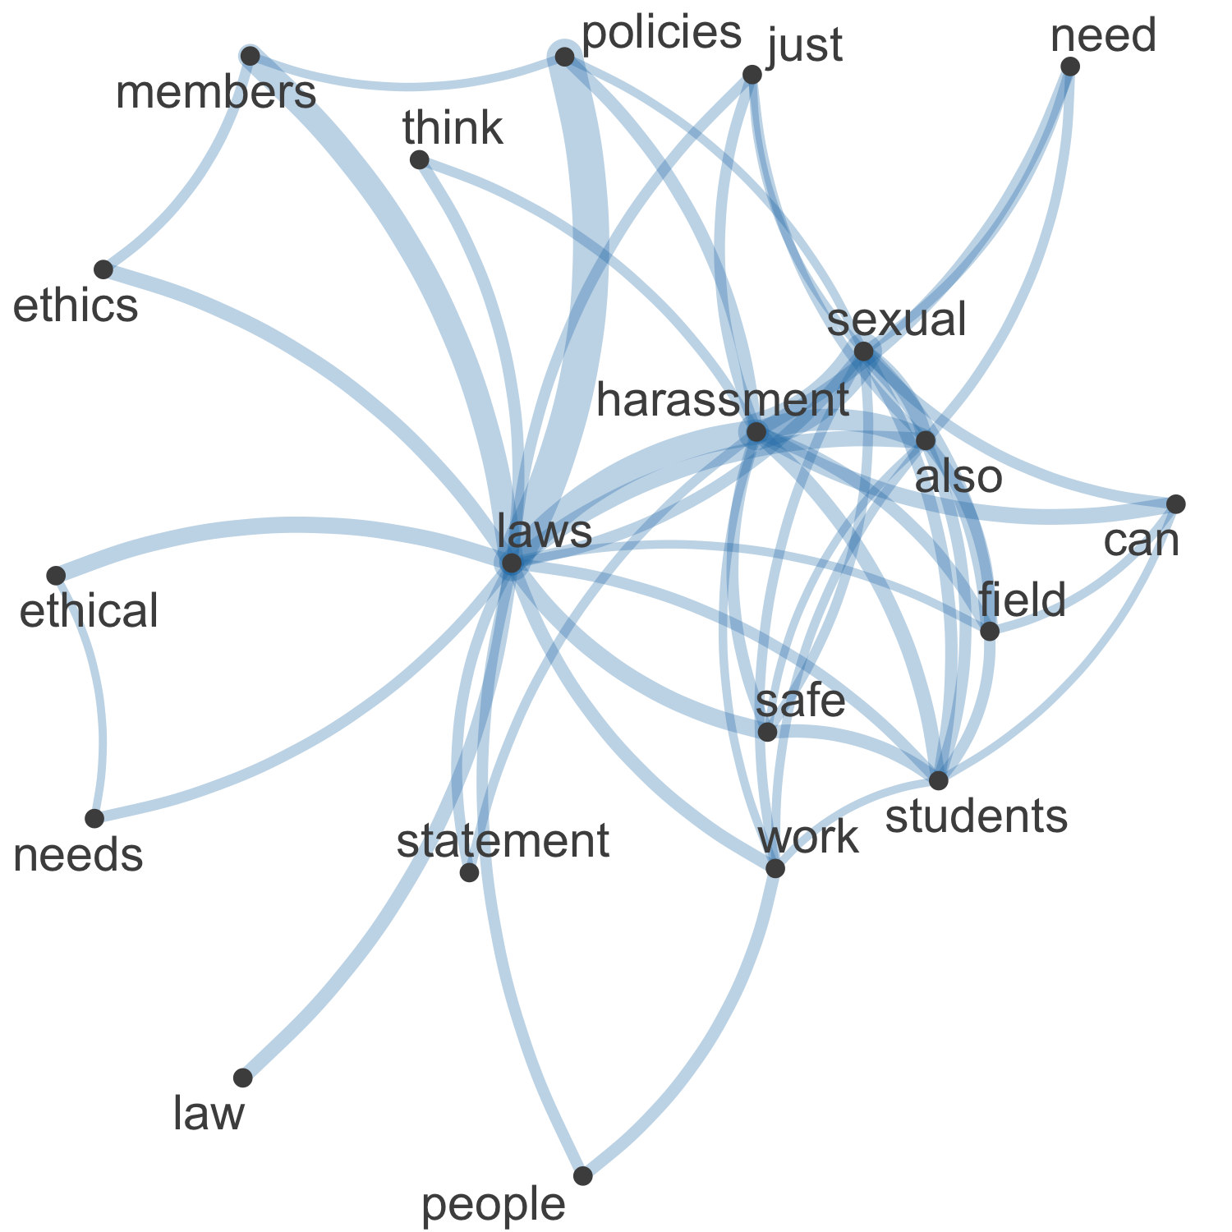

Figure 26. Network plot of high frequency words and their relationships in the 329 free text responses about Principle 9

In the network visualisation of the 329 text responses in the “Please elaborate here:” field for the question about Principle 9 (Safe Educational and Workplace Environments) we see that central concepts in the responses are “laws”, “sexual”, and “harassment” (Figure 26). We also see “ethics” and “ethical” here, indicating these policies about safe educational and workplace environments are perceived as a core ethical duty for the Society.

Commonalities

An large amount of the 329 responses to this question were concerned with the tag “sexual harassment”.

Contrasts

There were several tags in this section that were rarely seen together such as “sexual harassment” and “collegality” or “power dynamics”. One rare example of these tags appearing together can be found in this comment:

“Safe environment for students, trainees, employees, and colleagues" It’s very important that this is not framed only as a student issue.”

Comparisons

The tags that were often addressed in the same replies were “physical safety” and “sexual harassment”. Most of the 329 responses that mentioned these themes were about how to protect people from being harassed in the field or in a different country where the rules on sexual harassment might not be as stringent. One respondant showcasing this wrote:

“fieldwork is an easy place for predators to search for prey”.

Relationships

A notable relationship in responses relates to events of the 2019 SAA meeting, and the perception that the SAA has not taken a clear side on the matter of sexual harassment, and harassment continues to happen. Concern about lack of enforcement is evident in the 329 responses to this question. One response in particular enlightens this situation claiming that the SAA:

“actively foster an environment which not only enables harassment but re-victimizes survivors.”

Most of the responses that mentioned sexual harassment wanted the SAA to have a clear structure on how they are planning to enforce sexual harassers.

Sentiment

There was a mixed reaction to strengthening the policies on workplace safety with some responses urging for a stronger statement and other respondents claiming that it is not the SAA’s responsibility to enforce the law. Some responses claim that the SAA has no jurisdiction in enforcing sexual harassment when it is law enforcements obligation to handle these cases.

“Ethics principles are meant to cover domains that are beyond the law so this is a redundant principle”

“has next to no real power to keep sexual predators out”

There also seems to be a strong desire for clarification how to enforce these policies in areas where there are limited or different laws and protections against harassment. Many archaeologists research abroad in places where the local law may differ from US laws about sexual harassment:

“laws and policies of the country/workplace of origin but those of the country/institution in which the work is conducted”

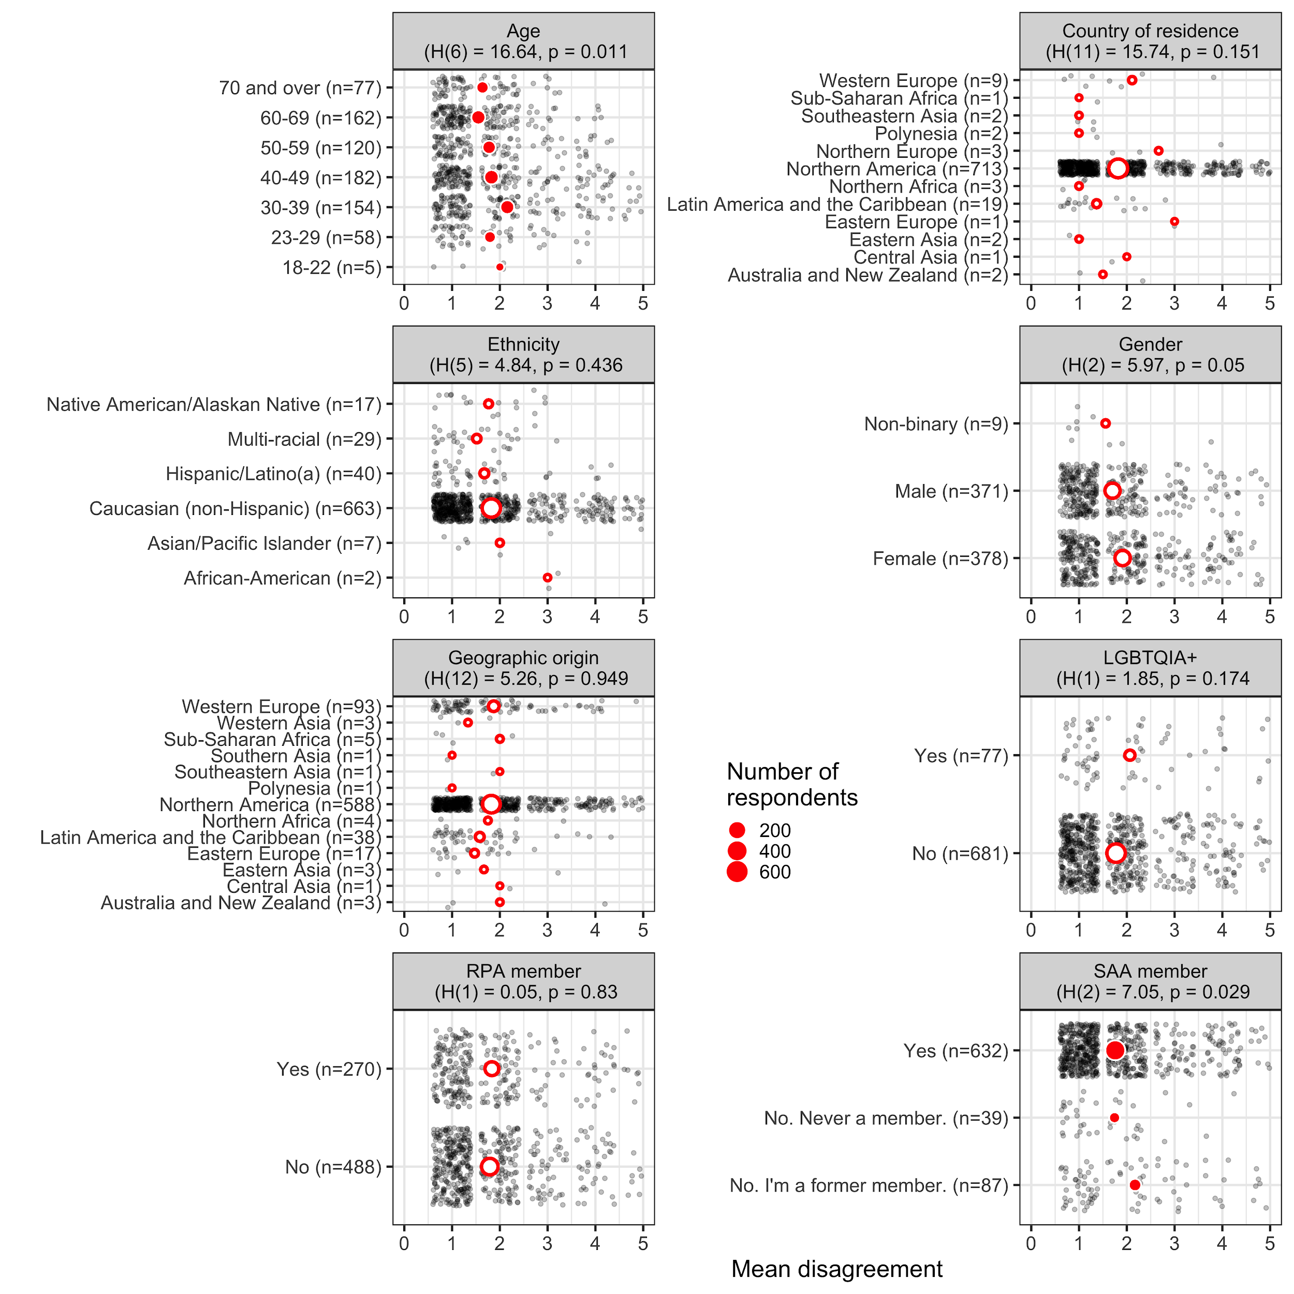

Figure 27. Plots of mean disagreement by demographic category for the 1058 Likert-scale responses about Principle 9

In the demographic plots of mean disagreement for Principle 9 (Safe Educational and Workplace Environments) we see significant differences among different age groups (Figure 27). Generally, older people agree more that “this principle and its description adequately applies to archaeological practice and its ethical challenges today”. Former SAA members disagree more than current members and respondents who were ‘never a member’. This hints at a causal connection between dissatisfaction between perceived safety in educational and workplace settings and SAA membership: people who experience unsafe situations leave the Society.

### Latent Factors in the Likert Responses about the Nine Principles

A factor analysis generates a model of the measurement of one or more latent variables. This latent variable cannot be directly measured with a single variable (e.g. intelligence, social anxiety, soil health). Instead, it is seen through the relationships it causes in a set of outcome variables. We focus on the Likert-type responses for all of the nine Principles and ask what latent variables might collectively underlie how people responded to the individual Principles. We investigate how many latent variables best explain the patterns in these responses, and what these latent variables are.

We assume that there are at least some correlations among the variables so that coherent factors can be identified. There should be some degree of collinearity among the variables but not an extreme degree or singularity among the variables. The Kaiser, Meyer, Olkin (KMO) measure of sampling adequacy suggests that our data seem appropriate for factor analysis (KMO = 0.93), and Bartlett's test of sphericity suggests that there is sufficient significant correlation in the data for factor analysis (Chisq(36) = 4060.92, p < .001). These tests indicate that our matrix is significantly different from an identity matrix.

We explore the structure in the data using a hierarchical cluster analysis where distances are calculated using polychoric correlation. This is a correlation method for ordinal responses such as likert-type data where we don't know the exact distances between each measurement unit. For example, is the difference between "Strongly Agree" and "Agree" the same is the difference between "Disagree" and "Strongly Disagree"? Are these distances the same for each person? With likert-type data it is we cannot be sure, so we use polychoric correlation. A graphical display of a correlation matrix indicates that all responses are positively correlated with each other to varying degrees (Figure 28). The questions are ordered in this plot using a hierarchical cluster analysis, and the largest three clusters are indicated by a thick black square grouping together correlated questions.

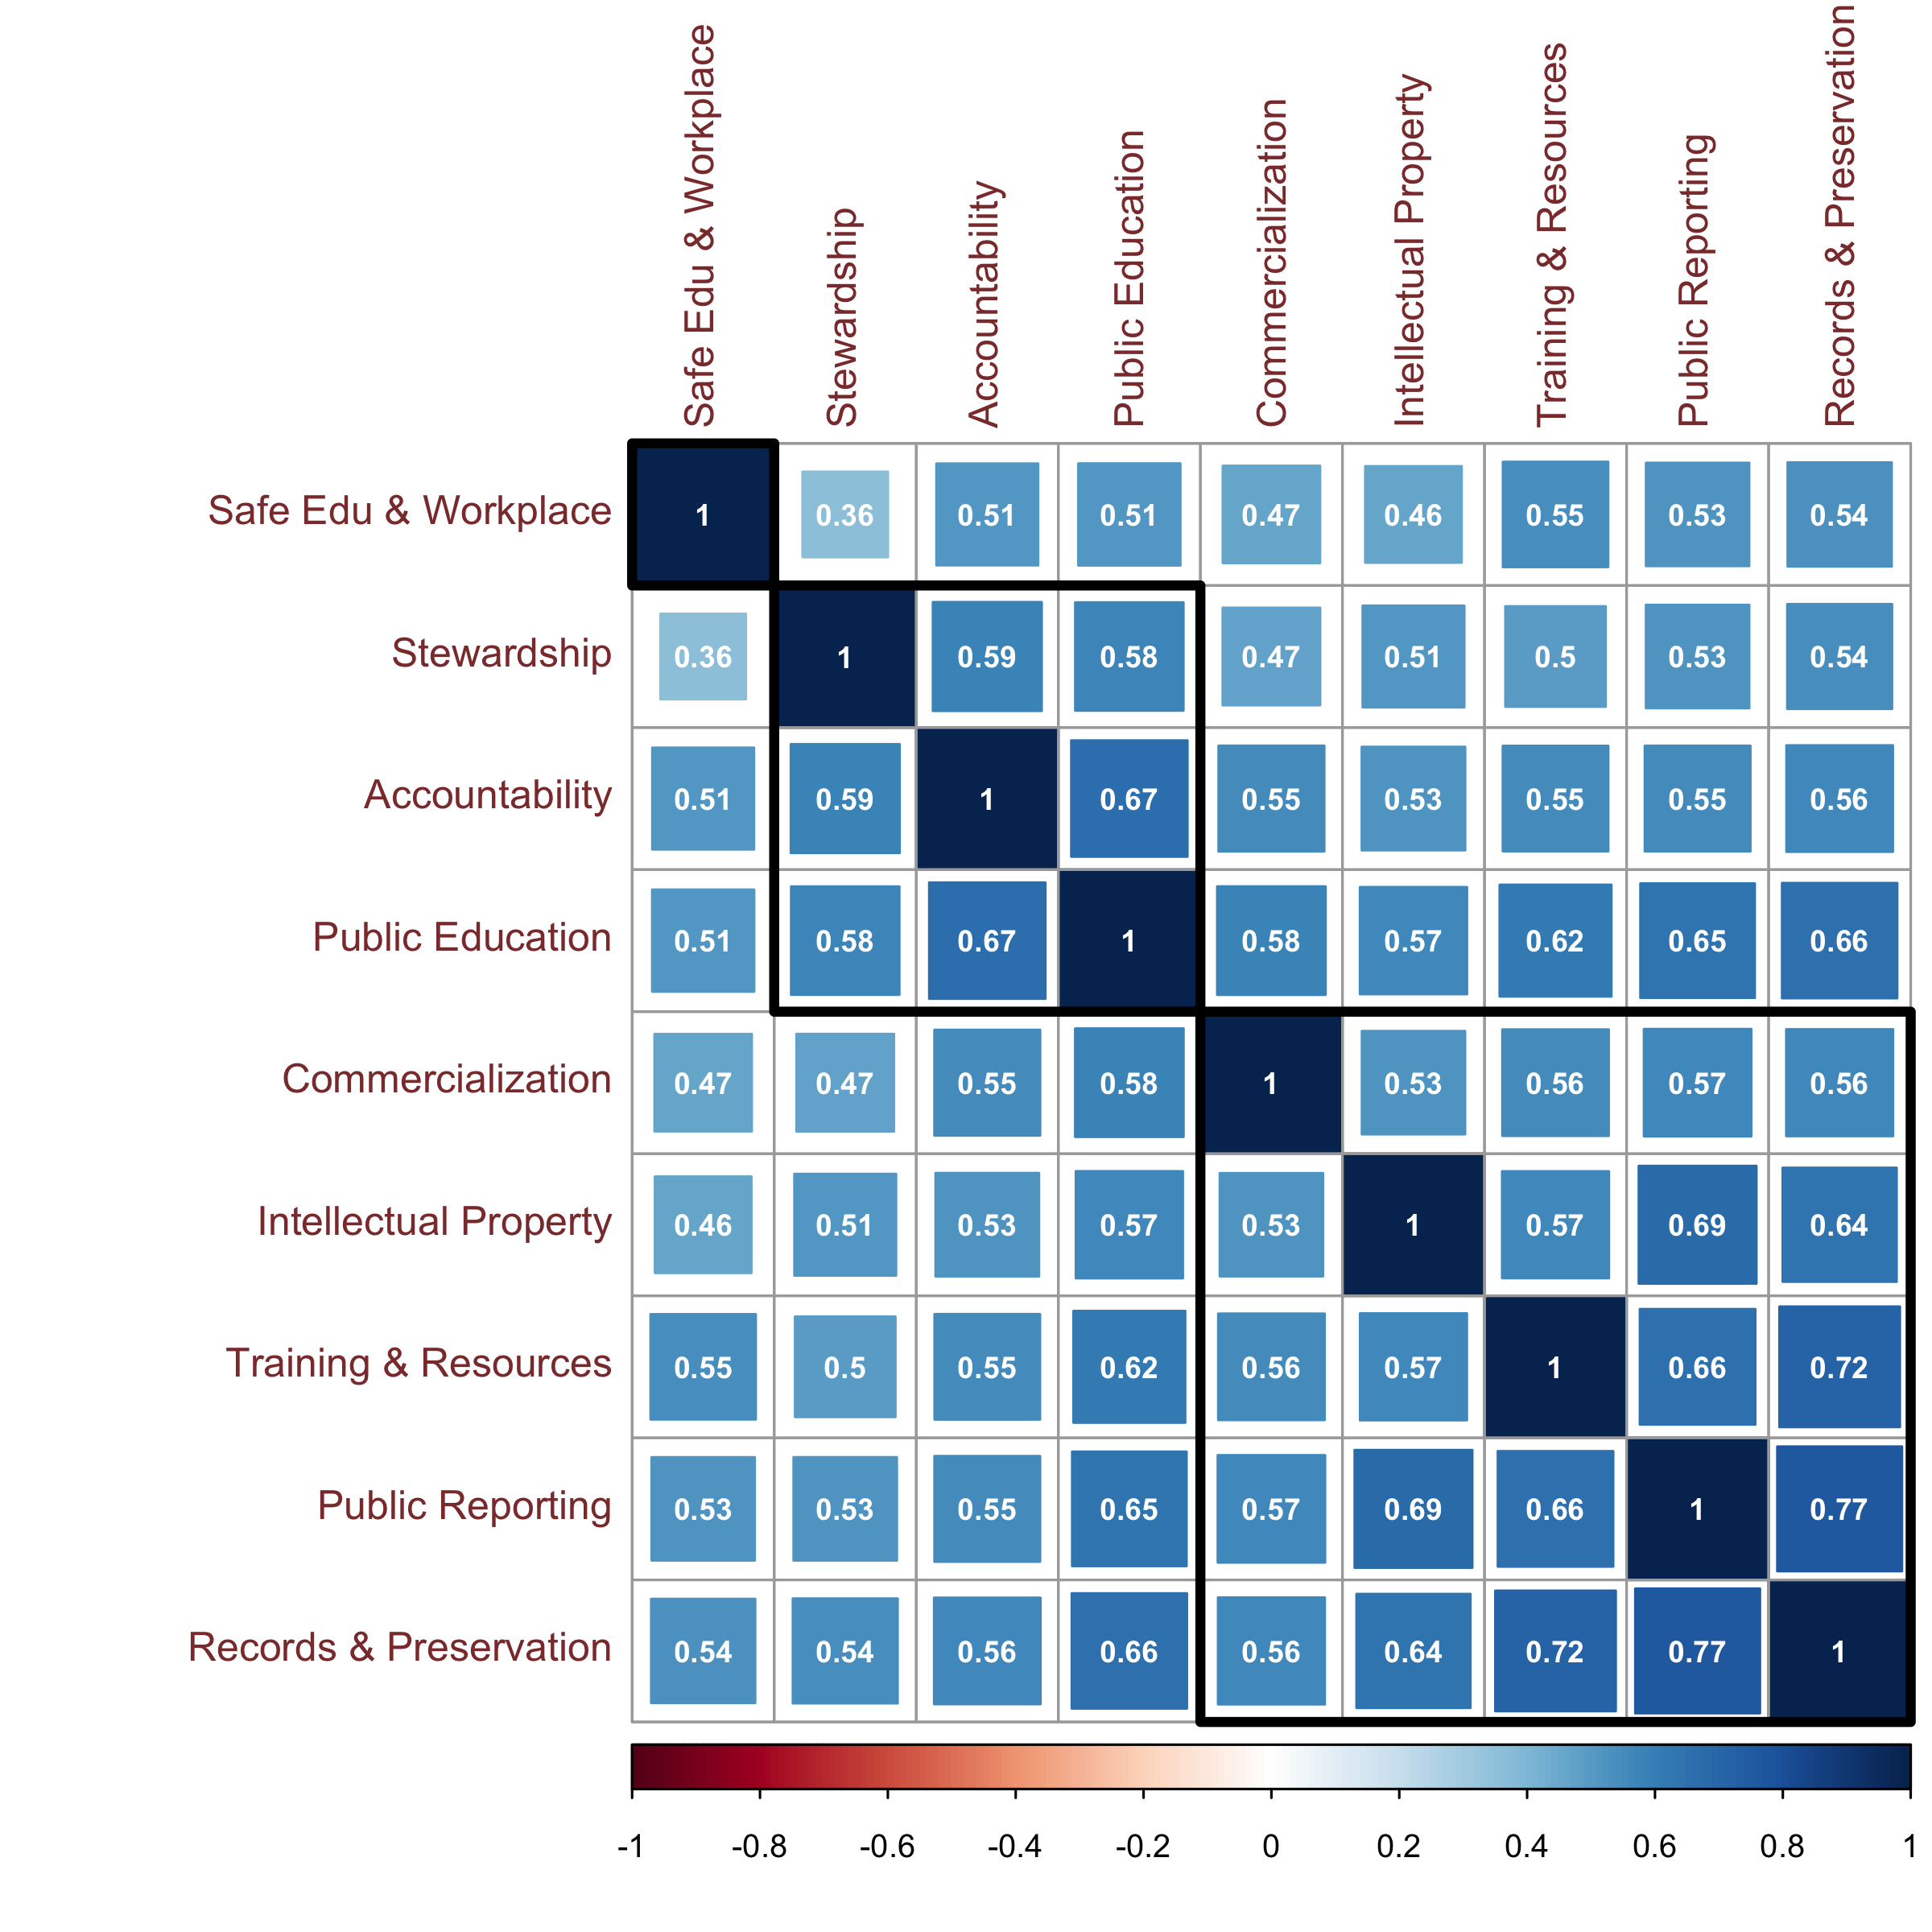

Figure 28. Graphical display of a correlation matrix of Likert-type responses to the nine Principles

We can see a more detailed view of how responses to the questions cluster in this dendrogram (Figure 29). Using the polychoric correlation values, we compute an Item Cluster Analysis [(Revelle 1978)](https://www.zotero.org/google-docs/?ZQGvUi). Alpha, the mean split half correlation, and beta, the worst split half correlation, are estimates of the reliability and general factor saturation of the test.

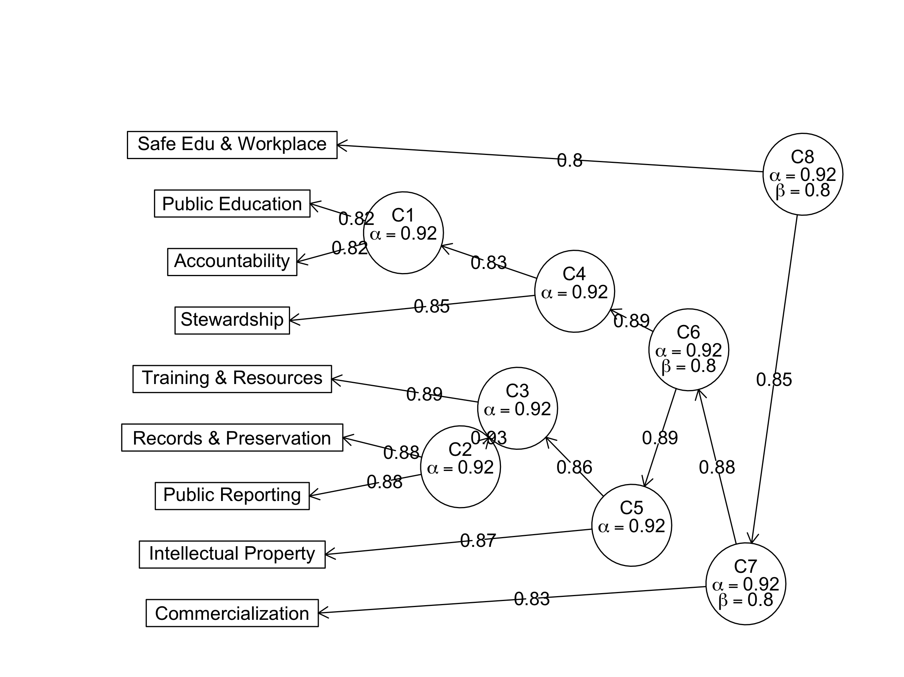

Figure 29. Dendrogram showing Item Cluster Analysis results of Likert-type responses to the nine Principles

These cluster visualisations suggest several possible numbers of clusters that might represent the latent variables. To determine the optimum number of latent factors we use Confirmatory Factor Analysis (CFA), which bridges factor analysis with Structural Equation Modelling (SEM), to evaluate several models of our data using different numbers of latent factors. We fit Confirmatory Factor Analysis models for one to five latent factors, and compared these five models using several metrics, including chi-square, Root Mean Square Error of Approximation, AIC, Bayes Factors, and several others. As a heuristic for ranking these five models we normalized all indices (i.e. rescaling them to a range from 0 to 1), and took the mean value of all indices for each model. This process indicated that the model with two latent factors was the best performing model.

Latent variable exploratory factor analysis using two factors produces a model where the two factors account for 61.47% of the total variance of the original data. In the figure below the plot on the left (A) shows a path diagram representation (Figure 30). The square boxes are the observed variables, and the ovals are the unobserved, latent factors. The straight arrows are the loadings, the correlation between the latent factor and the observed variable(s). This helps us to identify which item belongs in which factor, and the strength of its contribution. Factor loadings above 0.50 can be classified as practically significant. We can see that for MR1, the first latent factor, the highest contribution comes from responses to the Principles about ‘public reporting’ and ‘records preservation’. However, ‘safe workplace and ‘commercialization’ are only minimally correlated with this latent factor. For the second latent factor we see ‘accountability’ makes the strongest contribution, with lesser contributions from ‘public education’ and ‘stewardship’.

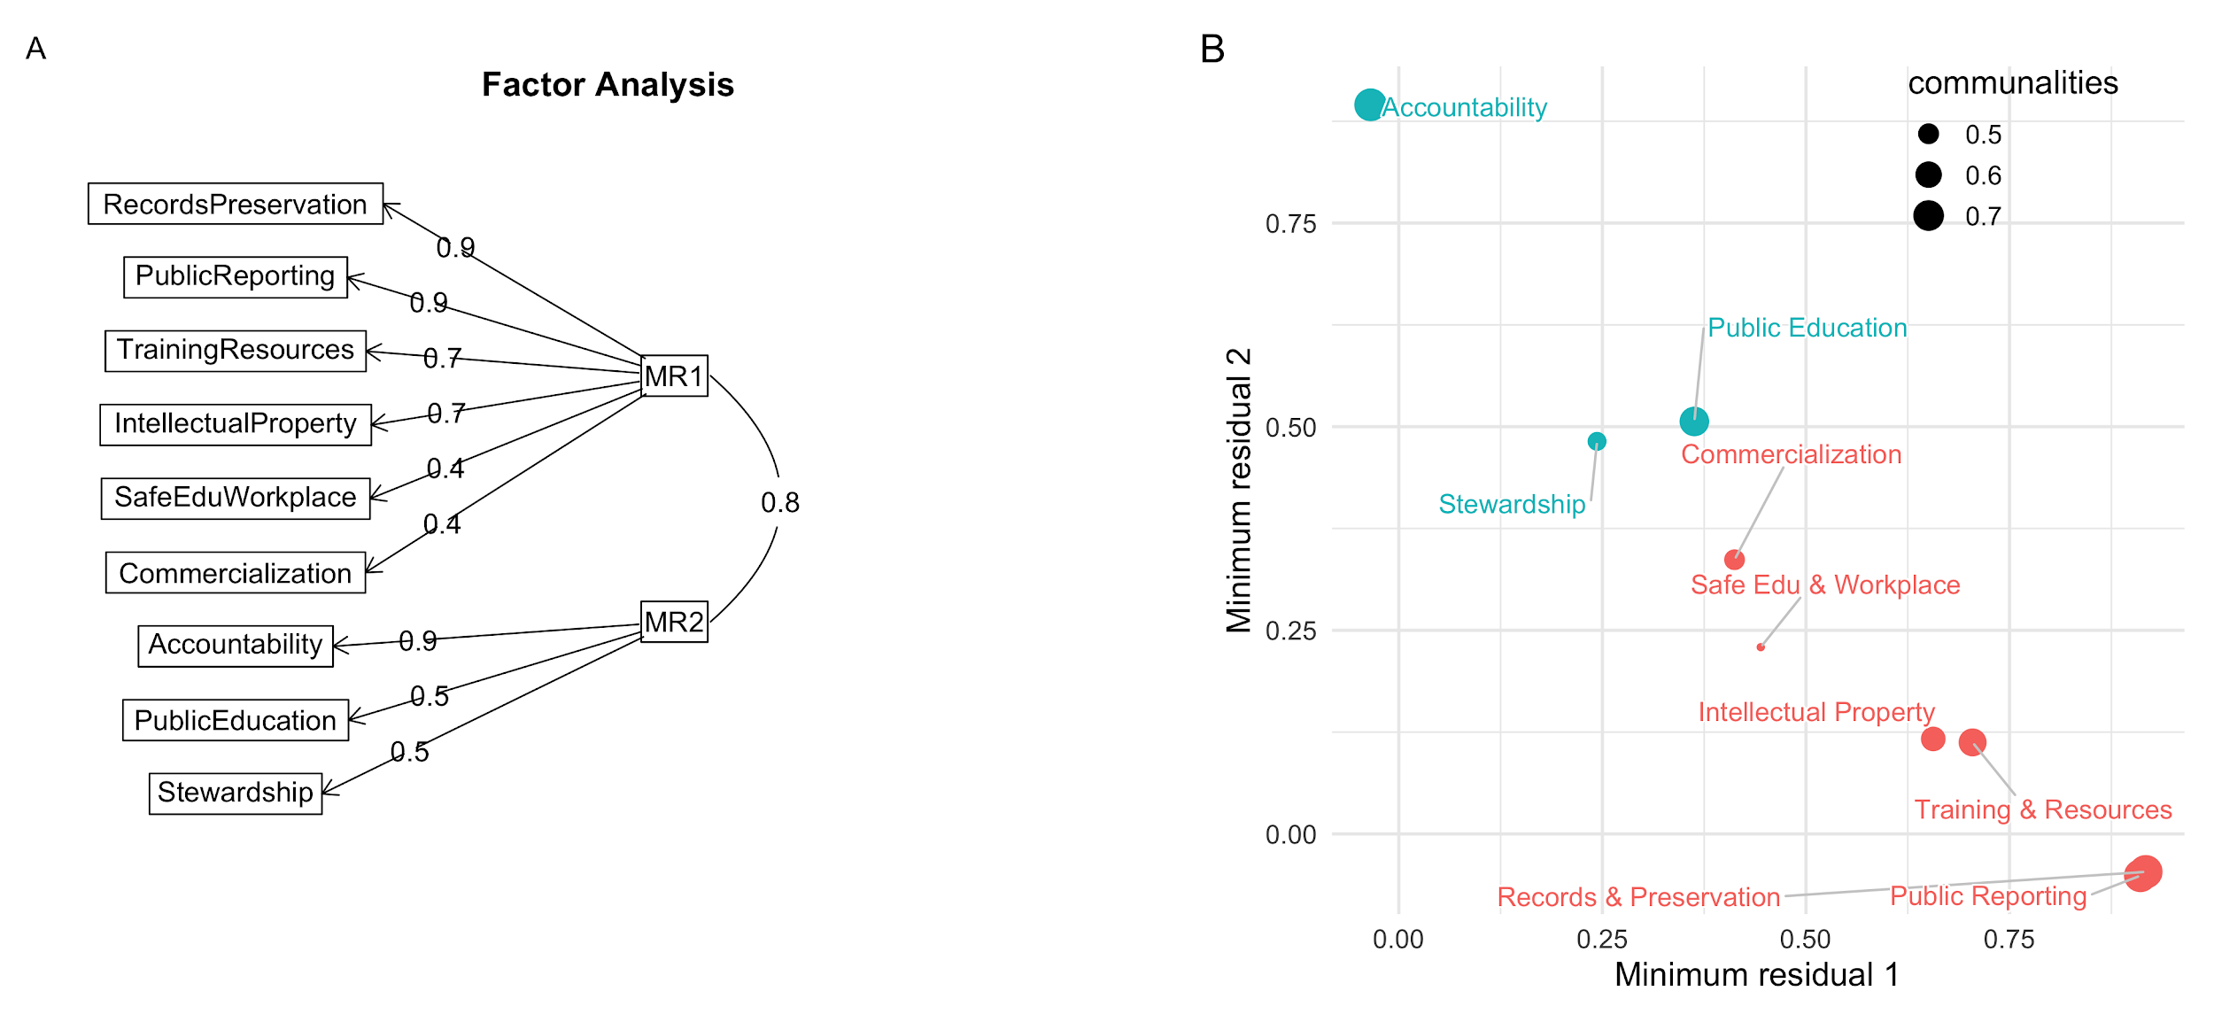

Figure 30. (A) Path diagram representation of latent factors, (B) scatterplot of the nine Principles organised by their contribution to the two latent factors.

We can interpret these two latent factors as representing concerns about community interactions and access to resources (MR1), and concerns about social and public responsibility and duty (MR2). This suggests two broad groups among the respondents, those that value intrinsic relationships, for example between archaeologists, and between archaeologists and the archaeological record (MR1), and those that value extrinsic relationships (MR2), for example between archaeologists and the public, Indigenous and descendent communities, and other groups that are not mostly composed of archaeologists.

## Questions about how the current Principles of Ethics address situations and concerns

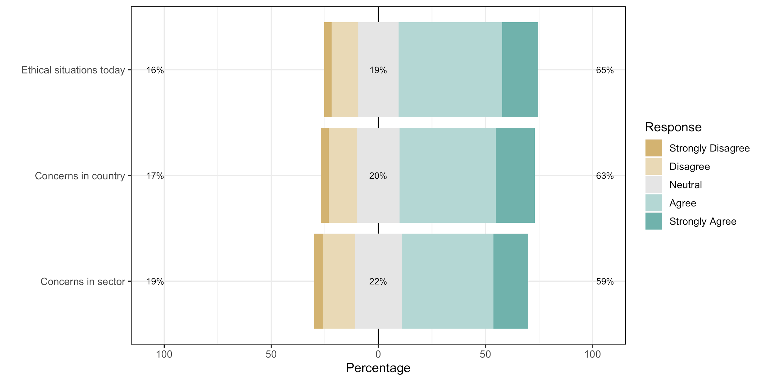

Figure 31. Summary of the Likert-type responses for questions about how the Principles address situations and concerns. Each question received a total of 1047 responses.

|  |  |  |  |  |  |  |
| --- | --- | --- | --- | --- | --- | --- |
| **Question** | **Strongly Agree** | **Agree** | **Neutral** | **Disagree** | **Strongly Disagree** | **Total** |
| Concerns in country | 191 | 470 | 207 | 139 | 40 | 1047 |
| Concerns in sector | 170 | 448 | 228 | 158 | 43 | 1047 |
| Ethical situations today | 175 | 507 | 197 | 130 | 38 | 1047 |

Table 2. Counts of responses to each Likert-type scale response anchors for the three questions about concerns and situations.

For these three questions about situations and concerns we see much higher levels of dissatisfaction (16-19%, Figure 31) compared to the individual Principles (5-12%).

Measurement of the average disagreement with the three statements about concerns and situations by each work setting group shows significant variation across three groups. Respondents in the 30-39 year old age category were more likely to disagree, especially relative to the 60-69 year old age group. Women and non-binary people were more likely to disagree than men. Respondents identifying with the LGBTQIA+ community were more likely to disagree than others.

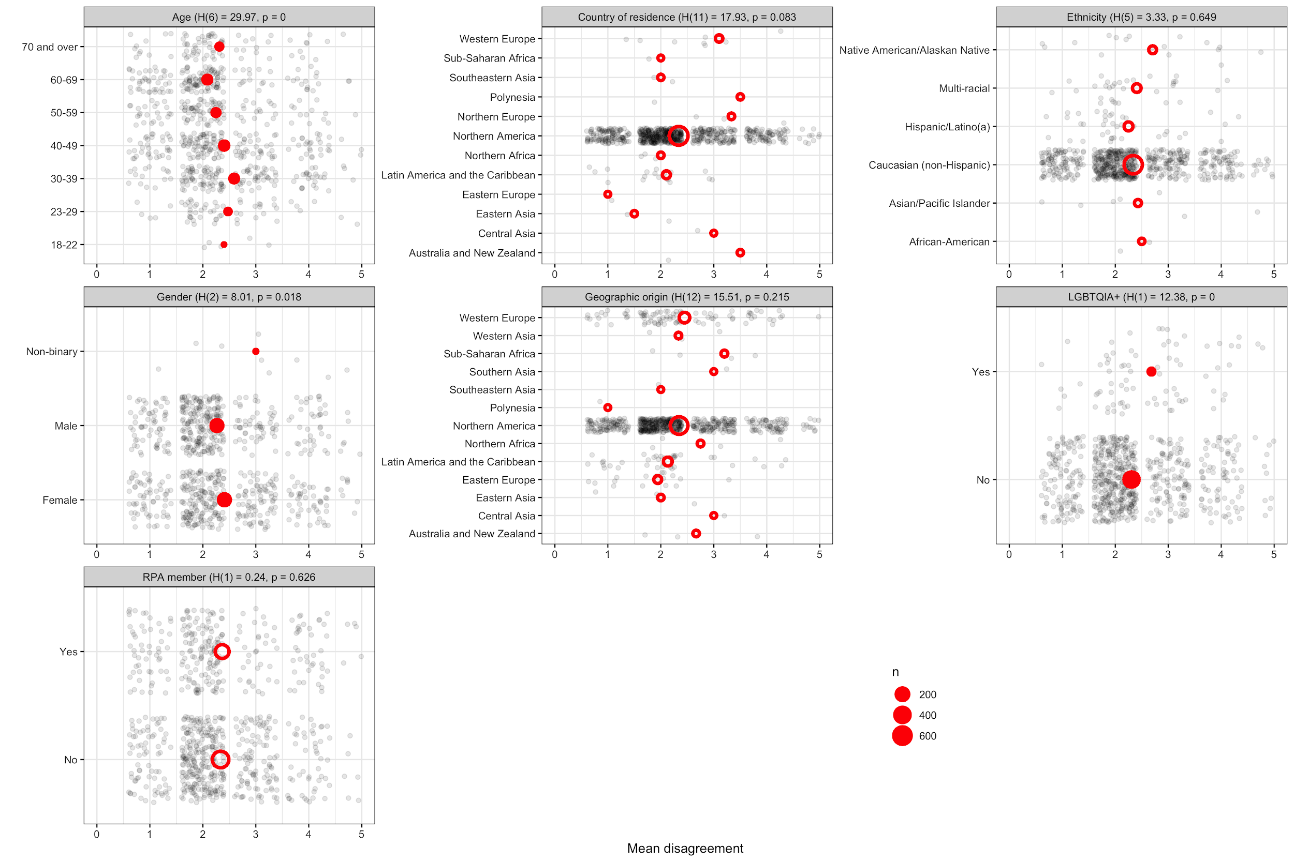

Figure 32. Plots of mean disagreement by demographic category for the 1047Likert-scale responses to `As a whole, the SAA Principles of Ethics satisfactorily addresses the ethical situations archaeologists find themselves in today.`

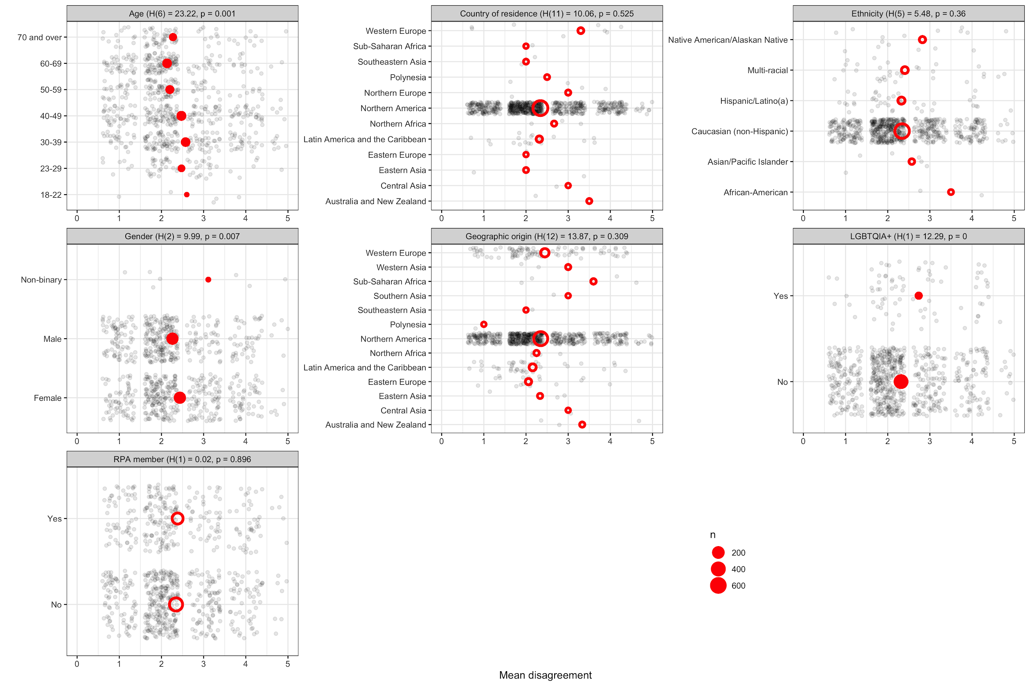

Figure 33. Plots of mean disagreement by demographic category for the 1047 Likert-scale responses to `The SAA Principles of Ethics adequately addresses ethical concerns in the country in which I work, am a student, or teach.`

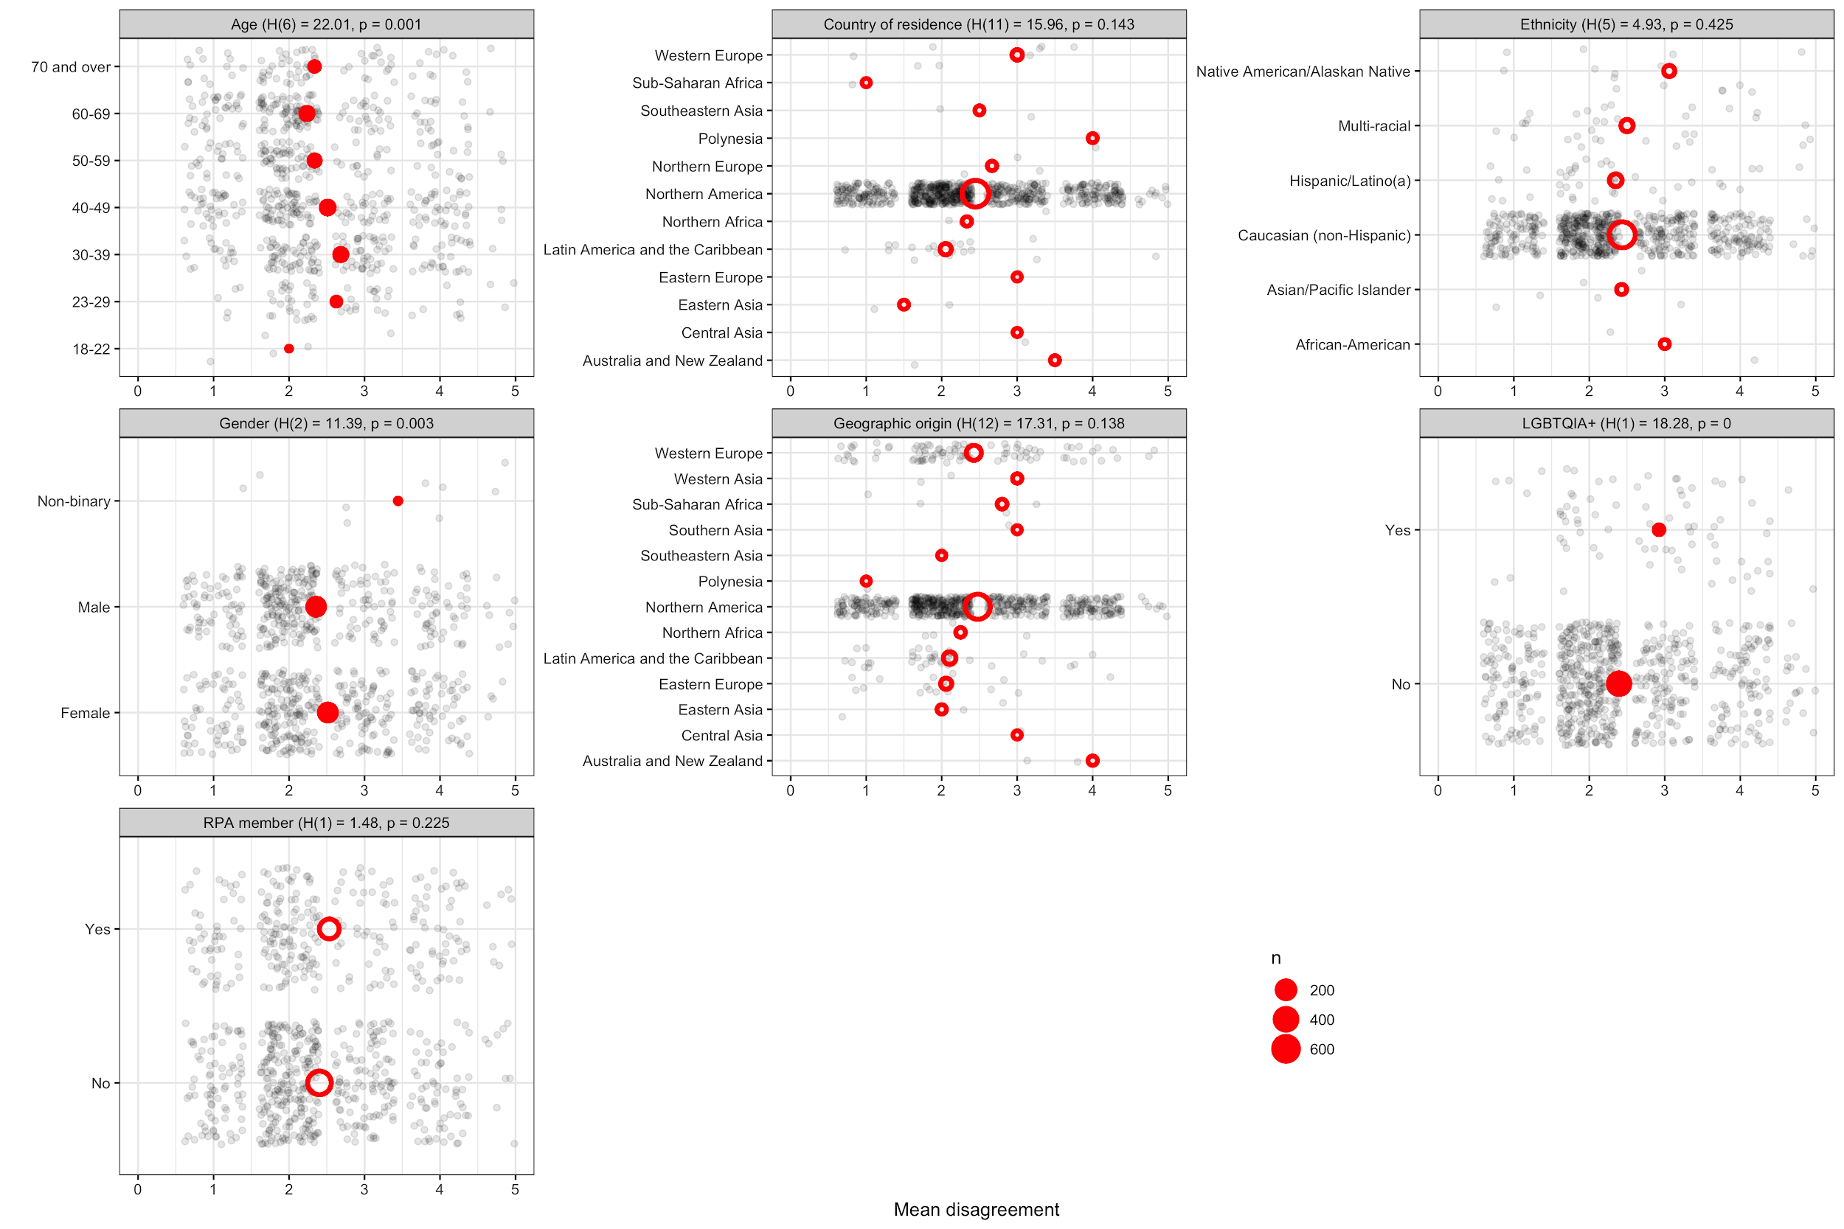

Figure 34. Plots of mean disagreement by demographic category for the 1047 Likert-scale responses to `The SAA Principles of Ethics adequately addresses ethical concerns in sector in which I work.`

There was little variation by workplace in disagreement with these statements. For the question about ‘addressing situations’ we see that respondents in the CRM are slightly more satisfied with how the Principles address ethical situations, compared to archaeologists in academia, government and elsewhere.

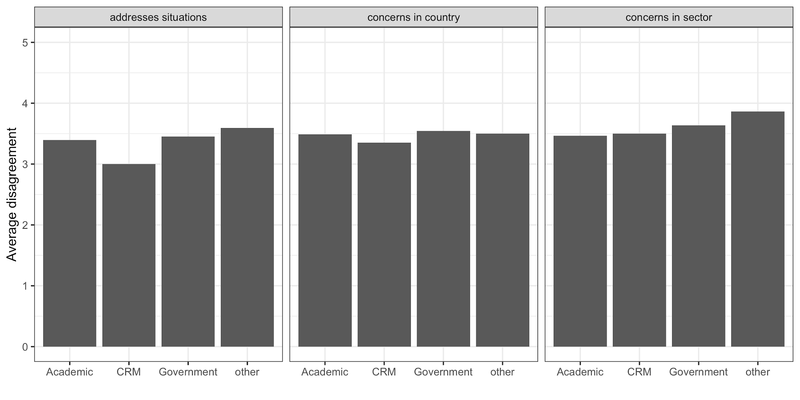

Figure 35. Plots of mean disagreement by work setting for the Likert-scale responses to the three question about addressing situations and concerns.`

### Q: As a whole, the SAA Principles of Ethics satisfactorily addresses the ethical situations archaeologists find themselves in today (323 text responses)

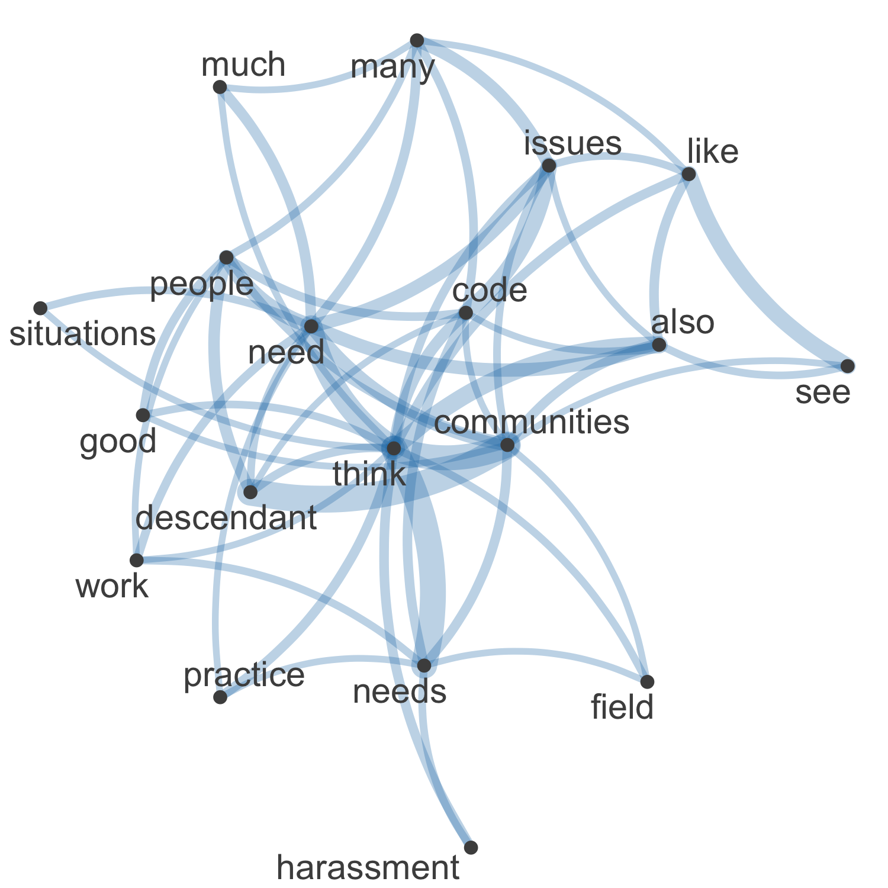

Figure 36. Network plot of high frequency words and their relationships in the 323 free text responses about addressing ethical situations

In the network visualisation of the 323 text responses in the “Please elaborate here:” field for the question about ‘satisfactorily addresses the ethical situations’ we see that central concepts in the responses are “descendant”, “communities”, and “think” (Figure 36). We also see “needs” and “people” here, indicating these policies about the social dimension and personal interactions of archaeology are foremost in the minds of the respondents here.

Commonalities

The most commonly used tags in the 323 responses to this question are “enforcement,” “indigenous,” and “relevance.” A main concern of the majority of the 323 respondents is the lack of enforcement and repercussions regarding the Principles of Ethics. The following response explains the need for stronger enforcement:

“It is rare to hear of repercussions for people who violate codes of ethics in any field. While having these topics outlined is nice, the next time there is a violator of the SAA’s code of ethics, there needs to be a stronger show of support from the organization for whichever party is victim [sic] and a hard-lined response to the violator. These words mean nothing if there is no follow through.”

Another primary concern of the 323 respondents to this question is the rights of indigenous communities. Many respondents specifically requested stronger statements from the SAA on working with indigenous groups. The following is an example of such a response:

“The Principles of Ethics need stronger statements on Indigenous rights in relation to archaeological knowledge and resources, and stronger guidelines on developing and maintaining equitable relationships with Indigenous communities.”

Many of the 323 respondents to this question noted that the principles needed updating and revision. One respondent noted:

“I think the SAA Principles of Ethics should adapt and be capable of adapting to contemporary circumstances. They should incorporate a flexibility to respond to changing technologies and social conventions.”

Contrasts

The majority of the 323 respondents to this question were in favor of working in an inclusive and collaborative manner with indigenous communities. However, several respondents fear this will lead to the loss of archaeological data. The following is an example of such a response:

“There doesn’t seem to be anything about protecting the archaeological record and data for research. What ethical principles prevent Native Americans as part of the archaeological community from disposing of archaeological data in the name of religious significance or anti-intellectual attitude?”

Comparisons

The tags “enforcement” and “relevance” are commonly paired together. Many of the respondents who want stronger enforcement of the principles, often also think they should be updated. One respondent explained:

“The basis of the code of ethics is a great place to start however I feel like the updates that need to happen are relevant to our modern-day issues and as much as these ethics cover our bases we should also not be afraid of having stronger language to guide our members towards a much more productive and inclusive future.”

Relationships

There is a cause and effect relationship between the tags “enforcement” and “sexual harassment.” When discussing sexual harassment, respondents to this question often cite lack of repurcussions as a major concern. One respondent stated:

“While the principles address the situations, SAA as an organization has shown a lack of abiding by these principles. Particularly as they apply to sexual harassment.”

The following is another example of a respondent’s views on the lack of enforcement and how it pertains to sexual harassment in the archaeologial community:

“There is a major difference between a code of ethics and actually putting things into practice. Maybe now that the additional language about sexual harassment is in here SAA will bother to take it at least semi-seriously.”

Sentiment

The majority of the 323 responses to this question can be categorized into two groups: satisfied with the Principles of Ethics as they currently stand, and satisfied with the basis of the Principles, but in favor of revision. The following is a response from a survey taker who falls into the first category:

“I think the principles are great, we just need to apply them more fully.”

The following response is from a survey respondent in favor of revising the Principles:

“Some are pretty good and still adequately address our current situation. However, others, particularly those that deal with harassment and our relationship to the resources and descendant peoples, do not go far enough. Archaeology MUST be a more equitable and fair practice, and the SAA MUST take a leading stance on these issues. We have to be better than this. If we continue with these aspirational guidelines, then we must develop a code of conduct, hold people accountable to it, and remove people from membership if they violate the code.”

### Q: The SAA Principles of Ethics adequately addresses ethical concerns in the country in which I work, am a student, or teach (197 text responses)

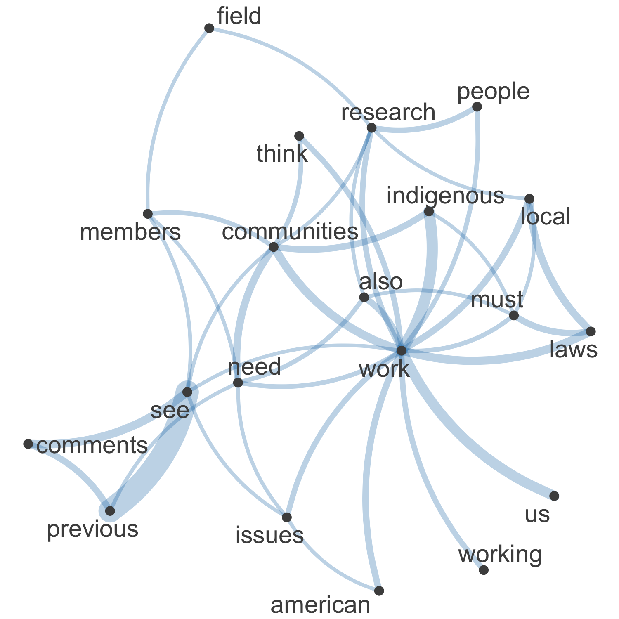

Figure 37. Network plot of high frequency words and their relationships in the 197 free text responses about addressing ethical concerns in country

In the network visualisation of the 197 text responses in the “Please elaborate here:” field for the question about ‘adequately addresses ethical concerns in the country’ we see that central concepts in the responses are “work”, “indigenous”, and “communities” (Figure 37). We also see “local” and “laws” here, demonstrating the importance of adhering to local ethical and legal standards, as well as those specific to US settings. .

Commonalities

The most commonly occurring tag in the 197 responses to this question was ‘Indigenous’, followed by ‘’relevance’ and ‘enforcement’. Many comments reflected a desire for greater involvement of Indignous people in the archaeological process, for example

"I work in a country with a long history of oppression against the Indigenous population and a recent genocide. Archaeologists need to actually and actively reach out to descendant communities and work with them and archaeology should be undertaken for their benefit and through collaboration with them rather than just the standard positivist bullshit we are taught to believe in. Archaeology is not objective and the archaeological record does not belong to everyone equally."

Contrasts

Important contrasts in the responses to this question were between the standards and practices of archaeology in the US compared to other countries. For example:

"The ethical thinking reflected in the Principles best reflects US academic culture. Other countries have different ethical cultures and other concerns. Additionally, although I think CRM in the US derives from the Academy, different or only partially overlapping ethical concerns arise in it, and the principles though, on the whole, good, do not fully encompass ethics needed for a discipline mixing science and business."

Many of the 197 responses noted that different levels of access to the scholarly literature led to different ethical expectations, for example:

"Major economic disadvantages of developing nations affect ethical principles, yet these are rarely addressed. For example, colleagues in Africa, Latin America, and Asia cannot access our journals, because they cannot afford SAA membership."

A second area of contrasts was between administrative requirements relating to doing archaeology in various countries (e.g. permits, publication obligations, etc.) and socio-cultural dynamics of fieldwork (e.g. behavioural norms). For example, one respondent makes a detailed comparison of various permit requirements:

"I don't actually recall reading anything about compliance with local, state, federal, and international laws and regulations pertaining to permits, operations, safety, reporting of results...for example, there are a fair number of countries, at least in Europe, where there are very strict permitting, data collection, training, education, and reporting requirements. As a specific example, Austrian laws say that only an archaeologist who is registered with the federal government may lead archaeological activities in that country, that all data must be collected in a particular way and submitted using particular electronic formats, and that all final reports must be written in German. This code should let folks know they're on the hook for knowing those and complying."

Others discussed different norms about ethical behavior during archaeological field work:

"I run research excavations in the USA and abroad. Ethical concerns abroad are slightly different based on the local culture's perception of gender stereotypes and a perpetuation of a machismo (toxic-masculine) culture. Just because I am abroad doesn't make it acceptable. The principles needs to address this somehow"

"I have experienced and witnessed sexual harassment in the field, by other archaeologists, while under supervision, which is at a level that is considered "legal”, but seriously inhibited my ability to perform my job. Right now, this is not adequately considered by the ethics code."

Comparisons

Tags frequently co-occurring were Indigenous-collegiality, power dynamics-collegiality, power dynamics-Indigenous, and relevance-enforcement. At the nexus of these is a view from the 197 respondents to this question that archaeologists’ engagement with local, descendant and Indigenous communities should transition from consultation to collaboration, for example:

"- The Principles need to be backed up by the SAA (e.g. help archaeologists engage the public somehow)

- The Principle 9 misses the mark

- How can the Principles be complete if we don't acknowledge that we are a predominantly white scholastic body studying (most often) communities and people of color?

- Archaeologists should be nudged toward meaningful collaborations, not just "consultation." The law handles consultation in many cases, we need to strive to be better."

and

"Not much here about ethics for those who work in other countries. Respect for local laws, customs, and the necessity of collaborations with local archaeologists as equals could be included."

Another respondent noted that the Principles should transcend local laws, because these may be inadequate or unjust:

"It does not matter what country I work in. These principles must apply to me because I am a member of the SAA. They must be universal, and be better than "comply with local laws" because many times the law itself is unjust."

Relationships

Cause and effect relationships that we observed in the 197 responses to this question include the historical context of colonialism that most contemporary archaeology emerged from, and the variation in ethical practice between archaeologists working in their home country and other countries. For example, a link between the extractive quality of archaeological research and harms that have resulted from archaeology was noted by this respondent:

"I think it is a mistake that we do not acknowledge or name the extractive history of archaeology (and colonialism as a broader movement) anywhere in our principles. It would be appropriate to say "we must acknowledge the harms that have been inflicted in the process of building the field of American archaeology and commit to considering the role our work can have in contemporary peoples' lives"."

Similarly, the colonial origins of archaeology are recognised here as responsible for bad practices by archaeologists in countries other than the US:

"I agree to a certain extent, with provisions previously indicated. I conduct field and lab research in other countries beyond the US as well, so would like to see some broadening of the ethical statements to include responsible cooperation and collaboration with antiquities organizations, training opportunities for students or local residents in that country, etc. Too many still operate in a very colonialist mode, which should be discouraged."

Sentiment

Similar to other questions, a negative sentiment was prevalent throughout the 197 responses to this question. Specifically, frustration that the Principles were not detailed enough, did not aspire to a higher standard of practice, and did not have any consequences for violations. These three responses capture the range of sentiment (with the exception of one cryptic but passionate response to this question, which was simply "*Jesus fucking Christ*"):

"Again, no duty of care and no consequences. These are not standards, they are guidelines. There are a fair number of archaeologists who do a poor job of following them, or flagrantly disregard them. Since there is no mechanism for compliance, reporting, or enforcement, they are just nice suggestions. That is a legitimate way to approach things, but then the SAA can't pretend to be the voice and representative of responsible archaeology. For instance, why should I take seriously the SAA efforts to lobby the US Congress regarding cultural heritage when the organization can't hold its own members to account in terms of protecting the same resources, not working with looters or looted collections, etc.?"

"I do not think the principles go far enough to address the underlying power dynamics and imbalances in our field/society."

"too aspirational without addressing difficulties of implementation."

### Q: The SAA Principles of Ethics adequately addresses ethical concerns in sector in which I work (189 text responses)

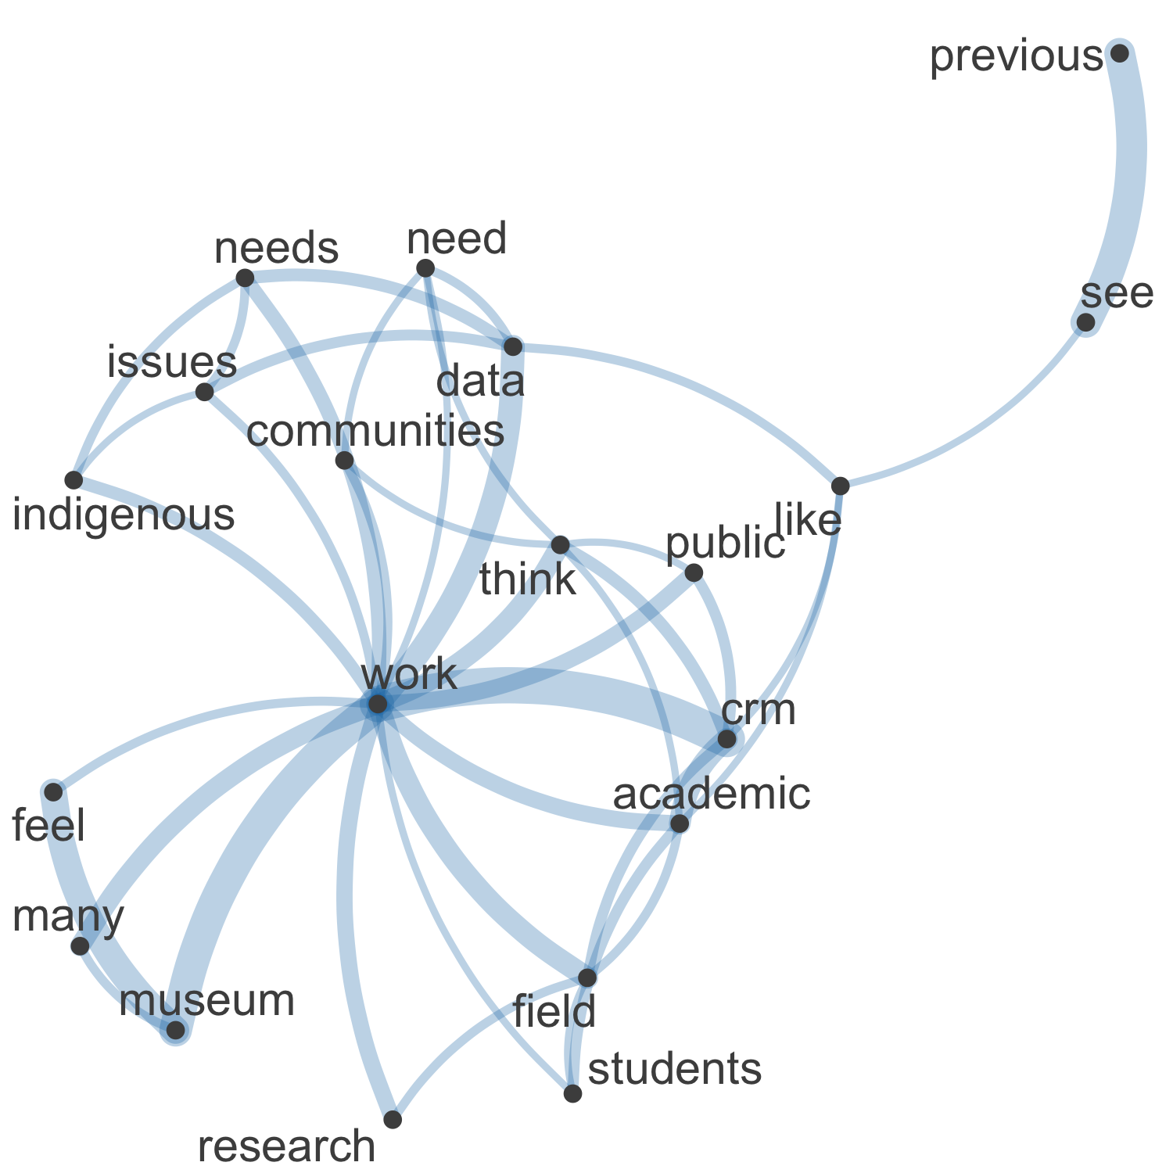

Figure 38. Network plot of high frequency words and their relationships in the 189 free text responses about addressing ethical concerns in sector

In the network visualisation of the 189 text responses in the “Please elaborate here:” field for the question about ‘adequately addresses ethical concerns in sector’ we see that central concepts in the responses are “work”, “CRM”, and “museum” (Figure 38). We also see “indigenous” and “communities” here, showing the centrality of collaboration with Indigenous groups across different work settings. Survey fatigue is evident in the high frequency that “see” and “previous” occur in responses here, indicating the respondents feel that they have reached redundancy in their input on this issue in this survey.

Commonalities

The most common tag across the 189 responses to this question was “Indigenous”. Many comments were concerned with Indigenous peoples rights and representation in archaeology and the archaeological process. Here are two typical examples:

“would like to see a much stronger focus on Indigenous concerns”

“I work in a part of the world with a horrible and violent history against the Indigenous population, and adequate ethics involves our obligations to the people we impact with our research.”

Contrasts

Although the majority of the 189 responses to this question that mention to Indigenous people were advocating for inclusion, there were some that had different opinions. Some respondents feel as if Indigenous people are an obstacle in the way of the pursuit of knowledge and the archaeological record.

“In California, Native Americans can dispose of archaeological data or make it impossible to conduct fieldwork and archaeologists have little say in the matter.”

Comparisons

There were rarely any tags that appeared together in this section of the ethics survey. Many responses were addressing one issue that they had particular opinions on how to change or improve that issue.

Relationships

A theme that came across the 189 responses to this question was the tag “Human Remains”, with all responses urging for representation of bioarchaeology and working with human remains in this section of the ethical document. The respondents wanted this section to address the concerns of working with human remains, especially under Indigenous circumstances, for example:

“SAA members to collaborate and consult with culturally affiliated descendant communities concerning various procedures with skeletal remains, funerary objects, sacred objects, and objects of cultural patrimony.”

Sentiment

The 189 respondents to this question had an overwhelmingly positive reaction to the tag “Open Science”. Many responses were expressing their interest in how to make open science practical for all archaeologists, and what the guidelines for Open Science should be. Here is a typical example:

“Privacy, normative commercial publishing, needs to better contextualize digital data, inclusive governance structures for digital data, and other topics need more attention and ethical guidance”

Although the responses were generally positive, many wanted a structure or set of standards on sharing data.

## Questions about the future of SAA’s documentation about ethics

### Q: What do you see as being the primary ethical concerns in the field today? (455 text responses)

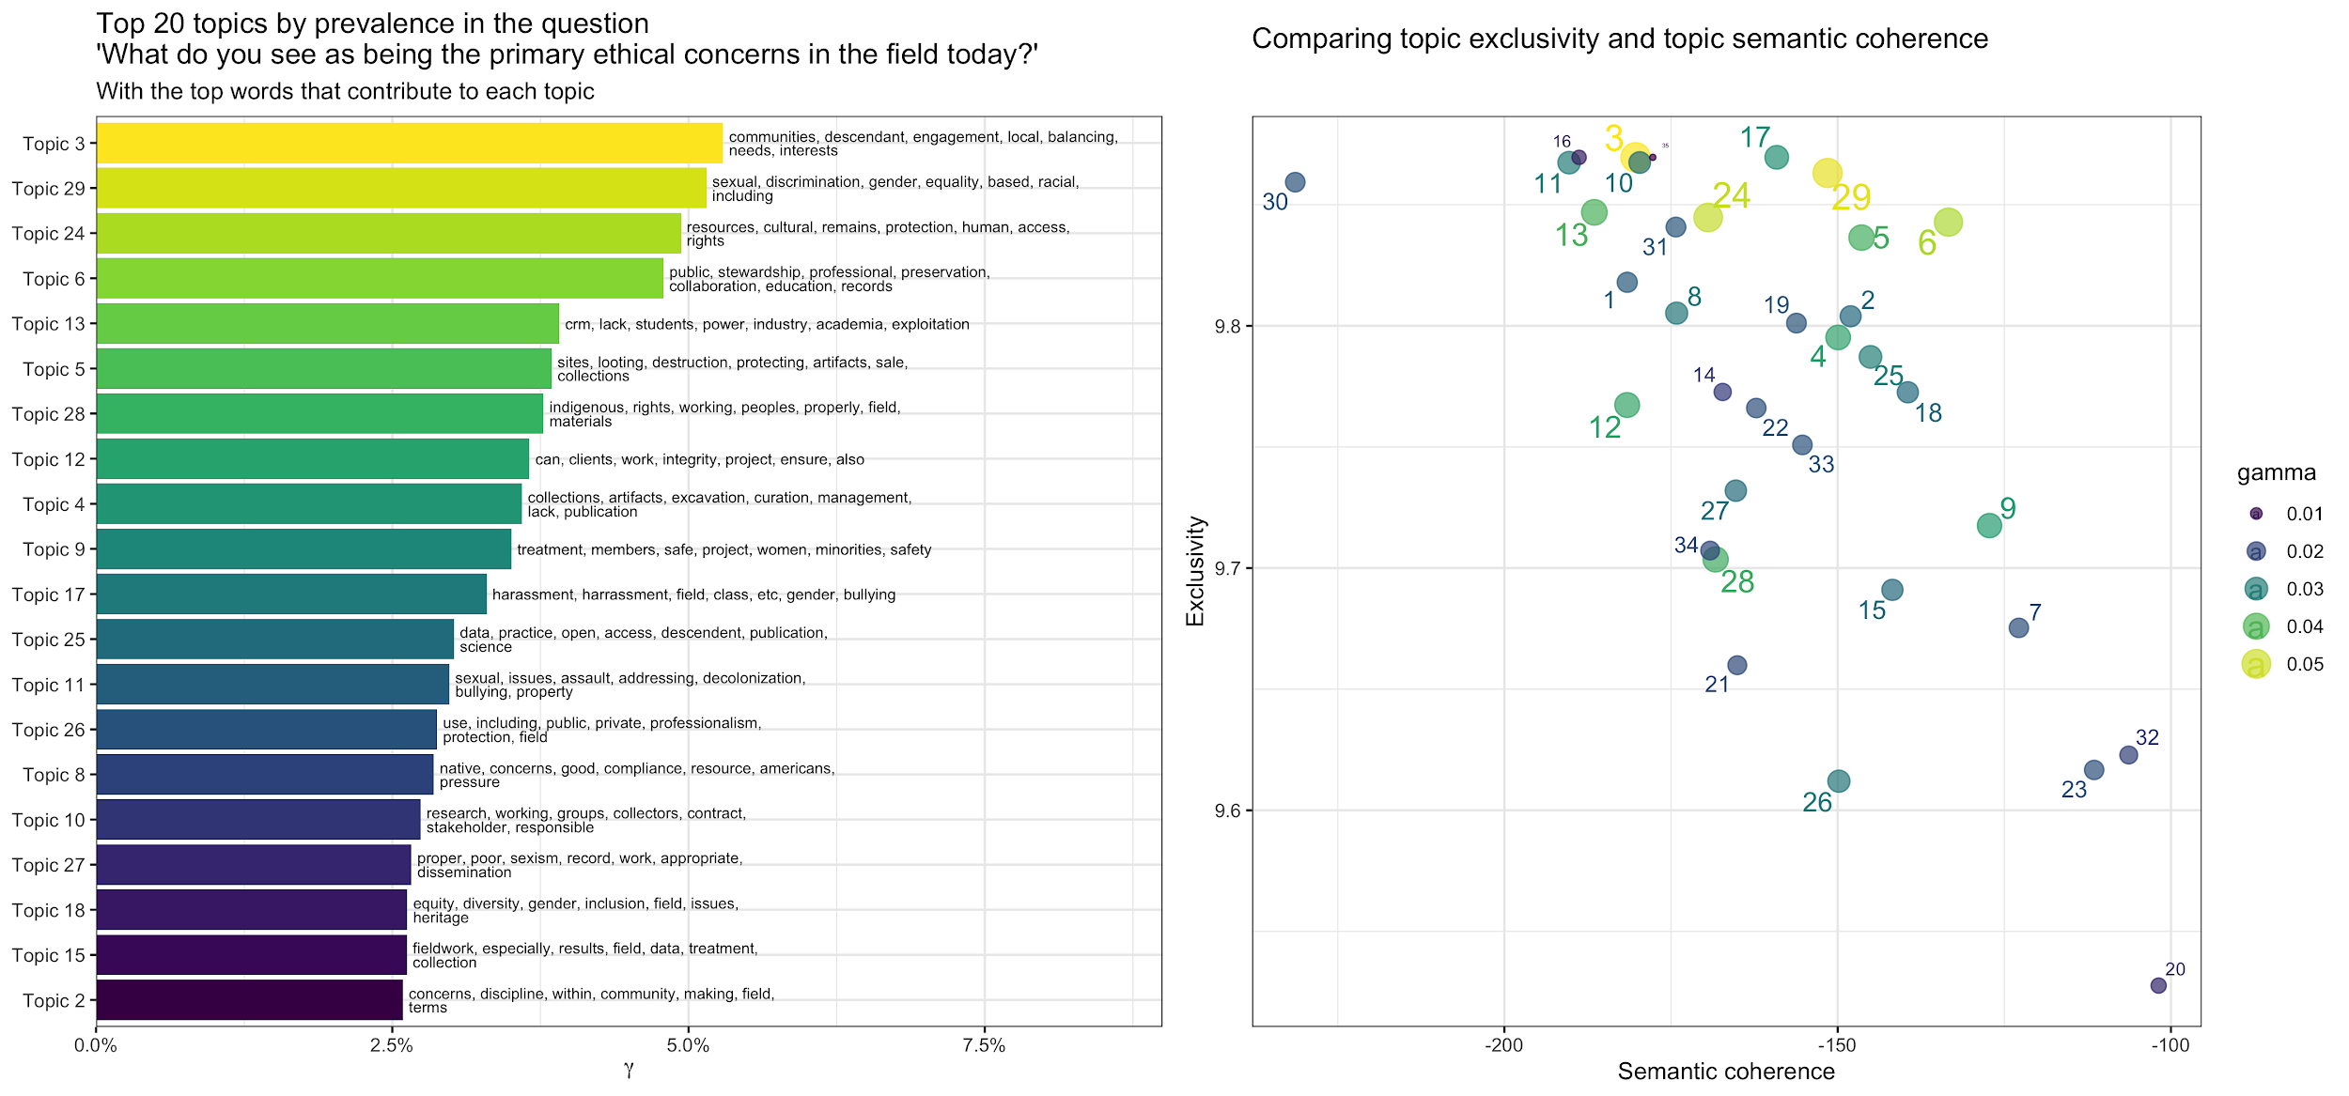

Figure 39. Left: The top 20 topics identified by machine learning, ranked by their prevalence in the text. Topics at the top are more common in the responses. Right: plot of topic exclusivity and semantic coherence. Topics in the upper right are more distinctive and interpretable.

This question was a free text response only, with 455 people responding. Topic modelling of the free text revealed 35 topics, the top 20 of these are shown in the figure above (Figure 39). Four topics stand out with higher gamma values, indicating that are more prominent in the responses than the other topics. In the left panel the length of the horizontal bar indicates the prominence of the topic among all responses, indicated by the gamma variable. The right panel shows some diagnostic attributes for each topic. Higher coherence and exclusivity correlates well with human judgments of high topic quality [(Mimno et al. 2011)](https://www.zotero.org/google-docs/?sKGVaL), so we focus our analysis on topics that appear in the upper and right areas of that plot.

We can take a closer look at some of the most prominent topics that also have high exclusivity and coherence values to see how the demographic variables of the respondents covary with the proportion of those topics in their responses. In the plots below we see the mean topic proportions for each group within each demographic category up for a given topic. Positive estimate values on the horizontal axis indicate a positive correlation between the covariate and the topic, and a red triangle point indicates a significant (e.g. non-random) relationship.

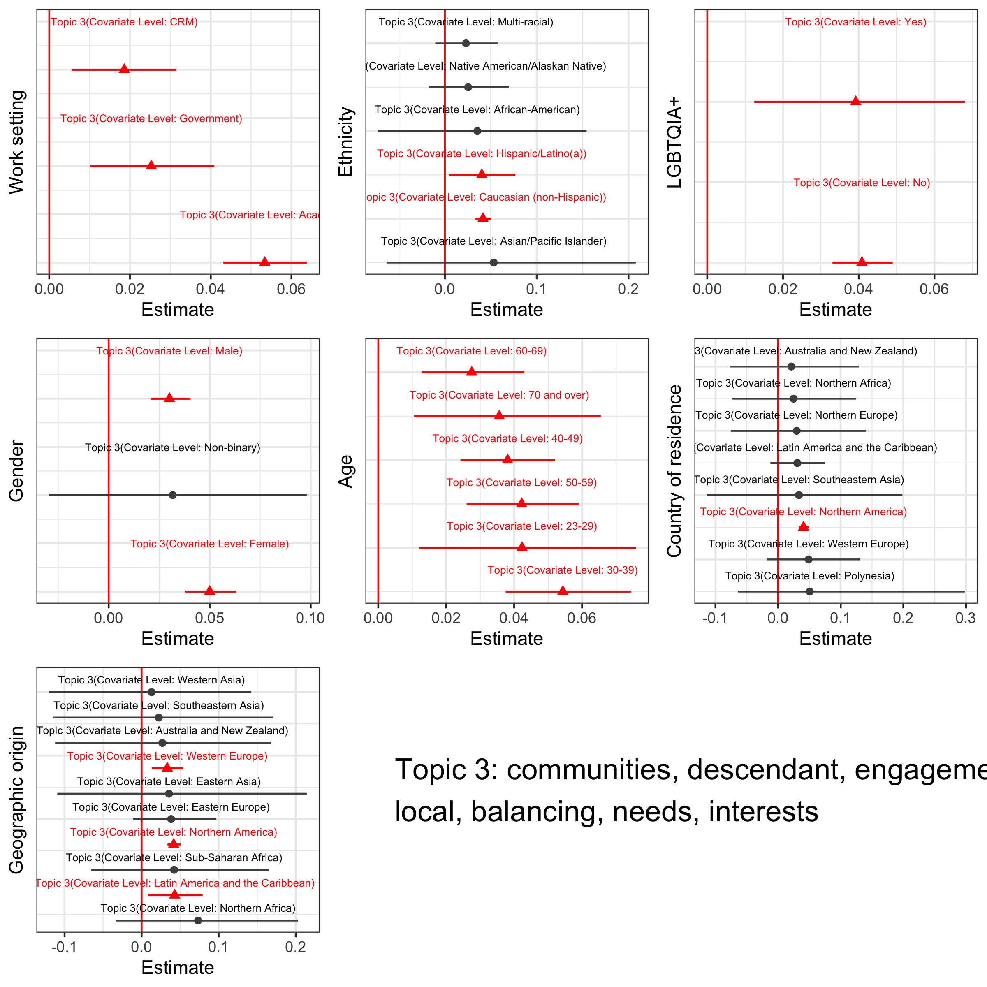

Figure 40. Effect of demographic variables as covariates on the prevalence of topic 3

For this topic about engaging with local and descendant communities, we see the strongest associations with respondents in all work settings, of Causasian and Hispanic ethnicities, male and female genders, all age groups, North Americans, Western Europeans and Latin Americans (Figure 40).

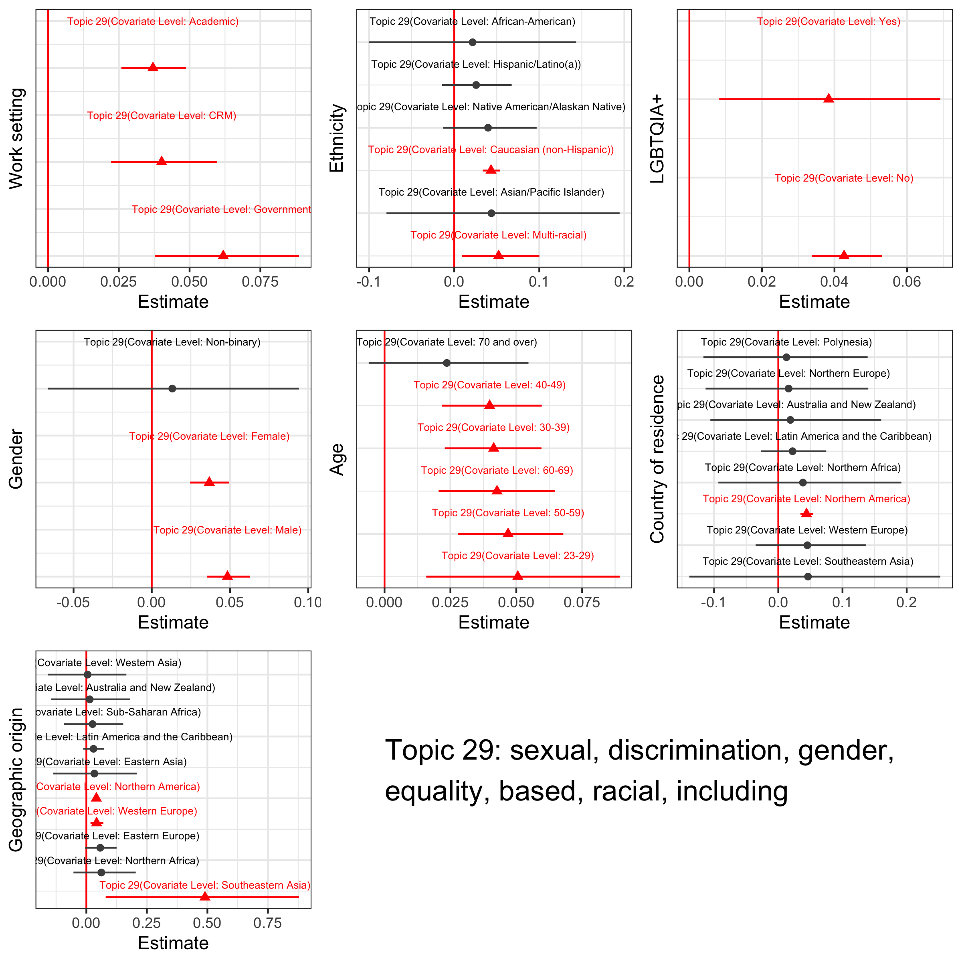

Figure 41. Effect of demographic variables as covariates on the prevalence of topic 29

For this topic about sexual and racial discrimination and equality we see the strongest associations with respondents in all work settings, of Causasian and Multi-racial ethnicities, male and female genders, all age groups except those over 70, North Americans, Western Europeans, and Southeast Asians (Figure 41).

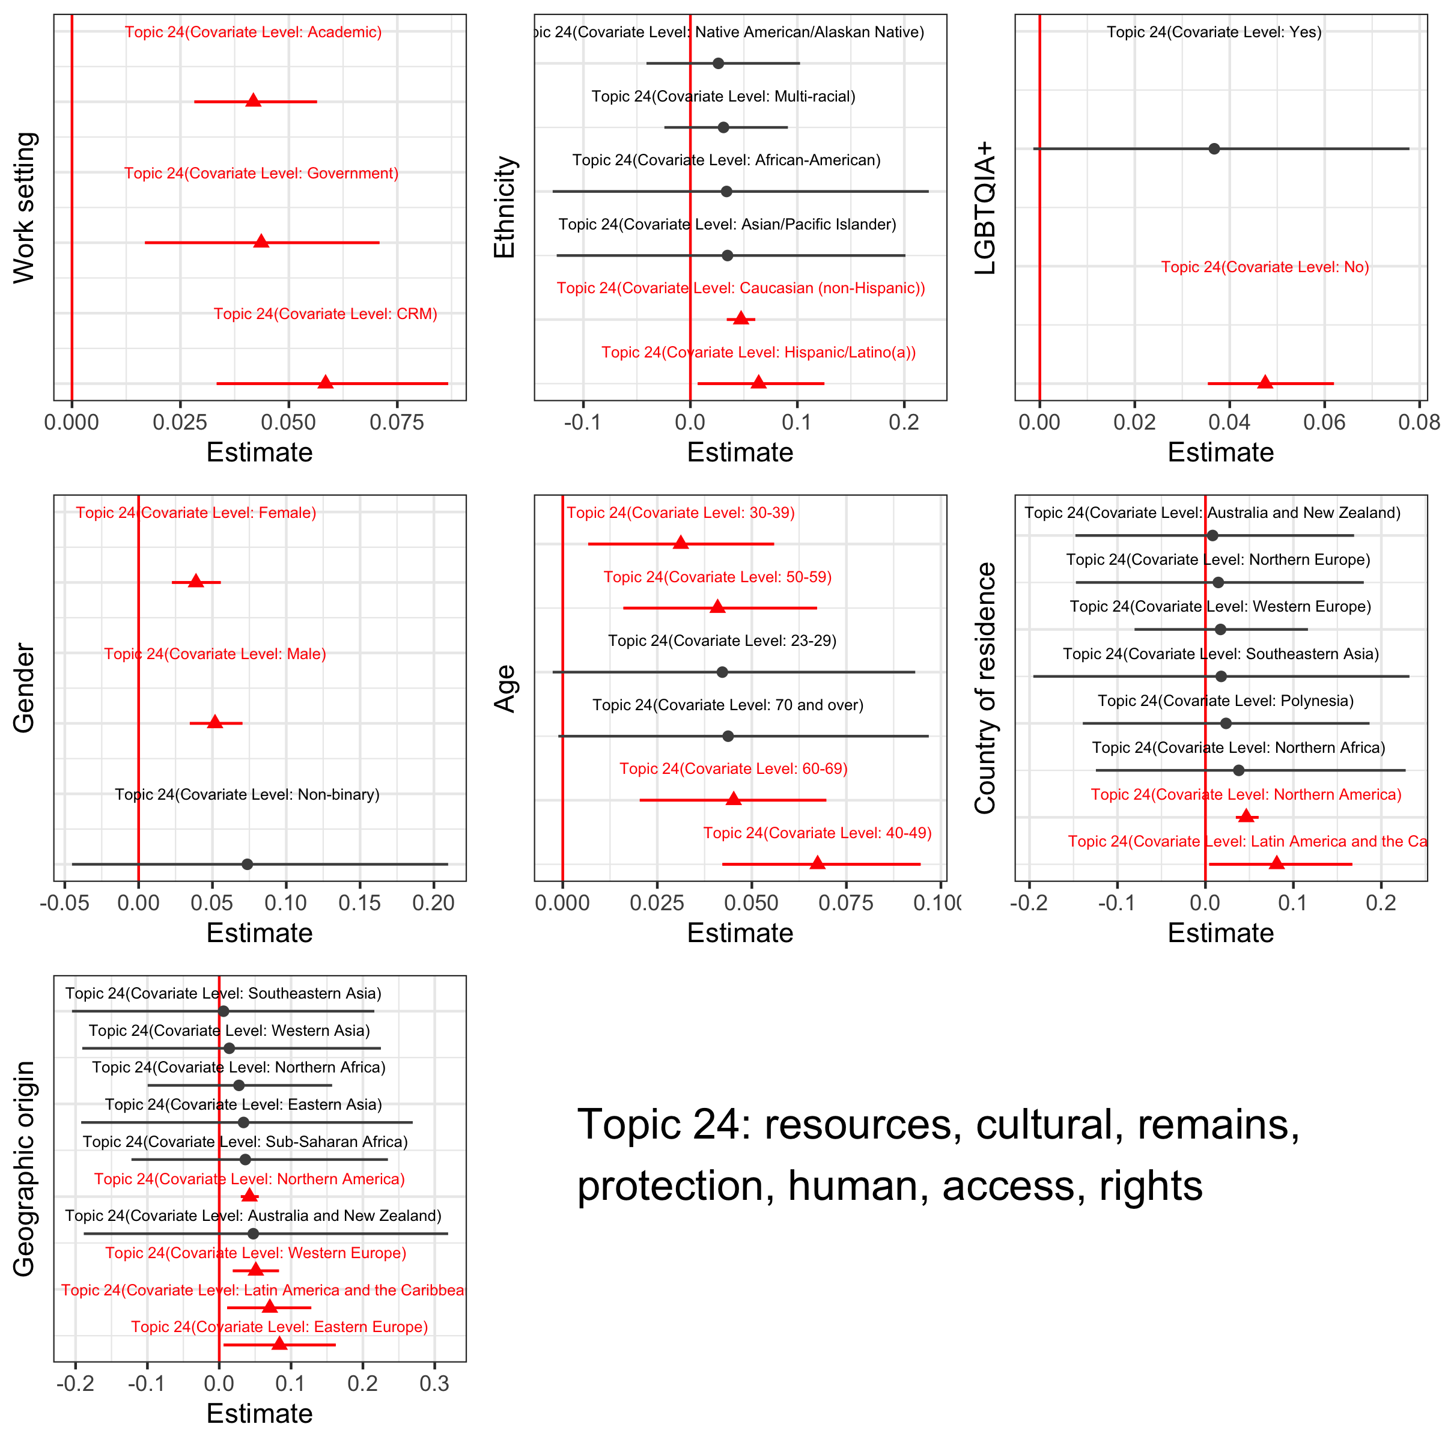

Figure 42. Effect of demographic variables as covariates on the prevalence of topic 24

For this topic about cultural resource access and protection, we see the strongest associations with respondents in all work settings, of Hispanic and Causasian ethnicities, not identifying with the LGBTQIA+ community, female and male gender, all age groups except the youngest and oldest, Latin and North Americans, and Europeans (Figure 42).

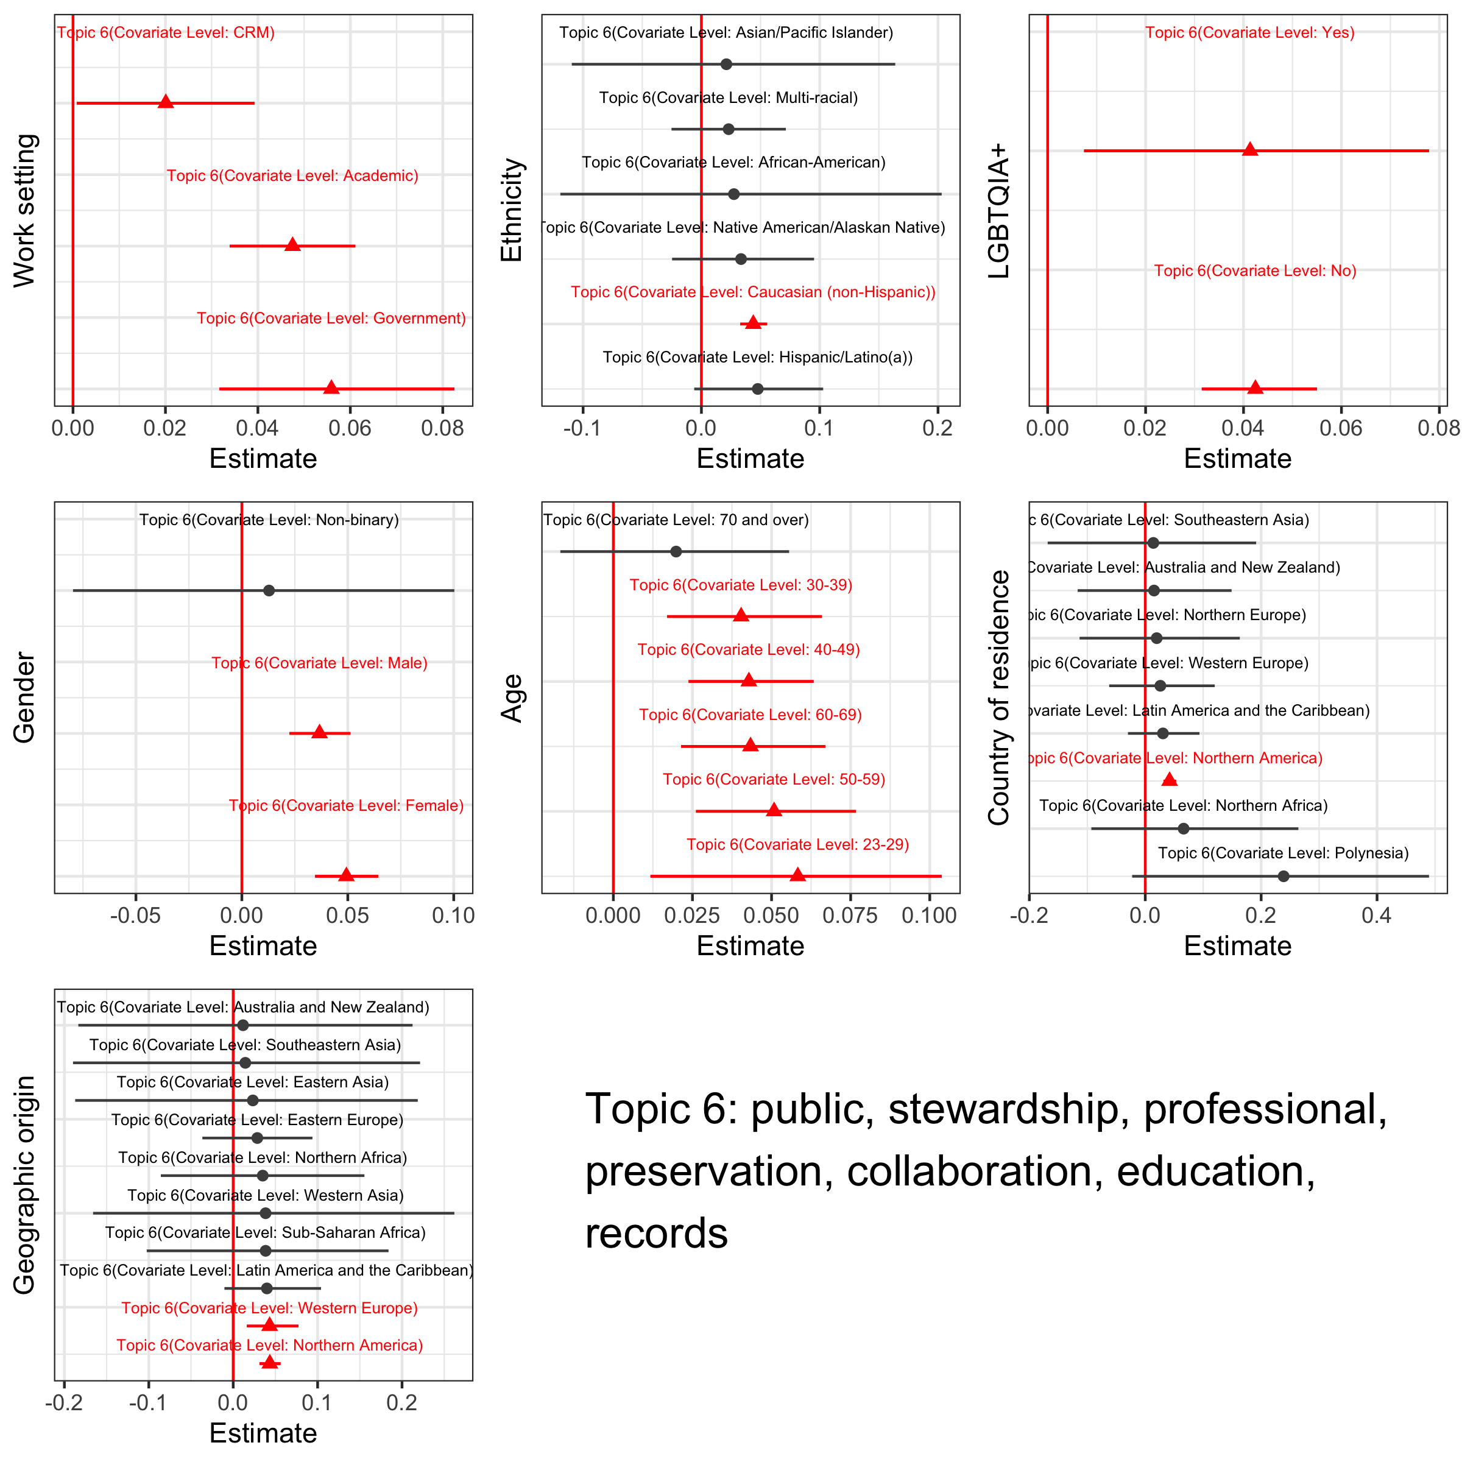

Figure 43. Effect of demographic variables as covariates on the prevalence of topic 6

For this topic about stewardship and education, we see the strongest associations with respondents in all work settings, of Causasian ethnicities, female and male gender, all age groups except the oldest, North Americans and Europeans (Figure 43).

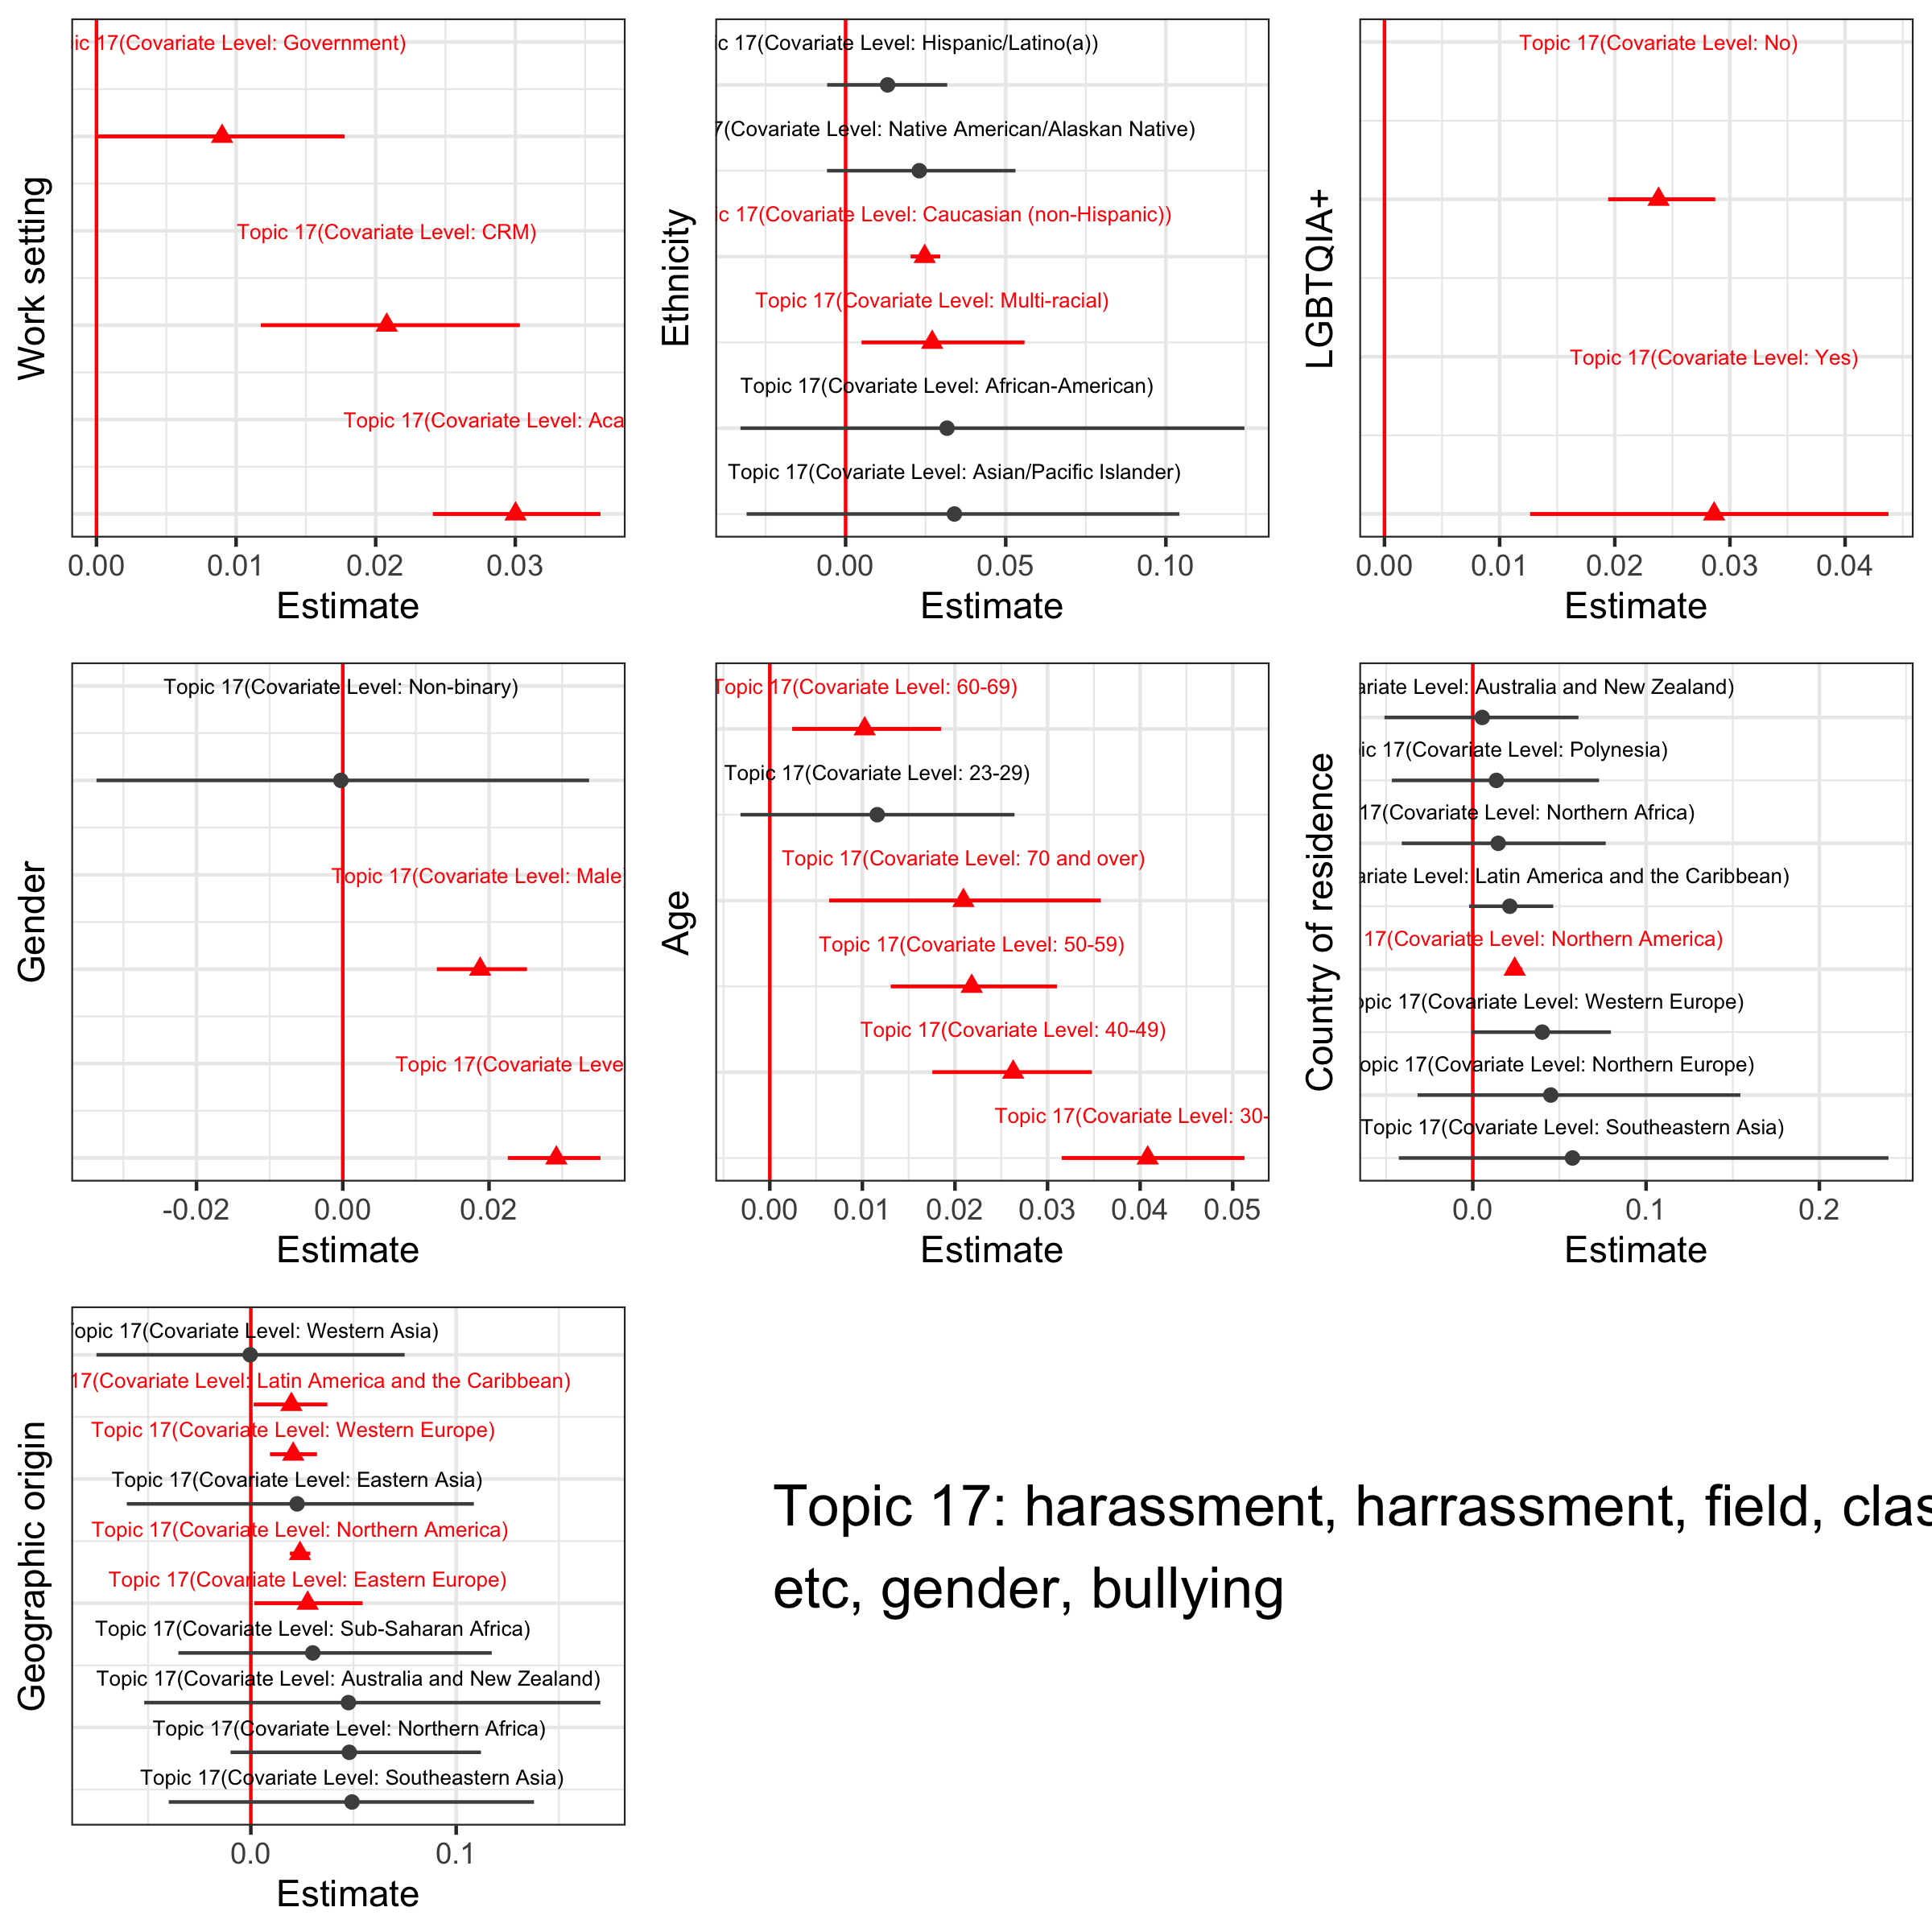

Figure 44. Effect of demographic variables as covariates on the prevalence of topic 17

For this topic about harassment and bullying, we see the strongest associations with respondents in academic work settings, of Causasian and mult-racial ethnicities, identifying with the LGBTQIA+ community, female gender, 30-39 years old, North and Latin Americans and Europeans (Figure 44).

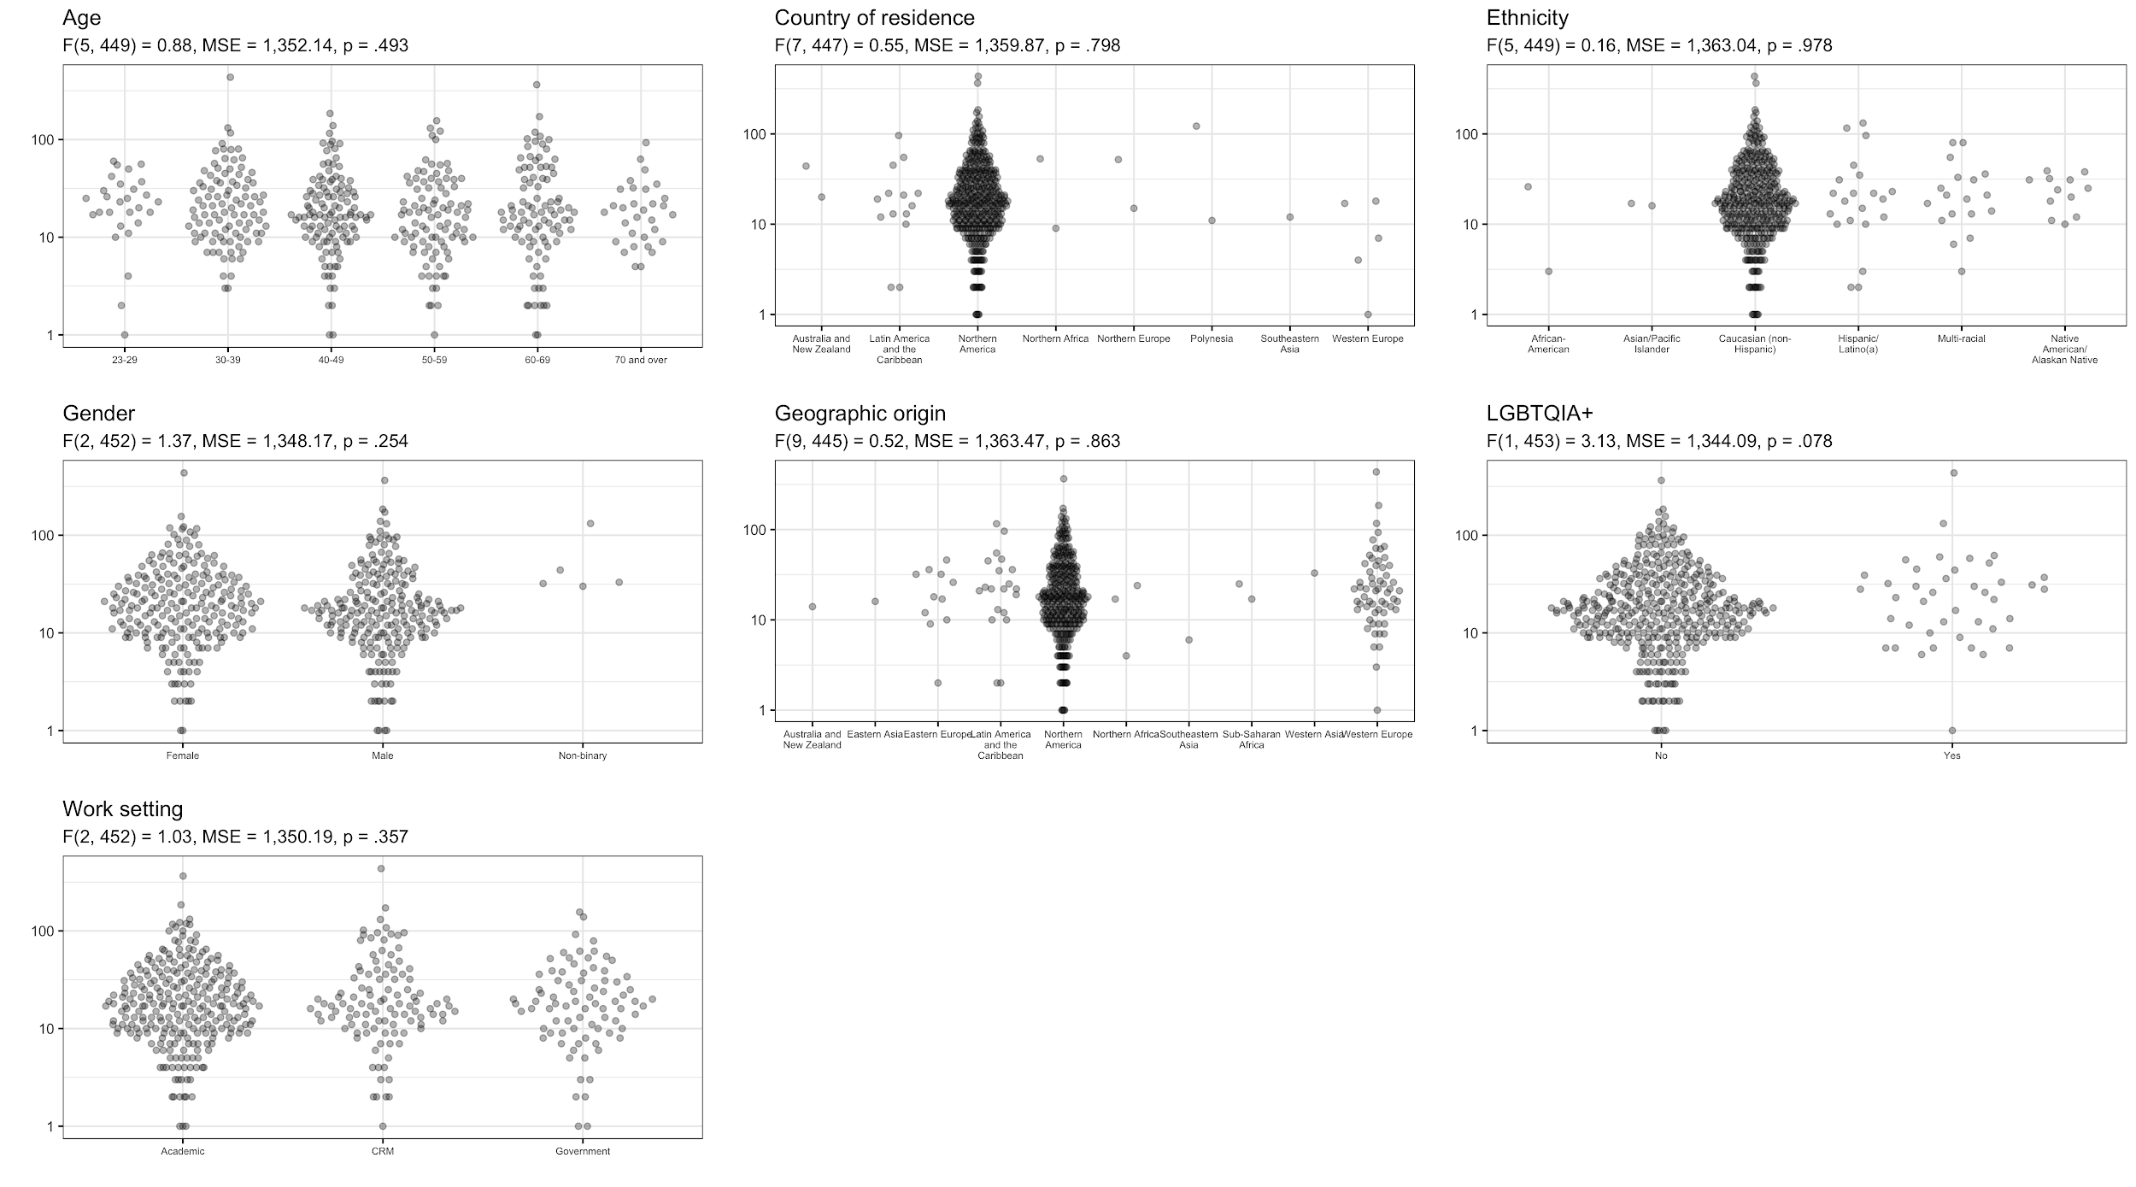

Figure 45. Distribution of word counts of responses to the question about primary ethical concerns by demographic category

The total number of words submitted for this question was three times more than any other single question in the survey, at about 37,210 words. This makes it a suitable sample size to investigate if there is any variation in response length by any demographic category (Figure 45). The plot above shows word count of responses to this question on the vertical axis (using a log scale because of a small number of outliers that represent very long reponses) and demographic groups on the horizontal axis. The title of each plot indicates the demographic category, and the subtitle shows the results of an ANOVA to test for significant differences in the number of words written by each group. We found no significant differences between any of the demographic groups in the length of text submitted for this question.

Commonalities

For the question about primary ethical concerns, the most common tags are related to “Indigenous”. We see many of the 455 responses to this question advocate the importance of archaeologists to collaborate with Indigenous people, and involve Indigenous communities in archaeological projects, such as:

“Way too much archaeology is being done by people of European extraction using the sites and data from indigenous victims of colonialism without any consent whatsoever”

Some of the 455 responses point out the right of Indigenous people to their cultural heritage and suggest how practices can be done in general to involve Indigenous people. For example:

“To rectify the human rights abuses committed by archaeologists on indigenous peoples: the consent of descendant communities must be sought prior to disturbing the material evidence of their presence on the land; indigenous peoples must be offered the right to participate in archaeological field work, excavation, analysis, and curation of material record of their own culture; indigenous perspectives must be given priority over non-indigenous views in analysis, publication, and in interpretive materials”

The second most common tag among the 455 responses this ‘primary ethical concerns’ questions is “sexual harassment”:

“Sexual harassment and the lack of true institutional efforts to deal with it”

And often appears in reference to the 2019 SAA meeting, such as:

“Allowing known sexual predators to still remain in the SAA and attend events (thus terrorizing their victims)”

The tag “discrimination” is the third common one that points out gender equality and unfair treatments of minority populations. This tag often appears together with “sexual harassment” in many responses, such as

“There is still way too much sexual and racial discrimination against women and minorities and sexual abuse against men and women, especially in university and field settings.”

and

“Sexual harassment, sexism, racism, bigotry. Should I go on?”

Other common tags that appear in more than 100 responses to this question include “laws”, “looting’‘, “power dynamics”, “open science”, and “enforcement”.

Comparisons

Among those tags, “looting” and “law” normally co-occur to address the protection for archaeological sites from any kinds of destruction, such as:

“Legal protections for heritage sites are being challenged, eroded and undone, and SAA has responded appropriately to work against these attacks. This situation requires further education and skill-building, both within and beyond our discipline.”

We also found that the tags, “open science”, “research” and “archiving”, often appear together when mentioning the access to data and good practice for research in general:

“SAA could and should do much more to promote this kind of data sharing (by requiring a data sharing statement with every article published in the society’s journals, for instance).”

In addition, “power dynamic” often correlates with “indigenous” and “sexual harassment” that shows the fundamental issue related to the impacts of senior archaeologists on younger colleagues and other groups, such as Indigenous communities, women, and minorities. For example:

“abuse of power by senior archaeologists towards junior archs, females, minorities, etc.”

and

“How to balance conflicting claims where multiple legitimate communities of interest (e.g. developers, community, indigenous populations, archaeologists) have conflicting POVs”

Contrasts

Although tag “Indigenous” has responses mostly relating to the lack of involvement of Indigenous people in archaeological projects, some responses show opposite opinions that point out the overemphasis of Indigenous consultation. For example:

“In the Rocky Mountain West, there is a current trend of overemphasizing Native American "consultation". Too frequently a "tribal position" is taken as gospel, i.e. "all sites are sacred and you archaeologists (read blue eyes) shouldn’t tough [sic] them."

and

“Also, Tribes declaring that certain objects are sacred. I understand burials and artifacts that are important, but this is a slippery slope when any bead found during a project calls for calling up the Tribe.”

For the tag “public engagement”, we see different viewpoints about sharing data with the public. Some responses advocate that archaeological data should be available to the public, but some degrees due to the concern of looting. The examples below demonstrate the opposite views:

“I believe open access to data is another ethical obligation we have to the public who funds most archaeology. We need to rethink policies about site location confidentiality, instead focusing on community engagement in protection rather than secrecy within the ivory tower”

“Data sharing and public access which might lead to destruction of archaeological resources”

The tag “Research” has responses relating to the lack of, or delay in publication, especially for archaeological reports, but we also found some responses address the issue of over-publication as shown below:

“Publication: This is an old ethical issue that continues to be unaddressed. Projects frequently get dropped by the field personnnel [sic] due to priorities, change in career, loss of institutional support, whatever. We need to as a discipline ensure that at a minimum field reports are always completed.”

“Overpublication: people writing the same basic article over and over and having it appear in multiple venues.”

Relationships

It seems there is a cause and effect relationship between the tags “power dynamic” and “discrimination”, reflecting a common situation present in the academy in general. Some responses address that the inequities are caused by imbalanced relationships and become deeper when the job opportunities are scarce. For example, we see these two responses:

“There are still inherent inequities in the academy, in agencies, and in other organizations where archaeologists work. There is still much to do in creating fair professional relationships between those in the profession whose positions grant them more power over those whose positions place them in positions of less power, particularly with regards to the access of opportunities and resources.”

“As job opportunities have become more scarce and also of lower quality (impermanent, part-time, low-paid, highly demanding), issues caused by systematic abuse of power by supervisors have deepened, and willingness to defend oneself or others has been eroded.”

The imbalanced relationship is present not only between archaeologists in working environments, but also between archaeologists and other groups, such as Indigenous people:

“Anthropology and archaeology are colonial fields in the United States, the power dynamics are not even, and it is up to archaeologists to be aware of the destructive nature of our science and how that affects other groups (especially indigenous groups).”

A similar causal relationship is between “sexual harassment” and “enforcement”, demonstrating the dissatisfaction of most people to the 2019 SAA meeting. For example:

“How the SAA’s handled the Yesnir [sic] case during the Albuquerque meetings. The SAA administration demonstrated that ethics were not of importance as they attempted to put the onus of the issue on a University instead of taking the time to address it.”

In addition, many responses indicate the relationship between insufficient “public engagement” and “looting”. They believe that looting or misuse of archaeological artifacts result from the failure of archaeologists to engage the public:

“Growing public interest in archaeology that results in both looting of artifacts and misuse of the past, and archaeologists’ failure to speak to the public in ways that might channel archaeological interest in positive ways.”

and

“We are often more focused on the in situ archaeological record, including the protection of archaeological sites and the prevention of looting, etc. This is somewhat ironic when many archaeologists don’t take the time to fully engage in public education and outreach in an effort to mitigate this problem.”

Sentiment

The choice of words in most of the 455 responses about primary ethical concerns are neutral without strong sentiment. Some responses are short and concise using only incomplete sentences. However, we also found that some responses are longer, with some words showing strong negative sentiment, such as ”rubbish”, and “disgusting”, when expressing their strong emotion for their concerns:

“Native Americans interference with archaeological investigations, research, DNA studies, misuse of NAGPRA, denying access to sites because "all sites are sacred". Rubbish! These sites and the data they contain "belong" to all Americans, all peoples of all nations, not a disgruntled minority of Tribal folks.”

and

“Disgusting exploitation of "archaeological technicians" by corporations and agencies.”

Some archaeologists stress their strong negative reactions by capitalizing some words, for example:

*“I am VERY concerned about the drift of SAA ethnics [sic] into social issues. Enshrining best practices for business (e.g., sexual harassment) into the SAA ethnical guideline dilutes the utility of the ethical code and makes it less useful, given that the SAAs provides the ONLY meaningful ethical code focused on the archaeological record.”*

Meta-themes

We found that most tags in the 455 responses to this question can be grouped into two major themes, preservation of archaeological remains, and treatment of individuals in a broad context. The concern about the preservation of archaeological remains is related to those tags: laws, looting, archiving, open science, museum, conflict of interests, field method, training students, and research. Tags associated with the treatment of individuals include harassment, sexual harassment, discrimination, racism, diversity, power dynamics, collegiality, mentoring, plagiarism, IP and copyright, and reporting. Treatment of individuals not only between archaeologists in the academy, but also between archaeologists and non-archaeologists represented by those tags: indigenous, avocational, and public engagement.

Those meta-themes can be also seen in some response that generalized the ethic concerns they observed:

“Traditionally, archaeological ethics dealt with how we collected, treated, and analyzed the archaeological record. Today, ethics tend to be focused on personal behavior; how we treat each other and how we are treated in business and academic situations.”

and

“Broadly, 1) protection of cultural resources 2) protection of individuals”

Sub-themes

“Indigenous” is the most abundant tag that could relate to a wide variety of issues. In general, the indigenous issues can be further divided into three sub-themes: involvement of indigenous communities in archaeological projects, indigenous right to their cultural heritage, and the tension between open science and indigenous sovereignty. We have demonstrated the first two sub-themes. For the third sub-theme, we see:

“The delicate balance between accessibility of research data and materials against national and tribal sovereignty”

“Public engagement” has two major sub-themes that one focuses on the concern of how much information we should share with the public, and another one stresses the importance of public education. For example:

“How much to tell the public about artifacts or a site, when there is a concern for looters or other privacy issues. Who owns the artifacts and sites archaeologists find”

And

“Public education and outreach are also of great concern. The vast majority of Americans have very little idea of what archaeologists do and the distorted media portrayal of archaeology still prevails”

For research, we also found two major common themes that address the issues of delays of publication, and unreliable research due to wrong interpretation. For example:

“Long delays between accumulation and publication of data in academic contexts”

and

“False representation of the certainty of statistical analyses in genetics and isotope data”

### Q: What should be the purpose of the SAA's ethical document? (526 responses)

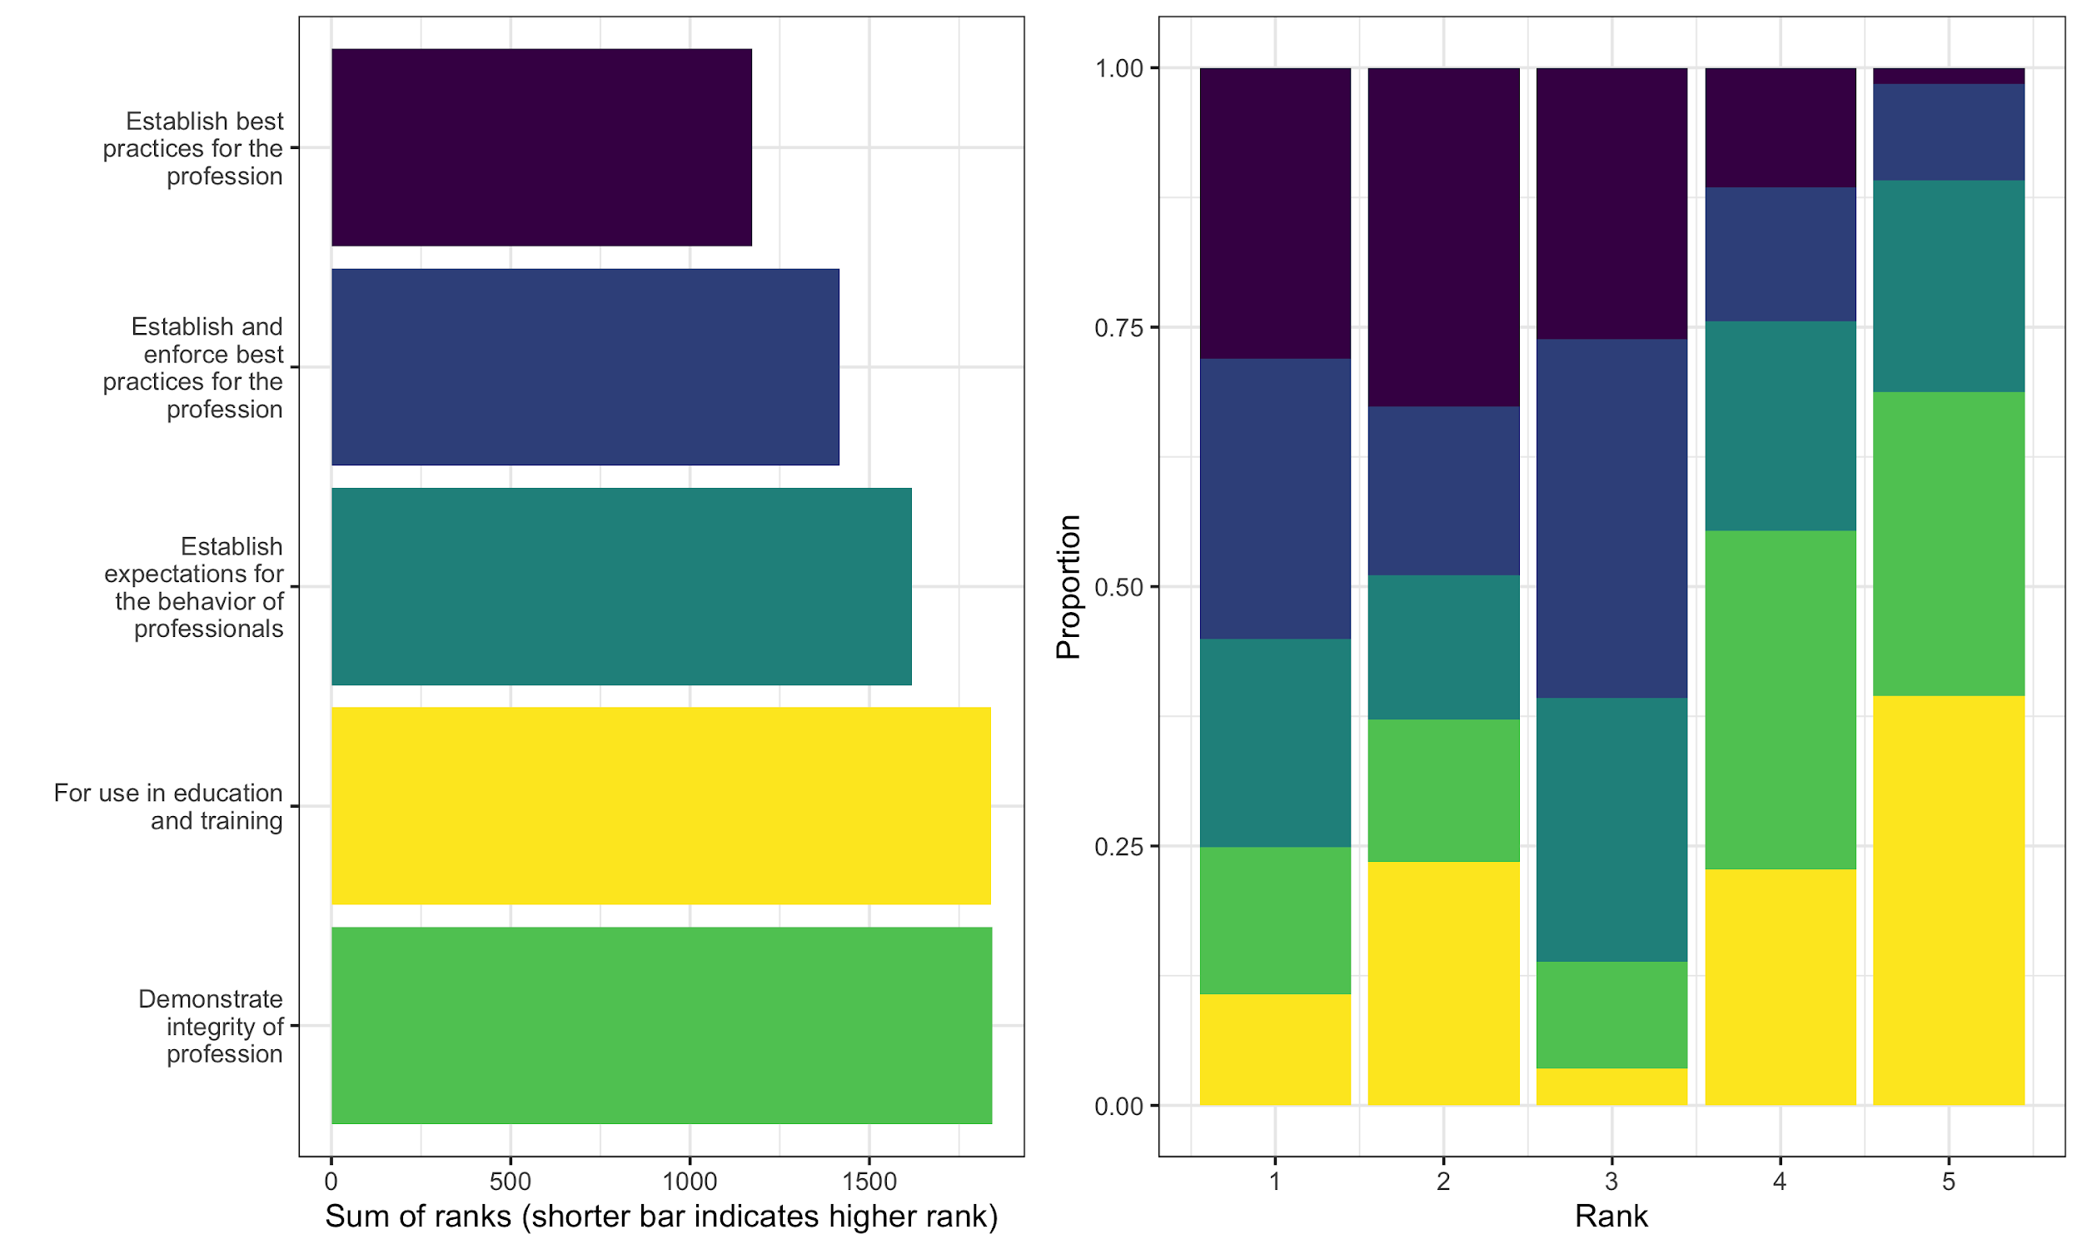

Figure 46. Left: Summary of ranks of options for the question about what should be the purpose of the SAA’s ethical document. Right: Proportions of each option selected as first-ranked, second-ranked, etc.

This question had 526 respondents who ranked four options that describe different purposes. Among the respondents to this question, the purpose that was most frequently ranked first was "Establish best practices for the profession" (Figure 46). This was followed by "Establish and enforce best practices for the profession". These top two options differ only by the word ‘enforce’ in the second-ranked option. Low ranking options were "Demonstrate integrity of profession" and "For use in education and training". The panel on the right shows the complication distribution of the ‘education and training’ option, which was often ranked second and fifth, but rarely ranked third. This indicated that this option was polarising, with respondents either ranking it highly or lowest.

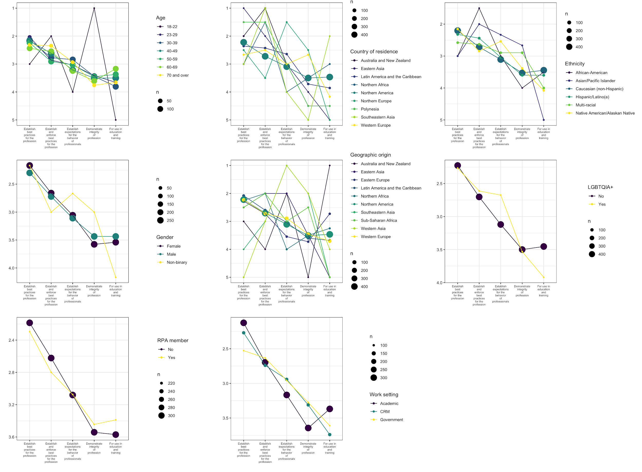

Figure 47. Average ranking of each option for each major demographic category responding to the question about the purpose of the SAA's ethical document. The size of each data point is scaled to the number of respondents in each category (total of 526 for this question).

Figure 47 shows the 18-22 year old group highly ranked ‘demonstrate integrity of profession’, in contrast to other age groups that ranked ‘establish best practices’ as their first preference. Similarly, non-binary respondents highly ranked ‘expectations of behaviour’ and ‘demonstrate integrity of profession’ compared to respondents of other genders. The same pattern about ‘expectations of behaviour’ is also evident for respondents identifying with the LGBTQIA+ community. Respondents in academic workplaces ranked ‘education and training’ more highly than respondents in other workplaces, and ranked ‘integrity of profession’ much lower.

### 

### 

### Q: What type of ethical document(s) do you feel would best serve the SAA membership? (1,016 responses)

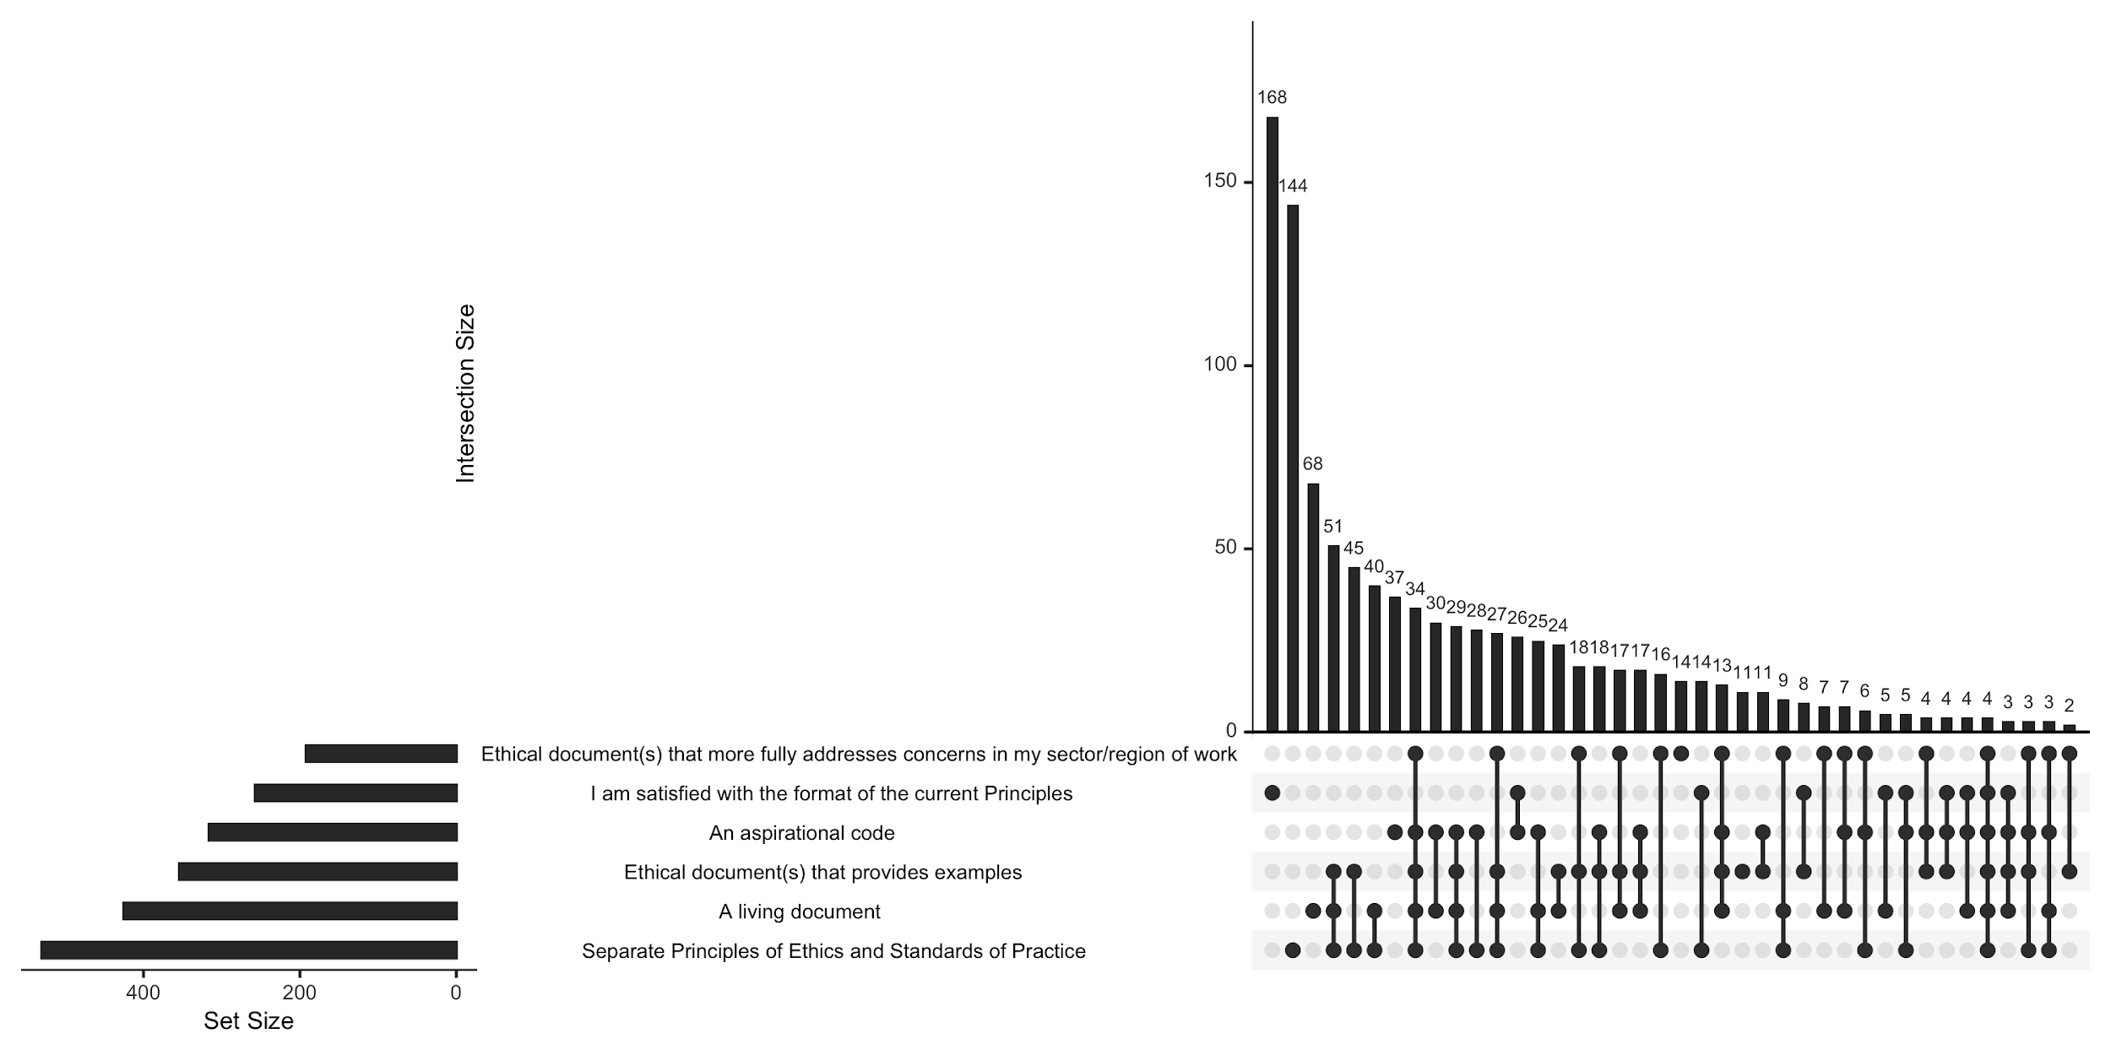

Figure 48. UpSet plot of the 1,016 respondents to the multiple choice question about what type of ethical document(s) do you feel would best serve the SAA membership

This question had multiple options available for respondents to select, and a free text option. In the Upset plot above (Figure 48), we see that overall the most popular option selected by itself and in combination with other options was ‘separate principles of ethics and standards of practice’. But where only one option was selected, the most frequently selected option was ‘I am satisfied with the format of the current principles’. The most common pair of options was ‘separate principles of ethics and standards of practice’ and ‘ethical documents that provide examples’, and the most common triplet of options was these two, plus ‘a living document’.

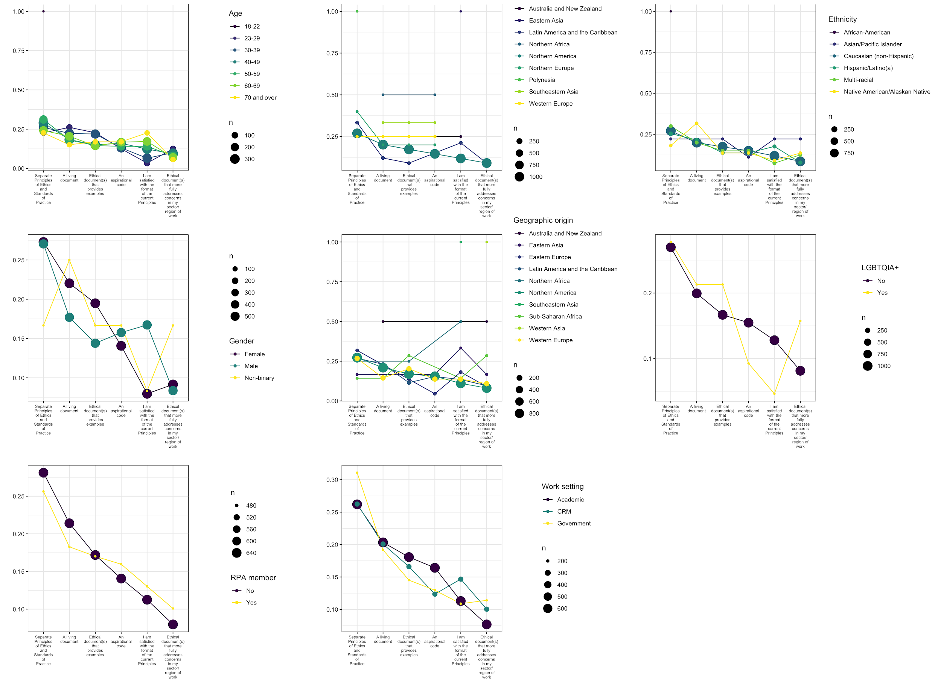

Figure 49. Average ranking of each option for each major demographic category responding to the question about what type of ethical document(s) do you feel would best serve the SAA membership. The size of each data point is scaled to the number of respondents in each category (total of 1,016 responses).

In Figure 49 we see a striking finding that age is inversely correlated with preference for ‘I am satisfied with the format of the current principles’ (with the exception of the single respondent in the 18-22 years old group). Generally, respondents in older age groups ranked this option more highly, while younger respondents ranked it low. This ‘satisfied’ option was also ranked very low by females and non-binary genders, and respondents identifying as part of the LGBTQIA+ community. Age was correlated with a preference for the ‘living document’ option, with younger respondents ranking this option highly. The ‘living document’ option was also highly ranked by non-binary respondents, relative to male and female respondents, and Native American respondents, relative to other ethnicities. In the work setting category, respondents in CRM ranked the ‘satisfied’ option higher than other groups, and respondents in the academic group ranked ‘aspirational code’ higher than other groups.

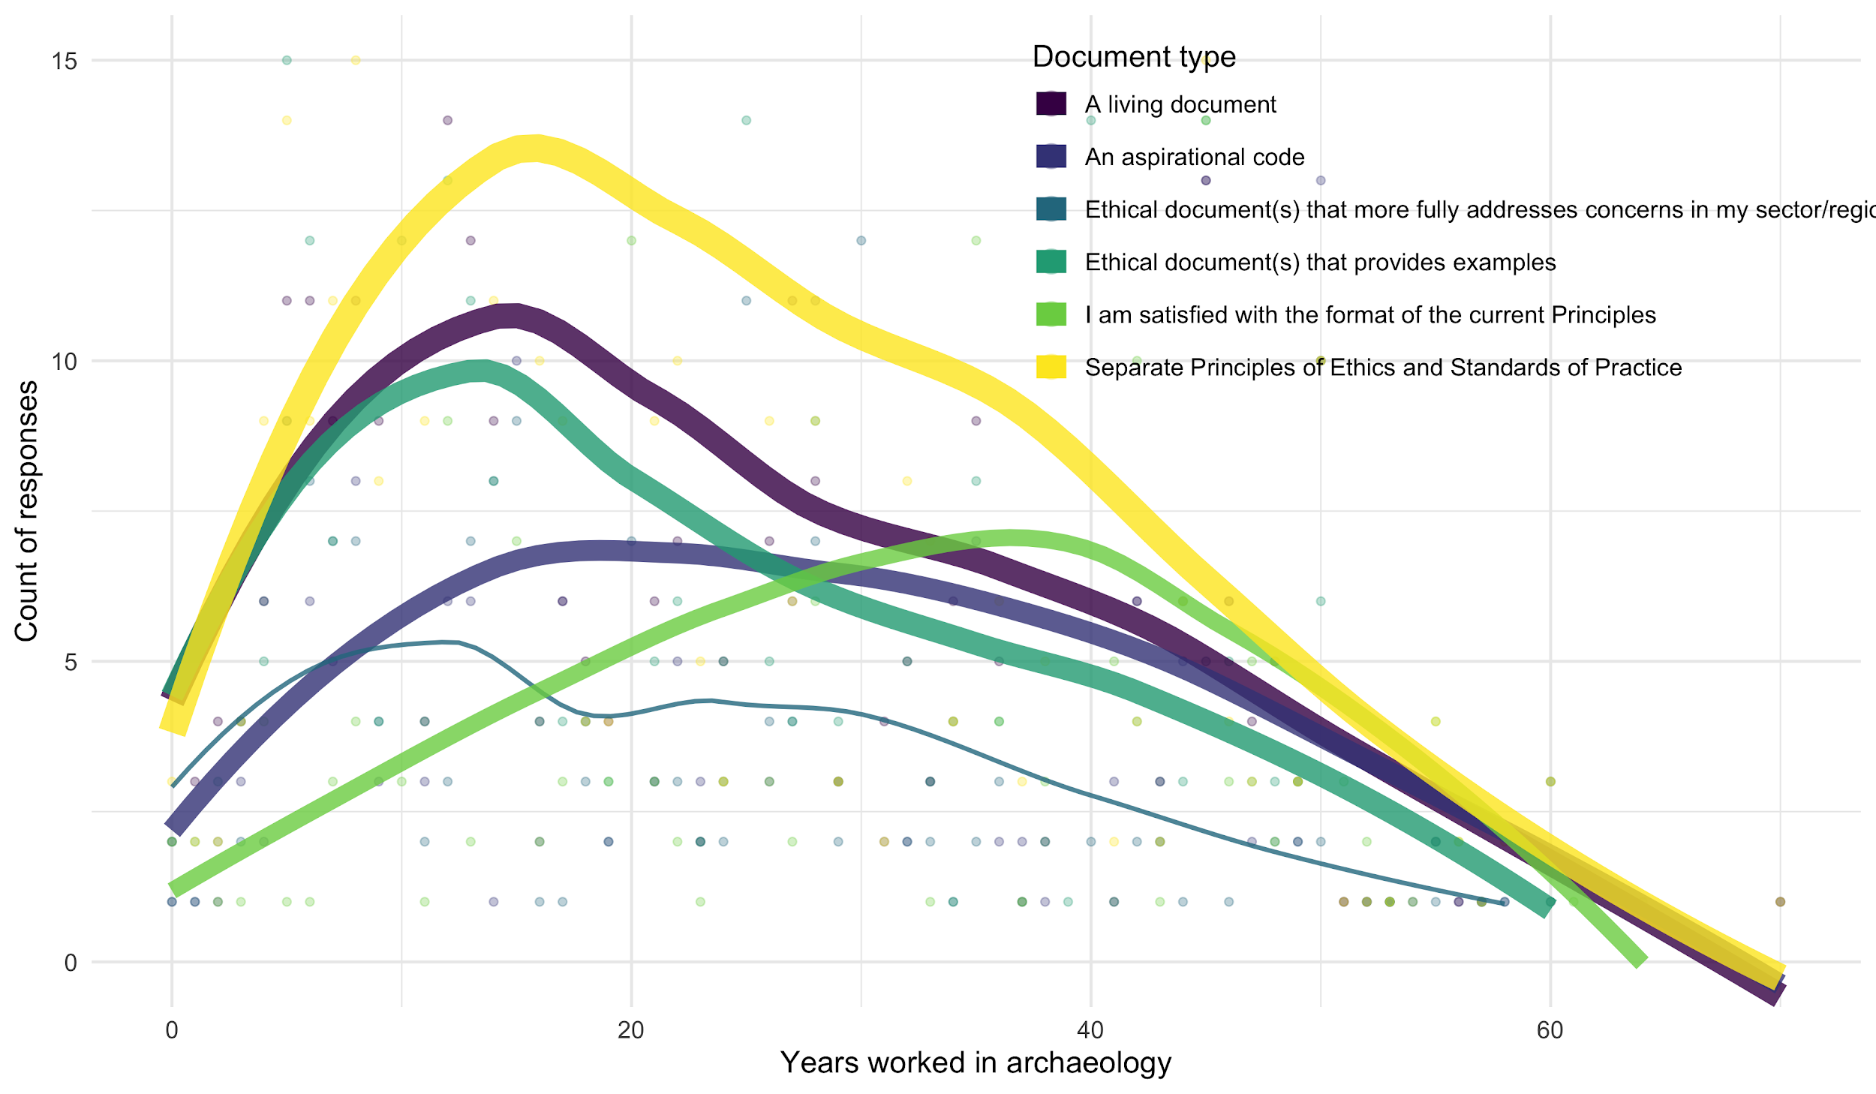

Figure 50. The relationship between age, in this case using the proxy variable ‘years in archaeology’ and the type of ethical document. The lines are a locally weighted regression (loess) line of best fit for each document type.

In Figure 50 we can see that overall the strongest preference among the respondents to this question is for ‘separate principles and standards’, consistent with the other visualisations. The ‘separate principles and standards’ option is most popular among respondents who have been working in archaeology for around 20 years. Against the trend is the ‘I am satisfied with the format’ which was more frequently selected by respondents who have been in archaeology for around 40 years.

In the free text responses a common theme was enforcement. Many respondents were ambivalent about document type, but felt that whatever it was, consequences were necessary:

"The code needs some teeth. When people sit on their data and/or violate ethical standards, there should be consequences. A living document might be maintained in parallel, but having a strong code or set of principles that establish standards and consequences is key."

However, several respondents noted the that the RPA already exists for this function of enforcement and consequences:

"I am not opposed to separate principles and standards of practice. I think they are two different things and the latter are important but cannot be ethical principles. It seems to me that a lot of why we have RPA is to deal with standards of practice and enforcement. I think it would be a BIG mistake for SAA to get into enforcement. And, by the way I have been an RPA for decades,"

and

"The principles have to be an aspirational code that encourages ethical behavior, there is little behavior that can be enforced. That is the role of the RPA. The archaeology profession has changed dramatically since its inception as has the world in which it operates. Thus, the principles that guide archaeology need to be updated and modified periodically. An ethics forum like that used by the AAA is an excellent idea. Such a forum not only provides a platform to respond to current ethical issues, but helps individuals understand how the principles apply. Including examples from the Ethics Bowl would provide fictional examples that would avoid actual controversies and maintain anonymity.."

and

“I like the RPA code of ethics and standards of research performance. And RPA has backbone that the SAA never has had because RPA has a grievance coordinator and committee to evaluate complaints, protect members, and when necessary, ajudicate [sic] disputes and censor members. Glad the SAA supports RPA"

We noted strong negative sentiment around the ‘living document’ concept, for example

"Strongly against a living document via a blog. As evident from the contemporary digital world, that could result in a small subset of the most radical and constantly disgruntled members to determine the nature and outcome of ethical decisions, while more balanced opinions would be drowned out or silenced."

and

"A living document sounds like a horrible idea for a replacement of the code of ethocs [sic], but good as a supplement. The point is to have shared standards, not to have a facebook comments section. I think a moderated discussion area or forum would be useful for bringing up items that should be added, but these need to be agreed upon and discussed at the SAA annual meeting, in a formal, professional setting."

### Q: Are there additional ethical issues that should be addressed by the Principles? (1012 yes/no responses, 409 text responses)

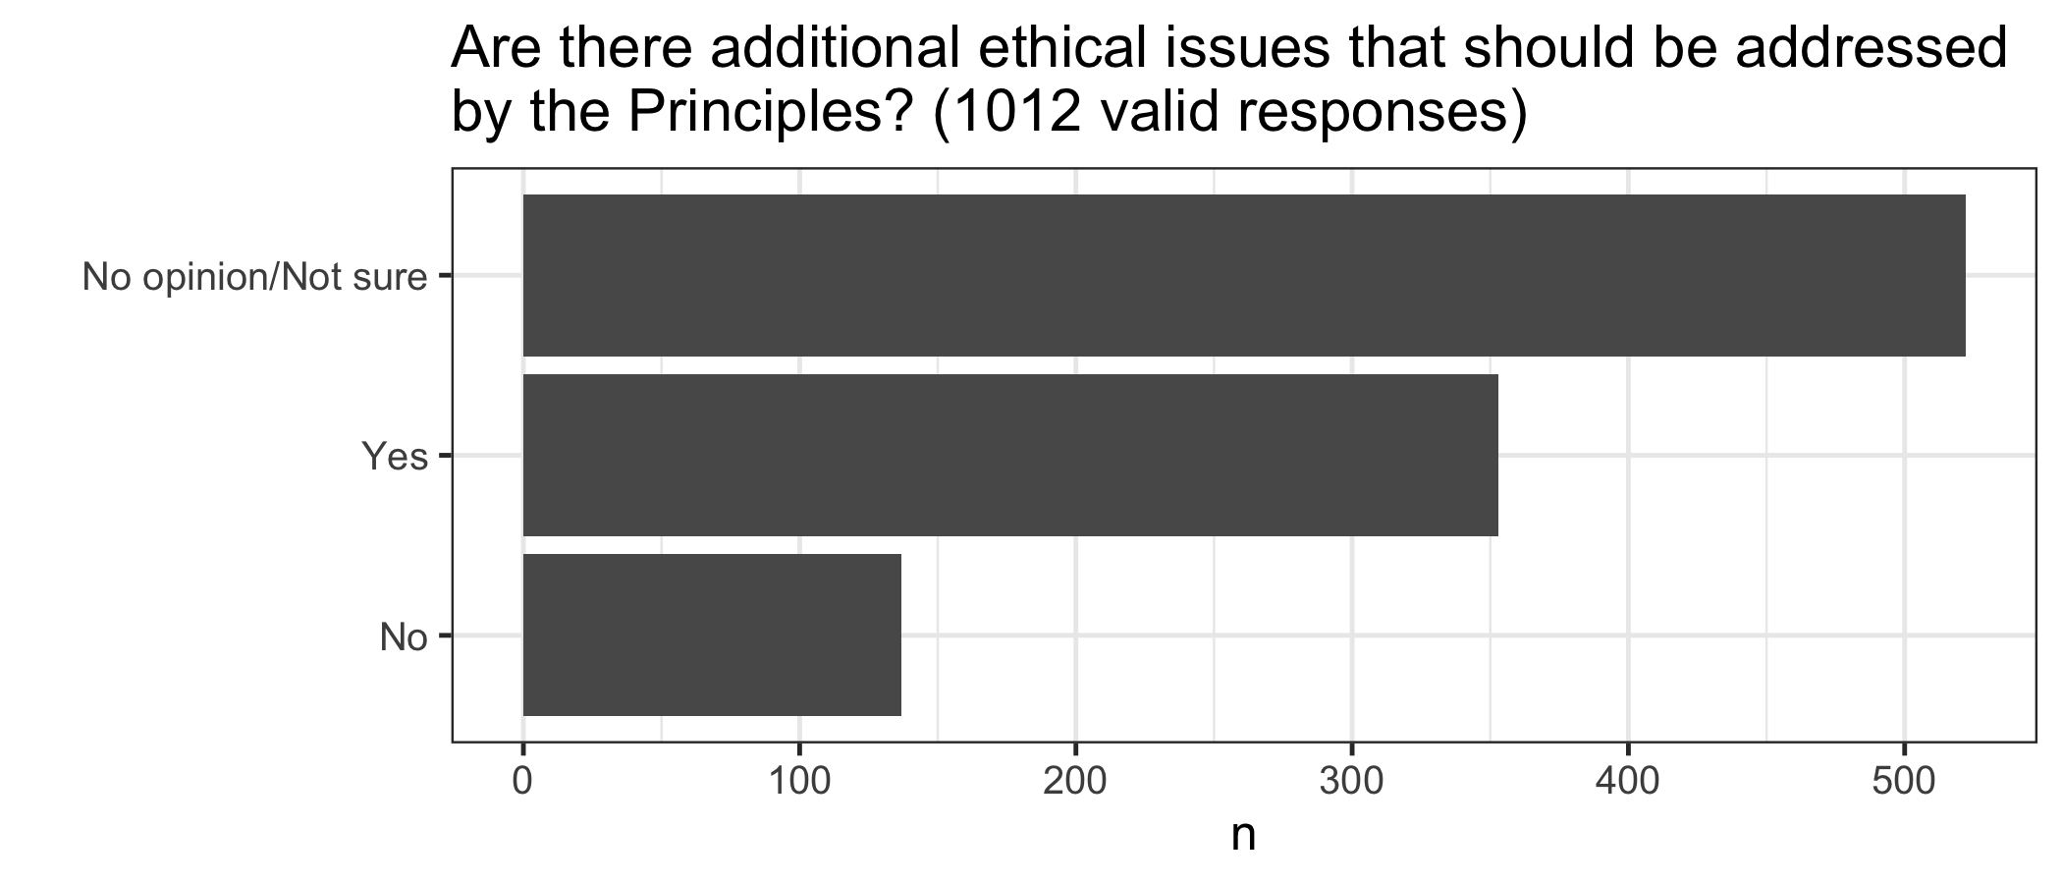

Figure 51. Plot of responses to the question ‘Are there additional ethical issues that should be addressed by the Principles?’

This question had a single choice response, with the options “yes”, “no”, and “no opinión”, and a free text response.

While the majority of respondents did not respond (34%, n = 530) or chose ‘no opinion/not sure’ (34%, n = 522), a high proportion of respondents chose “yes” (22%, n = 353) (Figure 51). The distribution of these options across the demographic groups show little variation, as we can see below.

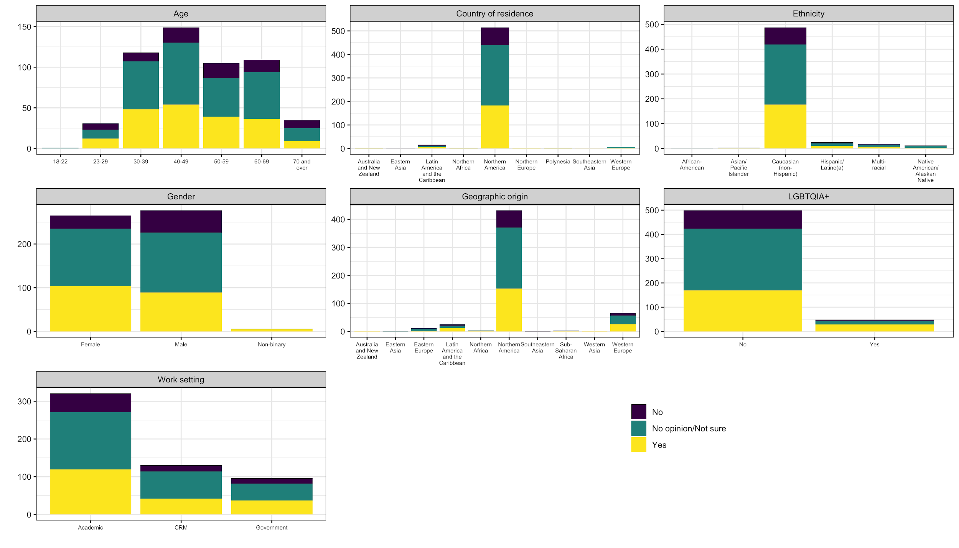

Figure 52. Distribution of responses to the question ‘Are there additional ethical issues that should be addressed by the Principles?’ by demographic groups

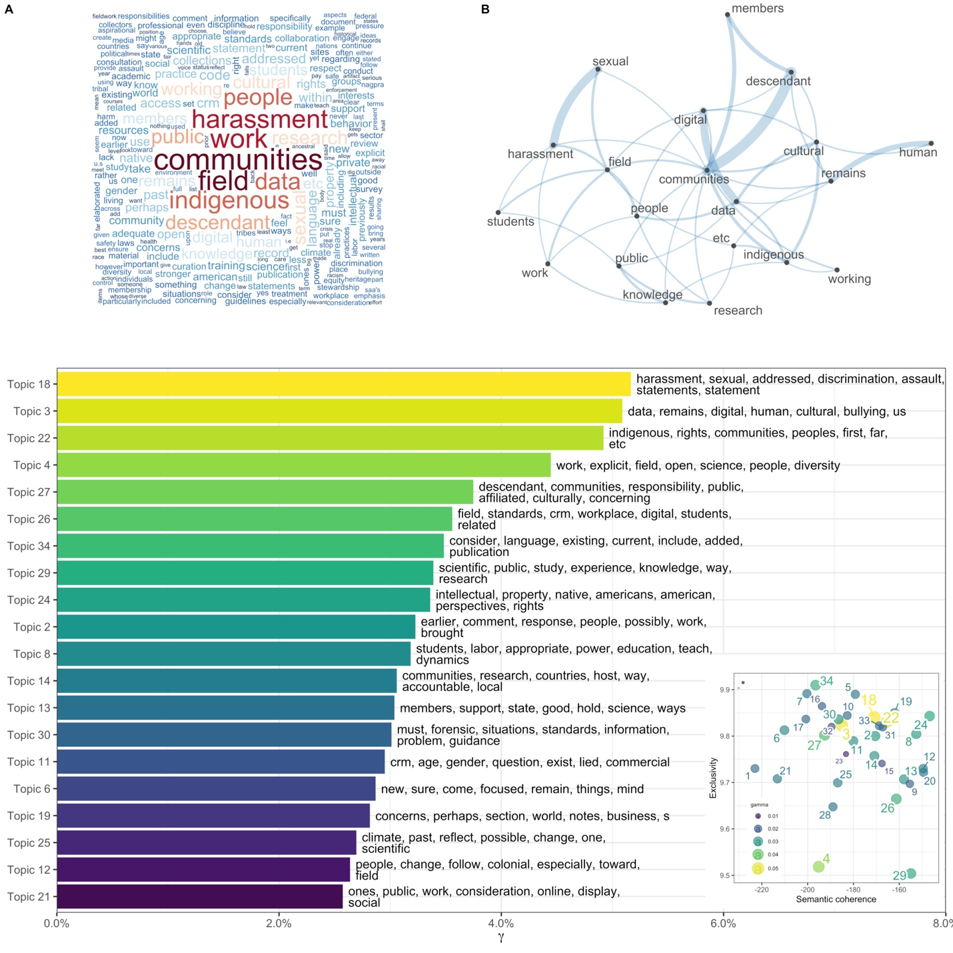

Figure 53. Summary of computational analysis of the 409 free text responses submitted for the question ‘Are there additional ethical issues that should be addressed by the Principles?’ A: word cloud that scales the size of a word proportional to how frequently it appears in the responses. B: a network plot showing how highly frequent words co-occur in the responses. C and D: output of the topic model

The topic model shows that the top three stand-out topics that are prominent in the responses to this question: sexual harassment, descendant communities, and open science (Figure 53). The number of responses to this question were too few to compute covariances between topics demographic variables.

Commonalities

A frequent response across this section was the tag “Indigenous”. The respondents' concerns were mainly with the relationships that archaeologists have with Indigenous peoples. Most responses were urging for more involvement and consideration between archaeologists and the Indigenous communities:

“collaborating with living communities and the subject of scholarship and integrity”

And some indicated that Indigenous concerns should take priority over archaeologists’:

“Indian tribes or other indigenous peoples supersedes the interests of anthropologists or ‘science.”

Contrasts

One tag in particular was rarely addressed in the respondents concerns and that was the tag “Racism”. This tag was mentioned in only a few responses. In the ones in which it was mentioned they were all advocating for more awareness of this issue in the archaeological realm, for example:

“commit to working against racism”

There were also some responses that advocated for academia to teach and recognize racist history.

“Racist beliefs such as manifest destiny”

Comparisons

Two tags that frequently appeared together were “Indigenous” and “Public Engagement”. Most of the feedback was regarding the engagement and relationships between Indigenous communities and the involved organizations. The replies requested more respect towards what Indigenous communities ask of organizations, for example:

“archaeologists engage with local communities, particularly those that have long-established archaeological and historiographical traditions of their own, is still rather inadequate and unaddressed by the guidelines.”

“Specific principle towards collaboration with and respect of descendant communities.”

Sentiment

Overall, the responses for the tag “Indigenous” was overwhelmingly positive in advocating for a strong and active engagement between communities and organizations. The positive reaction to this category comes with a desire for more guidance on how to manage these relationships:

“How to ethically proceed with disseminating archaeological findings if living communities do not want these findings made accessible to the public”

One response in particular claims that they would like

“details on working with descendant communities.”

# 

# Discussion

## Demographics of respondents

Our multiple correspondence analysis of demographic variables demonstrated that there is little demographic diversity among the respondents to this survey, with most respondents clustered in the older age and Caucasian (non-Hispanic) ethnicity. We speculate that younger members of the Society are probably underrepresented in the responses. This is a problem because younger members are also in our data most often associated with the LGBTIA+ community, and non-binary gender. In light of the high frequency of Indigenous themes throughout responses to questions in this survey, Native Americans, who made up only 1% of respondents are another important demographic category that is underrepresented in this survey.

As a baseline for establishing the representativeness of this survey about the Principles, we can compare demographic variables to values obtained from the [SAA 2020 Member Needs Assessment](https://ecommerce.saa.org/SAA/SAAdocs/Survey2020/ExecutiveSummary.pdf) (MNA, 839 responses). Note that the MNA excluded non-responses before computing percentages, unlike this survey. This means that the rank order of groups is more meaningful than direct comparison of percentage values. Ethnic representation is similar for the two surveys with MNA reporting ‘White or Caucasian’ (83.5%) and ‘Latino or Hispanic’ (5.8%) as the top two groups, compared to “Caucasian (non-Hispanic)” (51%), followed by “Hispanic/Latino(a)” (3%) for this survey. Currently place of residence was dominated by the US and Central/South America in both surveys (MNA: 89%, 2%, this survey: 61%, 2%). Representation of work settings is also similar with MNA reporting the top three categories as 43% Academic, 13% CRM and 14% government, compared to this survey with Academic (28%), CRM (11%) and government (9%). Age of respondents is skewed to people over 40 in both the MNA (62%) and this survey (47%). The wording of questions about sexual identities of respondents differed between MNA and this survey, and may not be comparable. In MNA 84% identify as heterosexual in MNA, and 63% in this survey identify as male or female (who may also identify as homosexual). In MNA 9% identify as homosexual/pansexual/bisexual/asexual and 6% in this survey as identifiing with the LGBTQIA+ community. Overall the demographic profile of respondents to this survey is similar to the 2020 Member Needs Assessment. Note that we cannot be sure this is capturing the demographics of the Society accurately, or only that subset of members who regularly participate in surveys.

## Use of the Principles

Seventeen percent of respondents indicated they have never consulted the Principles. The most common purpose for consulting the principles was only “To refresh or gain personal knowledge of ethics” or both “To refresh or gain personal knowledge of ethics” and “For teaching or training purposes”. A third of respondents said they had never used the Principles. The theme of ‘derivation’ was prominent in the free text answers to this question, with respondents stating they consulted the Principles to draft similar documents for other organisations or events. We also noted an evaluative use of the Principles, with some respondents finding a gap between their expectations about how the Principles should have guided the SAA leadership and what the leadership actually did in response to the events of the 2019 meeting.

Respondents most frequently use the SAA’s Principles together with the equivalent documents of the American Anthropological Association (AAA) and the Register of Professional Archaeologists (RPA). The AAA provides extensive supporting documentation for its code of ethics, or ‘Principles of Professional Responsibility’. The current AAA document is c. 4600 words, compared to the SAA’s Principles at c. 870 words. The RPA differs from the SAA and AAA with its formal grievance procedure that allows for the investigation of complaints regarding the professional conduct of an member who has violated the Register’s Code of Conduct of Standards of Research Performance (c. 1700 words). After these two organisations, another 119 other codes of ethics were referenced by respondents. These include state and regional archaeological societies and associations, and associations of other scientific communities.

## The Nine Principles

The survey included one question for each of the nine current principles, with the prompt ‘I feel that this principle and its description adequately applies to archaeological practice and its ethical challenges today.’ The majority of respondents (79-89%) agreed with this statement for all nine Principles. High proportions of disagreement (i.e. >10%) are evident for Principle 9 (Safe Educational and Workplace Environments, 12% disagree and strongly disagree), for Principle 5 (Intellectual Property, 10% disagree and strongly disagree), Principle 2 (Accountability, 10% disagree and strongly disagree). Key themes that were ubiquitous in the free text responses to all the questions in this section were Indigenous people, sexual harassment, and open science.

Responses to Principle 9 (Safe Educational and Workplace Environments) varied significantly by the age of respondents. Generally, older people agreed more that “this principle and its description adequately applies to archaeological practice and its ethical challenges today”. Throughout all the free text responses for Principle 9 the theme of sexual harassment was prevalent, and concerns about how archaeolgists can be protected from this. The SAA is perceived as ineffective at maintaining safe environments, with reference to the 2019 meeting. Concern was expressed about how to ensure safety in field locations where US law doesn’t apply.

Free text responses to Principle 5 (Intellectual Property) most frequently mentioned the theme of open science. This theme often co-occurs with mention of Indigenous people, IP and copyright, and expression of concern about how to enforce sharing data. Many respondents expressed concern that data availability and sharing standards in archaeology were not up to date with other fields, and that Indigneous groups were not properly involved in decision-making about archaeological data. There were no significant differences in responses to this question by any demographic category.

Responses to Principle 2 (Accountability) varied significantly by ethnicity, with African-Americans and Native Americans disagreeing more than other ethnic groups that the “principle and its description adequately applies to archaeological practice and its ethical challenges today”. Among the free text responses recurring themes were enforcement, followed by Indigenous people and conflicts of interest. A common sentiment was that the Principle was too vague, and that Indigenous, descendant and local communities should be in a special category of 'affected group' where collaboration is mandatory prior to and during fieldwork.

We analysed correlations among responses to all of the questions about the nine principles to investigate latent factors that might guide how people think about archaeological ethics. We found two broad groups among the respondents: those that value relationships intrinsic to archaeology, for example between archaeologists, and between archaeologists and the archaeological record, and those that value extrinsic relationships, for example between archaeologists and the public, Indigenous and descendent communities, and other groups that are not mostly composed of archaeologists. These latent factors map on to the dominant themes in the free text responses to the nine principles. For example, the intrinsic relationships latent factor corresponds to concerns about sexual harassment and data sharing, while the extrinsic relationships factor relates to archaeologists duties to Indigenous, descendant and local communities. These latent factors help us to see what are the most urgent and substantial concerns for the respondents to the survey, and where the Society should focus its attention in future work on ethics.

## How the Current Principles of Ethics Address Situations and Concerns

For the three questions about situations and concerns we see much higher levels of dissatisfaction (16-19%) compared to the individual Principles (5-12%). Disagreement was significantly higher among respondents in the 30-39 year old age category, women and non-binary people, and those identifying with the LGBTQIA+ community were more likely to disagree than others. Generally members of minority demographic groups in the Society are less satisfied with how the current principles address their situations and concerns. We might speculate that members of these groups are more vulnerable to unethical practices, and when the current principles are not followed, they bear more of the negative effects.

The different proportions of disagreement between these ‘situations and concerns’ questions and the questions about the individual nine Principles is noteworthy. It suggests a distinction between responses to the individual Principles as mostly responses to the concept or aspiration of the individual principles, but the responses to these three ‘situations and concerns’ questions are more about the application and practical use of the Principles. We can infer that people generally approve of the Principles, but are less satisfied with how effective they are at addressing situations and concerns. This hints at the need for some interpretive documentation that gives examples and more concrete standards of practice for typical situations and concerns.

The most common theme throughout the responses to the three questions in this section was Indigenous communities. Generally engagement with this theme was as advocacy for a greater role for Indigenous communities in the archaeological process. There were a small number of contrary responses that expressed concern that higher levels of Indigenous community involvement in archaeology might have a negative effect. This concern has been noted in previous discussions of archaeological ethics, for example Wylie [(1999)](https://www.zotero.org/google-docs/?ulycig) noted that some SAA members have long been hostile to what they consider to be a breach of their ‘rights and interests in scientists’ resulting from the involvement of Indigenous groups. A second prominent theme in the ‘situations and concerns’ responses was enforcement, especially with respect to local laws and norms. Generally the theme of enforcement was reflecting concerns about the lack of consequences for archaeologists who don’t follow the Principles in ways expected by others in the Society. This theme occurs with themes of Indigenous communities and sexual harassment, and a desire for more specific guidance about best practices.

## The future of SAA’s documentation about ethics

### Primary ethical concerns

The survey included four questions where respondents can share their thoughts on current ethical concerns, their vision for the future of ethics in archaeology, and how the SAA should address ethical issues. The first question ‘What do you see as being the primary ethical concerns in the field today?’ received more and longer responses than any other question in the survey, with a total of c. 37,000 words. Analysis of these responses using a machine learning algorithm identified four prominent themes.

The most important theme was engaging with local and descendant communities, which was most strongly associated with respondents in all work settings, of Causasian and Multi-racial ethnicities, male and female genders, all age groups except those over 70, North Americans, Western Europeans, and Southeast Asians. Qualitative analysis further indicated that this theme was concerned with the lack of involvement of Indigenous people in archaeological projects.

The second theme was sexual, gender and racial discrimination and equality, which was associated with respondents in in all work settings, of Hispanic and Causasian ethnicities, not identifying with the LGBTQIA+ community, female and male gender, all age groups except the youngest and oldest, Latin and North Americans, and Europeans. Qualitative analysis showed that this theme reflects concern about senior archaeologists mistreating younger colleagues and other groups, such as Indigenous communities, women, and minorities.

The third major theme was cultural resource access and protection, we see the strongest associations with respondents in all work settings, of Hispanic and Causasian ethnicities, not identifying with the LGBTQIA+ community, female and male gender, all age groups except the youngest and oldest, Latin and North Americans, and Europeans. Qualitative analysis highlights concern about looting and weak legal protection of the archaeological record, and also the desire for greater data sharing and open science practices between archaeologists.

The fourth major theme was about stewardship and education, with strongest associations among respondents in all work settings, of Causasian ethnicities, female and male gender, all age groups except the oldest, North Americans and Europeans. Qualitative analysis reveals a concern about failure to engage the public in archaeology, concern about delays in publication and sharing information, and tensions about demands for data sharing, open science practices and indigenous sovereignty over archaeological sites, artefacts, and data.

### The purpose of the SAA's ethical document

The most frequently first-ranked option for this question was "Establish best practices for the profession". This was followed by "Establish and enforce best practices for the profession". These rankings were consistent across most demographic categories, however ‘Establish expectations of behaviour’ was more highly ranked by the non-binary respondents, respondents identifying with the LGBTQIA+ community. This pattern suggests that these minority populations in the SAA are more concerned about behaviour and integrity than the majority groups. As noted above perhaps these groups rank that purpose higher because they are more vulnerable to negative impacts when others’ behaviour violates the Principles.

### Types of ethical document that would best serve the SAA membership

Of the six options presented in the survey, the most popular option selected by itself and in combination with other options was ‘separate principles of ethics and standards of practice’. But where only one option was selected, the most frequently selected option was ‘I am satisfied with the format of the current principles’. The most common pair of options was ‘separate principles of ethics and standards of practice’ and ‘ethical documents that provide examples’. We can infer a preference for maintaining the current principles, but with regular additions of further documentation that provide more details, examples and interpretation of the principles. This is consistent with the original framing of the Principles as ethical ideals or goals, as ‘ceilings’ of ethical behaviour [(Lynott 1997)](https://www.zotero.org/google-docs/?GHUGJI), which may be compared to the RPA’s codes and standards as the ‘floors’ of professional conduct [(Wylie 1996)](https://www.zotero.org/google-docs/?tZclZ2).

Preference for these options was strongly predicted by the age of the respondents. Younger respondents highly ranked ‘separate principles of ethics and standards of practice’ while older respondents highly ranked ‘I am satisfied with the format of the current principles’. This suggests a generational gap where older archaeologists are generally more satisfied with the status quo, but archaeologists in younger generations express a need for additional ongoing commentary and interpretation of the Principles. This ‘satisfied’ option was ranked very low by females and non-binary genders, and respondents identifying as part of the LGBTQIA+ community, once again showing a negative response from minority and more vulnerable demographics.

Respondents in CRM and who are members of the Register of Professional Archaeologists more highly ranked ‘I am satisfied with the format of the current principles’ than respondents in academia, government and non-members of the RPA. We can speculate that this is because CRM archaeologists and RPA members are more likely to be aware of the RPA’s Code of Conduct and the RPA’s extensive and detailed Standards of Research Performance. Archaeologists who are aware of, and guided by, these RPA documents may find that they make up for any deficiencies in the briefer and less detailed Principles of the SAA, and so feel no need for any further documentation from the SAA.

### Additional ethical issues that should be addressed by the Principles

Only 22% of respondents answered ‘yes’ to this question and we did not receive enough responses to compute demographic covariance with the themes in the free text responses. Computational analysis of these responses using a machine learning algorithm identified four topics or themes that were most abundant: sexual harassement, discrimination and bullying; collabaorating with local, descendent and Indigenous communities; open data and open science; and intellectual property, Indigenous sovereignty, and public access. The first two of these also scored highly for exclusivity and coherence, so we consider them key themes of these responses.

## Possible responses to concerns raised in the survey

In reflecting on the survey responses we have read, and the history of ethics documentation in the SAA, we identified a large number of possible measures available to the SAA to respond to member's concerns. We present here a selection of the most practical options that the SAA should consider to address the issues identified in this survey.

### Revising the text of the Principles

Many of the tensions described by Wylie [(2005)](https://www.zotero.org/google-docs/?PTk9Rp) that surrounded the initial drafting of the Principles remain evident in the responses to this survey, for example about who should have access to and control over archaeological sites and materials. This makes it challenging to identify future directions for the text of the Principles that we can be confident of unanimous support from the SAA membership.

That said, our results suggest that most survey respondents would support updates to the text that give a special role in the archaeological process to Indigenous, descendant and local communities. For example, Principle 2 currently uses the phrase ‘a commitment to make every reasonable effort, in good faith, to consult actively with affected group(s)’, and a minimalist edit might change this to ‘must consult actively with Indigenous, descendant and local communities’. Principle 5, on intellectual property could similarly be edited to require consultation with Indigenous, descendant and local communities to determine who has access and control over the knowledge and documents resulting from the archaeological process. This recommendation for Indigenous, descendant and local communities to have a special status in the Principles is not novel, it was also proposed in 2012 by the SAA’s committee on ethics [(Watkins 2012)](https://www.zotero.org/google-docs/?98Z96r).

A second prominent theme in responses to this survey that may be incorporated into the text of the Principles with minimal disruption is data sharing, data availability and open science practices. While Principle 7 on Records and Preservation includes aspirations about preserving and ensuring ‘collections, records, and reports’, these were drafted before the appearance of many of the technologies and standards of digital data sharing and archiving that are now ubiquitous in the majority of scientific communities. These new technologies have led to the appearance of new norms in many scientific communities, for example many economics and political science journals require all papers to be accompanied by digital files of the raw data used in the paper. Principle 7 could be edited to include mention that archaeologists should, unless it would put people or the archaeological record at risk, deposit their digital data records on trustworthy online repositories for unrestricted access by others and long-term storage.

Sexual harassment and bullying was a major theme in the responses to this survey. We note that Principle 9 on Safe Educational and Workplace Environments represents these concerns. Since this Principle was added in 2016, evidence of the extent and effects of sexual harassment has grown, and established an urgent need to manage this issue as central to the future of archaeology as a discipline, especially with respect to the inclusion of women and LGBTQIA+ people [(Clancy et al. 2014; Meyers et al. 2018; Meyers et al. 2015; Nelson et al. 2017; Radde 2018; VanDerwarker et al. 2018)](https://www.zotero.org/google-docs/?aV91I8). This accumulation of evidence makes the current wording of the Principles appear milquetoast and insufficient for the extent of the problem and damage it has caused. An edit that could be useful here is to more directly and concretely state that harassment of any kind should be unacceptable to archaeologists. That said, edits to this Principle will not be sufficient to satisfy concerns about sexual harassment. This is because the main issue with this theme was not that it wasn’t part of the Principles, but that the SAA had no mechanism (or did not employ available mechanisms) to satisfactorily manage grievances and punish violators. In the following section we outline some actions the SAA can take to beyond editing the text of the Principles to address these concerns.

While concerns about racism were not as prevalent as sexual harassment in the survey responses, they often co-occured, and were frequently accompanied by related broad structural and systemic issues such as gender and economic inequality, colonialism, and classism. All responses mentioned racism and related topics are included here in the Appendix. Three respondents noted surprise at the absence of mention of racial harassment and discrimination in Principle 9 on Safe Educational and Workplace Environments. The Principle currently lists “sex, gender identity, sexual orientation, ethnicity, disability, national origin, religion, or marital status”. We speculate that ‘race’ may have been avoided here by the original authors of this Principle in favour of ‘ethnicity’ as a more anthropologically precise term to reference issues that typically intersect with racial discrimination. However, the recent increase in public and scholarly discussions of racism due to the May 2020 protests about the killing of George Floyd have solidifed ‘racism’ as the term of reference to long-term systemic discrimination against Black people that has resulted in their disadvantaged social, economic, educational, and political conditions. This shift in public discourse on racism suggests that Principle 9 needs an edit to expand the list to include race. This would be a minimal step the SAA can take to show its awareness of the extent and negative effects of racism on the archaeological community. After reviewing dozens of examples of these lists of common types of harassment, we propose this updated list for Principle 9: “age, body size, disability, gender, gender identity and expression, physical appearance, race, religion, relationship status, or sexual orientation”. This includes race, and several other targets of harassment that have emerged in academic and professional communities in recent years.

### Actions beyond the text of the Principles

Our results indicate that several concerns surfaced by this survey might be more effectively addressed by structural and procedural changes in the SAA, rather than edits to the text of the Principles. For example, a major theme throughout the responses was lack of enforcement and consequences for violators, which no amount of updates or additions to the Principles can address. Precedents for these kinds of action to address ethical concerns can be found, for example, in the 1991 adoption of an editorial policy by *American Antiquity* and *Latin American Antiquity* not to publish research on looted objects [(Wylie 1996)](https://www.zotero.org/google-docs/?pp5EJC).

In the past the *SAA Bulletin* published regular commentary titled ‘Working together’ that was a source of concrete ethical guidance on collaboration [(Wylie 1999)](https://www.zotero.org/google-docs/?0hoCqg). The SAA should revive this concept in the form of a regular short column in *The SAA Archaeological Record,* focused on ethics more broadly. A starting point for contributions could be the key themes described in this report. This could be handled by a dedicated volunteer ethics editor, who might be drawn from the SAA’s standing committee on ethics, who solicits contributions from the membership. Other formats could include a web form for people to submit anonymous questions about ethics in archaeology, and a blog that responds to those questions.

The SAA's standing committee on ethics originated from an ad hoc committee in order to support ongoing discussion and review of archaeological ethics. Indeed, there was a previously unsuccessful proposal that the nine Principles include a principle to encourage research and education specifically about ethics. However, this committee is currently not very visible to the membership, has no public output aside from organising the annual Ethics Bowl, and was not mentioned at all in responses to the survey. Although the official duty of this committee is to "promote discussion and education about ethical issues", it's not clear how effective it is, or how it is accomplishing this. On the SAA website the link provided by this committee to ethics resources is broken (as of 14 Sept 2020). A more active role for this committee in organizing and sponsoring meeting events and publications would be more faithful to its original concept. The SAA executive should, according to the objective in the bylaws ‘To promote discussion and education about the ethical practice of archaeology’, assign this committee with specific work tasks that lead to more routine, thorough, and impactful engagement with the SAA membership on ethical issues that are important to them.

The composition of this standing committee on ethics is another area where important improvements can be made in response to concerns identified in this survey. Currently the committee is required to have at least two students (currently there is one student member). Our results show that concerns about ethics vary greatly among SAA members in different demographic categories. The committee on ethics should therefore include members from a wide variety of demographic categories to ensure adequate representation of the membership. One efficient way to accomplish this is to ask interest groups to nominate a representative to be a member of the ethics committee (e.g. Archaeologist-Collector Collaboration Interest Group, Digital Data Interest Group, Heritage Values Interest Group, Open Science in Archaeology Interest Group, Public Archaeology Interest Group, Queer Archaeology Interest Group, Quantitative Methods & Statistical Computing in Archaeology, Repatriation Interest Group, Teaching Archaeology Interest Group, Women in Archaeology Interest Group). This would support flow of information and ideas between different communities within the SAA membership and ensure the committee on ethics is responsive and transparent in its activities.

Responses to this survey generally indicate that SAA members have a strong desire for more specific ethical guidance and enforcement to punish violators. While the SAA already has a mechanism for this, the ‘Termination of Membership’ procedures detailed in its Bylaws, this is rarely used, and was never mentioned by survey respondents. Some respondents noted that the RPA was formed to supply the community with these more prescriptive ethical documents and grievance resolution infrastructure. Those respondents wrote positively about the RPA and were proud of their RPA membership. However many respondents seemed unaware of the RPA. Wylie [(2005)](https://www.zotero.org/google-docs/?kcxJL3) briefly describes the history of the RPA and notes that its emergence was partly because in the 1970s the SAA rejected proposals of a formal code of conduct governing archaeologists’ practice, and grievance procedures to enforce this code. Our observation is that since that time the RPA has been perceived by SAA members as only relevant to CRM work. An obvious step that the SAA should take is to promote greater awareness of the RPA and its ethical documentation and grievance resolution function. Since the SAA is a sponsor of RPA, a relationship already exists between the two organisations. The SAA should aim for a much closer relationship between the two organisations, and communication of a new expectation that all SAA members working as professional archaeologists in any type of workplace (i.e. not just CRM archaeologists) should also become RPA members and adopt the RPA code of conduct and standards of research. Possible actions here could include: free RPA membership for SAA members, a nudge to join RPA when SAA members renew their membership, free advertising for RPA in SAA publications, RPA membership required for SAA board members, committee chairs and task force chairs, and the RPA making an arrangement with SAA so that the RPA grievance process can be used with the SAA’s Principles.

# Conclusion

The SAA’s Principles of Archaeological Ethics were drafted during a time of intense concern between the relationship of scientific archaeology, looting, expansion of the CRM field, and salvaged material [(Wylie 2005; McGimsey 1995; Lynott 1997; Wylie 1996; Wylie 1999)](https://www.zotero.org/google-docs/?1p0edd). The ethic of stewardship emerged as a response to these concerns, and this has strongly influenced the current Principles. While these concerns remain evident in the responses to this survey, our results show that they have been eclipsed by the emergence of an urgent need for ethical guidance and standards on interpersonal relationships (both internal and external), and the power dynamics that shape these relationships. News media items and scholarly publications about the extent and effects of sexual harassment in archaeology are one of the most striking desmontrations of this need. However our results show that harmful power dynamics are a concern in many other kinds of professional relationships in archaeology also. In response to this we propose an ethic of care [(cf. Tronto 2005; Held 2006)](https://www.zotero.org/google-docs/?WcRI2w) as the defining concept for revising the Principles, to ensure that vulnerable members of the community are not excluded from participation. Perhaps the most effective methods for implementing an ethic of care will be outside of the text of the Principles.

The National Academies of Sciences, Engineering, and Medicine [(NASEM 2018)](https://www.zotero.org/google-docs/?xNnjRZ) published in 2018 a report, “Sexual harassment of women: Climate, culture, and consequences” which presented many detailed recommendations suitable for implementation by organisations such as the SAA. These include ‘Move beyond legal compliance to address culture and climate’ and ‘Improve transparency and accountability’. Many large scholarly and professional associations have actively implemented these. For example the Geological Society of America began a program called RISE (Respectful Inclusive Scientific Events) that provided Society leaders and members with training in how to respond to specific instances of sexual harassment and other forms of unwelcome behaviour [(Mogk 2018)](https://www.zotero.org/google-docs/?yuE2gb). Other societies have adopted RISE, such as the Paleontological Society. Our results suggest that the SAA could substantially benefit from following the example of other peer organisations that have taken a head start in implementing the recommendations of the NASEM report.

While the issue of sexual harassment is a challenge that is shared by many disparate scientific communities, the theme of Indignous people in the research process is a longstanding point of tension that is a more distinctive challenge for the archaeological community. Our results suggest that the archaeological community generally support a greater recognition of the special status of Indigenous, descendant and local communities in the archaeological process. Our results also show uncertainty in how best to recognise this special status [(cf. González-Ruibal 2018)](https://www.zotero.org/google-docs/?NSN9wE). Our view is that the regular publication and discussion of brief exemplary vignettes of good practice will be the most effective way to converge on norms of practice that respond to these concerns.

The most obvious limitation of this survey is the sample size and the relatively low level of representation of the archaeological community. With 1542 responses to the survey, and an estimated 6500 members of the SAA, we have responses from less than 20% of the membership. That said, the sample here is nearly double that of the most recent membership needs survey that collected 839 responses. A less obvious limitation on how effective surveys such as these can be is the distinctive approach that the SAA has historically taken to demarcation questions (What is archaeology? What is an archaeologist?). Historically the SAA has operated in the model of scholarly society, not primarily a professional association, and resisted drawing a line between professionals and non-professionals, for example, by refusing to codify professional standards to define who an archaeologist was and how their practice should be defined [(McGimsey 1995)](https://www.zotero.org/google-docs/?TQ8TAB). However, our results show that there is a strong desire among archaeologists for more firm demarcation between professional and unprofessional archaeological work and behaviour, and a desire for consequences (i.e. exclusion from the professional community) for people who violate standards. The history and culture of the SAA as a scholarly society poses a substantial challenge to addressing these concerns. Our view is that a much closer relationship between SAA and the RPA will be a productive path forward towards more specific ethical guidance and enforcement of ethical principles.

# References cited

[Baumer, Eric P. S., David Mimno, Shion Guha, Emily Quan, and Geri K. Gay  
 2017 Comparing Grounded Theory and Topic Modeling: Extreme Divergence or Unlikely Convergence? Journal of the Association for Information Science and Technology 68(6): 1397–1410.](https://www.zotero.org/google-docs/?qJ6G8z)

[Benoit, Kenneth, Kohei Watanabe, Haiyan Wang, et al.  
 2018 Quanteda: An R Package for the Quantitative Analysis of Textual Data. Journal of Open Source Software 3(30): 774.](https://www.zotero.org/google-docs/?qJ6G8z)

[Bernard, H. R., and G. Ryan  
 1998 Text Analysis: Qualitative and Quantitative Methods. *In* Handbook of Research Methods in Cultural Anthropology. H. R. Bernard, ed. Pp. 595–646. Walnut Creek, CA: AltaMira Press.](https://www.zotero.org/google-docs/?qJ6G8z)

[Charmaz, Kathy  
 2006 Constructing Grounded Theory: A Practical Guide through Qualitative Analysis. sage.](https://www.zotero.org/google-docs/?qJ6G8z)

[Clancy, Kathryn B. H., Robin G. Nelson, Julienne N. Rutherford, and Katie Hinde  
 2014 Survey of Academic Field Experiences (SAFE): Trainees Report Harassment and Assault. PLOS ONE 9(7): e102172.](https://www.zotero.org/google-docs/?qJ6G8z)

[González-Ruibal, Alfredo  
 2018 Ethics of Archaeology. Annual Review of Anthropology 47. Annual Reviews: 345–360.](https://www.zotero.org/google-docs/?qJ6G8z)

[Held, Virginia  
 2006 The Ethics of Care: Personal, Political, and Global. Oxford University Press.](https://www.zotero.org/google-docs/?qJ6G8z)

[Lex, Alexander, Nils Gehlenborg, Hendrik Strobelt, Romain Vuillemot, and Hanspeter Pfister  
 2014 UpSet: Visualization of Intersecting Sets. IEEE Transactions on Visualization and Computer Graphics 20(12): 1983–1992.](https://www.zotero.org/google-docs/?qJ6G8z)

[Lynott, Mark J.  
 1997 Ethical Principles and Archaeological Practice: Development of an Ethics Policy. American Antiquity 62(4): 589–599.](https://www.zotero.org/google-docs/?qJ6G8z)

[Marwick, Ben, Carl Boettiger, and Lincoln Mullen  
 2018 Packaging Data Analytical Work Reproducibly Using r (and Friends). The American Statistician 72(1): 80–88.](https://www.zotero.org/google-docs/?qJ6G8z)

[McGimsey, Charles R  
 1995 Standards, Ethics, and Archaeology: A Brief History. *In* Ethics in American Archaeology: Challenges for the 1990s. Mark J Lynott and A. Wylie, eds. Pp. 11–13. Washington D.C.: Society for American Archaeology.](https://www.zotero.org/google-docs/?qJ6G8z)

[Meyers, Maureen S, Tony Boudreax, Stephen Carmody, et al.  
 2015 Preliminary Results of the SEAC Sexual Harassment Survey. *In* Horizon and Tradition: The Newsletter of the Southeastern Archaeological Conference Pp. 19–35.](https://www.zotero.org/google-docs/?qJ6G8z)

[Meyers, Maureen S, Elizabeth T Horton, Edmond A Boudreaux, et al.  
 2018 The Context and Consequences of Sexual Harassment in Southeastern Archaeology. Advances in Archaeological Practice 6(4). Cambridge University Press: 275–287.](https://www.zotero.org/google-docs/?qJ6G8z)

[Mimno, David, Hanna M. Wallach, Edmund Talley, Miriam Leenders, and Andrew McCallum  
 2011 Optimizing Semantic Coherence in Topic Models. *In* Proceedings of the Conference on Empirical Methods in Natural Language Processing Pp. 262–272. EMNLP ’11. USA: Association for Computational Linguistics.](https://www.zotero.org/google-docs/?qJ6G8z)

[Mogk, David W  
 2018 Geoethics and Professionalism: The Responsible Conduct of Scientists. Annals of Geophysics 60.](https://www.zotero.org/google-docs/?qJ6G8z)

[NASEM, " "  
 2018 Sexual Harassment of Women: Climate, Culture, and Consequences in Academic Sciences, Engineering, and Medicine. National Academies Press.](https://www.zotero.org/google-docs/?qJ6G8z)

[Nelson, Robin G, Julienne N Rutherford, Katie Hinde, and Kathryn BH Clancy  
 2017 Signaling Safety: Characterizing Fieldwork Experiences and Their Implications for Career Trajectories. American Anthropologist 119(4). Wiley Online Library: 710–722.](https://www.zotero.org/google-docs/?qJ6G8z)

[Radde, Hugh D  
 2018 Sexual Harassment among California Archaeologists: Results of the Gender Equity and Sexual Harassment Survey. California Archaeology 10(2). Taylor & Francis: 231–255.](https://www.zotero.org/google-docs/?qJ6G8z)

[Revelle, William  
 1978 ICLUST: A Cluster Analytic Approach to Exploratory and Confirmatory Scale Construction. Behavior Research Methods & Instrumentation 10(5). Springer-Verlag: 739–742.](https://www.zotero.org/google-docs/?qJ6G8z)

[Roberts, Margaret E, Brandon M Stewart, Dustin Tingley, Christopher Lucas, et al.  
 2014 Structural Topic Models for Open-Ended Survey Responses. American Journal of Political Science 58(4). Wiley Online Library: 1064–1082.](https://www.zotero.org/google-docs/?qJ6G8z)

[Roberts, Margaret E, Brandon M Stewart, Dustin Tingley, and others  
 2014 Stm: R Package for Structural Topic Models. Journal of Statistical Software 10(2): 1–40.](https://www.zotero.org/google-docs/?qJ6G8z)

[Tronto, Joan  
 2005 An Ethic of Care. *In* Feminist Theory: A Philosophical Anthology. Ann E Cudd and Robin O Andreasen, eds. Wiley-Blackwell.](https://www.zotero.org/google-docs/?qJ6G8z)

[VanDerwarker, Amber M, Kaitlin M Brown, Toni Gonzalez, and Hugh Radde  
 2018 The UCSB Gender Equity Project: Taking Stock of Mentorship, Equity, and Harassment in California Archaeology Through Qualitative Survey Data. California Archaeology 10(2). Taylor & Francis: 131–158.](https://www.zotero.org/google-docs/?qJ6G8z)

[Watkins, Joe  
 2012 The Principles of Archaeological Ethics as a Living Document: Is Revision Necessary? SAA Archaeological Record: 27.](https://www.zotero.org/google-docs/?qJ6G8z)

[Wylie, Alison  
 1996 Ethical Dilemmas in Archaeological Practice: Looting, Repatriation, Stewardship, and the (Trans) Formation of Disciplinary Identity. Perspectives on Science 4: 154–194.](https://www.zotero.org/google-docs/?qJ6G8z)

[1999 Science, Conservation, and Stewardship: Evolving Codes of Conduct in Archaeology. Science and Engineering Ethics 5(3). Springer: 319–336.](https://www.zotero.org/google-docs/?qJ6G8z)

[2005 The Promise and Perils of an Ethic of Stewardship. *In* Embedding Ethics. Lynn Meskell and Peter Pells, eds. Pp. 47–68. Berg Oxford.](https://www.zotero.org/google-docs/?qJ6G8z)

# Appendix: Responses that include any of the words race/racism/racial/racist

In this appendix we present all of the free text responses in the survey that include any of the words race/racism/racial/racist.

Q: "Have you consulted other codes?"

* "My sororities (kappa delta chi), AA statement on race"

Q: "Principle 1: Stewardship"

* "I would add emphasis to the curation and re-analysis of collections that result from archaeological research. I would also add the importance of recognizing bias and avoiding age, gender, social status and racial bias when interpreting the past."

Q: "Principle 2: Accountability"

* "Due to the particular racist and colonialist historical and cultural background of archaeology (especially in North America), this should really include an explicit reference to working with Indigenous groups."

Q: "Principle 3: Commercialization"

* "In the communities I work, “subsitence looting” is one of the only ways to make money. Archaeology can’t do much to address this, until we help address the underlying structural violence and racism facing Native communities"

Q: "Principle 4: Public Education"

* "Public support is critical to the continued existence of the discipline, particularly in the public sector. Without a public constituency for archeological work, we won't exist. However, there is a crisis of expertise at the moment - pseudoarchaeology is pervasive, and the interpretation of archeological evidence by unqualified individuals has led and continues to lead to the production of misleading, damaging, or irresponsible narratives. Archeologists need to be able to share knowledge in a way that avoids outlandish, unsupportable, and/or racist theories about the past."
* "This goal needs to account for differences in social, political, and economic power. Not all stakeholders are equal. For example, it should be made clear that archaeologists need not assist white supremacists in promoting racist ideologies. Furthermore, archaeologists should include consultation with various publics in the design of research, too. Engaging with the public should involve determining how our research design or research outcomes (e.g., aDNA studies) could be misappropriated by stakeholders with marginalizing intents. SAA should position itself to compel archaeologists to develop foresight (as possible) for how our research is misused to do harm"
* "This only talks about the past for the public for the sake of the past. We have a duty to do outreach as stewards of the present and caretakers for the future. This should include an activist stance against the rampant bigotry and racism that is now becoming more and more accepted in the United States and others parts of the world. Furthermore, and more importantly, archaeologists should speak out clearly about what the past tells us about the dangers of climate change."

Q: Principle 5: Intellectual Property"

* "I would like to see some that addresses Traditional Knowledges (TKs) specially. For example: http://www.indigenousgeography.net/ Or UNESCO's best practices. There are many out there and I feel archaeology is not dong enough work to create anti-racist policy and our colonial history.”

Q: Principle 6: Public Reporting "

* NA

Q: "Principle 7: Records and Preservation"

* NA

Q: "Principle 8: Training and Resources"

* NA

Q: "Principle 9: Safe Environments"

* "Unfortunately, as Title IX guidance has changed in ways that now seem to no longer follow students or faculty into field settings (according to one Title IX investigator I spoke with) this Principle needs to be re-evaluated more substantially, esp. in light of the recent changes to bylaws as a result of SAA 2019. Also, let's note that even with Principle SAA 2019 still happened the way it did, not only with Yesner, but continued racial discrimination - also- why is race missing from this list? In the US, race functions very specifically in ways that are different from ethnicity, I never noticed that before. Also, veteran status is protected class, so perhaps an etc. should be added - both for US-based and international reasons."
* "It should be obvious that we need to revise this principle, with stronger language. ALSO - gender inequity is a thing in our discipline!! Opportunities, pay, and mentoring practices break along gendered lines. Can we address this please? I think gender inequities need their own, separate principle. Something like, "Archaeologists will work to create active awareness of the structural inequities that exist in our disicipline and in the wider society with respect to gender, race, sexual orientation, and ethnicity. In their professional activities and hiring practices, archaeologists will actively work to ameliorate, redress, and counter these inequalities....""
* "there should be stronger language related to diversity and inclusiveness. because we are the "American" professional organization, there should also be a baseline standard even for those working abroad as the home nation or institutions may or may not have as robust laws protecting gender, sexual orientation, ethnicity/race, etc. Sending students to the field for the required training should never be a risky business in terms of their physical or emotional health as it currently is..."
* "I believe "race" could also be added to that list. It is separate from ethnicity and an important thing to deliniate."
* "I really like the following language: "This includes knowing the laws and policies of their home nation and institutional workplace that pertain to harassment and assault based upon sex, gender identity, sexual orientation, ethnicity, disability, national origin, religion, or marital status." It is very important to list these clearly, as many people have experienced some sort of discrimination. I notice that race is not listed, and think it should be added to this list."
* "What happened in Albuquerque was shocking. But what about everyday gender bias? Sure, members shouldn’t physically assault others. But isn’t gender bias (and age, race, etc) just another form of soft violence?"
* "Again I believe the lede is buried here. We are ethically obligated to foster a supportive and safe environment in the research encounter, regardless of whether students are participating. It would be stronger to say that and then explain as this paragraph has done. That being said, this is much better than anything we have had up until this point and I commend the organization for this. I also don't understand why racial category is not included in this list? It may not be a biological reality, but it is a social and legal reality, and has become more pertinent since this was written surely. Consider whether a different version of the concept of race or presumed race could be included here to show visible support for Black members & directly critique racial categorization (as opposed to ignoring it)."
* "The archaeological profession has overcome the nemesis of dominate society intellectual elitism which shadowed the profession for multiple decades. The language of equality whether gender, racially, or intellectually based needs further refinement in this formalized Principle."
* "I have never been sexually and racially harrassed more than in an archaeological setting."
* "So, I have some real problems with this part. Before 2016, I thought this was about physical safety because I had seen so many team leaders ignore good practice about weather, water, safe working with tools, adequate food and housing, reasonable ladders, accommodating the smaller bodies of women archaeologists when providing equipment, being willing to abide by OSHA guidelines for standing walls in excavations, vehicle safety, parasitic diseases transmitted or exacerbated by excavation. etc. That kind of stuff, that is intrinsic to doing archaeology, and the things that have killed archaeologists over the generations. Now, it seems like "safety" is a code word for avoiding sexual violence and racism. Aspects of sexual violence protections are protected by law, as are racial hate crimes. Universities have broad mandates to enforce Title IX even away from the U.S. as a matter of protecting students involved in educational activities. I have thought a lot about this and feel like treating this as sexual violence only means that it ignores power differentials of several types that are intrinsic to education, to scientific research, and to work life generally. When a person is harassed or assaulted in the field or in a hotel by someone strong enough to overcome them, or armed, perhaps, it's bad but not all this behavior is illegal. When this is supervisor-worker setting, or a mentor-student setting, etc. it is a violation of other ethical standards involving the abuse of institutional or economic power and a crime. I know that this abuse was a root cause of the exclusion of women from the field for decades. Now that women dominate numerically in the field, I see that abusing economic or institutional power without necessarily involving sexual violence may be an even more profound issue, and one that I resist being labeled under "safety".
* "I feel like this language should be stronger. with recent issues regarding sexual harassment and racism in our community we can't have such a passive statement regarding one of the most harmful things that happens within our society. We need to take a stronger stand against harassers and protect all of our members that are minorities. we need to protect and enhance those voices within the academic space in order to foster true change"
* "I have known too many intelligent females who have been driven out of archaeology by misogynistic jerks. I've worked with very few blacks and hispanics, but, I suspect they face the same problems. The influx of middle class individuals into archaeology in the 60s and 70s via the GI bill was a huge boon to the field. Women have also has [sic] a significant change on the field, and including more women in the field can only be a benefit. Minorities will bring new insights into various issues that are often overlooked."

Q: "addresses ethical situations"

* "I think the existing Principles are good within a very narrow scope - of outlining a fairly self-serving vision of preserving the archaeological record for archaeologists. I don't mean that those considerations aren't important, just that they're narrow.

I think there needs to be more attention to community-based archaeology and archaeology that works with descendent communities. In that vein, I think more attention needs to be given to the specifically colonial and postcolonial political contexts that archaeology is conducted within. Trying to frame ethics in more neutral terms that leaves these power relations unnamed only re-inscribes normatively colonial and settler vantage points. As it stands, the Principles of Ethics normalizes archaeologists as the natural proprietors of the archaeological record - a state of affairs solidified in the 1906 American Antiquities Act as it classified Indigenous remains as national heritage - in a way that obscures the more complex and contested politics of who owns the past.

Likewise, I think the segment on harassment - and discrimination - needs to be expanded. In particular, the ongoing structural racism, colonialism, sexism, and classism in academic universities, as well as micro-aggressions, should be discussed explicitly. In this sense, I would take the review of the Principles of Ethics as an opportunity to frame a system of ethics for creating a discipline and practice of archaeology that better serves marginalized and historically underrepresented communities. For example, archaeology is not an especially diverse field - and I think we have an ethical responsibility to look at the systematic mechanisms that reproduce that situation and change them."

* "I would like to see a principle that addressed the history of racism and misogyny in our field head-on. We have a long legacy of both. I am not sure *where* to put this, but it's a cultural issue (much like alcohol abuse as described in my previous answer.)"
* "I think the consensus nature of the principles side steps some of the thornier issues in the ethics of archaeological practice. I think the biggest \"absent element\" is some sort of acknowledgement of the power issues inherent in standing as gate keepers for scientific knowledge about the past. That position is not neutral, but it is also necessary in some ways. But I think archaeologists need to acknowledge the power that they have as legitimate scholars (even if it isn't as much power as we would like) and the need (and the ethical difficulty) of using that power legitimately and wisely. As an \"American\" organization, ideally the SAA could also undertake some deep thinking about the power imbalances between researchers from the global north and researchers and stakeholder communities from the global south -- not to mention classed and racialized communities within the global north."

Q: "addresses ethical concerns in sector"

* "Yes, but also what about inequalities in access based on nation of origin, class, sex, race, ability?"

Q: "addresses ethical concerns in country"

* "To better fit the country I live and work in, ethics statements should be more explicitly anti-racist and cognizant of the impact of income."
* "-Again, missing important focus on racial/gender discrimination and exclusivity"
* "Community involvement in South Africa is somewhat different than in the US. We have black (this is an acceptable term here) majority rule. To most black South Africans, ritual places and human burials are the most sensitive subjects. We have another problem in that black political leaders do not care about the Stone Age past or about San/Bushmen peoples. We therefore have the added problem of protecting archaeological resources in spite of government indifference."

Q: "primary concerns"

* "equality for all regardless of sex, race, etc."
* "Discrimination generally (including sexual harassment, gender and age, and by race) - both in professional, academic, and field settings. Interactions with descendant and local communities, how those interactions occur, and the ways in which those interacts are beneficial for those communities. Public outreach and the importance of education about the misuse of archaeological data."
* "Sexual harassment, unfair treatment or access to resources based on sex, race, etc."
* "Cooperation with indigenous peoples, Cultural patrimony, looting, traffic in artifacts, equal treatment of all regardless of gender, race, religion, etc......."
* "Including voices of different groups with standing / vested interest, and negotiating competing interests. And issues of Discrimination based on sex, gender, and race."
* "Sex, Race"
* "Gender and race based harassment and violence. Economic class and data/research accessibility."
* "1- RACE- the use of the word incorrectly and the resurgence of racial based "science". 2- lack of diversity in science, racism. 3- mishandling of human remains, misunderstanding of NAGPRA & lack of concern for modern Native peoples perspectives and consent. 4- Lack of training in terms of what TO DO. We talk a lot about what not to do, but there is little training on how to properly engage with descendant communities etc. in the classroom. 5- sexism and sexual misconduct 6- broken academic system and the way it affects grad students and junior faculty."
* "We need ethical guidelines that place greater emphasis on the responsibility of archaeologists to living people and collaborative research. The current SAA code of ethics places too much emphasis on the archaeologist as the steward of the archaeological record. This is problematic because NAGPRA has established that we, as archaeologists, must share our stewardship responsibility with a diversity of stakeholders. A greater emphasis on living people also refers to issues of harassment in the workplace and the field. We are supposed to maintain professional relationship with our colleagues but I wonder if the SAA code of ethics should contain stronger language on gender-based, race-based and other forms of harassment."
* "One problem is the increasing dishonesty by archaeologists in academia to embellish the truth in publishing and in their cv, and this has everything to do with the pressures of academia. Another big problem is equality and discrimination based on race, sex, sexual orientation, or other things."
* "In addition to addressing clear cases of sexual harassment, as has been the focus recently, organizations like SAA should also be addressing broader issues stemming from systemic inequalities along the lines of gender/sexuality, race/ethnicity, age, income, etc. These issues will affect those in academia and in applied fields, though perhaps differently."
* "Equality based on race, gender, ethnicity. Specific adherence to ARPA and NAGPRA. Going beyond NAGPRA to develop meaningful and sustainable relationships with tribes and indigenous communities. Engagement of tribal and descendant communities in our work, hearing and including their voice and histories - written, drawn and oral. Including tribal and descendant community participation through paid contracting, internships, etc - do not "invite to volunteer" but engage and an equal when relevant.
* "protecting archaeological resources from commercial exploitation and vandalism; promoting inclusion of descendant communities in research, resource management, interpretation; gender equity and changing the current climate of sexual harassment, assault, and discrimination; other forms of harassment, assault, and discrimination (race, ethnicity, class, sexual identity and orientation, ability); workplace safety, equity, income disparity, job security, issues of job security and income/benefits for field techs, contingent faculty, and other job insecure sectors."
* "—Teaching students that the profession of archaeology actually does have ethical standards.

—Holding professors to those same standards, especially concerning fieldwork and artifact collection and NAGPRA issues on federal lands.

—Having a Fair way to sanction unethical behavior for both students and professionals

—Adhering to ethnically standards regarding race, gender, sexual preference, and sexual harassment, especially in fieldwork"

* "Decolonization, Appropriate treatment of human remains in state, local, and private contexts, Representation in the field - gender, race, age, cultures, communities, etc., Sexual Assault, Power dynamics, Alcoholism, Professionalism of specific subfields - especially "public archaeology" and "archaeology education”
* "Power dynamics and the practice of archaeology - how we address abuses in the field (including sexual harassment, exploitation of students & ERCs, etc.); making meaningful cooperation with local and descendant communities a priority; addressing and improving the appalling lack of diversity in the field; reckoning with the discipline’s colonial, racist, and sexist past (and present) and making meaningful changes; revising the SAA structure so that membership concerns and interests are actually seen as important to the organization."
* "In archaeology: sexual assault and harassment in the field in general and field work specifically. Knowledge appropriation (of Indigenous knowledge). Lack of focus on decolonizing the field of archaeology. No attention to creating anti-racist ethical guidelines. Little visibility around creating inclusive and accessible conferences."
* "Commercial selling of artifacts. Exploiting archaeological knowledge for personal gain, not advancement of science. Sexist, racist and gender bias in the hiring and funding of legitimate archaeological research. Television.s exploiting of archaeological sites for sensationalism, yet ignoring sound archaeological background. Native Americans interference with archaeological investigations, research, DNA studies, misuse of NAGPRA, denying access to sites because "all sites are sacred". Rubbish! These sites and the data they contain "belong" to all Americans, all peoples of all nations, not a disgruntled minority of Tribal folks."
* "Sexual harassment and racial/gender discrimination"
* "In no priority order but all are important:

1) The need for archaeologists to publish their field investigations in a timely manner, i.e. within 12-16 months. Too many archaeologists have never published their field work, even after decades. They are no better than looters.

2) The NECESSITY for EVERY archaeologist to work with collectors.

3) The NECESSITY for EVERY archaeologist to work with and engage constituent and/or descendant communities and other publics.

4) There is still way too much sexual and racial discrimination against women and minorities and sexual abuse against men and women, especially in university and field settings."

* Ensuring work and research environments where sexual, racial, or other types of harassment are not tolerated.
* "Lack of representation and racial discrimination, sexual harassment and assault, gender discrimination, improving but still lacking engagement with indigenous communities, and bullying and harassment by mentors toward students at all levels"
* "Discrimination of various sorts (racial, gender, etc), lack of basic civil discourse, concerns with staff treatment and work policies at private firms, Tribal relationships"
* "The problem of racial and gender discrimination in the discipline and the organizaitons that employ archaeologists
* "Racial disparities."
* "The continued use of sexist narratives and talking points within archaeology, eg: a particular site being "sexy" or the idea that fieldwork is a "boys club". The increasing amount of sexual harassment and violence reported by students and professionals in the field- holding men (it's almost always men) who sexually harass or assault people accountable. The concern for respecting Indigenous sovereignty in pre-contact archaeology, being increasingly respectful of human remains and culturally-sensitive materials and lands; we should be trying to empower Indigenous peoples through our work and that includes increasing opportunities for Indigenous youth to become involved with the practice and narrative of archaeology. I guess in a general sense, the primary ethical concern for archaeology going forwards should be to vulnerable communities, especially those who have been negatively affected by racial and class structures in the U.S."
* "Gender and racial discrimination"
* "-racial/gender equality and inclusivity

-community engagement

-access to public resources"

* "Underbidding and shoddy work by some contractors. Ongoing harassment and discrimination, particularly in field and academic settings against women. The lack of racial and ethnic diversity in the field. The lack of outreach and dissemination to the public of information gained with public funding. Lack of meaningful outreach to Tribes when projects might affect them. This is improving with legislation and policy, but not always with action."
* "Wages paid to field techs, sexual discrimination, racial discrimination, putting the client before the archaeological resource"
* “...We are also living in an era of climate change and - as I type - a US that may finally be waking up to its centuries of racial inequality and discrimination....” [from a c. 500 word comment]
* "ethnocentrism and racial/ethnic and gender biases as well as non-inclusive social networks."
* "sexual inequity, racial inequity"
* "Political Advocacy, racial inclusion, public outreach, and accountability."
* "Racial discrimination against Native Americans."
* "How we treat one another, racism, sexism, sexual harassment and assault, classism, high costs of field schools, ableism, heterosexism"
* "-First Nations rights to and claims on the past, repatriation -equity (both in terms of inter-personal relations within the field/classroom and in our interpretation of the past) re: racism, mysogyny, xenophobia, LGBTQIA -fieldwork practice and how we interface with government and industry"
* "Sexual assault and harassment in the field, Lack of appropriate consultation with descendent communities, especially Native folks, Gender discrimination in hiring and practice, Racism"
* "Sexual harassment, sexismt, racism, bigotry. Should I go on?"
* “...There are also the general concerns that are not specific to archaeology...treatment of students, sexism, racism, etc…” [from a long comment]
* "CRM firms that act for the benefit of companies not the public. Connecting indigenous people to their past in real ways . Racism and sexism in academia"
* "Repatriation and relationships with descendant communities. Sexual harassment in the workplace. Racism"
* "Sexual and gender harassment and assault. Racism. Equity for people of different income levels. Exploitation of graduate student workers and adjuncts in higher ed"
* "Sexual harassment, data/idea theft, institutional racism"
* "Systemic racism, ignoring descendant communities, sexual harassment and assault."
* "issues within the field itself - sexism, racism, all types of discrimination"
* "Wow. Big question. 1. Continued relentless digging that is encouraged by field schools in a time of curation crisis, 2 continued collecting of artifacts by faculty in academic settings with no concern for the collections’ future — academic institutions bear responsibility that they rarely assume, 3. Continued hoarding of data, 4. Continued misunderstanding of tribal sovereignty (seen as “reverse racism”) — this was evident in a survey by SAA a year or two ago, perhaps it will die out with the old timers. And finally, shouldn’t SAA have an ethical responsibility to its members? While what happened in Albuquerque was awful, the way SAA handled it was even worse. My interactions with HQ suggests lessons still need to be absorbed."
* "Sexual harassment, racism, and colonialism (in no particular order)"
* "Racism, sexual assault and harassment, safely and respectfully working with interlocutors."
* "This will be an unpopular answer, but the growing number of self-proclaimed activist archaeologists is dangerous. These folks often put their agenda before their mid-range theory and academic rigor. They also diminish the profession by making all these claims about what archaeology can and must do. They inevitably fail. Having said archaeology must be activism or it is nothing at all, having failed to solve any major world problem (have failed in their activism), where does that leave the profession? How do we justify archaeology when so many are preaching that only activist archaeology counts? The half-assed liberalism -- I can solve the world problems of mass migration by synthesizing archaeological studies of migration, or I can make racism go away by proclaiming myself an activist archaeologist or I can eliminate world sexism by donning my Activist Archaeology cape -- is dangerous and leads to poor archaeology. It also oversells what archaeology can and should do, and that sets us up for the weakening or elimination of Section 106 and such”
* "Sexual harassment, antiracism, necessity of engaging descendants and other publics”
* "Sexism, harassment, racism, looting"
* "Larger inequity in the field, systematic racism and sexism. Hierarchical structure of departments lending themselves to sexual harassment. Grossly inadequate responses to harassment and sexual misconduct. System of patronage in terms of getting any federal grants...when the money is very scarce, those resources tend to follow social networks (unsurprisingly). This is an issue in that schools and programs best able to work those networks and apply for grants are R1s...populated by white older guys (who are also on review panels)...so yeah, it's a problem if you're not in an R1 or a woman, or a person of color, etc. Ongoing issues with inadequate NAGPRA training and understanding actual representation and inclusion issues here."
* "Improving relationships with, and increasing involvement of Native and descendant communities; addressing sexual harassment and assault in academia, the government, and private practice; addressing issues of looting and the black market; addressing misrepresentation of archaeology (pseudoarchaeology) and descendant communities (racism) across media, both traditional and new social media."
* "Preservation and site destruction. Trivialization and boilerplate approaches in Cultural Resource Management. Racism and sexism in the work place."
* "Sexism, especially in fieldwork contexts, and Whiteness/racism"
* Working with descendent and local communities; making data open access; protecting cultural resources from looting and illegal sale"
* "Sexual assault, gender based harassment, classism and racism and the lack of codified ethics in these concerns”
* "Sharing information with the public, transparency, sexual harassment, illegal sales of artifacts, looting of sites, battling pseudoarchaeology and nonsense television programs, plagiarism, discrimination, equal opportunity and ending racism."
* "all the current ethics PLUS relevance of what we do to modern challenges, e.g., climate change, racism, inequality"
* "Ethical engagement and consultation with descendant communities. Transparency and reproducibility of data. Protecting against site destruction and sale of artifacts. Protecting sensitive information (culturally sensitive or location, etc). Sexual harassment and discrimination. Racism in our field and practice"
* "white supremacy, sexism, and racism"
* "Sexual assault, protection of predators, racism, elitism and prejudice based on gender, sex, social class and continuing to accept students into programs when there are not enough jobs."
* "Racism, neocolonial research, sexual harassment, exclusionary work environments"

Q: "additional ethical issues?

* "There is constant concern and discussion throughout the profession regarding proper and respectful treatment of individuals regardless of race, gender, and so on as set fort in Principle #9. How about a similar consideration of CRM archaeologists who are generally regarded, and often treated, in an elitist manner and mindset, as second and third class members of the profession?"
* "see previous question re gender inequities. i have no doubt that other inequities exist on the basis of race, ethnicity, age, etc."
* "Biases of age, gender, race and social status should be recognized with the aim of eliminating these to formulate a more equitable view of the past."
* "Decolonization, Appropriate treatment of human remains in state, local, and private contexts, Representation in the field - gender, race, age, cultures, communities, etc., Sexual Assault, Power dynamics, Alcoholism, Professionalism of specific subfields - especially \"public archaeology\" and \"archaeology education\". Appropriate use and updating of Secretary of Interior standards."
* "The SAA should consider a statement about racism and colonialism in the world. The organization must choose. Either to commit to working against racism or to passively allow the structures and systems to continue operation."
* "Prevention of vandalism and looting. Protections of sites in conflict zones. Combatting irresponsible interpretations of the archeological record, including anti-racism and anti-facism."
* "Genetic material, climate change, racism."
* "Racist beliefs such as manifest destiny or the belief that certain people are 'chosen' or that God gave a certain group the land, such as in Israel, should be condemned."
* "As in all my previous comments: many of us are doing our archaeology (teaching, fieldwork, etc) on stolen land. Many of us are working with the material remains of colonised societies. Archaeology has played a major and deleterious role in colonisation and cultural genocide. This must be acknowledged and presented within any ethical framework. Not to do so risks perpetuating 2 centuries of racist and colonialist practice."
* "They should highlight the use and abuse of the archaeological record to support racist and ethno-nationalist arguments and state that SAA members should avoid feeding into these/be aware of the ways in which their results can be misappropriated. In particular, these ideas prey on bad science that does a poor job of exploring or contextualizing their results, particularly those that overconfidently state the presence/absence of certain traits."

# Appendix: Confidential - Proposal for a Principle 10 on anti-racism

This appendix is only available to the SAA Executive Board